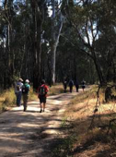

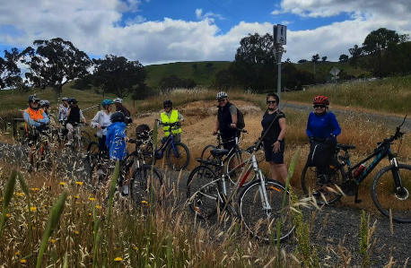

website: www.shepadventureclub.org.au
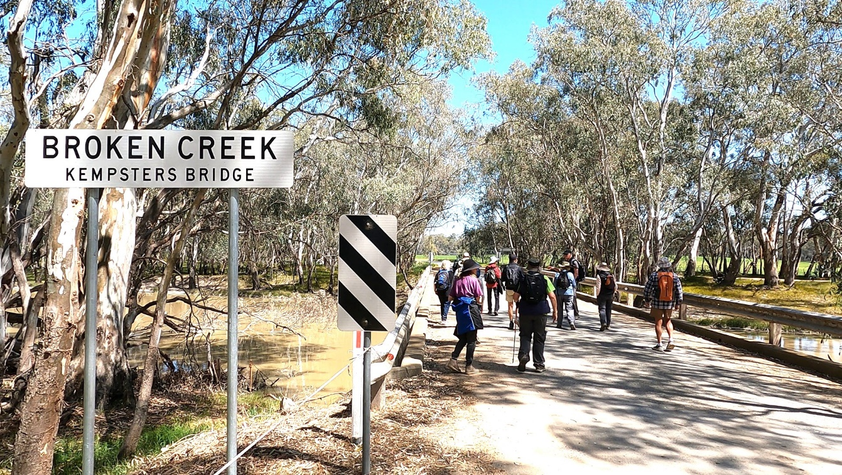

SHEPPARTON ADVENTURE CLUB inc. A0002706S

NEWSLETTER September – October 2023

Mid-Week Walkers enjoying a ramble in the Waaia area, walk lead by Graeme Betts.

Next club meeting Tuesday December 5

Save the date and keep an eye out for details of the SAC Christmas celebration event.

The SHEPPARTON ADVENTURE CLUB Inc.

General Meeting: Usually 3rd Tuesday in February, April, June, August, October
Committee Meeting: Bi-Monthly at 7.30pm.
Correspondence to: The Secretary SAC, PO Box 264, Shepparton 3632
Email: sacvicau@yahoo.com.au

OFFICE BEARERS
President Greg Smith 0429045732 president@shepadventureclub.org.au

Vice President Bruce Gill 0409819704 tatgills@westnet.com.au
Secretary Jan Gregory 0438093668 jangregory4@outlook.com
Treasurer Scott Birchall 0548210604 scott@agsystems.com.au
(email distribution to members)

Equipment Officer Richard Graves 0408 547065 richsue@bigpond.au
Publicity/Newsletter Karen Speedy 0448046958 karenspeedy@iinet.net.au
Calendar Coordinator Philip Schultz 0448324792 harwinpark@gmail.com
Mid-week coordinator Dianne Hanna 0437 289 281 dhanna3@bigpond.com
Committee member Maartje Heuperman 0407849794 maartjeheup@bigpond.com

www.bushwalkingvictoria.org.au

PO Box 1007 Templestowe Vic. 3106
Phone: (03) 9846 1132
Email: admin@bushwalkingvictoria.org.au

Affiliated member

SAC MEMBERSHIP FEES (Due JULY 1 each year)

Adult Club Membership $40
Child Club Membership (0-18yrs) $10 (must be accompanied by parent/guardian)

Membership benefits
Your Bushwalking Vic membership card enables you to obtain discounts at a number of retailers including:
AJAYS Snow and Country Sports (Heathmont), Bogong Equipment (Melbourne), Fjall Raven (Melbourne Central), Paddy Pallin (Melbourne, Ringwood), Smitten Online Tasmania, Wilderness Shop (Box Hill), Woodslane Walking Guides, Eastern Mountain Centre (Deepdene), Discovery Holiday Parks (Cradle Mountain)

Sunrise & Sunset (Melbourne GPO)
1 Aug 7.22am & 5.33 pm | 1 Sept 6.44 & 5.59 | 1 Oct 6.58 & 7.24 | 1 Nov 6.15 & 7.54
15 Aug 7.07 & 5.45 | 15 Sept 6.23 & 6.11 | 15 Oct 6.37 & 7.37 | 15 Nov 6.01 & 8.10
Full Moon
2023: 6 Jan, 5 Feb, 7 Mar, 6 Apr, 5 May, 3 Jun, 3 Jul, 1 Aug, 30 Aug, 29 Sep, 28 Oct 27 Nov, 26 Dec

President’s Piece - Greg
Hi all,
Spring is of course a great time to get out in the bush and see wildflowers in our region and beyond. After another winter of reasonable rainfall they have been out in force and change from week to week. Jill and I did a trip to the Grampians during October and were fortunate to come across a wide variety of wildflowers to distract us as we trudged up Mt William and across the Major Mitchell Plateau along a 3-day section of the Grampians Peaks Trail. It was a spectacular but hard walk, with lots of elevation gain and loss on mostly rocky tracks. We met several people doing the full 13-day, 164 km traverse and others doing sections as day walks. I’m pretty sure they were all older than me, but I was willing to believe them when they said the first 2 days we did were the hardest along the trail. We have done a lot of walking in the Grampians/Gariwerd over the years and it never fails to impress me, especially in spring.
In coming months you may stumble across turtles roaming about looking to lay eggs, particularly after a spot of rain. There’s some great information about their habits and what to do if you find one on a road at 1 Million Turtles(1millionturtles.com) and on the TurtleSAT app. There are numerous active people and groups in our area protecting their nests from predation and registering sightings, including Tatura Turtles | Facebook. Turtles need all the help they can get as numbers have been declining for decades.
I hope you continue to enjoy our great outdoors.

\

SAC Gets Out and About – Karen
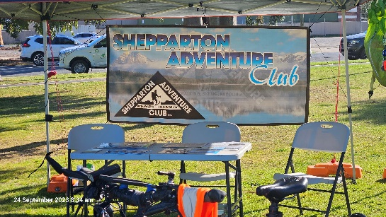
Shepparton Adventure Club has been busy. You may have noticed the recent article and photo in the Shepparton News. On September 24 SAC members set up a stall at the World Rivers’ Day event at Victoria Park Lake and attracted some interest from passers by. A new brochure promoting our club was ready in time to be handed out. We appreciate the willingness of our members to give up their time to assist with promoting the club.
We also have a smart new sign on our shed which is another way the club gains some publicity. Thanks to the efforts of Richard Graves in particular for his work on this project.
Some SAC members recently enjoyed dinner at the GV Hotel on a very wet Tuesday evening.
Finally the Facebook page gathers a lot of interest and we have 668 people following our page!

If you have any items of interest to contribute to the Newsletter, please email me.
Happy reading!
Photos: the new sign on the shed, SAC stall at the World Rivers’ Day, SAC members’ dinner

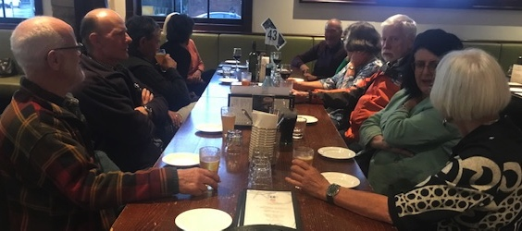

Calendar of Activities

Date | What | Where | Contact | Grade
21 Oct | Ride | Tocumwal Bike Ride | Peter and Jan  0438093668
25 Oct  8am | Walk | Warbies Spring time Flower walk and pine gully nature trail | Dianne H  0437289281 | Easy
8 Nov  8am | Walk | AST Walk 8am start for 2hr walk meet at SAC shed | Dianne H  0437289281 | Easy
25 Nov | Ride | Tatura 200 Gears and Graze  https://tatura200.com.au/  Register by 25/9 | Maartje and Alfred  0407849794
22 Nov  8am | Walk | Gemmill Swamp | Barbra B  0417364985 | Easy
5 Dec |  | Club Meeting  Christmas Celebration details TBA | Jan G  0438093668
13 Dec  8am | Walk | AST Walk 8am start for 2hr walk meet at SAC shed | Dianne H  0437289281 | Easy
16 Dec | Ride | Tatura Twilight Ride and dinner | Ray M  0438591749 | Easy

PLEASE RING THE TRIP LEADER TO MAKE SURE IT IS WITHIN YOUR CAPABILITY AND CONFIRM THAT IT IS GOING AHEAD. REGISTRATION ALSO HELPS WITH PLANNING SUCH AS CAR POOLING NUMBERS.
You will see our activities are graded. Find out more information on the website activities page Activities - Shepparton Adventure Club (shepadventureclub.org.au).

Note: TRIP LEADERS – it is imperative for every trip that temporary members/visitors sign the “Acknowledgement of Risk Form”. These completed forms must be forwarded to the SAC Secretary for filing as soon as possible after the trip – otherwise, in the case of a claim, the insurer will not acknowledge the risk.
Form can be downloaded from www.bushwalkingvictoria.org.au under Members > Forms

Travel Cost Reimbursement
30 cents per km per car split between all trip participants (used when car pooling for Mid Week Walks.)

Change of Mid Week Walk and AST start time

During the months of Daylight Savings (October to April) the start time for Mid Week Walks and AST is 8.00am. This allows the majority of the walk time to occur in the cooler morning hours. With a hot summer predicted walkers will appreciate the earlier start time.

Ideas Needed!
It’s time to start planning for our 2024 program of activities so if you have any suggestions for a location for a walk or ride or would like to try leading an activity please let a committee member know. It would be good to include some activities on a weekend like paddling or an overnight hike.

Meet your Committee

Each year at the Annual General Meeting, a committee is elected by the members. Some of the committee have served for years, if not decades! Jan Gregory has been an active member of SAC for a number of years. She was elected Secretary in 2022 and kindly accepted nomination for a second year. Jan has shared her story with us. Thanks Jan.

Tell us a bit about yourself

I was born in Kyabram and after about ten years away at school, college, travelling overseas for a couple of years, and working in Melbourne I returned to the Goulburn Valley in 1983. I wanted to get out of the city and applied for 119 schools (in the days of appointments based on seniority) and became head teacher at North-West Mooroopna Primary School where I was teaching my cousin’s children. I met Peter and moved to Shepparton.
I did a couple of years as a consultant and then taught at St Georges Rd Primary school in Shepparton and eventually became principal there. I worked in senior regional positions where I worked in schools on school improvement before my last position with the education department as principal at McGuire College. After retiring from the education department I went on to complete my PhD and worked as a consultant with a number of companies. I had a blessed career.

I love to travel and have travelled to many places but love travelling to Europe where there is so much history. The last few years my travel has incorporated walking and I have completed may iconic walks such as the Inca Trail and the Portuguese Camino.
I also love to read and belong to a couple of book clubs. I am also learning French at U3A which I have been able to put into practice (pretty poorly!) on my travels to France this year.

What are your outdoor interests?

I love to walk and, as already mentioned, I have done some great walks. Not being able to travel overseas the last couple of years gave me the opportunity to do some walks in Australia. In Tasmania - Three Capes, Bay of Fires and walks in the Cradle Mountain national park- and in the Northern Territory last year.
I also love to cycle. As well as participating in the SAC rides Peter and I have done most of the rail trails in Victoria and we have also ridden in NSW, Queensland and South Australia.
How did you become involved with SAC?

I always knew that SAC existed but it wasn’t until I retired from the education department that I had the time to participate in SAC events. Susanne Gill often spoke about the SAC outings so I joined. I have really enjoyed my time with SAC and also in the role as secretary.

Tell us something that others might be surprised to know about you

There are probably not many surprises about me but you probably do not know that I hitch-hiked across the English Channel in 1975 and I have also flown a plane solo.

BWV and Other Club News

A timely reminder from the BWV website to update all your Smartphone Apps & remind yourself where to obtain emergency Information
As our springtime adventures ramp up, if you haven't already, its time to check your smartphone apps. Are they up to date? Are your maps still available offline? Has your phone put them to sleep? There is nothing worse than needing one of your offline maps, or other emergency app quickly, only to find the app needs updating and you don't have the time, or even the phone reception to do it.
Start with your Vic Emergency App (for warnings and alerts), your BOM Weather App (for weather forecasts) and your Emergency Plus App (for finding your coordinates to advise emergency services if required). Check out the Bushwalking Manual (scroll to the section on Emergencies) for helpful apps, and other websites to obtain emergency information.

OTHER CLUBS’ ACTIVITIES

Nearby clubs share their newsletters with us and, as a member of SAC, you can attend their events (affiliated with BWV.)

Check out these clubs. You might be tempted by one of the events of offer.

Warby Ranges Bushwalkers Inc – warbybushwalkers.org.au
Bendigo Bushwalking and Outdoor Club - www.gobush.org.au/
Echuca-Moama Bushwalkers - www.echucamoamabushwalkers.org.au
and more can be found at www.bushwalkingvictoria.org.au

Trip Reports

Mid Week Walk August 23: Mt Saddleback, Dookie by Dianne

Fifteen walkers headed off from the gardens in Dookie along part of the western rail trail on a beautiful sunny day, much nicer than the rain the day before. Turning north on Chateau Road for another kilometer we entered private property and walked up the western side of Mt Saddleback. The grass was long and wet but our walkers were somewhat prepared with “dubbin wax” on their boots. The views back to the west showed Dookie’s crops of canola, wheat and beans in all their glory.

After climbing the first fence into a neighbouring property the grass was much shorter and dry but the exposed rocks created a little challenge. We reached the summit after a steep late climb revealing the township of Dookie to the south with a 360 degree view of the surrounding countyside, a view seldom seen by most walkers.
To the NW we could see a substantial area under water suggesting a pretty wet season. With the canola in flower, patches of green and gold were spectacular. One wedge-tail eagle kept an eye on us as it circled the top of the mountain. Of interest was a privately owned transmitter on the summit used by local farmers for precision guidance on machinery to prepare and harvest their crops.

Walking down the NW side of the mountain we headed for Hooper Road and a magnificent historical house known locally as The Chateau. The house was built around 1886 on a bed of rock and stands proud as it has been well restored. It was part of a substantial vineyard which operated until devastated by Phylloxera in 1909. The current owner, Brian Harker, explained the history of the property to us over lunch and gave us a tour around the grounds. His small flock of two endangered British breeds were lambing. Of most interest was a huge old yellow box tree with scars on two sides, which were identified as cut with stone axes. Brian thinks this particular area was a meeting place for the three main indigenous groups occupying the district.

The return to Dookie was east on Hooper Road to the rail trail then south to the town, a total journey of about 10 km with refreshments at the Dookie store on return.
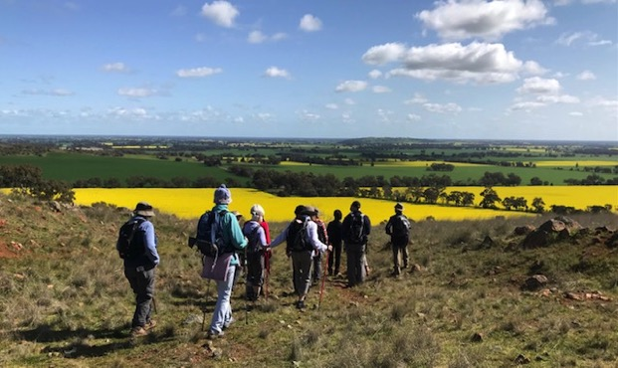
Gorgeous Dookie views in the spectacular Spring time!

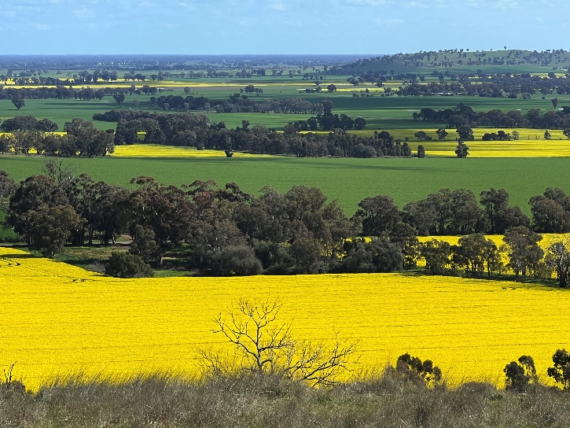

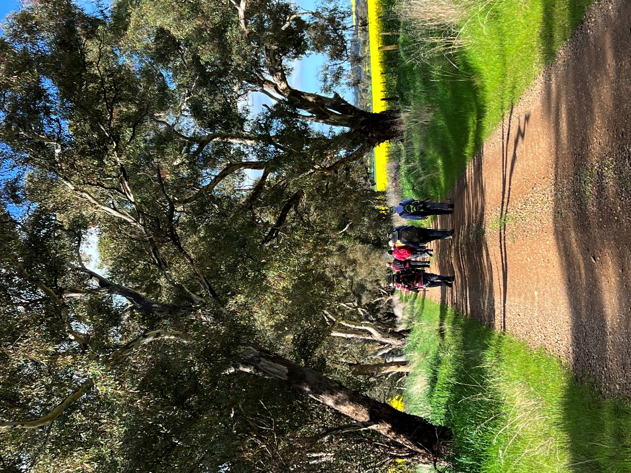

Bike Ride September 16: Kyabam to Girgarre Loop by Philip

The Spring weather really shone on a group of 10 members who joined the ride on Saturday.
We had a near perfect day for the ride with not a cloud in the sky and just a light breeze.

We met at Edis Park in Kyabram to prepare for the ride and have a chat in the sunshine.
We set off with a loop around the Edis Park shared track to view many established native Australian trees and bushes. The Park is very well patronised by locals as a walking track and exercising the dog.

Our first stop was the Kyabram Water Tank art site. A small band of dedicated volunteers has developed the former railway station platform into a first-class viewing site.

We headed over to the north side of the former Toolamba to Echuca rail line and followed its bumps and ups and downs up to the McEwen Road level crossing. From there we rode along the Main #9 GMW channel down to Everard Road, the first real bit of bitumen road we rode on was a real pleasure to ride along down to Gray Road. We headed west on the gravel up to Wigg Road and then south on the dirt along Wigg Road. We had a stop at a superb crop of canola in full flower for a group picture. From there we rode up the west side of Mount Scobie and stopped at the top of the rise to look at the flat plains to the West.

The gravel ride down to Girgarre was a pleasure as most of the gravel roads had recently been repaired and reformed so they were reasonably smooth going. At about 22km, we stopped at the former Girgarre rail station platform for a group picture and then over to the Botanic Gardens Café and native gardens for an hour-long break for lunch and a rest.

The first stage of the Girgarre to Stanhope rail trail is now very well established with all the native trees and bushes looking a picture. We turned east into Mason Road to start our journey back to Kyabram and then north into McColl Road. We then followed White Road up to McEwen Road which took us to the track along the Main Channel bank all the way up to Manley Road then a short ride to the Ky to Cooma Road to turn north. Traffic was light so we had an easy ride up to South Boundary Road for the run back on the Ky shared walking and riding path to the Fauna Park Café of a coffee.

One rider got the shock of her life when a rear tyre blew (with a loud bang) about 1 km from the Fauna Park. Fortunately, she only had to push the bike to the café. After looking at the meerkats and a coffee we rode back to Edis Park to wind up a successful ride on a superb day.
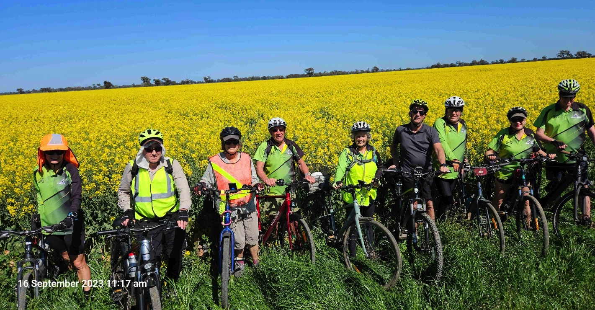

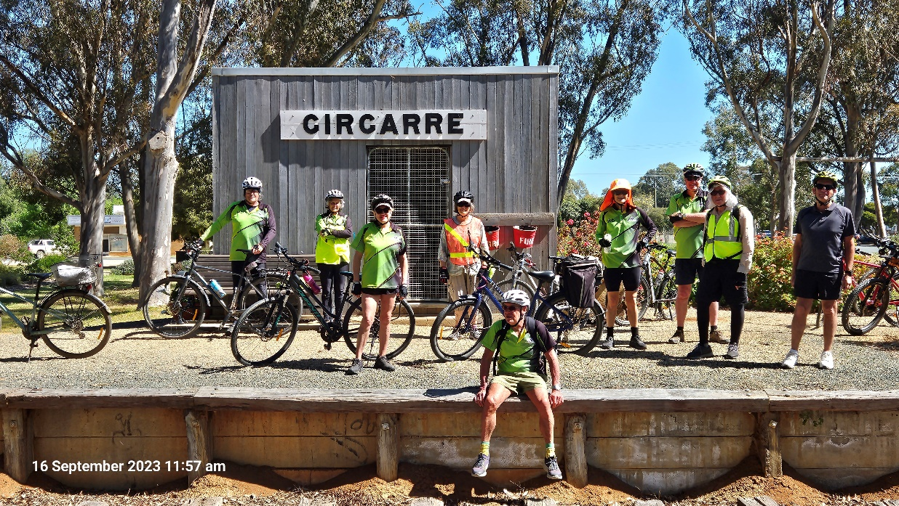

https://www.relive.cc/view/vYvEKMzQGw6

You can check out the ride on Relive, thanks to Philip.

AST September 13: Australian Botanic Gardens by Brendan

New member Brendan stepped up and offered to lead AST in September. Thanks Brendan for your enthusiastic involvement with the club. Brendan reported:

I had a very small group for my AST walk however there was plenty of conversation and great weather. Our walk along the Goulburn River to the Australian Botanic Gardens was very pleasant and the views from the lookout excellent. We continued our circuit past the Childrens’ Garden with wonderful recycled installations surrounded by native plants. We concluded our walk with coffee at the art museum’s café. Thanks to Marg and Carmel for some great company.
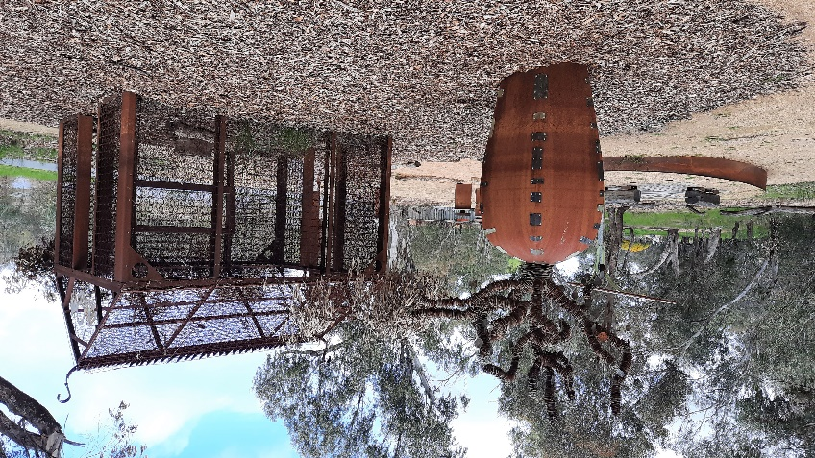
.
Photos:
Children’s Playground
View from the “hill.”

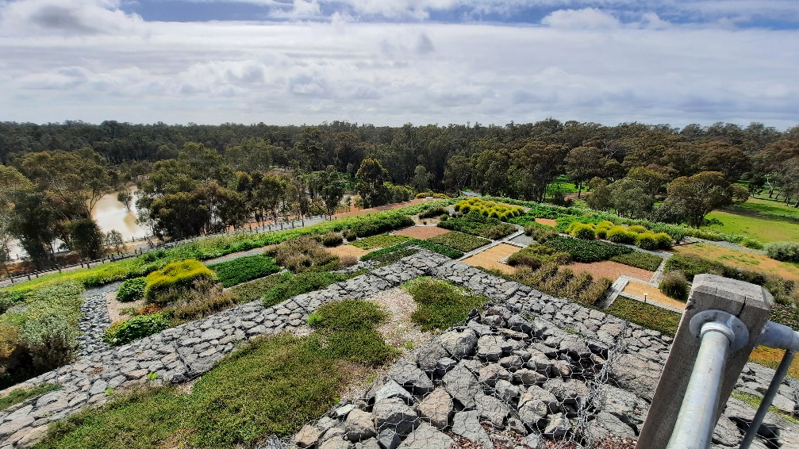

Mid Week Walk September 27: Waaia South by Graeme

Thirteen SAC walkers from all points of the compass (Mywee, Tallygaroopna, Mooroopna, Yundool, Kyabram, Kialla and Shepparton) assembled at the Nathalia Lion’s Anniversary Park in readiness for the monthly mid-week walk. After our customary morning beverage, we convoyed 8 kilometers in an easterly direction on the sometimes winding (but picturesque) Nathalia-Waaia Road.

On the short journey we observed the now disused 1888 railway line that branched from Numurkah, through Waaia and on to Nathalia (and eventually Picola); the many dead trees and tree stumps in the middle of the Broken Creek – a legacy and indication of the creek’s long history as an ephemeral stream that flowed only in Winter and Spring (and sometimes not at all); and finally houses and milking sheds that were constructed following WW2 as part of the successful Murray Valley Soldier Settlement Scheme.
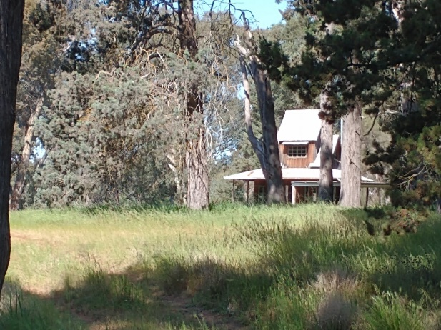

Destination reached, we parked our cars on the Broken Creek frontage and commenced walking south along Baxter’s Drive. Immediate points of interest included: the former restaurant of a well-known local chef; a large and unexpected sandhill covered in beautiful Murray Pine trees with an interesting ‘off-grid’ two story timber house perched on top; a colourful spread of Golden Wattles scattered over a broad expanse of sandy rise soil; and finally, an early 20th century farmhouse with wide verandah’s, sweeping gardens, and sundry farm sheds.

Little house on a sandhill – pre-COVID BnB

At the end of Baxter’s Drive, we crossed the bitumen surface of the Nathalia-Katamatite Road at Carland’s Bridge and commenced walking along Brooks’ Road. The Broken Creek stream, still on our right, featured many neatly sawn tree stumps – the result of a 1955 firewood collection project undertaken by a group of Mooroopna men. Standing precariously on a raft attached to 44-gallon drums, the men felled the dead trees, winched them to shore, cut them to shorter lengths, then trucked the wood to Melbourne to meet the urban dwellers demand for firewood.

Unfortunately, the peacefulness of the walk on Brooks’ Road was briefly interrupted for one walker who glimpsed a sizeable brown snake curled up on the edge of the road. Her ‘flight or fight’ response kicked in and only receded when it became apparent that the snake was …. dead!

At the junction of Brooks’ Road and Grey Box Road we departed from the ever-winding creek for a few hundred metres. On rejoining it near Kempster’s Bridge, a significant difference was observed. Gone were the many trees and stumps from mid-stream – the result of a 1965 dredging of 19 miles of the creek from Grey Box Road upstream to the junction of the Broken and Nine Mile Creeks near Wunghnu – a futile attempt at flood mitigation.

After a brief rest at Kempster’s Bridge (Mrs. Kempster was a midwife in the 1800’s) we soon reached the most distant point of the walk – the five acres bordered by Kempster’s Bridge Road, Howie’s Road, and Wilkinson’s Road. This was the site of a Presbyterian Church until 1961, the site of the Waaia South State School (1878 – 1916), and (from 1951) the farmlet of Howie Marshall O.A.M. Howie was awarded an O.A.M. for his lifelong service to the conservation and recording of our native flora. After listening to a brief synopsis of his remarkable life (as recorded in his autobiography ‘The Way It Was’), the walkers enjoyed a well-deserved lunch seated on a fallen log in a nearby clearing.

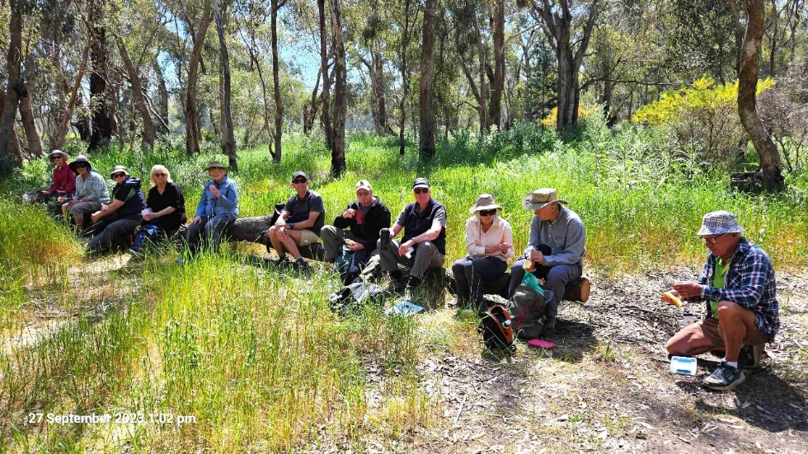

Lunch break. Is there room on the log for Ray?

During the walk, in addition to the expected wild ducks and magpies, Marg was able to identify Noisy Friarbirds, Yellow Type Crimson Rosellas and White-winged Choughs. Of particular interest were Rufous Songlarks with their melodious calls. These birds arrive from the north in Spring for breeding.

To keep the distance reasonable, this was a ‘there-and-back’ walk. Re-energised by lunch, we retraced our steps along the roads, often in dappled shade provided by the Red Gum, Grey Box and occasional Yellow Box trees. At Nathalia a leisurely coffee was enjoyed in the Bakery. Many thanks to the participants for your great company and good humour on what was a beautiful day for walking. Special thanks to Marg for her help with the bird life and to Phil for his excellent Relive video recording.
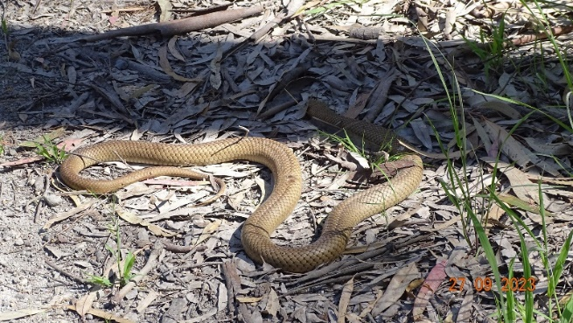
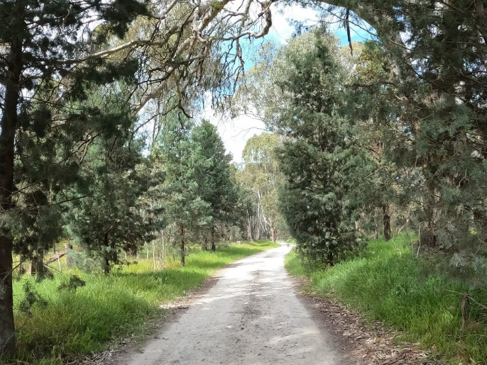
Photos: Murray pines, a not so slippery friend and heading back for coffee.
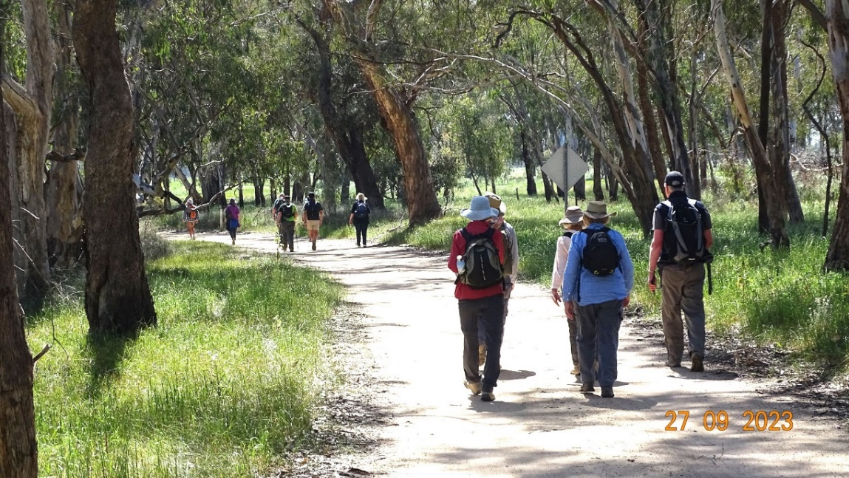

https://www.relive.cc/view/vYvrVZ3Ezxv
Click on the link to view Philip’s capture of this walk on Relive. Philip does a great job and the finished result is impressive - a map with photos embedded.
Wonderful Wildlife with Marg

White-breasted Woodswallow
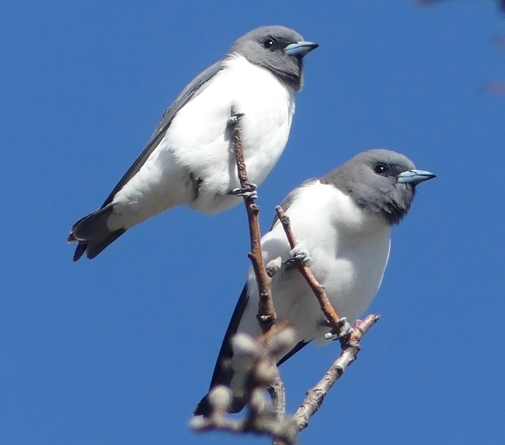
The White-breasted Woodswallows are the largest of the Australian woodswallows and are seen locally in wooded areas near wetlands.
This photo was taken recently near the Kialla Lakes and they are often seen at Victoria Park Lake, Shepparton and Reedy Swamp.
White-breasted Woodswallows are resident further north and migrate to our area and further south in the warmer months. They are mostly seen in groups and look quite cute lined up on branches or electric wires.

Members’ Meanderings by Jan

Gears and Beers Festival at Wagga Wagga

Six SAC members participated in the Gears and Beers weekend which is held on the first weekend in October (long weekend in NSW). Lyndall, Geoff, Marty and Wendy arrived on Friday and did the ‘warm-up ride’ on the Saturday. This was a 40km ride through various types of terrain, including a very steep hill that most participants had to walk up.

Peter and I arrived on Saturday and we were all ready for the event on the Sunday. Peter and I did the ‘Roadie 30’ while the others did the ‘Sic 60’. Both rides were great. There were about 3000 riders in total, some in fancy dress, a variety of bikes including e-bikes and even a push scooter! It is very well organised by the local Rotary Clubs and all money goes to local charities.

The ride started and ended at the Memorial Victory Gardens in Wagga. After the ride there was security for our bikes, beer (and wine) and many food choices. There was entertainment as well as a slide show of the rides. It was a fun weekend and we have all decided to book for 2024.

If you are interested in joining us, here is the website https://gearsandbeers.org.au/ I would suggest that you book accommodation first. We stayed at the Big 4 Caravan Park where we could ride to and from the event along the river bank bike trail.

Ready to ride Lots of riders!
