

**SAC Newsletter**

**October – November 2021**

**website:** [**www.shepadventureclub.org.au**](../AppData/Local/bg20/Documents%20and%20Settings/gregs/My%20Documents/SAC/Newsletter/2012/www.shepadventureclub.org.au)

**End of year gathering 7 December at the Shed from 6pm**

**BYO food, drink & chair - BBQ available for use**

**Canoes available to try on lake**

*** vaccination requirements tbc, look out for an email closer to 7th December ***

**Glenrowan District Bike Ride - 16 October 2021**

After several cancellations we finally began in the township of Glenrowan, eight riders for the morning and five in the afternoon. Weather overcast with a chance of showers but as it turned out no rain, just a strong SW wind most of the day.

Morning ride heading North of the town beginning on the bike track then onto back roads meandering along winding track with a few short sharp hills past lovely farmlets and orchards at the base of Warby ranges, due to wind we returned on the same route avoiding strong wind on the open road back to Glenrowan for lunch break, total distance being 16km.

Afternoon ride south towards Greta West, mostly downhill for first 5km then turning off bitumen for bush track past more small farms, plenty of pot holes and puddles for Ray to test his new ebike trying very hard not get it dirty!

Team event consisted of removing a fallen tree across the track. Mostly open fields back to Glenrowan with a nice tail wind, landscape looking wonderful after all the rain, cows looked happy watching us as we rode past, last section into town rather steep but Ray on his new ebike made it a no sweat, afternoon total 25km. Back to the bakery for a coffee before heading home.

Regards, Dallas

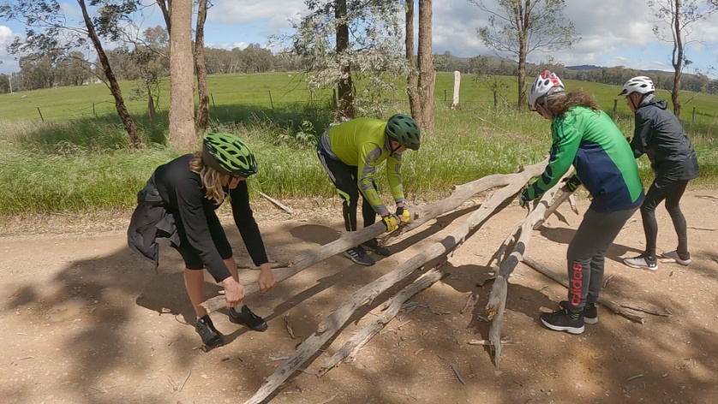

Adventure club to the rescue, large branch fallen on the road!!

BTW it WAS heavier than this photo shows ☺

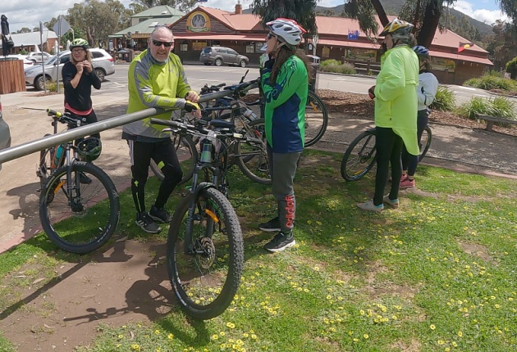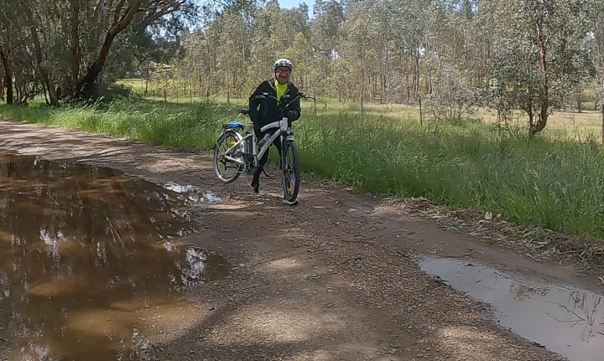

Mid ride bakery break

Rays new E bike was still too new to ride in the mud, so he stopped to carry it over it!!!

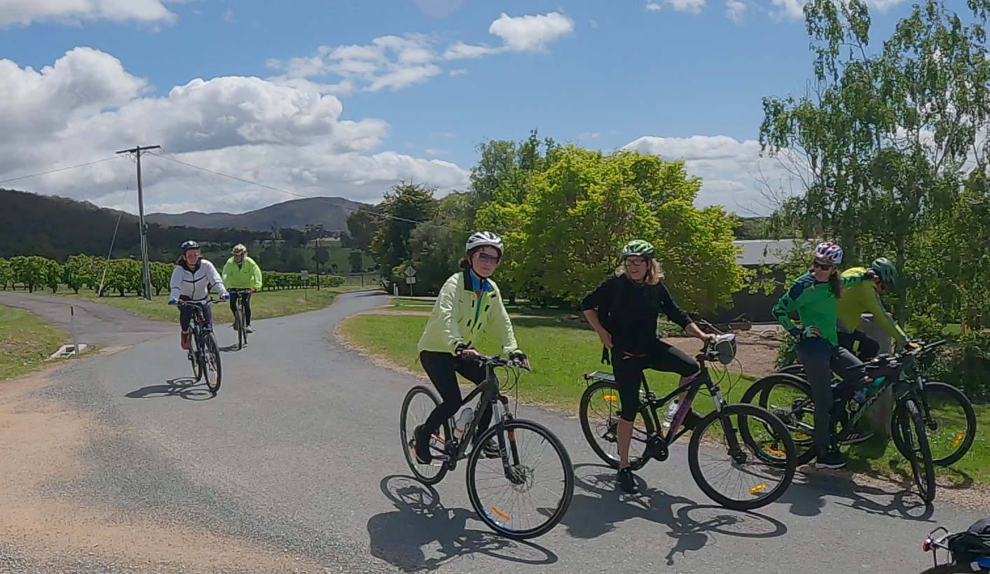

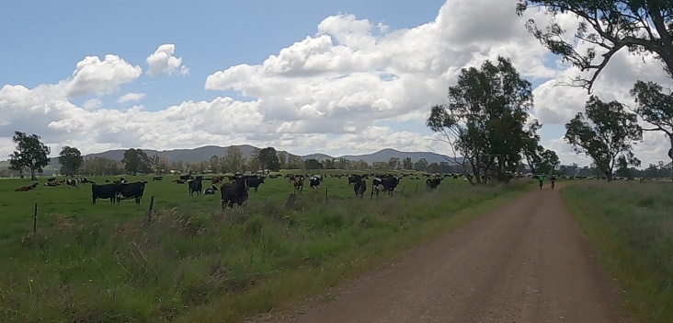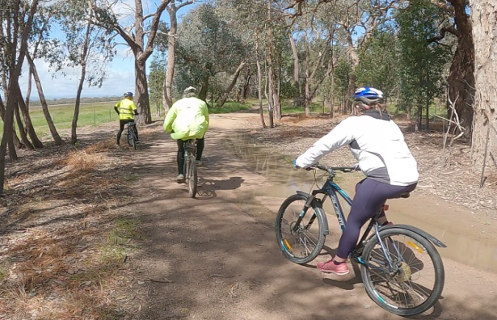

**Out and About on the Glorious Goulburn**

The October sun is shining and the Goulburn running high. What better way to celebrate the end of the latest lock down than to take the trusty canoe out onto the river?

We launch our trip at Cemetery Bend near Old Toolamba and finish just past the Toolamba bridge, a total of about 10 km.

The paddling is easy with the river well above its usual level – there is considerable current assist and all snags are well below the surface. The only disturbance to the serenity is the raucous screeching of the sulphur-crested cockatoos, the clumsy flapping of ducks as they launch themselves into the air ahead of the canoe and the soft swoosh as the paddles dip into the water. We spot other birds – cormorants, swallows, and a black faced cuckoo shrike.

Thick grass lines the river bank, majestic river red gums stretch overhead and a gentle breeze ruffles the water. The Toolamba rail and road bridges provide landmarks and interest along the way. Our river is a treasure that we often underrate.

We pull the canoe out of the river, do the car shuffle and are home in time for lunch.

Karen and Richard Speedy

9/10/21

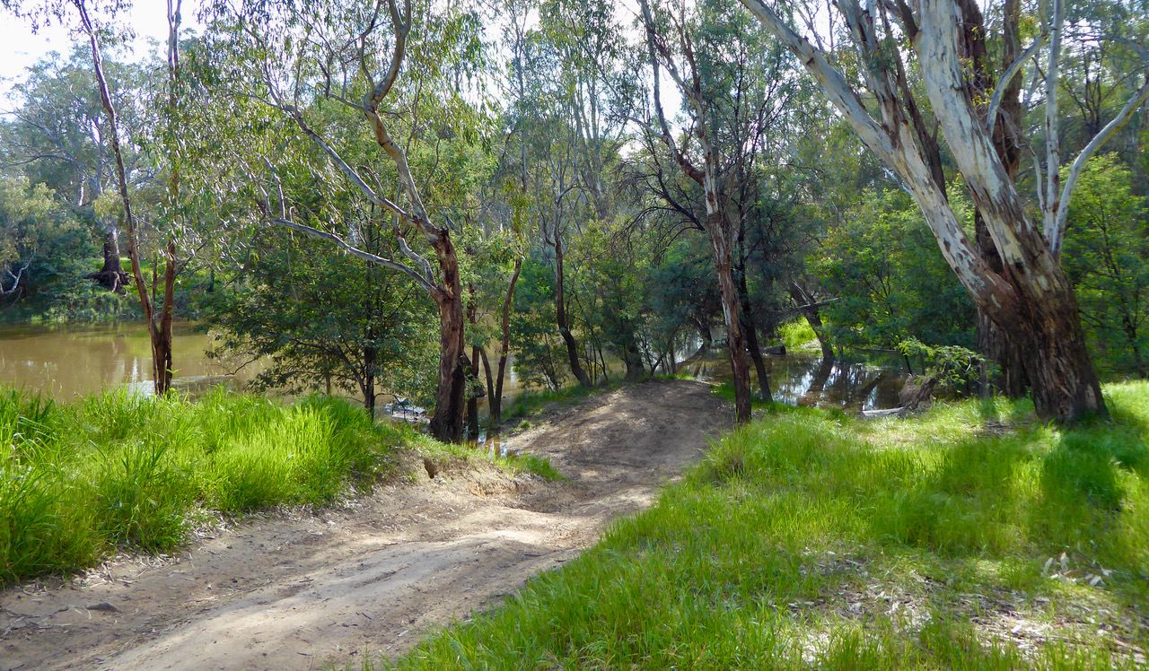

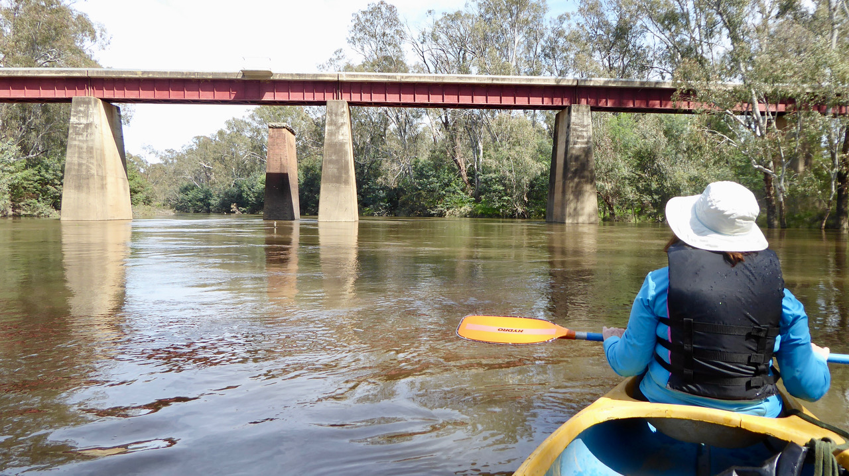

### A group of hikers were being led through the wilderness by a guide.

On the third day, the hikers noticed that they had been travelling in circles.  
"We're lost!" One of the men complained. "I thought you said you were the best guide in the United States."  
"I am," the guide answered, "but I think we may have wandered into Canada

### Picked up a hitch-hiker. Seemed like a nice guy

After a few miles, he asked me if I wasn't afraid that he might have Covid. I told him the odds of two people with Covid being in the same car were extremely unlikely.

### The clever smuggler

At a border between 2 countries, the Customs Officer stops a man. He's riding a bike and holding a huge sack.  
The officer asks "What's in the sack?"  
The man replies "Just some mud."  
The officer checks. Sure enough- mud.  
He's very suspicious, but has no choice, and lets him go.  
Next day, same man cycles to the border with a huge sack of mud.  
The same Customs officer stops him and searches thoroughly, but finds nothing except mud. This goes on for a few weeks, until the officer can't take anymore.  
He stops the cyclist and says "This is my last day on the job. I promise not to do anything but please tell me, what is it you're smuggling?"  
The man smiles "The bicycles."

### A man was driving in rural Pennsylvania

When he saw what looked like a Mennonite up ahead on his bicycle.  
“I’m gonna play with this guy,” he thought, as he stepped on the gas to give the poor Mennonite a scare and show him who the king of the road is. WHOOSH, he blasted by the poor, helpless bike rider.  
As he was having a chuckle, he noticed in his side view mirror that the man on the bike was pedaling furiously AND GAINING speed to pass the driver. The Mennonite on his bicycle flew by the driver like he was standing still.  
“What the hell?” screamed the driver. “I’ll show him!” he yelled as he floored the gas pedal once more. Again the driver flew past the poor Mennonite man on his bike. “That’ll show hi—“ he thought as he noticed the cyclist gaining on him AGAIN in the side view mirror. Whoooosh, went the bicycle right by again and came to a stop up the road.  
  
Amazed by this feat of super-human strength, the driver pulled up next to the spent cyclist, who was gasping for breath. “H-how did you ride your bike that fast?”  
  
The Mennonite, still gasping for air, half looked at the driver and replied, “My suspenders got caught in your mirror.”

**President’s report**

Hi members,

It’s great to see our trips starting up again in recent months and the reports in this newsletter.

While I haven’t managed to get on a club ride or walk recently, Jill and I did have a weekend in the southern Grampians and have done a few short walks closer to home. Along the way we have seen emus, echidnas, wallabies, kangaroos and a wide variety of wildflowers. It has been a great wildflower season, so much better than in the drier winter-springs we seem to be experiencing more frequently.

With summer nearly here please ensure you take plenty of water on your adventures and protect yourself from the sun to avoid heat stress or stroke. Watch out for how others are coping in heat and don’t be afraid to ask the leader for a rest break if needed.

I look forward to catching up at the end of year BBQ on 7 December.

Best regards,

Greg



SAC is affiliated with

[www.bushwalkingvictoria.org.au](http://www.bushwalkingvictoria.org.au)

*[Type a quote from the document or the summary of an interesting point. You can position the text box anywhere in the document. Use the Text Box Tools tab to change the formatting of the pull quote text box.]*

Ride dates for the remainder of 2021

|  |  |  |  |
| --- | --- | --- | --- |
| 20 November 2021 | Yea to Cathkin Rail Trail | Dallas | Medium |
| 11 December | Rushworth twilight ride | Jan 0438 093668 | Medium |

And for next year 2022 (walk list still in preparation):

|  |  |  |
| --- | --- | --- |
| **Date** | **Location** | **Organiser** |
| 15 January 2022 | Twilight ride along Shepparton bike tracks and BBQ at the Shed | Shelley/Ray |
| 19 February | Huntly – Whipstick Forest | Jan 0438 093668 |
| 19 March | Katamatite | Kerry |
| April | *Possible camp so no ride* |  |
| 21 May | O’Keefe Rail trail | Dallas 0413 910 018 |
| 18 June | Waranga/ Murchison | Geoff and Linley |
| 16 July | Everton to Myrtleford | Wendy and Martin |
| 20 August | Moyhu | Ray |
| 17 September | Winton Wetlands | Ray/Dallas |
| 15 October |  |  |
| 19 November |  |  |
| 17 December 2022 | Twilight ride TBD and BBQ at Shed |  |

**Trip Leaders:** *Please remember to ask visitors to sign an Acknowledgement of Risk form for Temporary Members and pass it on to our Secretary, Karen. This form is available on our website once you login (member, bushwalk) under Members>Leader Information. It is a requirement of our club insurance policy.*

**TOTAL FIRE BAN**

**If a day of TOTAL FIRE BAN is declared please contact the Activity Leader for confirmation whether the activity will go ahead or not.**

#### President: Greg Smith 5824 1143 president@shepadventureclub.org.au

#### Vice President: Bruce Gill 5824 2548 tatgills@westnet.com.au

#### Secretary: Karen Speedy 5825 1785 karenspeedy@iinet.net.au

#### Treasurer: Scott Birchall 5831 6063 scottb@agsystems.com.au

#### Newsletter: Shelley Wyllie Shelley.wyllie@gmail.com

#### Equipment Officer: Richard Graves 5824 2929 richsue@bigpond.com

#### Publicity Officer: Karen/Richard Speedy 5825 1785

#### Calendar coordinator: Neville Paynter 5831 1576 Neville.Paynter@jacobs.com

#### Mid-week coordinator: Dianne Hanna 0437 289 281 dhanna3@bigpond.com

Do you have a favourite to share?

Shelley.wyllie@gmail.com

**Bush Tucker recipes**

**Spiced Chicken & Tomato Pilaf**

Heat 1 TBS of olive oil in a large saucepan on medium. Sauté 1 chopped onion till golden, stir in 1tsp ground coriander; cumin and chili stir till fragrant. Mix in 1 ½ cups basmati rice, 400g can dice tomatoes and 1 ½ cup of water.

Bring to boil and reduce heat to low and simmer, covered, for 12-15mins (liquid has absorbed)

Meanwhile, Toss 500g diced chicken thigh fillets in plain flour, shaking excess off and cook for 4-5 minutes in olive oil until golden and cooked through.

Serve Pilaf topped with chicken and sprinkled with chopped parsley. **(YUM level 10/10)**

**#TRENDING**

**SWEET POTATO TOAST**

This new foodie trend is a great gluten-free toast substitute and a good way to get an extra serve of veg. Just thinly slice, toast and top with avo and tomato – easy!

**Quiz time**

Sitting

World

Head Ache

VIT _ MIN

NO NO

CORRECT

**Myrtleford to Bright ride - Saturday 6th November**

12 people turned up for the Bike Ride from Myrtleford to Bright the weather was kind to us for a great Day's  Ride.

We departed Myrtleford around 10am our first stop was at Eurobin Station then proceeded to Porpunkha for Lunch Break

Great place for lunch as some of us sat on the Lawn by the River enjoying the Sun and some under the covered area at the picnic tables.

After lunch we rode onto Bright at Bright we had a 45 minute free time to do whatever.

Bright was a Buzz with visitors families enjoying some freedom it was so nice to see the kids playing along the waters edge on the playground and doing whatever Having Fun and the Shop Keepers would be Happy with the Visitors.

Our Return Ride with a short stop at Eurobin Station then back to Myrtleford..

You could say it was a very BRIGHT DAY...

Cheers to all Ray

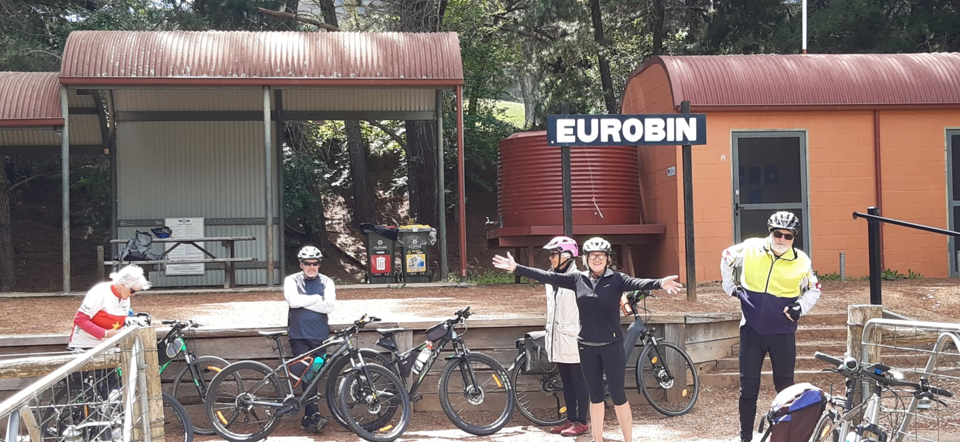

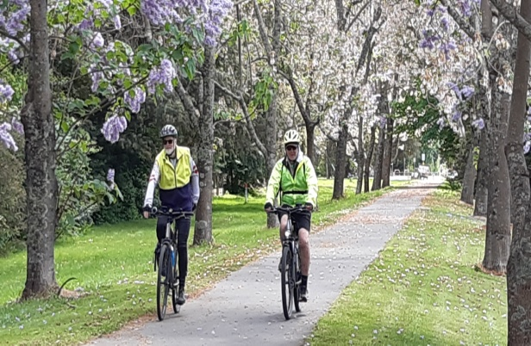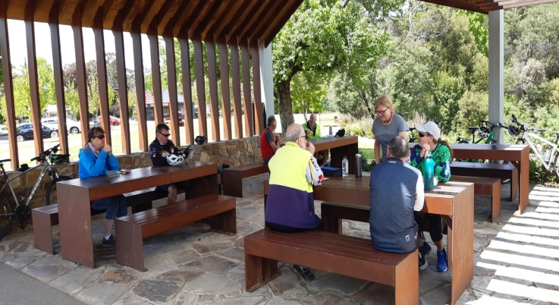

Toilet break at EUROBIN and Lunch at Porepunkah

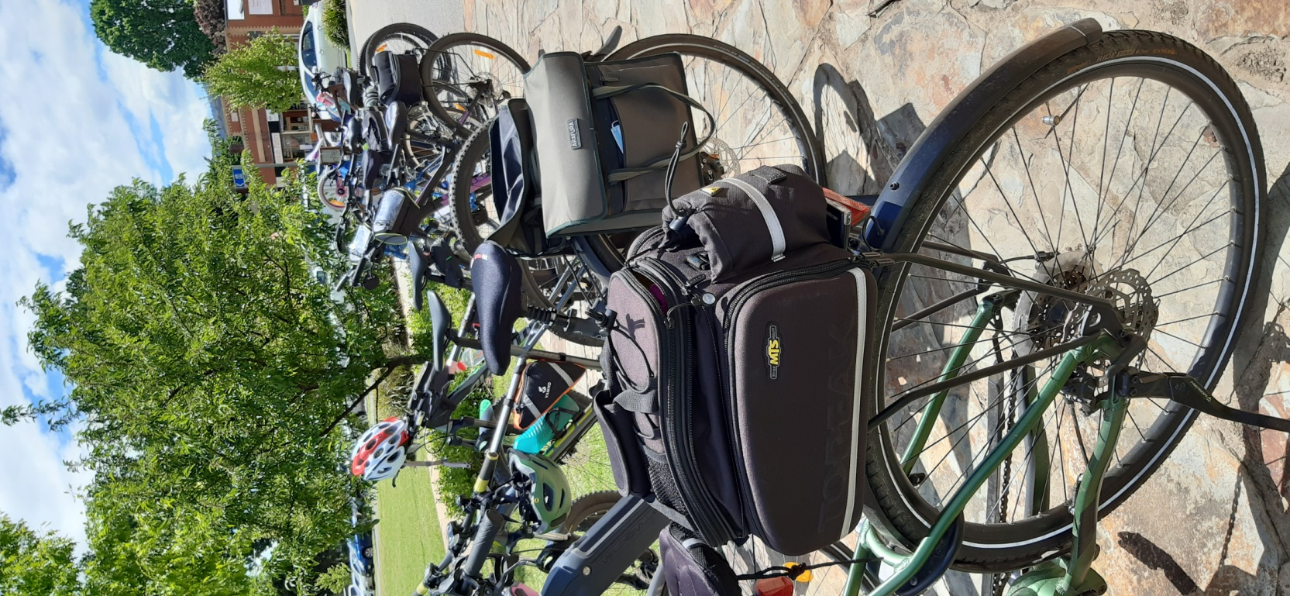

**Wangaratta to Everton ride – 10 November 2021**

Saturday November 10th Bike Ride we rode from Wangaratta to Everton Return a 53klm Ride

8 Riders turned out for the Day

The weather was kind to us once again a bit of cloud cover which made it a pleasant ride with a couple of short breaks on the way to Everton where we had lunch at the Railway Station

The Ride back to Wangaratta was a little bit different just a little bit along the trail Geoffrey noticed he needed a bit more air in his rear tyre ( not Pic ) then not so long after ( oh no) Dallis had a puncture another Pit Stop

The Pit Crew Dallas Pit Supervisor and  Jan and Wendy as Tyre Technicians Great job Pit crew back on the trail in no time

 ( see Pics ) as we got close to Wangaratta we came across thousands of little Bugs there was some quick thinking by some and the face masks came in handy ..

All in all it was a Great Ride ..

Cheers Ray .

Geoff pumping up his tires. And the group enjoying lunch at Everton grabbing the only table minutes before another bike group turned up.

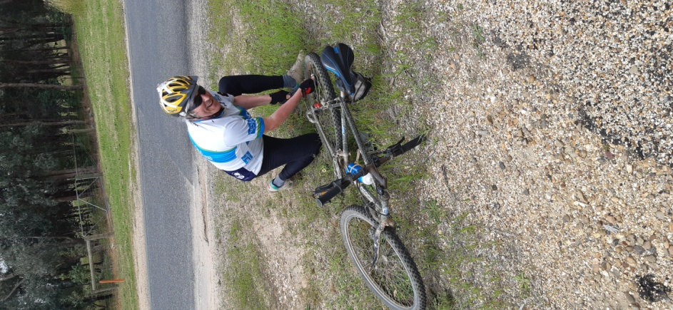

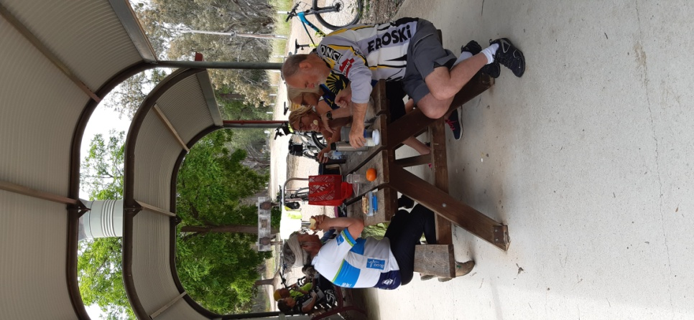

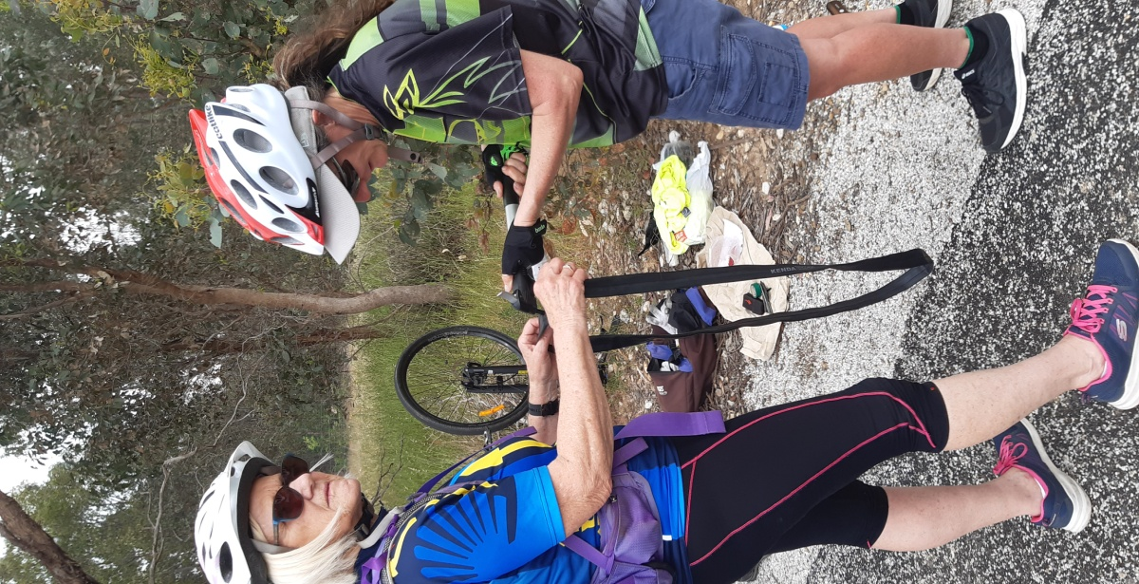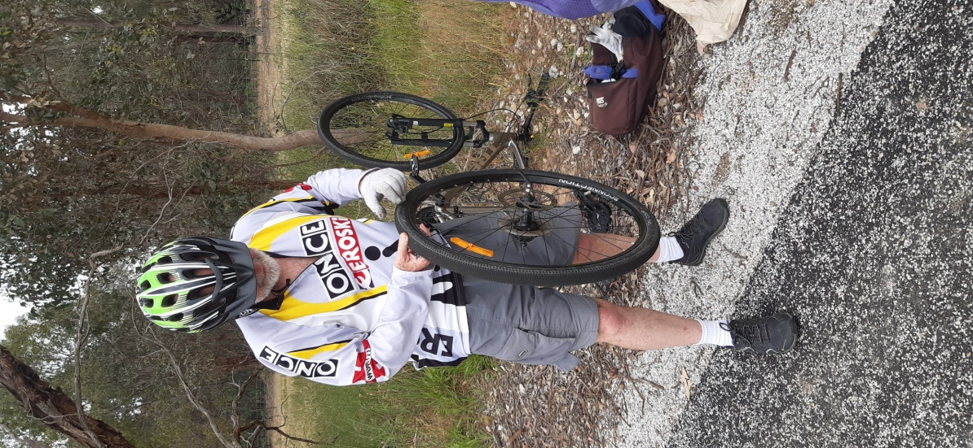

**Wednesday 27th October 2021 Mid-week Walk near Heathcote**

Our Midweek Walk for this month was to the Heathcote area (Heathcote Graytown NP). 16 members booked in. Perfect sunny weather. A bit of an unusual start from Tatura Cussen Park with a stop at Rushworth for coffee. From there we drove in convoy to the Dargile Camping ground NW of Heathcote. With reasonable rain fall the area was green with quite a few flowering bushes around. Its mainly Box Iron Bark Forest with very little undergrowth and here and there a few grass trees. We did the Wattle Gully walk, a loop of 5.5km, sparsely signposted but the help of phone maps it all went well. Back at the campground we enjoyed lunch under the shaded roof building and finished the day with the 1.5km Forest Walk. This brought us to a nice grassy camp spot where we followed the signs to the Lagoon, an artificially dug big dam. Lovely day!

Maartje Heuperman

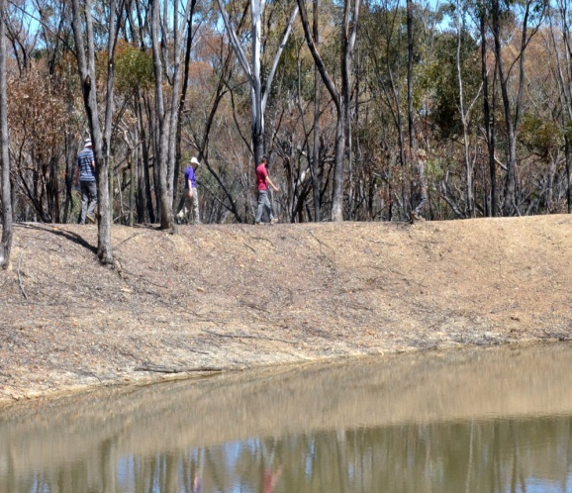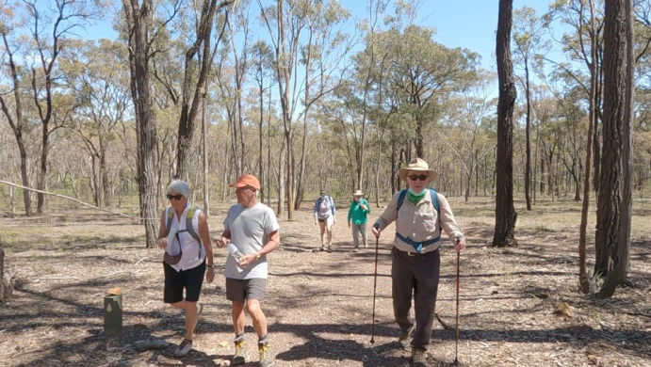

**Everything BIRD’S**

**Marg Clarke**

Rainbow Bee-eater

Rainbow Bee-eaters are widespread throughout Australia.

They are resident in the North while some fly South in the Spring to breed, returning in April.

Rainbow Bee-eaters are beautifully coloured, the females slightly duller with shorter tail streamers as seen in this photo of a female and male taken recently.

Rufous-brown is seen on the wings while they are in flight.

These birds can sometimes be seen perched on bare branches.

They take bees, wasps and dragonflies while flying and usually go back to the same branch where they knock the insect on it to remove stings before swallowing it.

Nests are in burrows made usually in sandy ground in banks or cuttings.

A regular breeding area for Rainbow Bee-eaters locally is on the northern edge of Shepparton. The SAC Mid Week Walkers saw some sitting on fences while on a walk near Reedy Swamp one year.

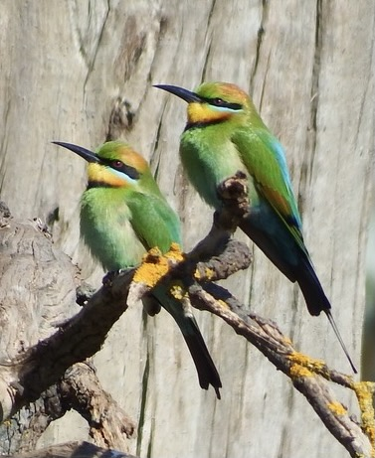

Photo and description by Marg Clarke

**Editors note**

**The long time wait for a club shirt is nearly over,** a favoured design was sent to the print house last week. So at the Christmas dinner we hope to have a sample for everyone to see, touch and feel and hopefully order!

As we could not cater for every member (Short sleeve, long sleeve, hi neck low neck ETC) we went with a generic design that promotes the club with t*he intention of getting more members.* The walkers have a very varied requirement we could not cater for so we looked at a design that was of uniformity for the bikers and all other members may wear them as a casual shirt to get our club name out there!!

At the Christmas dinner we should know more information on cost, time line and sizing.

**What a jammed packed newsletter this was**, WOW talk about adventures! Go team Shepparton. I really enjoyed the extra rides and walks thrown in these couple of months, it was so pleasing to walk and hear the long awaited chatter of our members.

Di and Jan both are organising next year’s walks and rides, both are very pleased with the uptake of members putting their hands up to lead the events.

As Di stressed, please be vocal at your willingness to car share, there is no shaming here as we are all protecting our own families.

Don’t forget if you want to do an adhoc event, let Di or Jan know and they will share your idea ☺

**We are still looking for an experienced member to be a kayak leader** to take the club out on the waters, Shelley (Me) wants to but she can’t swim and has only had 30mins experience!!

So Please if anyone is interested on taking the Adventure Club back to the waters put your hand up and let us all follow your lead ☺

Being Newish to Victoria I am so impressed and can’t wait to re-visit some of these towns we are adventuring! Bright is top of my list, And the list is growing!