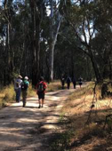

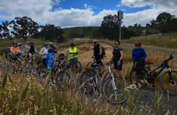

website: www.shepadventureclub.org.au

SHEPPARTON ADVENTURE CLUB inc. A0002706S

NEWSLETTER November – December 2023

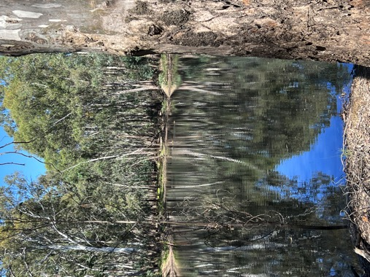

Beautiful reflections, November Mid Week Walk, Gemmill Swamp

Shepparton Adventure Club extends our best wishes for this festive season to all our members and we look forward to walking or riding together in 2024.

The SHEPPARTON ADVENTURE CLUB Inc.

General Meeting: Usually 3rd Tuesday in February, April, June, August, October
Committee Meeting: Bi-Monthly at 7.30pm.
Correspondence to: The Secretary SAC, PO Box 264, Shepparton 3632
Email: sacvicau@yahoo.com.au

OFFICE BEARERS
President Greg Smith 0429045732 president@shepadventureclub.org.au

Vice President Bruce Gill 0409819704 tatgills@westnet.com.au
Secretary Jan Gregory 0438093668 jangregory4@outlook.com
Treasurer Scott Birchall 0548210604 scott@agsystems.com.au
(email distribution to members)

Equipment Officer Richard Graves 0408 547065 richsue@bigpond.au
Publicity/Newsletter Karen Speedy 0448046958 karenspeedy@iinet.net.au
Calendar Coordinator Philip Schultz 0448324792 harwinpark@gmail.com
Mid-week coordinator Dianne Hanna 0437 289 281 dhanna3@bigpond.com
Committee member Maartje Heuperman 0407849794 maartjeheup@bigpond.com

www.bushwalkingvictoria.org.au

PO Box 1007 Templestowe Vic. 3106
Phone: (03) 9846 1132
Email: admin@bushwalkingvictoria.org.au

Affiliated member

SAC MEMBERSHIP FEES (Due JULY 1 each year)

Adult Club Membership $40
Child Club Membership (0-18yrs) $10 (must be accompanied by parent/guardian)

Membership benefits
Your Bushwalking Vic membership card enables you to obtain discounts at a number of retailers including:
AJAYS Snow and Country Sports (Heathmont), Bogong Equipment (Melbourne), Fjall Raven (Melbourne Central), Paddy Pallin (Melbourne, Ringwood), Smitten Online Tasmania, Wilderness Shop (Box Hill), Woodslane Walking Guides, Eastern Mountain Centre (Deepdene), Discovery Holiday Parks (Cradle Mountain)

Full Moon
2023: 6 Jan, 5 Feb, 7 Mar, 6 Apr, 5 May, 3 Jun, 3 Jul, 1 Aug, 30 Aug, 29 Sep, 28 Oct 27 Nov, 26 Dec

President’s Piece - Greg
The club had a great Christmas break up in Mooroopna Pizzeria on 5 December, with a room to ourselves and lots of ‘entertainment’. Thanks to Jan, Di, Karen and Phil for organising everything and congratulations to all the award winners. It certainly set a high standard for future events.
I recently attended a Bushwalking Vic Club Connection online forum where around 20 clubs discussed their wins, challenges and ideas. A common challenge appears to be recruiting younger members and working out the best way to engage them. Another was some clubs had experienced a decline in club meeting participation so, like SAC, had successfully turned to more social events. A few mentioned the costly need to regularly update website software platforms and whether it is worth continuing with websites, which it sounds like we may face in a year or two. On the positive side, I heard some successful ideas tried were sunset walks (in Bendigo) and dawn walks followed by breakfast. I’ll take some of these to the next committee meeting to discuss what’s useful for SAC. BWV is also looking for ideas to celebrate its 90th anniversary next year.
Thanks to all our members for another great year and I wish you an enjoyable festive season.

\

From the Editor – Karen

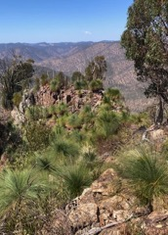
My love of long distance hiking began with a 600km walk across Spain in 2014, almost 10 years ago. Walking a Camino route in Europe was a very kind introduction to a hike of this length because so much is readily available – food, water, shelter, company.
Since then I have been fortunate to complete many other hikes, including two sections of the Australian Alps Walking Track, the Overland Track, the Great Ocean Walk and numbers of shorter hikes in the High Country as well as the Portuguese Camino and part of the Via de la Plata, another Camino in Spain.
This year I have had the pleasure, privilege and, at times, challenge, of walking The Great South West Walk (Portland to Nelson) in January, a section of the Heyson Trail (Quorn to Hawker) in July and the Green Gully Track in September.
Green Gully Track is a five night/four day hike in the Oxley Wild Rivers National Park in northern NSW, operated by NSW National Parks and Wildlife Service. The hike follows management trails, creeks and ridgelines and includes some steep ascents and descents.
Walkers must book onto the hike with a limit of six people on any one section. The park was a cattle farm until the 1990s so the track links three cattleman’s huts and these provide the campsites. With basic accommodation in the huts, there is no need to carry tents, sleeping mats or cooking gear, leaving more room in our packs for food and wine!! This was a great hike to complete with Richard, two of our daughters and two of their friends.
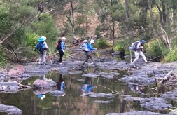
I hope to keep the hiking going in 2024 and beyond! The Bibbulmun in WA, the Larapinta in the NT and the Grampians Peaks here in Victoria are hikes I am keen to complete in the next few years.
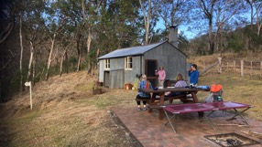

Calendar of Activities

Date | What | Where | Contact | Grade
13 Dec  8am | Walk | AST Walk 8am start for 2hr walk meet at SAC shed | Dianne H  0437289281 | Easy
16 Dec | Ride | Tatura Twilight Ride and dinner | Jan G  0438093668 | Easy - Mod

PLEASE RING THE TRIP LEADER TO MAKE SURE IT IS WITHIN YOUR CAPABILITY AND CONFIRM THAT IT IS GOING AHEAD. REGISTRATION ALSO HELPS WITH PLANNING SUCH AS CAR POOLING NUMBERS.
You will see our activities are graded. Find out more information on the website activities page Activities - Shepparton Adventure Club (shepadventureclub.org.au).

Note: TRIP LEADERS – it is imperative for every trip that temporary members/visitors sign the “Acknowledgement of Risk Form”. These completed forms must be forwarded to the SAC Secretary for filing as soon as possible after the trip – otherwise, in the case of a claim, the insurer will not acknowledge the risk.
Form can be downloaded from www.bushwalkingvictoria.org.au under Members > Forms

Travel Cost Reimbursement
30 cents per km per car split between all trip participants (used when car pooling for Mid Week Walks.)

Change of Mid Week Walk and AST start time

During the months of Daylight Savings (October to April) the start time for Mid Week Walks and AST is 8.00am. This allows the majority of the walk time to occur in the cooler morning hours. With a hot summer predicted walkers will appreciate the earlier start time.

OTHER CLUBS’ ACTIVITIES

Nearby clubs share their newsletters with us and, as a member of SAC, you can attend their events (affiliated with BWV.)

Check out these clubs. You might be tempted by one of the events of offer.

Warby Ranges Bushwalkers Inc – warbybushwalkers.org.au
Bendigo Bushwalking and Outdoor Club - www.gobush.org.au/
Echuca-Moama Bushwalkers - www.echucamoamabushwalkers.org.au
and more can be found at www.bushwalkingvictoria.org.au

Meet your Committee

Each year at the Annual General Meeting, a committee is elected by the members. Some of the committee have served for years, if not decades! Maartje Heuperman is certainly not new to SAC but she has recently become a general member of the committee, elected at the AGM in August. Here are Maartje’s answers to the “meet your committee” questions.

Tell us a bit about yourself
Born in Gouda (Netherlands) in 1951 from a Dutch father and Chinese-Indonesian mother. After “Nursing” I worked in the disability sector. Met Alfred and spent time living in Indonesia, Philippines and Mozambique. As part of the baby-boomer generation we travelled a lot, what shaped me into the person I am today.
What are your outdoor interests?
I love just being outside, in the bush as well as in my garden. It has an enormous calming influence on me. Gardening, walking, bike riding, bird watching or just relaxing with a book and a cup of coffee. But maybe because of my European background, it took me 2 years to learn to appreciate the Australian bush landscape that I used to label as grey and rather messy.

How did you become involved with SAC?
We arrived in Australia (Tatura) in August 1980, with 2 little kids (1,5.) Our camping background (2x2man tents) took us all over Victoria, including Mt Buffalo. Through the local outdoor shop “Chandler’s” we must have heard about SAC and became members in 1981, the start of our Nordic Skiing love adventure.

Tell us something that others might be surprised to know about you
After a workshop with the local art group, I created my first mosaic piece. I got totally hooked, checking out every possible op-shop for ceramic bits. It has turned into a very creative hobby.

Wonderful Wildlife with Marg

European Birds

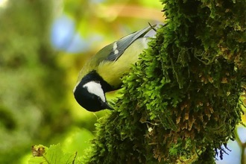
I was pleased to spend three weeks in Europe with my Western Australian daughter in October this year. We travelled up the Rhine and Moselle Rivers starting in The Netherlands and passing through Germany, Luxembourg and France ending up in Switzerland where we spent a number of days.
There were a lot of opportunities for walking; in villages, alongside lakes and rivers and in the mountains and, of course, some bird spotting. Among forty bird species seen, new to me, were White-backed Woodpeckers, Great, Blue and Crested Tits, Canada, Egyptian and Greylag Geese, Magpies and European Robins (sometimes featured on Christmas cards).
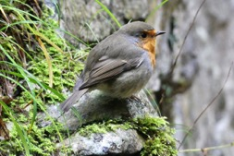
Photos: European Robin (left) and a Great Tit (right)

BWV News

The Bushwalking Victoria website is a source of accurate information and I encourage you to take a look. With 2024 trip planning happening, this is a timely reminder about safety (information from the BWV website.)
Safety begins with careful and thorough trip planning and preparation. A well planned trip will include:
Route: A carefully considered route; taking into account
  - The people who will be undertaking the trip.
  - Information from: Guidebooks, Land management staff (e.g. rangers), websites, local information, bushwalkers who have done the trip.
  - Track conditions and terrain
  - Time of year; expected and possible weather conditions
Capabilities. Ensuring the trip is within the capabilities of every member of the group, taking into account: skills, experience, fitness and equipment.
  - A trip with children, or beginners, or for training, will require particularly careful planning to ensure that the trip is easily managed by the group. On the other hand, an experienced group planning a challenging trip to a remote area involving hazardous terrain, will also require detailed planning, but with a different focus.
Preparation. Ensuring that each group member is well prepared; fitness, gear, clothing, special equipment, first aid skills and kits.

Weather. Monitoring the weather and forecasts up to and during the trip.

Trip contact. Appointment of a suitable trip emergency contact.

Emergency communications. Ensuring that an emergency communications device appropriate for the trip is carried.

Trip Reports

AST October 11: by Karen

The October AST was impacted by the high level of the Goulburn River after recent heavy rainfall. However, trip leader Dianne had done a thorough “reccie” and knew where the wet spots were so the eight walkers who joined the walk were able to enjoy a two hour stroll in perfect Spring weather with just a couple of deviations to avoid a swim!

The two hour out and back walk began at the SAC shed and we turned around at the bridge over the Broken River on Melbourne Road. We took a short side trip onto the bridge into the Australian Botanic Gardens to view the high water levels. Topics of conversation were wide and varied as we walked and chatted.

We welcomed two new walkers to the crew. It’s great to see our group growing and that there is plenty of interest in getting outside. The SAM café provided an excellent venue for a post walk coffee and, of course, continued conversations. The spin off of the earlier start time with Daylight Saving was that we were all wrapped up before 11.00am, leaving lots of time in the day for other activities.

Bike Ride October 16: Wangaratta to Eldorado Return by Jan

Twelve riders met at the Wangaratta North Recreation Reserve to embark on the ride to Eldorado. It was a beautiful day for riding as we set out on the Murray to Mountain Rail trail and then we turned off to go along Byawatha Rd. It was a quiet road that eventually became gravel as we climbed up and over three big hills. The views at the top were sensational.

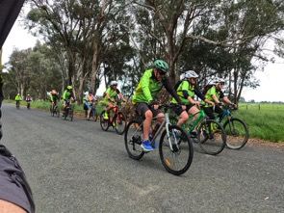
We continued on until we came to the Eldorado Dredge which was used to dredge for gold from 1936 until 1954 along Reedy Creek. It was one of the biggest dredges in the Southern Hemisphere. We stopped to have a look and then conquered the last challenging hill before arriving at Eldorado.

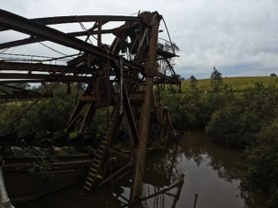
Eldorado is a pretty town with the smallest hotel in Victoria. Some people indulged in a pub lunch while the rest enjoyed a picnic lunch in the gardens.

On the way back there was only one big hill and we enjoyed scenic farmland. The ride was approximately 40km long. We all enjoyed some refreshments and talk at the Vine Hotel before venturing home.

Check out the ride on Relive thanks to Phil
https://www.relive.cc/view/v4OGgQNjmmO

AST November 13: by Karen

What can you say? Perfect weather (though the early start was appreciated as the heat increased), nine willing walkers and conversations on a multitude of topics equalled another most enjoyable AST.
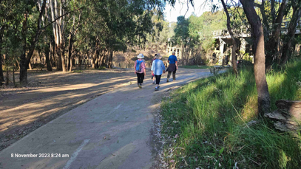
This time we were not impeded by flooded pathways. We headed north from the SAC shed, under the bridge, along the levee bank behind Princess Park to the turn around point on The Boulevard, completing a 9km walk in exactly 2 hours.

No-one turned down the option of a relaxing coffee/tea/iced coffee/iced chocolate at the SAM cafe and the chat continued there.

Thanks Philip for your Relive video. Philip always does an amazing job recording SAC activities and his AST photos show what a great resource we have here - accessible trails and gorgeous riverside scenery. Take a look and see what we did. https://www.relive.cc/view/vMv8gokmDNq

Mid Week Walk October 24: Warby Ovens NP by Dianne

18 walkers had a most enjoyable day walking amongst the wildflowers in the lush forest ecosystems of the Warby Ovens National Park, on Yorta Yorta land. The morning was spent in the northern part of the National Park - the Box-Ironbark ecosystem of the Killawarra Forest. The afternoon was in the mid section of the park - the granitic hills and woodlands of the Warby range where Blakely’s Redgum, Red Stringybark and a range of Box species dominated.
The contrast between the two areas was quite marked and gave very different walking experiences.

After leaving Shepparton with 10 walkers, another 5 joined at Dookie and a further 3 were waiting at Forest Camp. There was much talking and laughter as we greeted each other at each place. It was great to have two new walkers this month. It certainly feels like the group is vibrant and thriving.

We set off in the brisk morning air from Forest Camp along the very aptly named Springtime wildflower southern loop walk. The flat track meandered through a carpet of yellow everlasting flowers, patches of shrubs such as Alpine grevillea and Calytrix and with many different orchids, lilies and herbs sprinkled underneath. The bird calls echoing through the morning air added to the experience. We extended our walk a bit further south before returning to the campsite. After this initial 4.5 km walk, we did a further 2 km along the northern loop. There were subtle changes in the Box Ironbark forest either side of the camp with less flowering wildflowers in the northern loop.
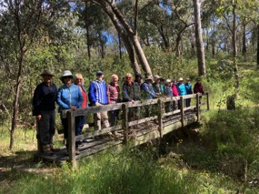
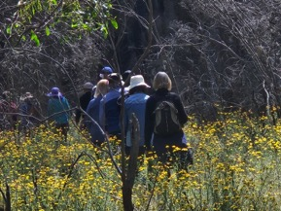

The group then drove along Tower Track to a picnic spot with panoramic views across towards the Chiltern direction. The large granite slab provided a lovely place for lunch and to plan our 2024 program. Thanks to everyone for their input and to those who volunteered to lead a walk. Stay tuned for further information about the great program we have in store for 2024.

The car convey then continued along Ridge Road to The Pine Gully Nature trail; a really picturesque 2 km walk up, down and around the Pine Gully. The highlight being the platform lookout over the gully with some water falling over the waterfall. Again, a range of wildflowers and numerous bird calls added to the walk.
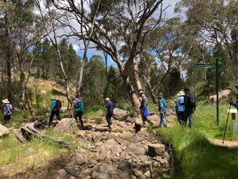
Coffee and jelly cake at the Dookie Emporium café completed a most enjoyable day amongst truly beautiful environments, in perfect walking weather and with great company.

Photos:
1. Spectacular wildflowers at Forest Camp
2. The happy group of walkers
3. Pine Gully Nature trail

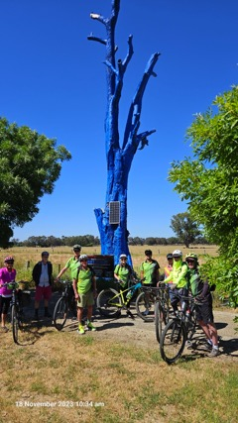
Bike Ride November 18: Wangaratta to Myrtleford by Ray

The November ride was along a section of the Murray to Mountains Rail Trail from Wangaratta to Milawa, starting at the Apex Park in Wangaratta.

Ray was the ride leader. (Ed: quote directly from Ray’s trip report) “The leader was yours truly who thought he knew his way through town to the trail head. With a few wrong turns and help from Philip, yep, we found the trail to Milawa.”

And Ray continues “But wait there is more! Again the leader, whose name you already know, thought he knew a different way back though town. Yep, you have it. I say we were not lost, just took a longer tour around town.”

This ride was a great day weather wise and turned out to be a great FUN ride.

(Ed: I think we need to hear more about this ride from Ray and the other riders!)

And, as we have come to expect and enjoy, here is Philip’s record of the ride on Relive.

https://www.relive.cc/view/v8qkpD9APKv

Mid Week Walk November 22: Gemmill Swamp by Dianne

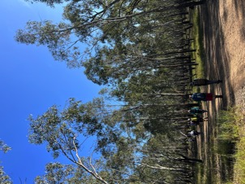
On a lovely sunny morning 15 walkers headed out to circumnavigate Gemmill Swamp. It was a most enjoyable 11.5 km walk amidst thick forest, with lots of water giving lovely reflections and attractive vistas.

The recent high-water levels had receded sufficiently for us to take advantage of the many trails that traverse this area. Initially we walked beside the swamp from the scout hall, north to Cemetery Road. There was much chatting as we walked through the bush where the streams of sunlight through the trees, and the constant early morning bird calls, created a picturesque setting.

We then explored a loop to the north through less well-made tracks, which we successfully navigated despite sections being muddy with some deep erosions from four-wheel drives. The section back to Cemetery Road gave us some good views of the Goulburn River.

Before returning to the main swamp, we detoured to the sand hills area downstream; a different landscape but one that was unfortunately scarred by bikes and four-wheel drives.

We completed our walk via tracks along the east of the swamp to McFarlane Rd and then around back to the scout hall, concluding our morning with a very pleasant lunch together at Bill and Beat’s in Mooroopna.

The walkers appreciated getting to know this area and once again our walk was to a new area for some participants. It is always good to spread the word about these wonderful environments so close to the Shepparton/Mooroopna urban areas.

Members’ Meanderings
United Energy Around the Bay 2023 - 8 October by Lyndall
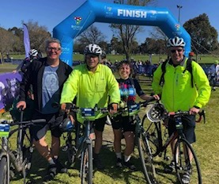
Four SAC members participated in the “lazy” 100km event this year. (‘Lazy’ compared with the 210km and 300km events!) They were Marty, Wendy, Geoff, and Genevieve, plus Geoff’s two brothers. The 100km event started at about 7am from Albert Park in perfect riding conditions - no wind, clear skies. In the excitement of different bunches of riders being told to roll out, Wendy and Marty got going as they optimistically thought the Lodge group may have been ahead of them in the line. Hahaha!
The route took riders up and over the West Gate Bridge to Williamstown. Brilliant! There was a Bicycle Network rest stop at the harbour, with the bridge as a back drop - a mobile bike mechanic was there and was able to supply and fit new pedals to Geoff’s brother’s bike - one had broken off in the first 5 km; he rode 15km using just the bolt!
Photo: the Lodge mob after finishing. Geoff and Genevieve are in the middle.
After the extended break for Brothers Lodge and Gen, the route continued with a circuit around the Williamstown waterfront and then riders were back over the bridge (again brilliant, with different views!) and tracking south following the bay down to Mordialloc. Soooo picturesque. It is such a treat to be able to ride over the bridge and along the coast in protected lanes. Marty and Wendy finally caught sight of the Lodge gang as they passed each other going in opposite directions - the Lodge mob were heading towards lunch and Marty and Wendy were cruising back towards Albert Park.
Bicycle Network put on a great reception at Albert Park, with a members bar, live music, food options and more. As the Lodge contingent were approaching the members bar, Marty and Wendy were approaching Shepparton! A great day, and, yes, it’s already in the calendar for next year…
TAT 200 25km Longleat Winery - 25 November by Karen

Three SAC members – Maartje, Richard and Karen - joined a group of riders on a 25 km ride from Tatura to Longleat Winery at Murchison. The day was under threat with heavy rain and storms the night before causing organisers to contemplate cancelling the event. As it was, the Saturday morning was perfect for the ride with clear skies, a gentle breeze and mostly quiet back roads for riding. One gravel stretch did cause a flat tyre for one rider and he completed the last 10km in the “sag wagon.”
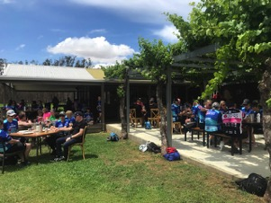
The leafy vines of the winery greeted the riders as they rolled to a stop. Registration included an antipasto grazing plate for participants. The cellar door did a brisk trade in beverages of all kinds. A bus for the riders and trailers for the bikes were provided for those needing a transfer back to Tatura.

This event was very well organised and a pleasure to be part of. Riders received a generous bounty bag of goodies and a shirt. Well done to all.
Photo: Lunching at the Longleat Winery

Out and About with SAC

2023 was celebrated by about 40 SAC members who attended the Mooroopna Pizzeria for a fun night on December 5. The evening progressed with good food and good company along with a slide show, a quiz, lucky seat prizes and the inaugural SAC awards, magnificently organised and presented by Dianne, with the help of President, Greg. However, the undisputed highlight of the night had to be the singing of Lyndall’s epic “Whroo Riders in Grey Skies” by Len and Alfred.
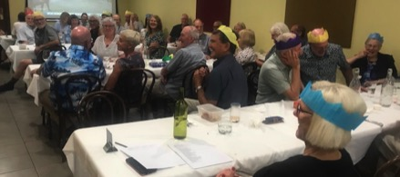

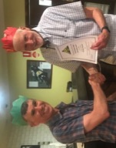

If you missed them, here are the awards and their worthy winners:

The SAC Cyclowalkley Print/Text Journalism award Lyndall Ash

The SAC Cyclowalkley Digital Journalism award Philip Schultz

The SAC Fill-in Coach of the Year award Richard Dickens

The SAC “Which Way Ray” award Ray Mustey

The Above and Beyond award Barb Brown

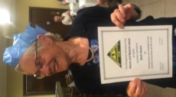
The SAC Influencer award Alfred Heuperman

The SAC Recruiter of the Year award Karen Speedy

The SAC Best First year Player Brendan Espagne

The SAC Best Clubperson award Graeme Betts

The SAC 2023 Best and Fairest award Richard Graves

Photos top to bottom: happy diners,
Greg & Philip, Barb, Greg and Ray,
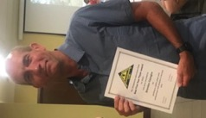
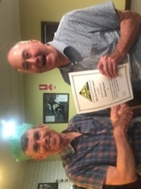
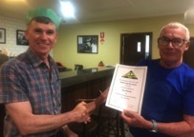
Brendan, Greg and Richard G.

