SAC Newsletter
March 2023 www.shepadventureclub.org.au

Trip Report by Richard Graves
Midweek Walk - Cussen Park Tatura - February 2023
With the club policy of starting early and finishing up by lunchtime over the usually warm to hot summer months, a walk in our local Greater Shepparton Council area was suggested for our February walk.
Tatura, with an emphasis on the Cussen Park and its natural drainage wetlands, was the chosen location. Fifteen club members met at the Cussen Park Rotunda at 8.30am ready for an exploratory walk to be followed by a relaxing coffee at the Olive & Vine Café. Prior to heading off we were treated to a most interesting and informative talk by Terry Court from the Cussen Park Advisory Committee.
Terry is a font of knowledge and he covered the history of the formation of the park over thirty years ago and the importance of the park’s waterways to the treatment of storm water from the Tatura Township and the surrounding district.
The eighty or so acres of park area have had a number of transformations from grazing land to sections that were used as a tip for some years and nearly became a residential development until pressure was applied to the then council to transform it to wetlands and parklands. Well done to those who lobbied to save it all those years ago. Also to all those fifty thousand volunteer hours to make it what it is today. What a jewel in Tatura’s crown.
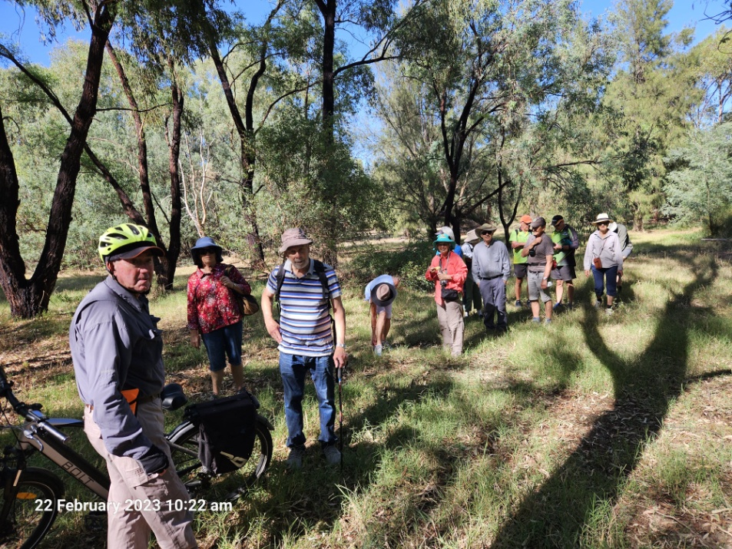

We first proceeded to explore some of the less seen off-track sections of the park, keeping well away from the five thousand or so flying foxes currently nesting in the trees on the north east section of the park. With the current drying conditions bird numbers were down somewhat but a black wallaby was observed in one bushy area along with three sleeping possums.
We were cautious of the possibility of snakes in the off-track undergrowth but none were observed. We traversed all the formed tracks, checked out the various bird hides and observation platforms and with the walk down to the township for coffee and back the overall distance for the morning was approximately seven kilometres. It was warming up by the time we returned to the rotunda and our cars.
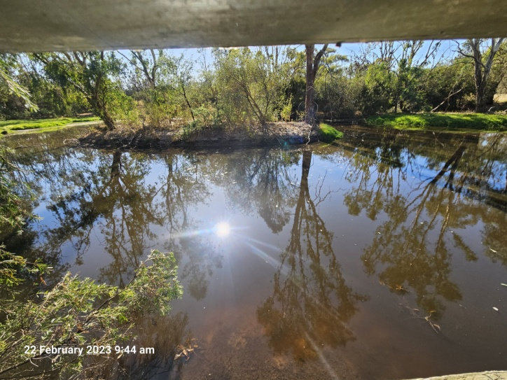
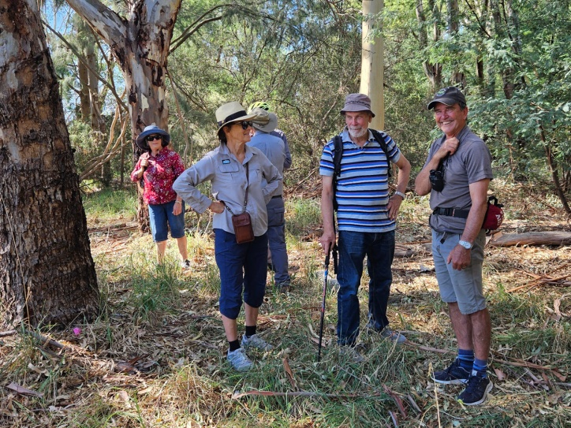
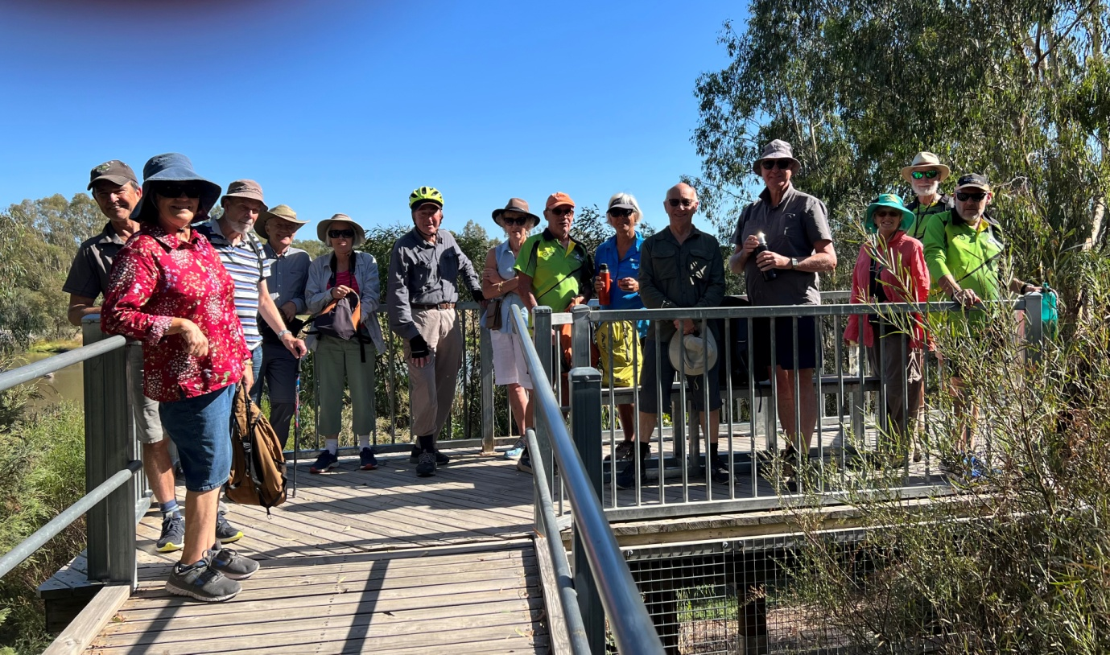

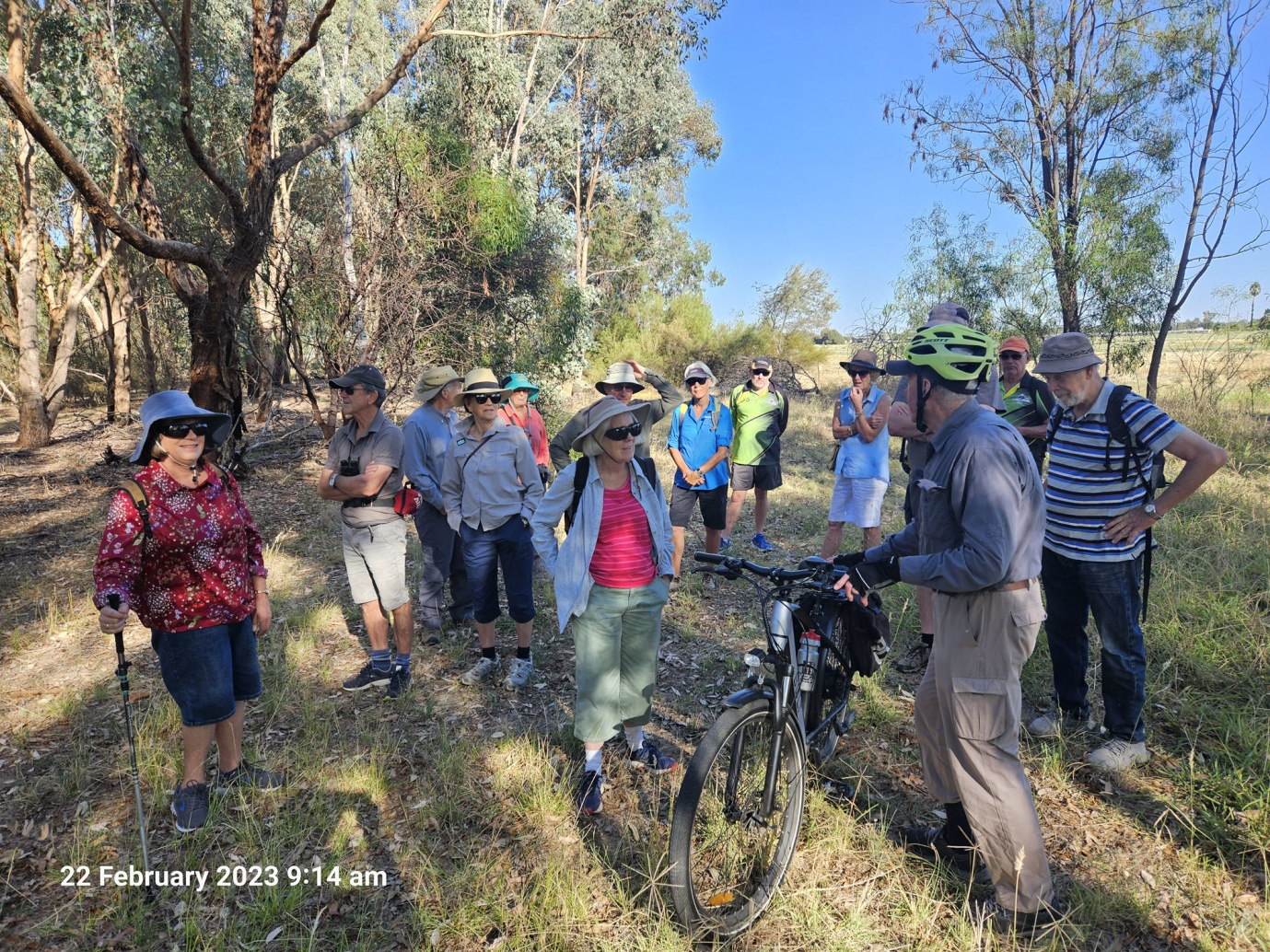

January Mid-week walk by Lyndall Ash
25/1/23

Version 1: Cold hard facts
Estimated reading time: 30 seconds

Date: 25/1/23
Number of participants: 9
Walk leader: Dianne Hanna
Start: Aquamoves Shepp 8.07am
End: Aquamoves Shepp 11.05am
Route: via shared path south and west past confluence of Goulburn and Broken Rivers, then via botanical gardens to Riverview Drive. Turned east and headed to Riverside Plaza then north via footpath across the Broken River to the shared path heading west, then north under railway bridge, then back to starting point.
Distance: 8kms approx
Rest stop: 4.3km mark
Weather: sunny, 7kph nw wind, temp range: 17 to 25 c

Version 2: descriptive essay
Estimated reading time: 2 minutes

The first midweek walk for the year, led by Dianne Hanna, has set the standard for future walks to aspire to. The 8am start on 25 Jan welcomed nine SAC members with a hint of a cool breeze and golden sunlight reflecting off Victoria Lake. The forecast for clear skies and a ‘destination coffee’ set the scene for an enjoyable outing.

We followed the sealed shared paths that meander beside the Goulburn River, with the occasional wooden bridge providing added interest and accessibility across natural drainage lines. I am reasonably familiar with these paths but each time they are a delight. Some new or different element, such as time of year, time of day, the weather, and the company each time provide a fresh perspective. And, for some of the group, this was their first foray into these parts.

With the “October floods” still fresh in some of our minds, it was interesting to see up close how the bush was responding. Fresh green growth now offers a contrast to the dusty palette, and rain had washed all trace of the high water mark from the tree trunks as well as the silt from the paths. Only a random fence paling or other domestic object such as a plastic bucket wedged tightly in tree branches above our heads provided physical reminders of what living in a flood plain means.

We crossed the bouncy bridge into the Shepparton Botanic Gardens after noting the merging of the Broken River into the Goulburn River, with a fisher trolling quietly along in a small ‘tinny’ fishing boat. The paths are understandably popular with Shepparton locals who were also out and about walking, jogging, or cycling and we were kept on our toes with regular calls of ‘rider/walker coming’.

The pace was as lively as the conversation with members who hadn’t seen each other for a while catching up on the news. Degani’s, the “destination cafe”, provided the opportunity for more laughs and banter among the group. An iced coffee with ‘the works’ took the cake as the most stunning beverage while an actual cake gave me a mild case of “order envy” when it was placed in front of someone else.

The fresh early morning air was being noticeably replaced by warmer temperatures as we made our way back along the north side of the Broken River. Corellas and the occasional cockatoo and galah were noisily jostling for their favourite perch as they settled in the shady tree tops for a mid-morning siesta. In contrast to this cacophony, other bird calls, such as the pan flute tones of a pied butcher bird and the staccato chitter of a kingfisher could also be heard.

We got back to Aquamoves car park at about 11am. We bade farewell to each other until next time, before turning on our engines and turning our thoughts from shared ‘trails’ to our individual ‘to do’ lists.

Version 3: experimental/interpretive
Warning: The following version is not for the literary faint hearted or poetically purist, especially if recited to the tune set by ‘Wallis and Matilda’ for their version of Clancy of The Overflow!
Average reading time: 2mins 30. Estimated reading time range: 10 seconds - 10 minutes depending on your tolerance and interest!

Fancy walkers of where the rivers over-flowed
(With a fun nod to AB Paterson)

I had written Di a text
in which I had, because of extra knowledge
Said I’d join the midweek walkers starting from out back of the lake.
And the people already busy on the lake paths made me dizzy
As they did their fitness workouts with pre-work grit and haste
Dianne had agreed to lead us
and we had agreed to meet thus,
at Aquamoves at 8am where there’s room to park your car.
It was a group of nine SAC members
Looking fit and being adventurers
And verbatim* I will quote one, “I’ve never walked this track this far!”

With the path so nicely shaded
the ravages of flood had faded
as we crossed the vision splendid of the Broken River on its bars.
The group had friends to meet you
and their smiling voices treated us to
chatter like the trees full of corellas and galahs**.

While the pace was set to get the job done
On the way to the botanic garden
we could enjoy the scenery and nature where the two rivers recently overflowed.
For the cyclists in a hurry
the views were prob’ly blurry
Coz the slower pace gives walkers pleasures that a rider never knows.

For a minute I rather fancied
that I’d stay longer at Degani’s,
I could get some bread, or perhaps sit back and just relax
but I’d have missed the rounds effusing
of the comments so amusing
And sharing the joy that comes with a morning walk along these tracks.
So onward all nine wended
To where our journey ended
Beneath the river redgums towering and strong
And at eleven with walk completed
before the day got really heated,
we started up our engines and with that, the first walk of the year was done.

*: maybe not as ‘verbatim’ as I imply - editorial licence?
**: Sorry, I know there weren’t many galahs, but it rhymed!
Cheers, Lyndall

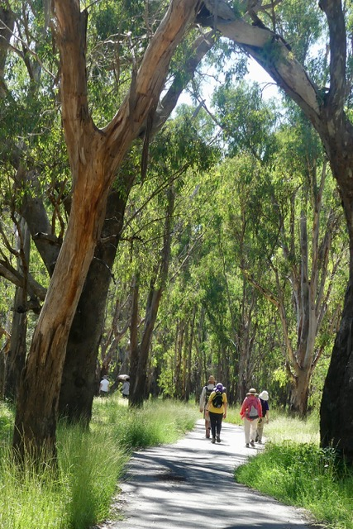
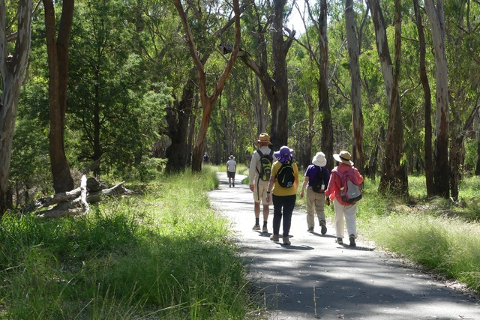

January ride Shepparton – Mooroopna

January ride was all about October Floods, looking at trail disasters and recoveries.
21 riders met at our shed on the lake, where our first view was the caravan park noting it still has not re-opened or recovered.
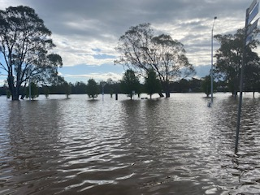

Our ride started heading south to the Archer street suspended bridge; here we were lucky to have a firsthand account of water levels/time lines from Glen who lives on the Boulevard. Thank you Glen, the informative talk was fantastic especially for those who live out of town or in safe zones!

We then headed North starting with deter over to the botanical gardens, which was completely under water during the floods.

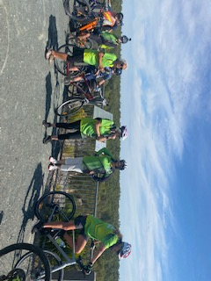

We then continued north, visible on the way was the damage around the swim centre where foliage was still waiting to recover and a large part of the bank had receded into the water (still blocked off) then under the causeway bridge onto Jordens bend we discussed water levels and many of the homes in this area were still under water for weeks as the river was initially slow to recede.

Heading over to Mooroopna we rode over the Causeway bridge, this area between Shepparton and Mooroopna was the last area to re-open after the floods and still showed damage of tree trunks hanging over other tree branches and dead foliage.

We then headed to lunch at the Mooroopna Golf club; all riders attended which a great turn was out. After lunch we headed back to the shed and said our goodbyes.

.
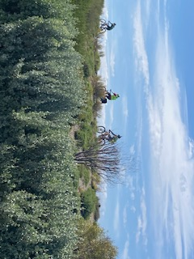
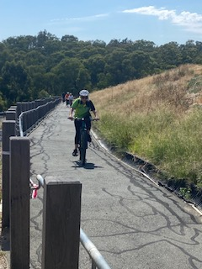

February Club Bike Ride

This Ride was along part of the O'Keeffe Rail Trail Between Heathcote and Axedale of approximately 53klm Return.

This was a great Ride enjoyed by all of us and the weather was perfect for a enjoyable Days Ride taking in the scenery, especially Riding along the Trail at Lake Eppalock where you have the water from the Lake on both sides of the Trail. When we reached Axedale we had a break and Lunch in the Local Park, then we returned along the Trail to Heathcote and of course a refreshment at the Local watering hole.
Great Ride
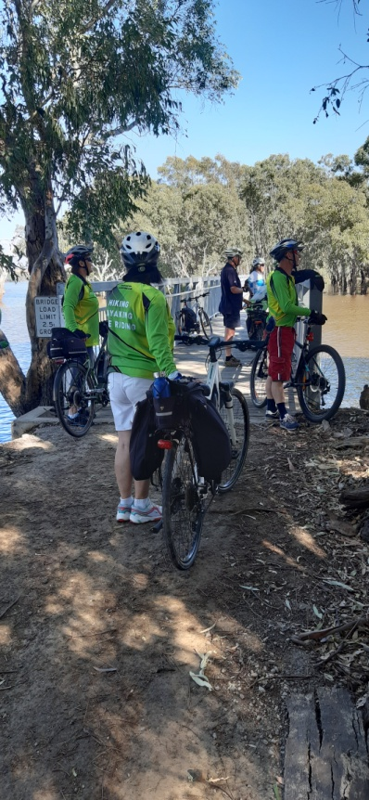
Cheers to all, Ray

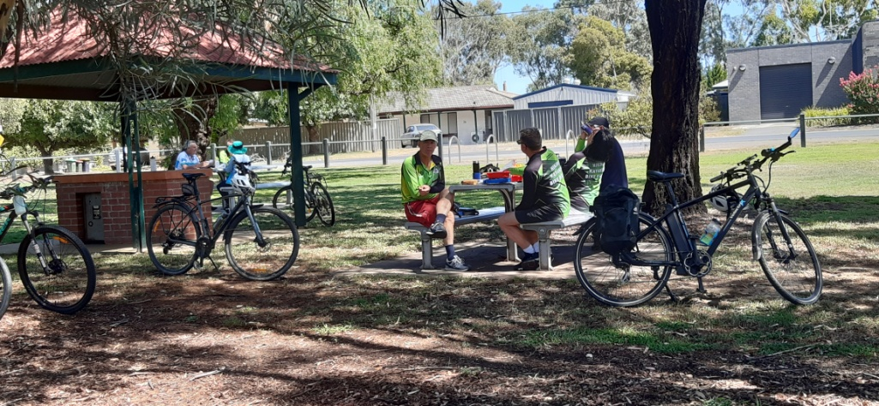

﻿Wednesday AST (Around Shepparton Trails) walks.

At our last committee meeting it was decided to start a walking group on the second Wednesday of each month using the trails around Shepparton. It is to be an informal group without pre planning. Participants just need to be a financial SAC member for insurances requirements.

The idea is that we would meet at the SAC shed for a two hour walk.. Just turn up on the day at either 8 am daylight saving time or 9 am for the rest of the year. The group would head off in either N,S,E or W direction on the shared pathways for an hour and then return.

The aim is to help participants keep up their fitness, so although It won’t be a power walk, it won’t be a stroll either. We can finish off with a coffee somewhere… Aquamoves, SAM etc.

First AST walk- Meet at the shed 9 am 12th April.
Any inquiries contact Dianne Hanna
0437 289281.

Club Calendar
Date | Location | Leader | Rating
21 Jan | Local Bike paths from shepp to Mooroopna | Shelley Wyllie  0422268102 | Easy  Flat | Ride
25 Jan  8am | Goulburn River walking tracks of Shepparton | TBC | Easy | Walk
13 Feb | Committee Meeting 7.30pm  11 Nillahcootie Cres Kialla | Scott Birchell
18 Feb | Axedale to Heathcote O’Keefe Rail Trail | Ray  0438591749 | Easy-Mod | ride
22 Feb  8am | Cussen Park Tatura | TBC | Easy | walk
28 Feb  6pm | Club Day BYO, BBQ, Food, drink, Chair  Canoeing from earlier time
11 March | Beechworth to Yackandandah or Elmore to Rochester | Ray  Peter and Jan |  | ride
27-31 March | Tree tops camp Gunbower Island Mon-Fri 3 days walking. Canoeing, bike riding, bird watching and scenic driving | Richard Graves  0408547065 | Easy
15 April | Wahgunyah to Rutherglen | Peter and Jan  0438093668 | Easy | ride
18 April | Club Meeting
26 April | Winton wetlands walk | Dianne Hanna  0437289281 | Easy | walk
20 May | Mulwala to Corowa  Overnight ride | Marty and Wendy  0421050880 | Easy | ride
24 May  9am | Boat Hole to Mineral Springs Strathbogie | Dianne Hanna  0437289281  Justus Hagan | Easy - Mod | walk
17 Jun | Bike Ride TBA | Geoff and Lyndall  0429036658 |  | bike
20 Jun | Club Meeting
28 Jun | Murchison Area Walk | Jenny Stammers  0407556639 | Easy | walk
15 July | Murchison Bike Ride | Maarjte and Alfred  0407849794 |  | bike
26 July  9am | Yundool | Kerry Storer  0417115385 | Easy | walk
15 Aug | Club Meeting
19 Aug | Bike Ride TBA | Geoff and Lyndall |  | bike
23 Aug  9am | Taylor’s Surprise | Ross and Judy Taylor  0428994654 |  | walk
16 Sept | Melbourne Ride | Susan and Bruce  Rodney and Lee |  | ride
27 Sept  9am | Whroo Forrest Rushworth | Karen and Richard Speedy  58251785 | Easy | walk
13 – 15 Oct | Weekend Camp Melville Caves | Maartje Heuperman  0407849794 | Easy - Mod
17 Oct | Club Meeting
21 Oct | Tocumwal Bike Ride | Peter and Jan  0438093668 |  | bike
25 Oct  8am | Warbies Spring time Flower walk and pine gully nature trail | Dianne Hanna  0437289281 | Easy | walk
18 Nov | Bright to Harrietville  ( Possible weekend ) | Maarjte and Alfred  0407849794 |  | bike
22 Nov  8am | Gemmill Swamp | Barbra Brown  0417364985 | Easy | walk
5 Dec | Club Meeting
16 Dec | Tatura Twilight Ride with dinner at the pub | Ray  0438591749 | Easy | ride

President’s report

President’s Piece
In February I attended an online forum by Bushwalking Victoria (BWV) that provided information on BWV’s goals, role and projects and also covered club health and development, promotion ideas, club management tools, insurance and leadership training.
The training package is still under development but well progressed, with lots of resources that will be available to use in the near future for current and aspiring trip leaders. If you are interested in brushing up or developing your trip leader skills let me know and I can provide more information when it’s available. BWV do run some leadership training courses, usually in metro Melbourne (see the March Bushwalking News).
During the forum we were also informed that the insurance through BWV doesn’t not cover members using E-bikes because they are motorised, but BWV are hoping to change this.
Finally, thanks to all those members who helped with the shed clean up after the flood and disposed of damaged items, I omitted to mention this last time.
… Greg

President: Greg Smith 5824 1143 president@shepadventureclub.org.au

Vice President: Bruce Gill 5824 2548 tatgills@westnet.com.au

Secretary: Jan Gregory (sacvicau@yahoo.com.au

Treasurer: Scott Birchall 5831 6063 scottb@agsystems.com.au

Newsletter: Shelley Wyllie Shelley.wyllie@gmail.com

Equipment Officer: Richard Graves 5824 2929 richsue@bigpond.com

Publicity Officer: Karen Speedy 5825 1785 karenspeedy@iinet.net.au

Calendar coordinator: Wendy Kennedy wendykennedy01@outlook.com

Mid-week coordinator: Dianne Hanna 0437 289 281 dhanna3@bigpond.com

Trip Leaders: Please remember to ask visitors to sign an Acknowledgement of Risk form for Temporary Members and pass it on to our Secretary, Karen. This form is available on our website once you login (member, bushwalk) under Members>Leader Information. It is a requirement of our club insurance policy.
Share your adventure with the club!
Shelley.wyllie@gmail.com.au

All things Birds with Marge

Blue-faced Honeyeater

The Blue-faced Honeyeater is one of Australia’s largest Honeyeaters and is relatively common in the Goulburn Valley area.

It has a distinctive bright blue bare patch around the eye, the juvenile having a green patch.
It is white on the nape band, on a stripe below the eye and on the under parts.
The crown and hind neck are black and it has a dark grey throat. The upper body is olive green.

The Blue-faced Honeyeaters are usually seen in flocks and can be quite noisy.
They are omnivores (an animal whose diet is both plants and animals) and in this case the diet consists mainly of nectar, insects and fruit. I have often seen them foraging on and under the bark of the same tree late in the afternoon.
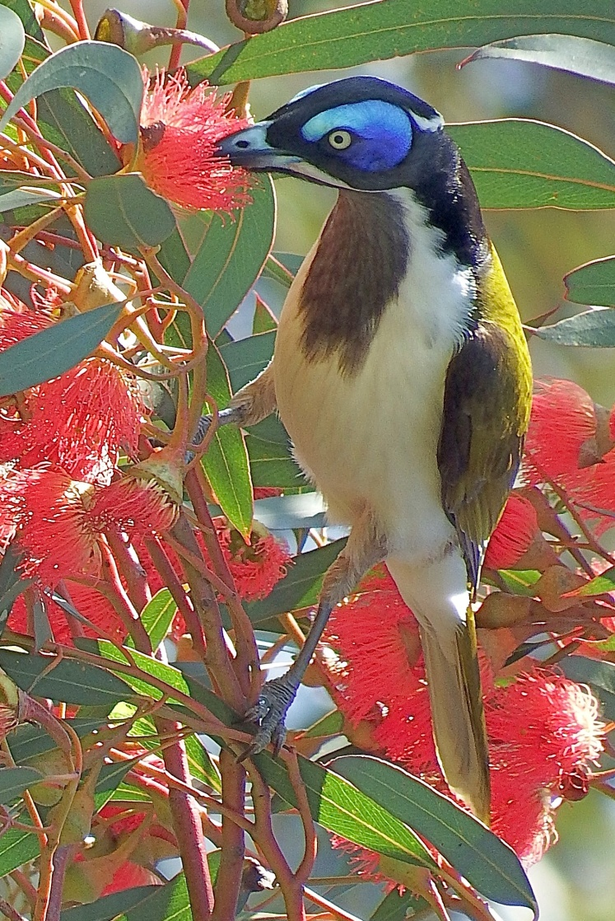

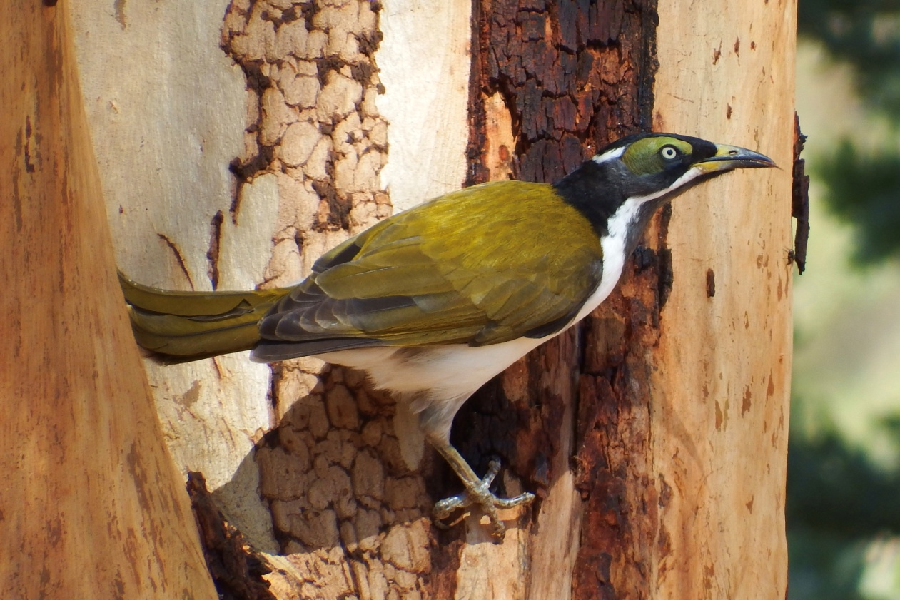

Editors note

Look what I found in our local paper!
“A beautiful handmade jumper”!
If anyone knows where we could get one, please contact the editor of this newsletter.

E-Bikes Insurance - Worth Noting
Bushwalking Australia (BA) advise that the cover provided under our group insurance scheme does not include cover for members using E-Bikes on club activities as they are a motorised vehicle.
While BA is looking at the issue further, E-Bikers are advised to consider private insurance or the insurance offered through some of the cycling organizations.

SAC Shed Flood October 2022 Report for SAC Newsletter

This Report has been prepared for SAC Members information following the October 2022 Goulburn River flood which peaked at 12.06M on the 17th October 2022.

As it had become increasingly obvious that the Goulburn River was going to breach its banks into a major flood, Scott, Ray & Richard (and Sailability members) met at the shed on the morning of the 14th October and made provision for an anticipated intrusion of about one meter of flood water inside the SAC Shed.
Canoes were turned upside down in lower areas to ensure any that flood water is not trapped inside them with the danger of the weight bending the support arms as the flood receded. Gear items in the cupboards were stacked in the top shelves and the map drawers taken out and placed up high also. The bottom 3 drawers of the filing cabinet were also placed up high. The life jackets were placed inside a canoe well above anticipated flood height. The solar lights battery and controller were disconnected and placed at a safe height also. In other words we did our best to minimise any potential damage. The canoe/bike trailer was removed to Ray Mustey’s house yard.
As it turned out, what we couldn’t control of course was the resultant filthy muddy mess that covered the shed walls and anything that could not be moved. The flood peaked on the 17th October at 12.06 meters which saw 690 MM flood water height into the shed. As the river was slow to recede we were unable to approach the shed for a few weeks afterwards and the council then prevented us from entering until their insurance assessors gave us the go-ahead. (For member’s information, the SAC Shed is now owned by the Shepparton council and we pay a yearly lease – even though it was SAC money that paid for the erection in full some 30 plus years ago. It is erected on DSE land). Consequently, when the flood recovery process began quite a significant mould problem had arisen on anything covered by the flood water.

On the 6th December a brigade of members from both SAC and Sailability attacked the daunting job of cleaning up everything and we also took the opportunity to sort out items that had been stored there and for which there was no more use. This also gave us the opportunity to do a stock take of our outdoors camping hiking and skiing equipment. Some of which was outdated and had not been used in over 30 years and was no longer suitable for use. A trailer load to the tip resulted.
The whole shed was pressure washed down with an antiseptic solution to remove mud and mould. The walls were washed as high as could be reached and all the floor and any items that had been in contact with the flood water.
The job took half a day with a team of some ten persons from both SAC and Sailability. Thank you to SAC members who attended, Barbara, Jan, Peter, Ray and Richard.
This was the second time that flood waters had entered our shed, the first in 1993 which was about 300mm higher that this flood. The 2010 flood came to the south west corner of the sheds but did not enter our shed.
Hopefully there will be a long time before we have to go through this again,
but this report might give some assistance to any future members that may encounter a flood into the shed.

Richard Graves
December 2022
Mooroopna 3 days after peak

