website: www.shepadventureclub.org.au
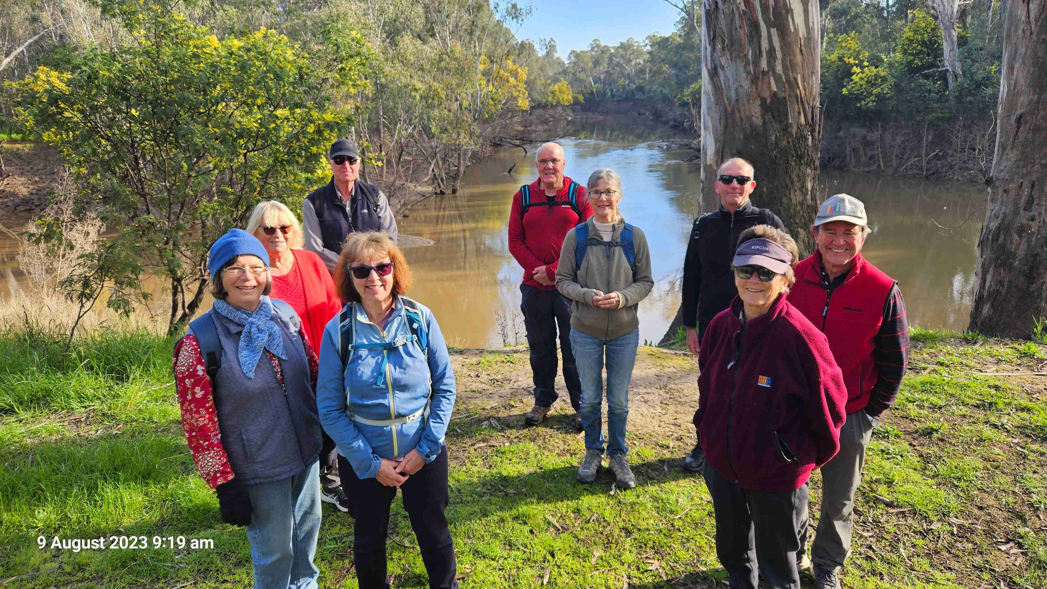

SHEPPARTON ADVENTURE CLUB inc. A0002706S

NEWSLETTER June – August 2023

The recent Around Shepparton Trails walk

Next club meeting Tuesday October 3rd
Meet for dinner and conversation
6.00pm at the GV Hotel, High St, Shepparton.

NOTE CHANGE OF DATE

The SHEPPARTON ADVENTURE CLUB Inc.

General Meeting: Usually 3rd Tuesday in February, April, June, August, October
Committee Meeting: Bi-Monthly at 7.30pm.
Correspondence to: The Secretary SAC, PO Box 264, Shepparton 3632
Email: sacvicau@yahoo.com.au

OFFICE BEARERS
President Greg Smith 0429045732 president@shepadventureclub.org.au

Vice President Bruce Gill 0409819704 tatgills@westnet.com.au
Secretary Jan Gregory 0438093668 jangregory4@outlook.com
Treasurer Scott Birchall 0548210604 scott@agsystems.com.au
(email distribution to members)

Equipment Officer Richard Graves 0408 547065 richsue@bigpond.au
Publicity/Newsletter Karen Speedy 0448046958 karenspeedy@iinet.net.au
Calendar Coordinator Philip Schultz 0448324792 harwinpark@gmail.com
Mid-week coordinator Dianne Hanna 0437 289 281 dhanna3@bigpond.com
Committee member Maartje Heuperman 0407849794 maartjeheup@bigpond.com

www.bushwalkingvictoria.org.au

PO Box 1007 Templestowe Vic. 3106
Phone: (03) 9846 1132
Email: admin@bushwalkingvictoria.org.au

Affiliated member

SAC MEMBERSHIP FEES (Due JULY 1 each year)

Adult Club Membership $40
Child Club Membership (0-18yrs) $10

Membership benefits
Your Bushwalking Vic membership card enables you to obtain discounts at a number of retailers including:
AJAYS Snow and Country Sports (Heathmont), Bogong Equipment (Melbourne), Fjall Raven (Melbourne Central), Paddy Pallin (Melbourne, Ringwood), Smitten Online Tasmania, Wilderness Shop (Box Hill), Woodslane Walking Guides, Eastern Mountain Centre (Deepdene), Discovery Holiday Parks (Cradle Mountain)

Sunrise & Sunset (Melbourne GPO)
1 Aug 7.22am & 5.33 pm | 1 Sept 6.44 & 5.59 | 1 Oct 6.58 & 7.24 | 1 Nov 6.15 & 7.54
15 Aug 7.07 & 5.45 | 15 Sept 6.23 & 6.11 | 15 Oct 6.37 & 7.37 | 15 Nov 6.01 & 8.10
Full Moon
2023: 6 Jan, 5 Feb, 7 Mar, 6 Apr, 5 May, 3 Jun, 3 Jul, 1 Aug, 30 Aug, 29 Sep, 28 Oct 27 Nov, 26 Dec

President’s Piece

22/23 was looking like a fairly settled, normal year until October rains caused major floods that curtailed travel and trips for a while. Although it got wet, our shed beside Vic Lake survived along with most of our contents, thanks to the efforts of some members to stack equipment well above the floor before the water rose.
Mid-week Walks each month have ventured near and far including Shepparton, Tatura, Terrick Terrick NP, Hughes Creek, Rushworth (one of my favourite places) and Winton Wetlands with good numbers on all. In recent months Di has also introduced the mid-week AST walks, a less formal few hours walking Around Shepparton Trails on the 2nd Wed of each month for fitness, followed by coffee of course.
Bike riding destinations ranged from Corowa to Axedale and many places in between, mostly on the flat or gentle slopes but many with mud and puddles this year – pack spare socks suggests Lyndall. It seems the E-bikes are starting to outnumber the pure pedal power, so it’s fortunate that our insurance now covers the hybrid treddleys.
Another mid-week camp was held at Tree Tops Camp on Gunbower Island in March with walks, rides, canoeing and bird watching to choose from plus campfire socialising again. An added bonus was seeing a turtle nesting, which was later protected by a volunteer from Turtles Australia, and finding the highly venomous Red-headed Mouse Spider.
We have welcomed some new members over the course of the year and I wish them an enjoyable time with the club.
Thank you to all the trip organisers, report writers and photographers.
Finally, thanks to the committee, new and old – Bruce, Scott, Jan, Shelley for the newsletters over the past 2 years, Wendy for the calendar, Di, Richard, Marty and Karen our Publicity Officer - who keeps our FB page lively, which is how we gain most of our new members – it has 600+ followers!

Greg

From the Editor
First of all a big thanks to Shelley for her work as Newsletter Editor over the last two years. We appreciate the work that goes into producing each Newsletter.
At the recent AGM there was some discussion about the role/purpose of the Newsletter with the club’s Facebook page covering much of the same information. However it was agreed there was a need for both as a way to share the news and activities of the club. So Newsletter Editor has been added to the Publicity Officer’s role and here is the first one!
I am keen, as was Shelley, to include some new segments to maintain interest. So I bring you Meet your Committee – this edition showcasing our newest committee member, Philip, who has kindly taken on the role of calendar coordinator. Thanks to Marty and Wendy who looked after the calendar for the past year.
I have also added a Members’ Meanderings which is an opportunity to share the wider travels of our club members. And I have indulged in sharing my recent adventures on a section of the Heyson Trail. What an experience that was. Please email me a summary of your trip and some photos to be included in a future Newsletter.
And finally I hope to continue to share our wonderful wildlife. You are welcome to send items, however I am sure Marg will be able to fill the space with her wonderful bird photography.
If you have other ideas for the Newsletter I would love to hear them!
I think we will need to have some of Lyndall’s amazing poetic efforts performed at our Christmas get together! Thanks to all contributors to this Newsletter.

Enjoy the outdoors through SAC events or other activities.

Karen

Calendar of Activities

23 Aug  9am | Walk | Dookie walk with Richard and Valda | Dianne H  0437289281 | Easy/Mod
13 Sept | Walk | AST Walk 9am start for 2hr walk meet at SAC shed | Brendan E  0418577607 | Easy
16 Sept | Ride | Melbourne Ride | Susan and Bruce  Rodney and Lee
27 Sept  9am | Walk | Broken Creek Nathalia/Waaia | Graeme B  0458 216598 | Easy
11 Oct  8am | Walk | AST Walk 8am start for 2hr walk meet at SAC shed | Dianne H  0437289281 | Easy
13 – 15 Oct | Camp | Weekend Camp Melville Caves | Maartje H  0407849794 | Easy - Mod
3 Oct |  | Club Meeting  6.00pm GV Hotel Shepparton | Jan G  0438093668 | Dinner
21 Oct | Ride | Tocumwal Bike Ride | Peter and Jan  0438093668
25 Oct  8am | Walk | Warbies Spring time Flower walk and pine gully nature trail | Dianne H  0437289281 | Easy
8 Nov  8am | Walk | AST Walk 8am start for 2hr walk meet at SAC shed | Dianne H  0437289281 | Easy
25 Nov | Ride | Tatura 200 Gears and Graze  https://tatura200.com.au/  Register by 25/9 | Maartje and Alfred  0407849794
22 Nov  8am | Walk | Gemmill Swamp | Barbra B  0417364985 | Easy
5 Dec |  | Club Meeting  Christmas Celebration details TBA | Jan G  0438093668
13 Dec  8am | Walk | AST Walk 8am start for 2hr walk meet at SAC shed | Dianne H  0437289281 | Easy
16 Dec | Ride | Tatura Twilight Ride and dinner | Ray M  0438591749 | Easy

PLEASE RING THE TRIP LEADER TO MAKE SURE IT IS WITHIN YOUR CAPABILITY AND CONFIRM THAT IT IS GOING AHEAD. REGISTRATION ALSO HELPS WITH PLANNING SUCH AS CAR POOLING NUMBERS.

Note: TRIP LEADERS – it is imperative for every trip that temporary members/visitors sign the “Acknowledgement of Risk Form”. These completed forms must be forwarded to the SAC Secretary for filing as soon as possible after the trip – otherwise, in the case of a claim, the insurer will not acknowledge the risk.
Form can be downloaded from www.bushwalkingvictoria.org.au , under Members > Forms

Travel Cost Reimbursement
30 cents per km per car split between all trip participants.

Meet your Committee

Each year at the Annual General Meeting a committee is elected by the members. Some of the committee have served for years, if not decades! As the new kid on the block, I am pleased to introduce Philip Schultz, the Calendar Coordinator. Philip has shared his story with us. Thanks.

Tell us a bit about yourself
I was born in Horsham as all my family were farming in that area. Our family have been involved in farming since my ancestors arrived in South Australia in 1846. Our family moved to a Soldier Settlement block of land bordering the Coliban River between Redesdale and Metcalfe in 1956.
I left school at 15 due to the drought of 1967/68 as my father had to get work off farm. I started working on our farm and also at neighbouring farms. The family farm was sold in 1972 but I have been in agriculture all my life.
After 30 or so years I left farm management and worked in other agricultural fields locally and in Asia up until my retirement. I was most fortunate that my work gave me the opportunity to travel extensively to overseas countries.
Lotty and I got married in 1974 and have lived in Kyabram for close to 20 years. I retired after 50+ years in agriculture but have continued on with private planning and consulting.

What are your outdoor interests?
I had always been an active sports person and loved walking miles while out shooting or going fishing.

How did you become involved with SAC?
A year or so before retirement I was somewhat concerned that I might find it difficult to adapt to. I was reading the SheppNews one day and saw the mention of the Shepparton Adventure Club and thought this might be just what we are looking for so I made enquiries. Our first adventure with the Club was in the Warby Ranges walking up to the Glenrowan lookout.
I am looking forward to being able to contribute to the Club by being a member of the committee.

BWV and Other Club News

BWV Federation Walks 2023 - Bookings Open

Bookings for the Federation Walks weekend based at Trentham on 21-22 October opened on Monday 31st July.
This year provides an opportunity for participants to visit sections of the Wombat State Forest that have reopened after the devastation of the 2021 storms. The program will include visits to Lyonville Springs, Garden of St Erth, Blackwood township and Mineral Springs, Lerderderg River, Nolan’s Creek Picnic Ground, Balt Camp and Yankee Mine.
More information and the booking link are available on the event website.
Bookings open at 9:00am on Monday 31 July 2023.

OTHER CLUBS’ ACTIVITIES
Bendigo Bushwalking and Outdoor Club - www.gobush.org.au/
Echuca-Moama Bushwalkers - www.echucamoamabushwalkers.org.au
and more can be found at www.bushwalkingvictoria.org.au

Trip Reports

Bike Ride June 17 by Maartje and Alfred
Saturday 17th of June, a chilly but sunny day. Eight keen “mature age” riders met at the White Hart Hotel in Longwood for the June SAC bike ride. (did you know that “Hart” is an old English word for “deer”? In Dutch it is called a “hert” so the Poms probably copied that from the Dutch before they swam over the Channel many moons ago!)
We had surveyed the route 2 weeks before (by car) and had found that it could be “subject to flooding” at some places but it had been dry since so ….. “she’d be right” we thought!. The area was as flat as a pancake so manageable for even the 2 non-powered riders in the group (6 E-bikes and 2 man-powered bikes; we are not getting any younger!).
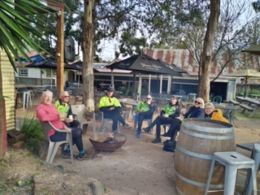
We went off on a good start; nice dirt track, bit wet but manageable till it suddenly “kind-of-stopped” and turned into a flowing river. That’s what happens if you rely on Google Maps! After some discussion and with help of Philip’s impressive GPS instrumentation, we backtracked a km or so and proceeded over the main road to Locksley where we picked up the planned track again and finalised the 34km circuit without any further problems.
We normally just cross the plains north of Longwood en-route to Euroa or the Bogies and don’t pay much attention to the landscape, but it is actually quite an attractive area with lots of winding tracks, some nature reserves, old trees, and creeks (currently even “flowing” as we found out!). We all enjoyed it!
We finished the trip at around 1 pm, just in time for drinks and a hearty lunch at the White Hart Hotel; excellent end of the tour! Thanks to all for making this another memorable SAC event, especially to Philip who as always video-taped the day with the results for sure being made available on-line.
Alfred and Maartje

Mid Week Walk: Murchison Ramble June 28 by Jenny

The weather was kind to us and, although overcast, the temperature was mild for this time of the year. The rain held off and we even saw the sun later in the day.
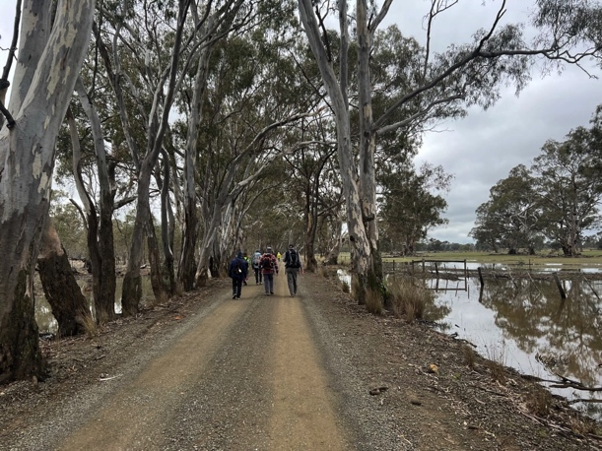
Thirteen happy walkers meet at the Murchison Museum and, with lunch in our backpacks, we headed west towards Rushworth along the rail trail. The first section of our walk followed the north boundary of Doctor’s Swamp Wildlife Reserve, a significant river red gum wetland. The trail crosses the Stuart-Murray and Cattanach canals which divert irrigation water to the Waranga Basin. Information boards have been erected to inform the passers by about the water history of this area.
We turned left at the Murchison-Whroo road and after a short distance we took a left turn into Willow Road. This quiet back road allowed us to enjoy the river red gums and the birdlife while we walked. The wet land is 271 hectares and is important for resident and migratory wildlife including a large black swan breeding population observed in the distance. At the south boundary of Doctor’s Swamp, we turned left into Old Whroo Road and headed to a well needed lunch stop. Although the walking was easy, we had covered around 9km.
Due to recent rains the swamp was wet so we chose to have our lunch break close to the road opposite the Murchison recovery centre. After we had satisfied our hunger Lyndall took us on a walk up the hill at the recovery centre to see the view and hear about what has been happening at the site and future possibilities. We then headed back towards Murchison along Old Whroo road, the railtrail and then into Station Street.
At the end of Station Street, we took another deviation to the Murchison cemetery. We visited the Italian Ossario, the home of the remains of 130 POWs and internees who died during WW2 on Australian soil. It is an impressive building built of Castlemaine stone with roman roof tiles and an altar of white marble. The Ossario was dedicated on the 10th September 1961. From here we headed back into the Murchison township and ended the walk at the bakery for a well-earned afternoon tea after walking approximately 16km.
Photos:
Happy walkers
The Ossario at Murchison cemetery
Majestic gums at Doctor’s Swamp

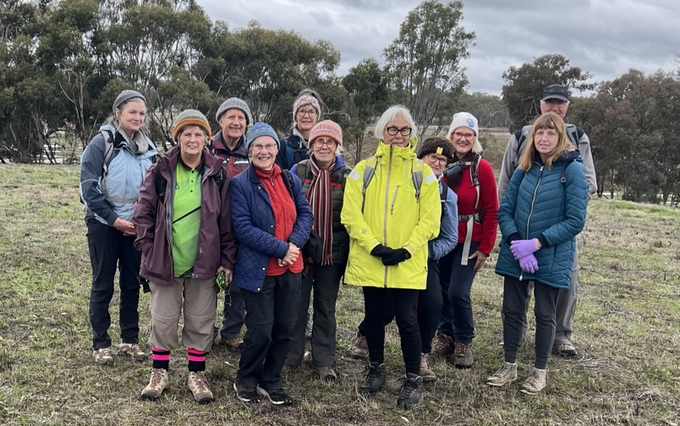

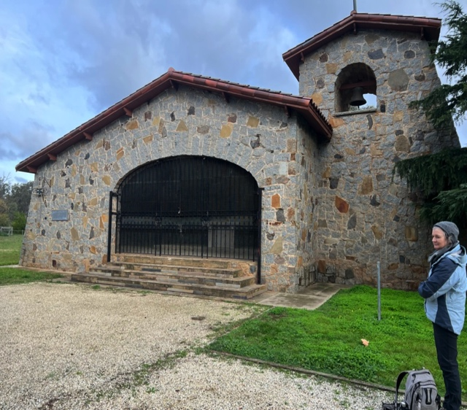

Mid Week Walk – Yundool/Katamatite July 26 by Kerry

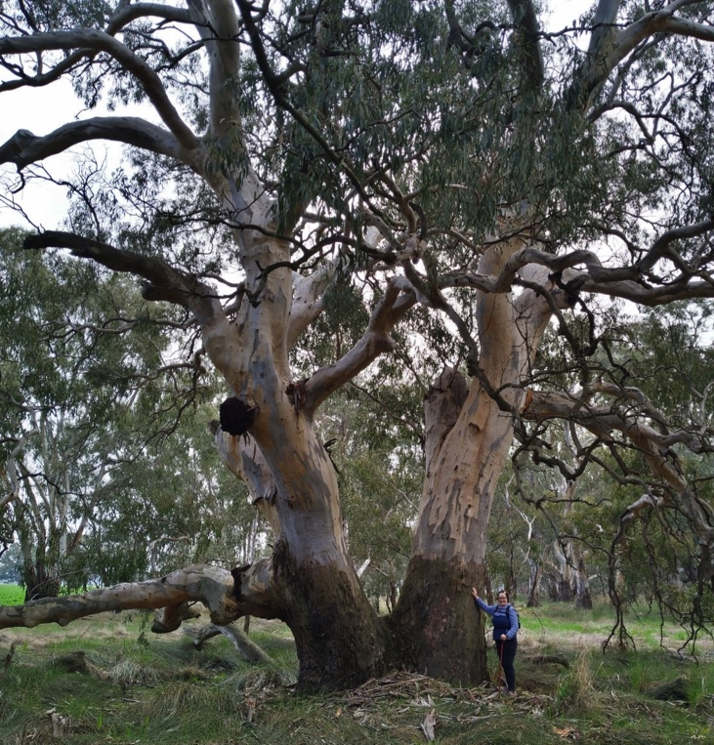
July's midweek walk saw us doing an almost 8km circuit on the Broken Creek in the Yourang Natural Features Reserve at Yundool. This walk took us past several scar trees and some very impressive red gums. We had lunch at the Yundool Community Hall before driving to Katamatite to have a look at the newly painted silos there. We finished our day off with a short walk in the Boosey Creek park and coffee at the Triple Bean Cafe. We also had two new walkers this month.
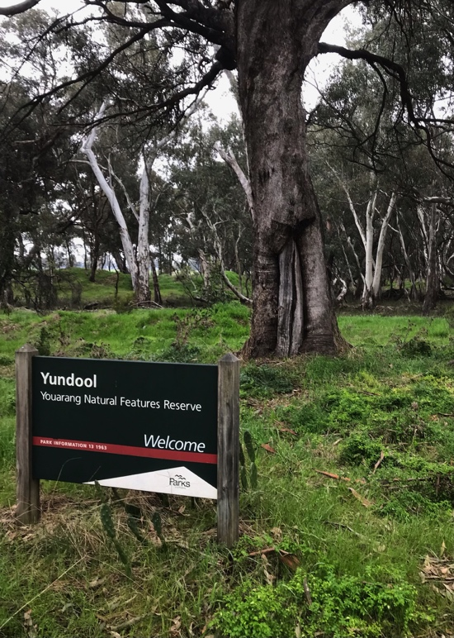

Photos:
Yundool Reserve
Mighty red gums

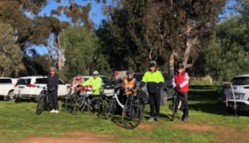
Bike Ride July 16

Fast facts:
When: Sunday 16/7
Start/Finish: Shiraz Republic Winery, Hamblin Rd, Cornella.
No. of riders: 8, (5 e-bikes, 3 p-bikes)
Time: roll-out 9.30am, roll-in 3.30pm
Total km: 58-60km
Speed: Ave approx 14km/h; max approx 42km/h
Riding time: 4 hours
Elevation: max 261m; total gain: 496m
Weather: cool/fresh, sunny, temp 2c to 14c by 3pm; wind 8km/h WSW
Route: 35+ km am to Tooleen via Muskerry East and Crosbie Conservation Reserve. 20km pm return to winery via circling south of Mt Camel. west from winery
Ride surfaces: bitumen, gravel, rocks, dirt, mud, water.
Leaders summary:
Participants all had a good gauge of their fitness, ability and battery longevity in the face of our deadly ride description: distance, terrain, slope, riding time, potential misery (ie wet socks, or is that just me?) and were prepared to be a bit tired and sore.

Ride details:
We departed the winery at 9.30am and headed west to the top of Mt Camel range via Hamblin Rd. We warmed our muscles up on the 2km before the steepest section of the day’s ride and made it to the crest where we stopped to take in the spectacular view while catching our breath. The riders were warned the downhill section was rough and ‘technical’. Message received and understood…

Everyone took it steady over the rocks and ruts and braked cautiously to navigate safely to the boggiest section of the day’s ride. Fortunately farm vehicles had created a “rut-ridge” that we could tip-toe on so my plastic bag overshoes were not required! With the most drastic route challenges out of the way, it was a lazy 35+km of rolling hills to Toolleen.

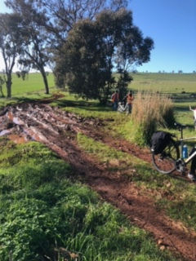
After initially heading west, then north, and then due west again, we eventually turned south to head through Muskerry East. We enjoyed more vistas to the west, across paddocks noisy with new born lambs, and neatly cropped expanses. Most roadsides were healthy with native vegetation such as magnificent swards of Dianella, plenty of understory beginning to blossom and red gum, grey box overstorey. Kangaroos abounded; a wedgetail eagle circled overhead; eastern and crimson rosellas raced through the tree tops, and at ground level there was evidence of echidna activity.

We had a couple of brief stops to make sure everyone’s batteries (physical, electrical and emotional!) were in the comfort zone. Graham described his e-bike battery capacity in glowing terms and I got the impression it would probably have enough spare energy to percolate coffee for us all. So we confidently passed the last possible short cut and kept a steady pace. We eventually turned east and then north giving group a taste of the Crosbie Conservation Reserve to take us toward Toolleen.

Tired legs burned on the rough bush tracks in the reserve but spirits remained high. Alfred got ahead of the pack and missed a crucial turn. We waited and called, but on firm advice from a close source we were told to “let him go… he’ll be fine”. So we did….and he was. We emerged from the reserve onto a main road with a 1-2m wide bitumen shoulder. It felt like we practically sprinted the 2.5km up the hill to Toolleen.

Lunch was enjoyable at the Toolleen Hotel and Tin Shed with some bringing their own ‘mains’ and some going for the whole 2 course pub meal experience.

It all went downhill after lunch, for about 1.5km. Then we turned south and started a stretch of undulating gravel road past wineries and olive groves and more sheep. We enjoyed views across the Campaspe plains on our right and Mt Camel and Mt Pleasant on our left. When we turned east we climbed back over the range. Even though it wasn’t as steep as the earlier summation, it was a decent challenge. A glorious 2.5km downhill run was the reward. The gravel road was sheltered, quiet and smooth and the riders glided effortlessly down the gentle twists and turns and through the 18th and final and deepest, and easiest water feature (aka floodway).

But the hills weren’t done with us. After 300m on bitumen we were back on gravel and climbing very gradually. At one stage Dallas remarked “the road looks flat but feels like it’s going up hill”. And, yep, we were. A soul-sapping kilometre of thigh burn. Then at last, we were heading north, looking across the Goulburn Valley to our right and with the faintest of tail winds at our backs.

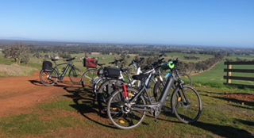
We paused at the final turn that would put us back on Hamblin Road and within sight of our vehicles. Critical questions were asked. Firstly, how did Phil manage to keep his white runners so clean and, how was Jenny’s e-bike still sparkling white? They were both very coy. The final question was who is hanging around for a debrief at the winery? Answer: EVERYONE! Yippee! The last 850m was another glorious gentle downhill run all the way to the car park - the perfect way to finish the day’s ride.

By 4pm we had our bikes securely loaded. The winery greeted us with live music and cheery voices around the fire pits. We opted to sit inside… we’d all had enough fresh air for one day. It was nice to relax and chat for a while before the group headed home.

Around Shepparton Trails August 9 by Karen

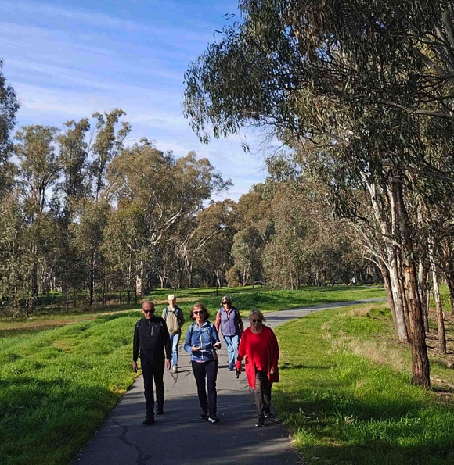
Around Shepparton Trails (AST) is a new initiative of SAC to offer other more accessible walks to our members. It’s also an easy introduction to the club for people new to town or those interested in finding out more about SAC. Three ASTs have now been run. Two were cancelled due to poor weather and then high river levels closing off some of the paths.
The most recent walk was on August 9 and ten walkers gathered for a delightful stroll of about 8km on a beautiful sunny morning. Conversations were varied and non-stop and it was such a lovely way to spend two hours.
Some of the group continued their conversations in the nearly SAM café.
AST happens on the second Wednesday each month at 9.00am then switching to an 8.00am start with Daylight Saving October to March. You can just turn up on the day.

Bike Ride Whroo to Reedy August 18 by Lyndall

Fast facts
- Time-roll out: 9.30am, roll in: 12.15pm
- Distance: 28.5km approx
- Riders: 9
- Weather: very overcast, light fog early, very faint breeze; temp: 7c-13c
- Terrain: From Whroo along Toblerone-like pressed gravel road to minor gravel road to rough bush track to wallaby track to invisible track to bush tracks and open gravel roads then muddy clay ruts at entrance to Reedy Lake.
- Elevation change: 187m to 128m
- Notable field notes:
  - Greg's light weight, clip-on rear mudguard remained in place and intact despite bone-shaking track sections. But it also remained effectually unproven despite urging from co-riders for Greg to ride through the muddy sections with the rest of us prepared to provide a vocal performance report.
  - Wedge tail eagle - dropped out of trees on the roadside and flew low along the road ahead of us for 50-100m until it turned into the forest at Reedy Lake entrance. We glimpsed it again at the morning rest stop.
  - Whroo forest - everything is easy at the moment - low daytime temperatures perfect for exercising; no dust, no flies, the roads (not the tracks!) are firm and smooth like pressed clay, the vegetation is magical and the bird life .....

The poem/song (Heavily borrowed from "Ghost riders in the sky")

Whroo riders in grey skies
Nine SAC members headed out
one grey and misty day;
Upon their bikes they chatted as they pedalled on their way.
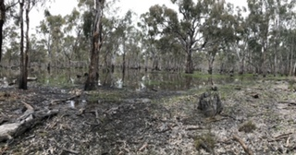
When all at once Geoff heard a cry
from his co-leader's mouth
"Oy! You've missed the turn, the track's back here
where we must now turn south!"

Yippy yi yay
Yippy yi yo
For most riding we'll stay dry

The wattle's bloom and fresh new growth
And birds we heard and saw
the rough and rugged country
Who could want for anything more?

Then a bolt of fear went through them
as they wandered on their way
When the leaders doubled back two times
some were inclined to say...

Don't lead us astray
Which way do we go-oh?
But SAC riders do not cry

Their faces gaunt, their eyes were blurred
Their shirts all soaked with sweat
They're riding down to Reedy Lake
for morning tea to get.

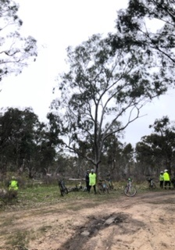
The mist began to clear up
and some blue was in the sky
A wedge tail eagle flew ahead
from a tree branch way up high.

Yippy yi yay
Yippy yi yo
SAC riders found their way.

The riders were on fire
Though their muscles they could feel,
Their tyres were still black and shiny
and their brakes they did not squeal.

The riders used their gears so that
together we could stay
As we cycled up the hill to Whroo
Then drove to a Cafe

Yippy yi yay,
Yippy yi yo-oh
Thanks all for a great day-ay

Wonderful Wildlife by Marg

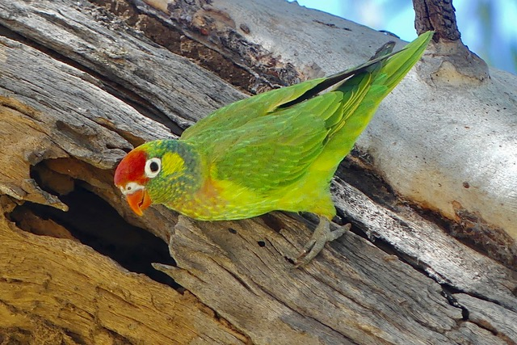

VARIED LORIKEET
On a recent birdwatching trip in the Gulf of Carpentaria area I was pleased to see a number of bird species only found in Northern Australia including Varied Lorikeets.
They are one of the smaller lorikeet species and they follow the flowering eucalypts and paperbarks.
This particular bird was probably investigating this branch hollow as a nesting opportunity. There are 4 species of lorikeets found in the Goulburn Valley.

Members’ Meanderings by Karen

The Heyson Trail extends 1200km from Cape Jervis to Parachilna Gorge in South Australia. I recently had the pleasure and challenge of completing a section of this trail between Quorn and Hawker, covering around 110km over six days with my daughter. The track is remote. We saw no other hikers and only one vehicle in the time we were hiking. The weather in July was bleak and cold. We were fortunate to have only one day of light rain.
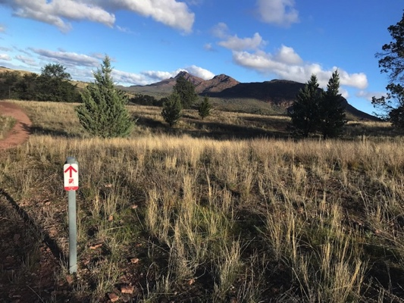
This section of the Heyson included four general types of track:
1. Walkers follow fence: the trail tracked beside fences on vast stations. Occasional markers and styles to allow crossing of fences. Often no defined track. Constant climbing in and out of gullies.
2. Walkers follow creek: kilometers of rock hopping and scrambling up or down creek beds.
3. Walkers follow track: kilometers of gravel track of varying quality, often including very steep ascents and descents.
4. Walkers follow markers: making your way between trail markers. No or little path, often very rocky.

Campsites were simple with a small shelter to catch rain water in a tank, a bench, a few flattish tent sites and sometimes a long drop toilet.

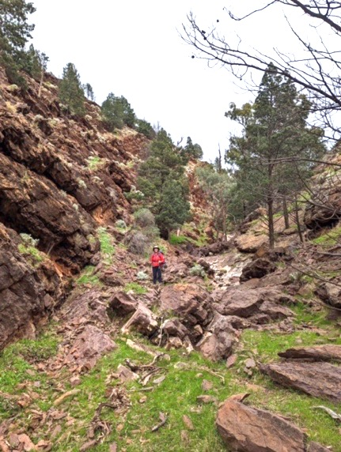
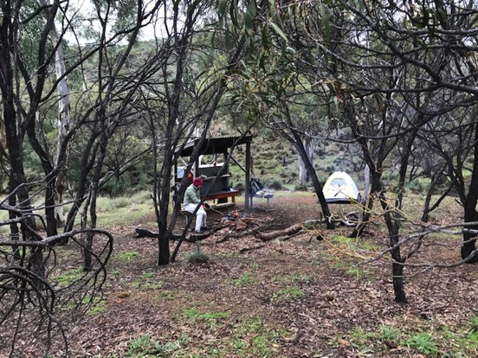
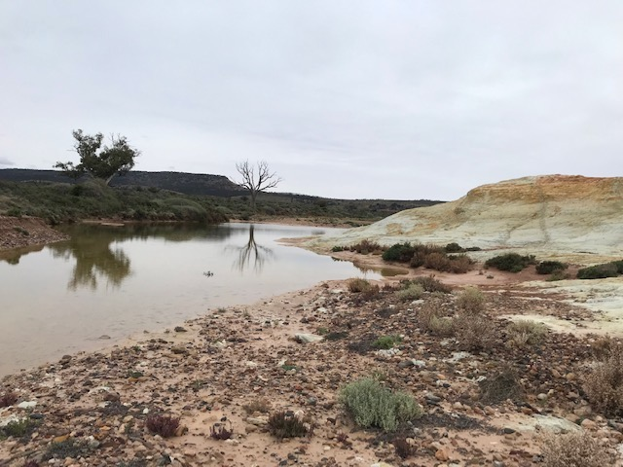
Wildlfe spotted included wallabies, kangaroos, emus, feral goats and sheep that clearly don’t see many people – they fled in panic on spotting us approaching.
Photos:
1. Heyson trail marker and countryside
2. Wilochra Creek
3. Campsite
4. Rock scrambling down a creek bed

