

**SAC Newsletter**

**June - July 2022** [www.shepadventureclub.org.au](http://www.shepadventureclub.org.au/)

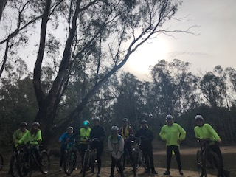

**SAC June 2022 Bike ride report**

***Here are three versions of the June ride report to cover the range of adult learning styles out***

***there: essential facts/zero adjectives; experimental, you decipher it; and fully described!***

***Fast facts: (26 seconds)***

Date: June 18th 2022.

Ride organisers: Lyndall Ash and Geoff Lodge.

Start: Murchison near Heritage Centre. 9.30am for 10am roll out.

Morning ride: 18 riders; 17-18km.

Lunch: 12.00-1pm at Murchison Riverbank Gardens picnic area

Afternoon ride: 11 riders; 10-11km

Finish: 3.30pm

Post ride: Railway Hotel Murchison East. Homeward by 4.30pm

***Ride Rap: (45 seconds to read, longer to decipher?!)***

**This wrap up has a hip hop beat and it ain’t neat so…….**

***Chant*** it to yourself and breathless go

take that chance and see it through

Like we did on SAC ride June twenty-two

Rail trail riding side-by-siding got us to the road to Whroo

through fog and past the froggy, bog land,

land filled and wetted lands to stoney zones as upward going

Two tricky rocky hills showing

Clunking chains gears grinding

Huffing puffing more upward winding then

Zoom zoom down to looming lunch

munching next and then a bunch went

Bridge crossing, heritage stopping to

Hopping grids and puddle pedalling,

just … like…. kids

Slipping dripping sliding gliding

River streaming smiles beaming

Load up the bikes…

**Now drop the mic.**

***Descriptive essay! (4 minutes):***

Eighteen members made their way through the fog to Murchison in full knowledge of impending steep hills, rocky roads, and muddy bush tracks.

We headed off at 10am with the sun beginning to break through. Geoff Lodge led the way through the quiet back streets to Old Whroo Road. At the end of the bitumen we had a quick stop to appreciate the tourism trifecta of Murchison: the infrastructure hub on one side (the resource recovery centre/Tip and the sewerage farm!), and on the other side, the very

picturesque Doctors Swamp.

A gradual climb past open grazing land saw us reach the edge of Whroo Forest. A couple of steep and rocky hills were literally ‘just around the corner’ with no chance for a run up.

Ride leader Geoff strongly encouraged us to get into our easiest gear before we turned the corner, rather than try to change gears under pressure on the steep, gravelly slope. Fully prepped, all riders crested these hills with ease.

We also then fully expected it to be downhill all the way back to the bakery. Unfortunately Geoff forgot to mention the three more hills further along that were equally steep, if not steeper!

While some of us laboured our way up, Jenny maintained her cadence and wended her way through the peloton with very polite ‘excuse me’s and ‘coming through’s on her bright, white charger!

The 17km morning ride finished with a relaxed lunch at the Riverbank Gardens picnic area with members taking advantage of Murchison’s two eateries.

After lunch, eleven members headed out for the afternoon ride that promised lots of optional mud, and some not-so-optional mud. A few riders mentioned they might turn back “depending on how muddy it gets”. I am delighted to report that the group stuck together despite how muddy it got! (there are so many muddy metaphors to choose from!).

The route was about 10kms into the wilds of Murchison East North. We crossed the Goulburn River via the steel span bridge riding on the metal, disconcertingly bouncy and narrow, shared pedestrian path that is perched precariously on the upstream side.

We had a quick stop to appreciate the heritage listed plane tree and the iconic and historic “Thornbridge” (aka Gregory’s Hotel). We continued on the shared path on the “Low Road”, to safely head further east.

Soon enough, the promised bush ‘access’ tracks presented themselves in all their slushy, muddy glory. How bad can it get? Well, in some places the muddy water was up to the axles - we know that because Martin and Wendy and a few other brave souls pedalled straight along the ‘tram tracks’.

“How deep is it?” Response: “you’ll find out!” Riders got to ‘choose their own adventure’ to get around, or through the ridiculously boggy sections. Free-styling, cross-country and single track riding skills came to the fore. I may have had my fingers crossed when I heard someone say, “I’m following Lyndall, she looks like she knows what she’s doing”.

The remainder of the ride was a comparatively civilized 3 km loop at Campbells Bend (NKA Murchison East South), beside the Goulburn River, under the old railway bridge (which is part of a longer term rail-trail extension project), then back across the bouncy bridge to the cars.

Jenny’s white charger miraculously still relatively unsullied…

Before we knew it, with dignity intact and smiling faces, bikes were quickly loaded up, and feet were warming up in dry shoes and socks. Seven members retired to debrief over light refreshments at the Railway Hotel at Murchison East.

And many thanks to Phillip for his great pics and for capturing the morning ride using the Relive program and sharing it with us. The short video provides visual and geographic context that adds a whole other dimension for those who enjoyed the ride, while those who weren’t able to join us get a sense of the route.

Thanks to all who joined us on our first attempt to organize a SAC ride, (our route reconnoiters were a hoot and a lot muddier!). When my phone pinged with the first text rsvp message I was a bit like the surprised receptionist on the ‘Ghost busters’ movie: “We got one!”. It was a great turn out of riders, especially considering the ride description and the fog. It confirms that SAC members really are adventurous by name and by nature!

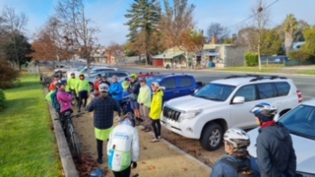

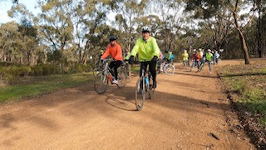

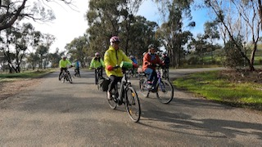

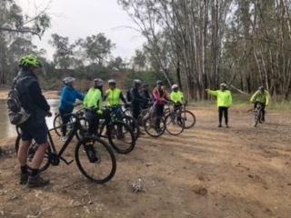

**Bird life**

***The Golden Whistler*** can be seen in this region in the winter months.

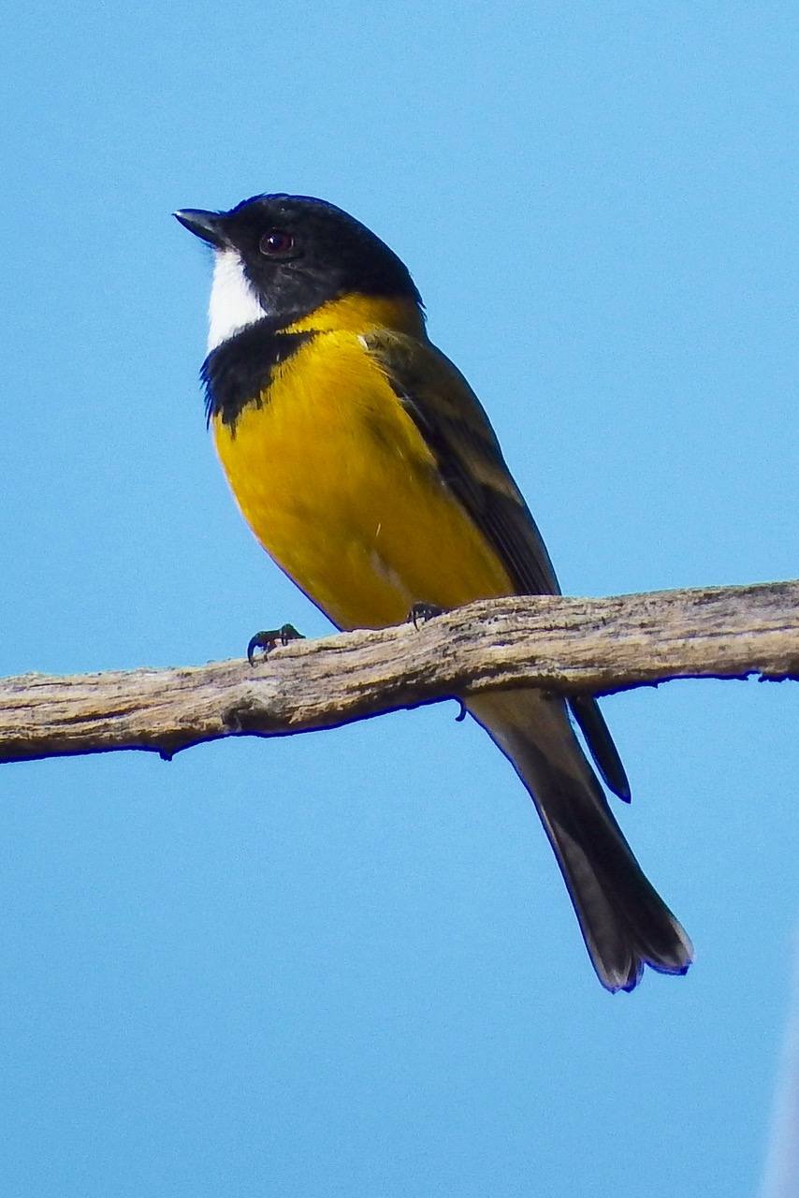This photo is of the striking male bird. The female is mainly plain grey.

They are usually seen in singles or pairs and have a long melodious call.

Golden Whistlers are found in a variety of habitats and feed on

arthropods found on foliage and bark.

**Article and photo - Marg Clarke**

Midweek Walk at Whroo

After numerous queries about the weather nine adventurous people met at the library carpark to carpool to Whroo. On the way the windscreen wipers were on and we wondered if it was going to be a repeat of the June walk last year! However, we ventured on and met another three walkers at the Whroo Visitors Centre. After morning tea in the shelter of the verandah on the information centre the rain had gone so we set off.

We walked to the Balaclava Mine and although many of us had been there many times it is always an interesting place. We walked through Lewis Park and on the Whroo Cemetery. We spent some time here looking at the graves and the newly erected information board and many new plaques depicting the various families that were buried there. From there we walked the loop to the water hole where various theories were muted as to where the water comes from. We walked back to Cemetery Road to the Nagambie-Rushworth Rd to the puddling machine and then to Reedy Lake Road where we had lunch. The rain had held off and it was very pleasant walking.

After lunch we walked down Greens Road to Blacksmiths Road and walked to the Blacksmith Dam and then retuning the same way. We saw some wildlife on the combined walks – kangaroos, a wallaby, red rosellas and there were lots of different fungi.

We returned to the cars and adjourned to the Rushworth Bakery for a well-earned coffee/hot chocolate and some sweet things.

**Dine and Chat at the Aussie**

The SAC June members’ meeting took the form of dinner out at the Aussie Hotel in Shepparton. Twelve members came along and enjoyed good food and interesting conversation on a cold winter night.

It was a great opportunity to get together in person after the cancellation of many events over the last two years.

Such was the interest that the group decided to meet again. The next dinner get together will be on Tuesday July 26, from 6pm, this time at the GV Hotel in Shepparton.

SAC walk Euroa - Balmattum 25 May 2022

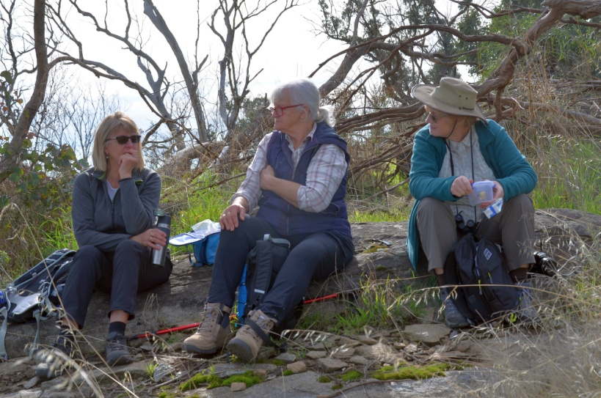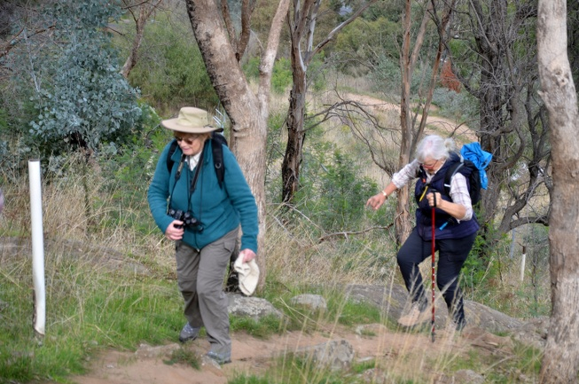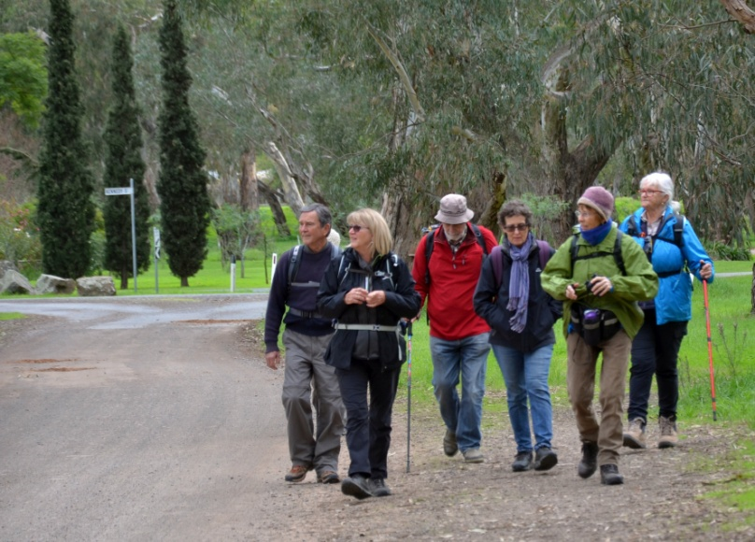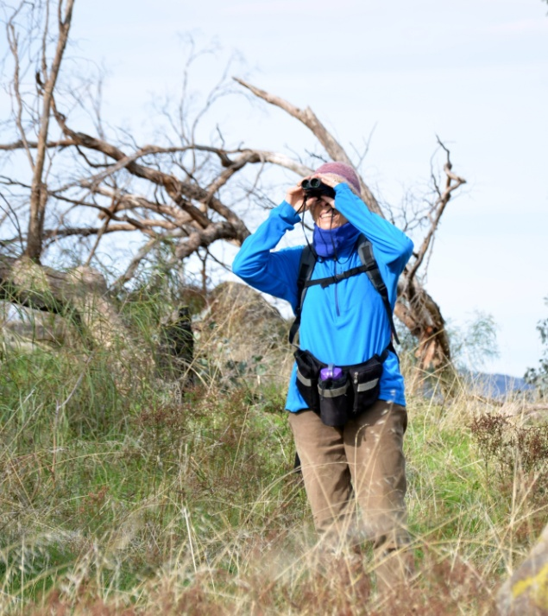

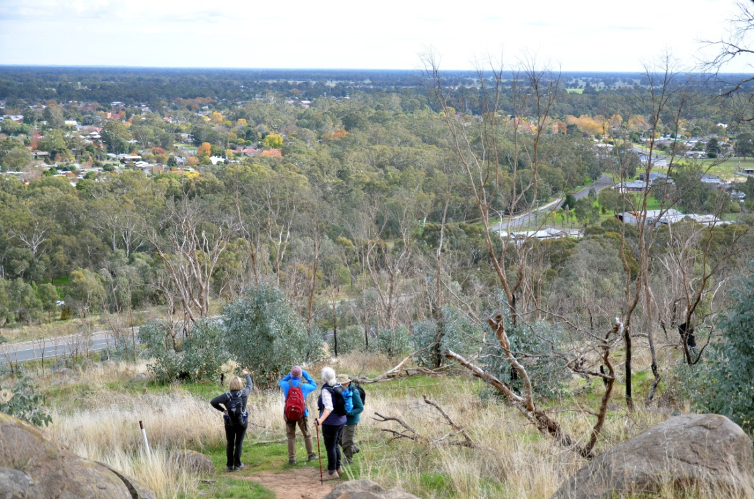

**Adventure Calendar 2022**

| Date | Type | Location | Leader | Grading |
| --- | --- | --- | --- | --- |
| 20th Aug | Bike Ride | Moyhu | ? |  |
| 24th Aug  9am | Midweek Walk | Warby Ranges | Maartje Heuperman  0407 849794 | Easy/Medium |
| 30 Aug  7.30pm | meeting | AGM from 7.30pm, possibly with dinner beforehand | Greg/Karen | social |
| 17th Sept | Bike Ride | Winton Wetlands | Ray/Dallas  0438 591749 |  |
| 28th Sept  9 am | Midweek Walk | Terrick Terrick N.P | Dianne Hanna  0437 289 281 | Easy |
| 12th Oct  9. am | Midweek Walk | Mt Black (offroad) | TBC | Easy/Medium |
| 15th Oct | Bike Ride | TBC | TBC |  |
| 26th Oct  8 am | Midweek Walk | TBC | TBC | Easy/Med |
| 19rd Nov | Bike Ride | Dookie + optional walk up Mt Major | Shelley 0422268102 |  |
| 23rd Nov  8 am | Midweek Walk | Boathole to Mineral Springs Strathbogies | Howard Hanna  0437 628279  Justus Hagan | Easy/Mod |
| 17th Dec | Bike ride | Twilight Ride Kids Town/Gemmill Swamp & BBQ at shed | Ray  0438 591749 |  |

**Trip Leaders:** *Please remember to ask visitors to sign an Acknowledgement of Risk form for Temporary Members and pass it on to our Secretary, Karen. This form is available on our website once you login (member, bushwalk) under Members>Leader Information. It is a requirement of our club insurance policy.*

FOR SALE

**Mens “Masi Nouva Strada” 56cm Road / Triathlon Bike**

Aluminium frame & Carbon Fibre Forks & Seat Post

Weight 10.2 kgs.

In Very Good to Excellent condition.

Asking price $450.00 Negotiable.

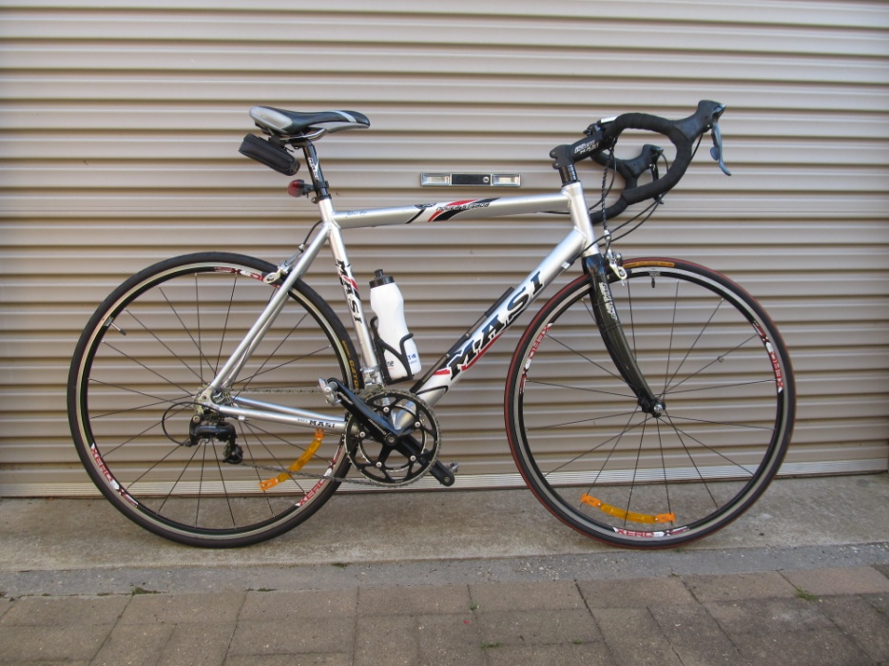Contact: Richard Graves on Mobile 0408 547 065

**To Give Away to a good home**

**“Wild Magazines”**

Richard has been collecting “Wild” Magazines since the 1st edition in 1981 and

has every copy since, all 180 of them.

Regretfully it’s now time to de clutter, so if anyone is interested in all or just a few copies

give Richard Graves a ring on 0408 547 065 to arrange collection.

If there is no interest then they will all go to council recycling.

**President’s report**

Hi all,

I hope you have been able to enjoy some outdoor activities so far this winter, it’s certainly been a challenge with the weather at times. I’ve managed a few bike rides and shorts walks, then a trip to the Top End to warm up a bit.

Our AGM is coming up on 30 August and includes the election of office bearers. We already have an offer for a new Secretary, does anyone else want to join the committee? President, Vice President and other positions are available. Full details and a nomination form will be sent separately soon.

The Bushwalking Manual, put together by BWV, provides guidelines and information for safe and enjoyable bushwalking across Australia: <https://bushwalkingmanual.org.au/>. It includes information on trip planning, clothing & equipment, navigation, leadership and much more.

Cheers, Greg

#### President: Greg Smith 5824 1143 president@shepadventureclub.org.au

#### Vice President: Bruce Gill 5824 2548 tatgills@westnet.com.au

#### Secretary: Karen Speedy 5825 1785 karenspeedy@iinet.net.au

#### Treasurer: Scott Birchall 5831 6063 scottb@agsystems.com.au

#### Newsletter Shelley Wyllie Shelley.wyllie@gmail.com

#### Equipment Officer: Richard Graves 5824 2929 richsue@bigpond.com

#### Publicity Officer: Richard Speedy 5825 1785

#### Calendar coordinator: Neville Paynter 5831 1576 Neville.Paynter@jacobs.com

#### Mid-week coordinator: Dianne Hanna 0437 289 281 dhanna3@bigpond.com

**Editors note**

*Committee is calling all members to contribute to our newsletter. We are able to insert “for sale” items that are relevant to Adventures, Birthday celebrations, personal adventure stories, recipes and much more. Simply email Shelley.*

**Thank you Karen and Ian** for organising a SAC dinner at the Aussie hotel, it was a good turn out and a pleasant evening catching up with members.

It was so successful that a few members have asked Karen to set up another dinner!!!

Keep an eye out for when and where ☺

Pleasing to see a lot of content this newsletter considering a couple of wether cancellations, thank you to all that have sent through reports and pictures for this issue, keep them coming – including your own adventures!!!

**Club T Shirts**

Are finally here and already we have 30 orders! How amazing will our trips be when we are all wearing our club T Shirts as a group!

Tops are sized from XS to XXL.

Men’s sizes are pretty accurate, while the ladies XS is equivalent to a size 10, S-12, Med- 14 ETC

All enquires to Marty on 0421 050 880

