
If undelivered, please return to PO Box 264, Shepparton 3632

SHEPPARTON ADVENTURE CLUB inc. A0002706S

NEWSLETTER June-July 2016

website: www.shepadventureclub.org.au

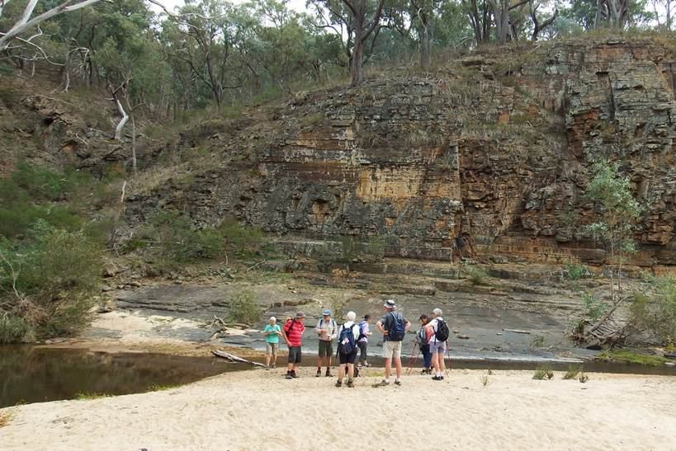

SAC members on Hughes Creek

Next club meeting Tuesday 28 June 2016
7.30pm at the Mechanics Institute, Wyndham St, Shepparton
Ray Mustey with talk & photos on the Great Himalaya Trail in Nepal
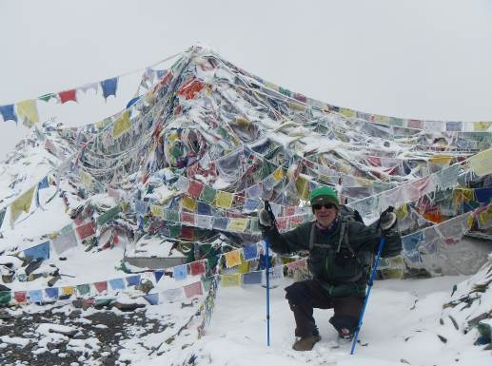

The SHEPPARTON ADVENTURE CLUB Inc.
General Meeting: 4th Tuesday of the months: February, April, June, August, October
usually at: 7:30 pm at the Mechanics Institute, Wyndham St, Shepparton.

Correspondence to: The Secretary SAC, PO Box 264, Shepparton 3632
Email: sacvicau@yahoo.com.au

OFFICE BEARERS
President Bruce Gill 5824 2548 tatgills@westnet.com.au
Vice President Karen Speedy 5825 1785 karenspeedy@iinet.net.au
Secretary Howard Hanna 5828 9281 howard_hanna@yahoo.com
Treasurer Scott Birchall 5831 6063 scottbirchall@aapt.net.au
(for email distribution to members)
Newsletter Editor vacant (interim Greg Smith – see contacts below)
Equipment Officer Richard Graves 5824 2929 richsue@bigpond.com
Publicity Officer Rach Keen 0400 238276 rach_elkeen@hotmail.com
Calendar Coordinator Neville Paynter 5831 1576 Neville.Paynter@jacobs.com
Mid-week coordinator Dianne Hanna 0437 289 281 dhanna3@bigpond.com
Web Master Greg Smith 5824 1143 greg.smith@gmwater.com.au

We are still seeking a permanent Newsletter Editor, a good job to brush up on your computer skills and add your own touch. Contact Bruce or Greg if interested. Phone support available!

Newsletter Printing

Our newsletter printing is kindly sponsored by Hon. Wendy Lovell, MLC for Northern Victoria Region
138 Welsford Street, Shepparton

SAC is an affiliated member of 

SAC MEMBERSHIP FEES - from 1 September 2015

Single Club Membership $35
Family Club Membership $60 (2 adults and children)
Concession – Single Membership $30 – Pensioner/Senior/Student Cardholders
Concession – Family Membership $45 – Pensioner/Senior/Student Cardholders

Membership benefits
Your Bushwalking Vic membership card enables you to obtain discounts at a number of retailers including Ajays (Heathmont), Bogong Equipment (Melb), EMC (Deepdene), Melb Map Centre (Malvern East), The Wilderness Shop (Box Hill), Paddy Pallin, Smitten merino wear Tasmania, Woodslane Walking Guides.
5% on Outdoor Travel tours and all reservations made directly with the office at Bright. Check out their website or join their email newsletter list for tours and current deals: www.outdoortravel.com.au, 1800 331 582 info@outdoortravel.com.au
Discovery Holiday Parks, Cradle Mountain 20% discount off shoulder and low season rates (16 April - 2 December)
Contact Claire on 03 6492 1289, 1800 068 574 www.discoveryholidayparks.com.au

Full Moon
2016: 24 Jan, 22 Feb, 23 Mar, 22 Apr, 21 May, 20 Jun, 19 Jul, 18 Aug, 16 Sep, 16 Oct 14 Nov, 14 Dec
Source: www.ga.gov.au

President’s Piece

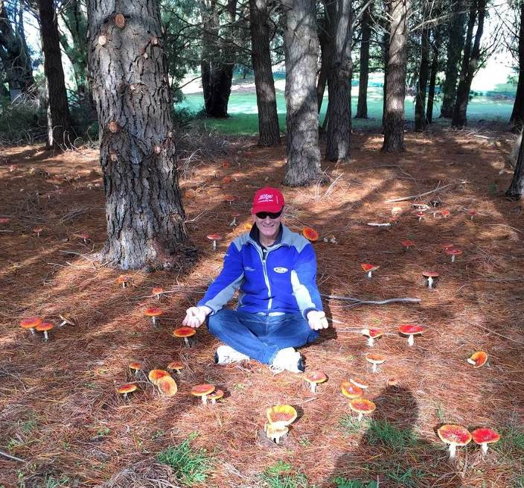
I hope everyone enjoyed some recent outdoors time over the Queen's birthday weekend. It is certainly very nice to see the countryside greened up again after the good rain that's fallen since the start of May. Up in the Strathbogie ranges, the golf course was boggy in places, with groundwater seeps active again and the peep of small frogs heard from among the sedges and rushes. The other amazing thing I noticed as a consequence of the rain was an amazing profusion of mushrooms and fungi of all sorts around the golf course. Especially the red variety with white spots (that I had previously thought only existed in fairy stories) were in their thousands under the pine trees, and some as big as dinner plates. Too bad they are not truffles!
I presume the abundance of fungus at this time is a result of the warm dry autumn and a long build up of organic matter that, once the rain arrived, provided ideal conditions for the fungi to go berserk.
On to things committeesq, we recently had a successful morning tidying up the canoes in the SAC shed. Thanks to Richard, Rachel, Neville and mushy-man, we removed an old damaged canoe from the shelves, along with some serious clutter from beneath them and rearranged the more active boats to the racks next to where the trailer is parked. This will help make it a bit easier to load up for forthcoming canoe trips.

On matters of state, I was browsing the most recent edition of Bushwalking News (From BWVictoria) and was interested to read about the volunteer track repair work some members were doing on what's called McMillans Walking Track. It was cut by Angus McMillan in 1864 when commissioned by the Colonial Government to connect the goldmining communities in the Gippsland high country. It starts on the Great Alpine road near Omeo and winds its way through the high country above Dargo and Licola and finishes at Woods Point. Sounds like an very interesting part of our state and historic legacy - will have to add it to the list!
A reminder to all, please think about nominating yourself for SAC committee (AGM coming up in August) especially for newsletter coordinator, as Greg has given above and beyond this past year. It's only bi-monthly, and on the job training will be given by the successful applicant. It is an essential part of the club, so please dig deep!
Cheers, Bruce Gill

Walking with Children (from Walksafe booklet, by VicWalk/BWV)
When planning walks with children allow for a slower walking pace, more frequent and longer rest times, higher water consumption and the inevitable tendency of children to either run ahead or fall behind the adult party.
Preferably plan short walks with as much variety as possible that will hold their interest and will remain easily and enjoyably within their physical capabilities.
As a rule of thumb, children between the ages of 5 and 15 can only comfortably walk as many kilometres per day as their age. Less in difficult terrain or poor conditions.
Children under 7 should not be relied upon to carry a pack or equipment.
Very young children can enjoy being piggy backed in special child carriers on short bushwalks if the terrain is not rugged. However, be aware of the potential danger from overhanging branches and take extra care to protect the immobile child from the sun and the cold. Remember that whilst you may be uncomfortably hot with exertion, the child could be quite cold, particularly if there is a wind.

Ed. – I have found that kids walking with other kids, friends and/or cousins who they can talk and play with along the way, makes it much more enjoyable and less effort for all.

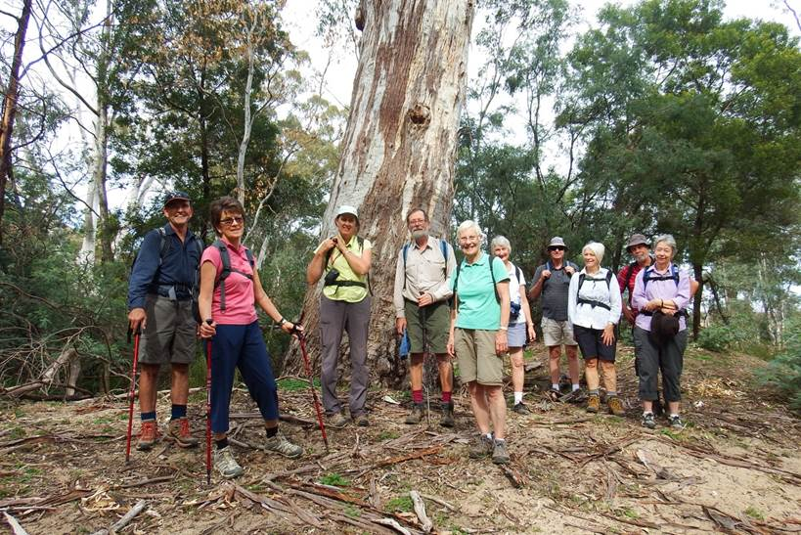

Hughes Creek mid-week walk in April

www.bushwalkingvictoria.org.au
PO Box 1007 Templestowe Vic. 3106
Phone: (03) 8846 4131
Fax: (03) 9846 7473 admin@bushwalkingvictoria.org.au

From the May & June 2016 BWV News
See them here: http://www.bushwalkingvictoria.org.au/what-we-do/publications/newsletters

Track Maintenance and Conservation
Various reports can be found in the BWV news on what clubs are doing to assist in maintaining tracks and clean up rubbish, generally in their local area.

Federation Walks weekend is on 8-9 October 2016 in the western Grampians area, hosted by the Wimmera Bushwalking Club. See www.fedwalks.org.au for details of walks, registration etc.

Training is available from BWV for leadership at both day-walk and extended-walk level, including navigation theory. Training materials in the day-walk and extended-walk skills are available on the Bushwalking Victoria website for clubs to use or adapt to conduct their own training.
In addition, the Training Coordinator (Judy Hunter) can assist with training if requested by a club. This can be for either course; either as a whole block or as single units. The final format and presentation can be arranged as agreed to with the Training Coordinator and the club. Contact training@bushwalkingvictoria.org.au

Promoting bushwalking: BWV has identified three groups to be targeted over the next three years as potential bushwalkers and club members. They are retirees/pre-retirees, families with young children and 20-30 year olds. A number of promotional initiatives have been identified for each group and clubs are welcome to participate in these. Contact strategy@bushwalkingvictoria.org.au

Work should have begun by now on preserving the Mt Buffalo chalet and an advisory group has been set up to identify future tourism options.

If you are planning to holiday in WA, you should visit the Trails WA website and have a look at the Trails: Bush Walk page which lists 67 walks ranging in location, distance and grade.

If you see someone dumping rubbish in a National or State Park or reserve, please contact Parks Victoria on 131963 or the local police station.

---oo0oo---

Calendar of Activities

Date | Activity | Location & details | Grade | Leader | Contact
22 June | Mid-week walk | Dookie area, always beautiful. Tallis winery indigenous trail & Mt Major. Meet 9am at carpark opposite Shep library. | E/M? | Dianne Hanna | 0437 289281
28 June | Club meeting | 7.30pm at Mechanics Institute, Wyndham St, Shepparton.  Ray Mustey will present on the Great Himalaya Trail in Nepal.
10 July | Walk & pub lunch | Winter warmer railway walk from Tatura to Toolamba, finishing with lunch at Toolamba hotel. Car shuffle required so meet Toolamba at 8.30am and start walking at 9am in Tatura. | Easy | Jill & Greg | 5824 1143
27th July | Mid-week walk | Warrenbayne: Winsome McCaughey & Snow Barlow property | Easy/ Medium | Di Hanna | 0437 289281
30 July Sat | Walk | Mt Samaria bushwalk approx 10km, some steep sections. Meet 9.30am | M? | Rachel | 0400 238276
20 Aug Sat | Walk | Mt Macedon bushwalk, option of 10.5km or 18km - some steep sections. Meet 8am | M? | Rachel | 0400 238276
23 Aug | AGM | Annual General Meeting. 7.30pm at Mechanics Institute, Wyndham St, Shepparton.  Guest speaker …? maybe “Walking in Kakadu” | social
24th August | Mid-week walk | Warby Ranges; Wenhams? |  | Any volunteers?
Sun 11th – Fri 16th Sept | Walks | Grampians camp & walks  As with previous such camps organised by midweek walkers, participants are to organise their own transport, accommodation and meals. We are recommending participants book with Halls Gap Caravan park. Ph: 03 53564251, info@hallsgapcaravanpark.com.au http://hallsgapcaravanpark.com.au  A program of day walks of various lengths and degree of difficulty will be organised for participants to opt in or out of. The goal is to have a series of walks that will enable all participants to join in at their own pace. |  | Dianne Hanna | 0437 289281  dhanna3@bigpond.com
21-25 Sept?  School holidays | Walks | Another Grampians trip  We are planning a trip to the Grampians, in particular the Victoria Range in the south-west. There are lots of great walks with interesting geological features – The Fortress, caves and gorges. Probably day walks, possibly some off track. Definitely camping.  The suggested dates are the first week of the school holidays but we are flexible. Please let us know if you are interested and whether the dates suit. | M+ | Jill & Greg | 5824 1143
28th Sept | Mid-week walk | Whroo forest |  | Richard Dickins | 58 285267
8-9 Oct | walks | Federation Walks Weekend in the Grampians & nearby areas hosted by the Wimmera Bushwalking Club.  This is a Bushwalking Victoria (BWV) event. | various | See http://www.fedwalks.org.au
25 Oct | Club meeting | 6pm BBQ at SAC shed? | social
26th Oct | Mid-week walk | Strathbogies; Shean’s Creek? |  | TBC
23rd Nov | Mid-week walk | Barmah forest | Easy | TBC

PLEASE RING THE TRIP LEADER TO MAKE SURE IT IS WITHIN YOUR CAPABILITY AND CONFIRM THAT IT IS GOING AHEAD.

OTHER CLUBS’ ACTIVITIES
Benalla Bushwalking Club http://benallabushwalkingclub.org.au/
Border Bushwalking Club (Albury & Wodonga) - www.borderbushwalkingclub.com.au
Wangaratta Out and About Club - www.wangarattaoutandabout.org.au/
Bendigo Bushwalking and Outdoor Club - www.gobush.org.au/
Echuca-Moama Bushwalkers - www.echucamoamabushwalkers.org.au
and more can be found at www.bushwalkingvictoria.org.au

TOTAL FIRE BAN
If a day of TOTAL FIRE BAN is declared please contact the Activity Leader for confirmation whether the activity will go ahead or not.

Note: TRIP LEADERS – it is imperative for every trip that temporary members/visitors sign the “Acknowledgement of Risk Form”. These completed forms must be forwarded to the SAC Secretary for filing as soon as possible after the trip – otherwise, in the case of a claim, the insurer will not acknowledge the risk.
Form can be downloaded from www.bushwalkingvictoria.org.au , under Members > Forms

Emergency Contact Procedures
All enquiries about the return of participants from club activities should first be directed to the activity leader, and then to the Emergency Contact Person (ECP) for the activity if the leader cannot be found.
It is the activity leader's responsibility to organise an ECP and advise him/her (in writing) of trip & participant details and what to do if contact is not made by the nominated time.
Travel Cost Reimbursement
Option 1: Preferred. Fuel Cost per car plus 5 cents per km per car to be split equally between the numbers of people in the car including the driver. If appropriate, the cost of running all vehicles should be shared equally amongst all trip participants.
Option 2: 25 cents per km per car split between all trip participants.

Summary of Public Liability insurance coverage at 5-3-2014 (from www.bushwalkingaustralia.org.au )
Bushwalking, Track/Hut Construction and Maintenance, Caving, Canyoning, Liloing, Abseiling, Alpine Walking (Summer and Winter),Snow Skiing, Canoeing, Kayaking, Boating, Rafting, Swimming, Cycling, Rock Scurrying and use of hand held ropes as part of a Bushwalk, Orienteering, Rogaining, Leader Training and other related instructions.
Activities NOT COVERED include Rock Climbing, Water Skiing, overseas trips (except NZ) and any activities not listed above.

Trip Reports

Kayaking on the Goulburn River 21 May 2016
A crisp autumn morning saw Rachel, Patricia, Richard and Ray out for a kayak from Shepparton to Mooroopna and back. As it was Patricia's first kayak trip, I demonstrated some paddling techniques to her and then we started off. The water was so calm and there was a little bit of mist. There were a few ducks around but apart from that it was quiet. We made it to Mooroopna in what seemed a very short time - we had been listening closely to Ray's latest trekking adventures. After a short break, we decided to get ready to paddle back to Shepparton. Attempting to sit in the new kayak to see how it felt, Patricia almost tumbled over into the water. Luckily this did not phase her and she cheerfully made her way back downstream with us after a laugh. All in all, a pleasant morning out with a great bunch of people.
By Rachel Keen

Thanks to all newsletter contributors for their articles and great photos.
The next newsletter will be out in August, but feel free to submit items at any time.

Wilson’s Prom 4 day hike 3-6 April 2016
11 members (3 families) had an enjoyable 4 day walk at Wilsons Prom, visiting Little Waterloo Bay, Refuge Cove and Sealers Cove. Possums were curious at the first night’s camp, while fish were spotted at Refuge and Sealers while we were swimming. Three beautiful sunny days came to end on the final day, when we walked through the paperbark swamp to the sound of myriad frogs enjoying the rain.
Thanks to the Camerons, Cathy & Alice O’Brien and the Smith-Clappertons for your company in this beautiful park.
By Greg Smith

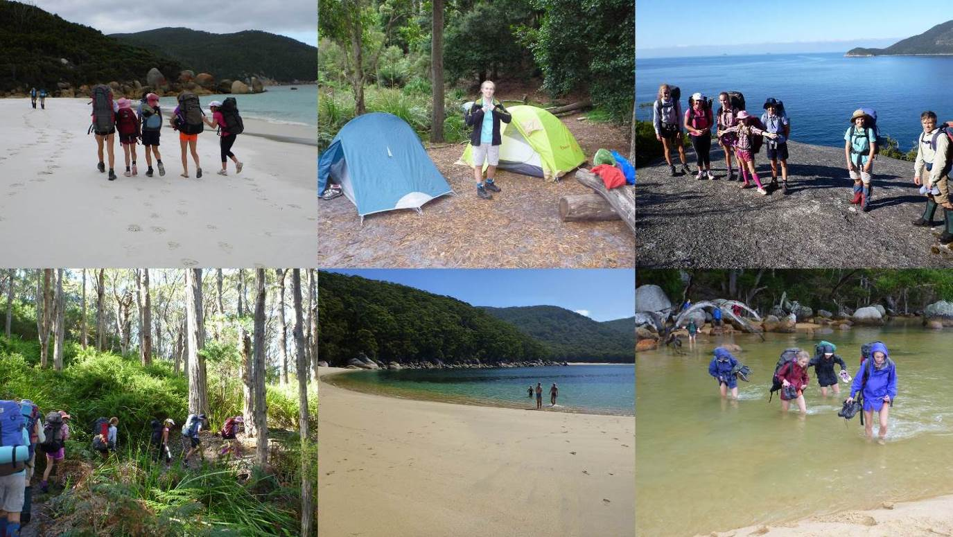

Midweek walk Hughes Creek 27 April 2016

Howard Hanna organized with Justus Hagen, Ruffy landholder, to take the Mid Week Walkers on another walk in the Strathbogie Ranges this year. This time he suggested a walk down a section of Hughes Creek.
Ten walkers, in two cars, traveled to Avenel where we met Justus. We followed him for some distance along the Avenel Ruffy Road where we left his vehicle at a spot where our walk would end. We then travelled to the site of the Koolabah shearing shed on Hughes Creek Rd where we had morning tea before setting off on our walk.
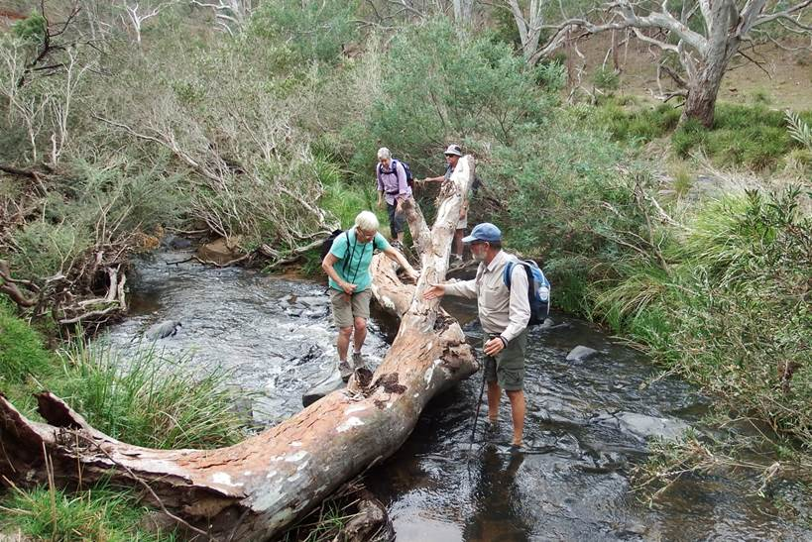
Initially we needed to cross the creek so off came our shoes. As there were no tracks to follow, except an occasional wallaby or wombat track, we needed to cross the creek a number of times in order to stay close to it, logs coming in handy a few times for that purpose.
The weather conditions were ideal for walking with cloud cover most of the time. We passed through interesting natural vegetation but disappointingly we found some introduced species like blackberries and gorse have taken over in various places. We stopped at one of many picturesque spots for lunch where there was a sandy beach and a high rocky cliff on the other side of the creek. While there we spotted a Wedge-tailed Eagle overhead and saw a number of birds and enjoyed their calls. Some large fish jumping caught of attention at various spots along the way.
Further along we needed to cross a number of fences, some that we were able to climb through the wire of while others we needed to squeeze under. There were some interesting ways of doing that, commando style being quite popular.
At the end of our estimated 13 kilometer walk, while waiting for the cars to come and pick us up, we enjoyed a lovely sunset in mild conditions. We decided that we had had quite an adventure and were pleased to have had the experience of following a creek for some distance.
Thanks to Howard and Justus for their organizing and help along the way enabling us to enjoy walking in another part of this unique area.

By Marg Clarke
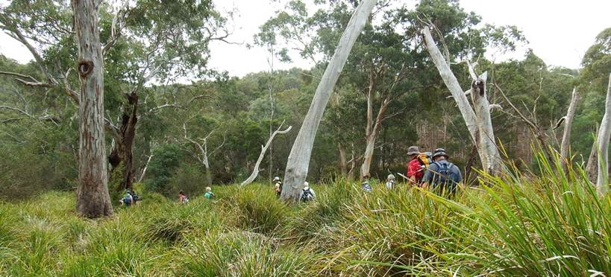

Mid week walk Winton Wetlands 25 May 2016
Fourteen people participated in the walk in the wetlands. It threatened rain all day but we did remain dry thank goodness. We car-pooled to the Mokoan Hub for morning tea after which we car shuttled to the start of the walk at Nelsons Rd.
It was a pleasant and easy walk along the old dam wall with a view of the mountains and farmland to our left and the remains of the Mokoan Lake on our right. The lake was established in 1971 and in its heyday the lake provided about 16 gigalitres of water per year to irrigators and added about $30 million per year in agriculture. The lake was also used for recreational activities such as fishing and yachting and of course the population increased on duck-opening weekend. The dam wall was erected to create the lake and was the longest dam wall in the Southern Hemisphere at the time (7.5kms)
Our walk along the wall gave us the opportunity to imagine what the lake had been and enjoy the bird life, although I don’t think we saw 180 species of birds that live in the wetland but we did see a few. We also had the privilege of seeing an echidna curled up on the edge of the wall as we all walked past. After walking the 7.5kms of the wall the drivers collected the cars while the rest of us ambled down the road until we were picked up and taken back to the Mokoan Hub.
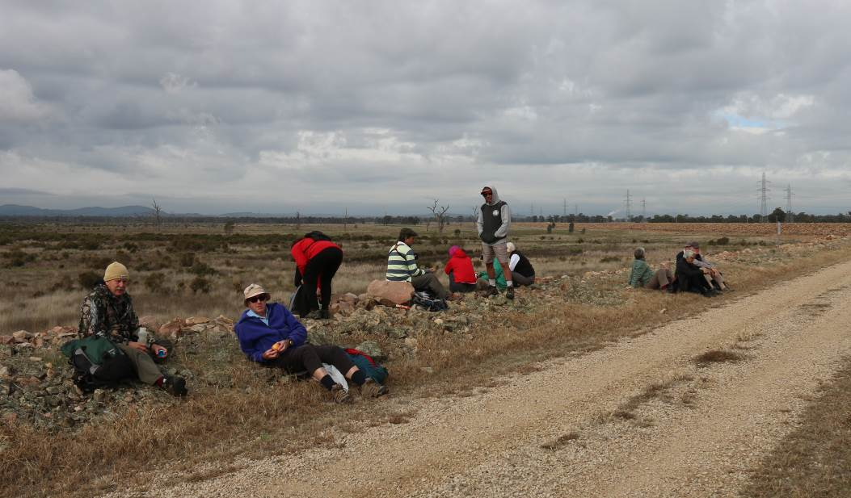
Before returning to Shepparton we all had a well-earned coffee at the Mokoan Hub Café which is a beautiful building with huge windows to enjoy the views of the wetlands. I would recommend the drive out there to enjoy lunch and a ramble or a bike ride.
Thank you Dianne for organising the walk; it was a very enjoyable day.
By Jan Gregory

Colca Canyon, Peru April 2016

Colca Canyon is the second deepest in the world (the deepest is NOT the Grand Canyon - it’s also in Peru). Karen and Richard Speedy spent three days and two nights walking in it.

Day 1: the day began very early with a 3am pick up from our hostel and a long drive to Chivay where we had breakfast. It was suggested we sleep - not easy to do with Peruvian pop belting out in the minibus. A stop at Cruz de Condor gave us a a brief glimpse of these huge endangered birds then on to Cabanaconde where we
met our guide, James, donned our packs and headed off on our trek. James was a wealth of knowledge on plants and animals and told us of the medicinal uses of plants by his people. We walked 11km and descended around 1100m, much of it on loose shale so keeping our footing demanded constant attention. This side of the canyon was very dry. We were very relived to reach Llahuar Lodge, our accommodation for the night at around 3pm. This small lodge had no electricity but had a wonderful thermal pool where we soaked away the grime and aches of the day.

Day 2: breakfast at 7am and on our way at 7.30. This was the 'easy' day! About 10km of what James called 'Peruvian flat' - in other words lots of up and down. We followed the rim of the canyon at times with spectacular views to the valley floor. We stopped in a village for a welcome drink - Colca sour is made with cactus fruit. We then began a steep descent to the floor of the canyon. Summer floods had washed away the bridge so we crossed on the makeshift one! We reached our accommodation at San Juan de Chuccho around 2pm, had lunch looking at our ascent for the next day then a thunderstorm hit. We were very glad not to be caught out in that!

Day 3: our last day began at 4am!! And we walked by torchlight. Our task was to ascend 1100m over 5km. In retrospect torchlight was brilliant - just one step at a time. No looking back to regret how little you had progressed and no looking ahead to feel overwhelmed at what was still to come! Light gradually dawned around 5.30am - we were walking along the edge of a valley filled with cloud and it had snowed overnight so the peaks were snow capped - it was spectacular! We arrived back in Cabanaconde around 7.30am and enjoyed breakfast before catching the bus back to Arequipa. Almost all the other hikers were in their twenties so we felt pretty proud of our effort to manage a very strenuous trek at high altitude.

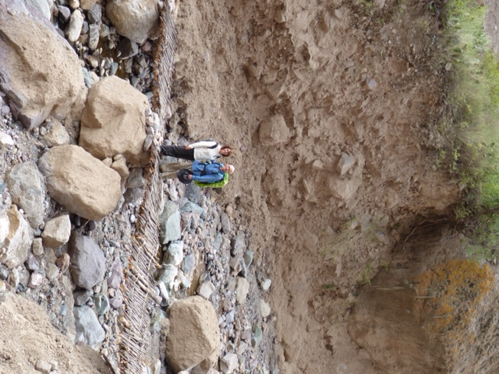
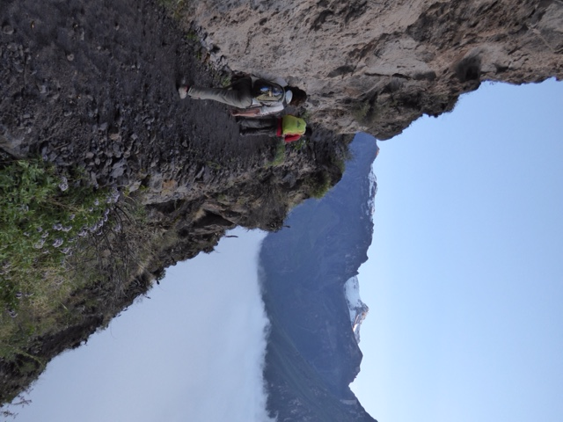
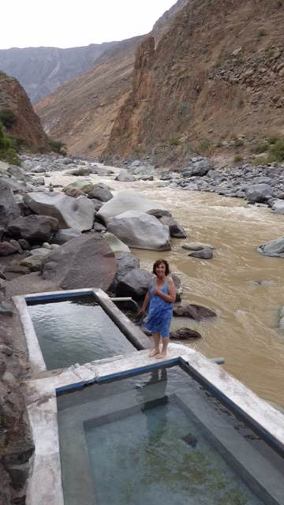

2016/2017 COMMITTEE ELECTIONS

New And Enthusiastic Volunteers Needed

Shepparton Adventure Club committee elections will be held during the Annual General Meeting at the Mechanics Institute, Wyndham St, Shepparton on Tuesday 23rd August 2016.

All positions will be declared vacant and new volunteers are eagerly sought. Please consider offering your services to keep our club going for the benefit of our members.

Elected positions are: President, Vice President, Secretary, Treasurer and up to 6 ordinary members consisting of Newsletter Editor, Equipment Officer, Publicity Officer, Mid-week Walk Co-ordinator, Calendar Co-ordinator and Web Master.

Our committee meetings are light hearted and good fun and believe it or not it makes for a good night out. Join the committee to find out why.

Nominations should be made on the form below and submitted to the committee at least 1 day before the AGM.



SHEPPARTON ADVENTURE CLUB COMMITTEE 2016/2017

NOMINATION FORM

I _______________________________________________________________________

wish to nominate ___________________________________________________________

for the position of ___________________________________________________________

for the 2016/2017 year.

I hereby accept the nomination (nominees signature) ……………………………………………

Signed by the Nominator ……………………………………………………………………………

MEMBERSHIP FORM
SHEPPARTON ADVENTURE CLUB Inc. A0002076S

Membership Fees for the 2016-17 year are due on 1st JULY 2016.
Please return this form with your payment to:
The Treasurer, Shepparton Adventure Club Inc. PO Box 264, Shepparton. Vic 3632

Please list name of each person and circle their age group (Insurance underwriting categories)

Name _________________________________________ U16 16-17 18-34 35-54 55-94 95+

Name __________________________________________ U16 16-17 18-34 35-54 55-94 95+

Name _________________________________________ U16 16-17 18-34 35-54 55-94 95+

Name _________________________________________ U16 16-17 18-34 35-54 55-94 95+

Name __________________________________________ U16 16-17 18-34 35-54 55-94 95+

Address: __________________________________________________________________

__________________________________________________________________

Phone: BH _____________________________ AH ________________________________

Mobile _______________________ Email Address: ___________________________________

Payment options (please circle):

1. Mail cheque or Money Order to PO Box 264, Shepparton 3632

2. Direct deposit to Bendigo Bank
BSB 633 000
Account No. 129 076 972
Please add your name as the reference and post the signed membership renewal form back.

Single Club Membership $35 ________

Family Club Membership $60 ________

Concession (Single Membership)* $30 ________

Concession (Family Membership)* $45 ________
*Concession applies to Pensioner/Senior/Student Cardholders

TOTAL $ _________

ACKNOWLEDGEMENT OF RISK - ALL Adults must sign
I acknowledge that when I am participating in any activity of the Shepparton Adventure Club Inc, I am doing so as a volunteer in all aspects and as such I accept all responsibility for loss of property or bodily injury to me however it may occur.
I acknowledge that my participation in this activity may expose me to hazards and risks that could lead to injury, illness or death or to loss of or damage to my property. In particular when participating in abseiling, caving or above the snowline activities I am aware that these activities expose me to additional hazards and risks.
I will make all reasonable effort to avoid or minimise these risks by :
- only participating in activities within my capabilities,
- carrying food, water and equipment appropriate for the activity, and
- advising the leader if I am taking any medication or have any physical or other limitation that might affect my participation in the activity.

I acknowledge that the payment of my (renewal) subscription will be deemed as full acceptance and understanding of the above.
I agree to be bound by the rules of the Shepparton Adventure Club Inc. (which are available from the secretary).

Signed ………………………………………………………………………… Date ………………………………

Signed ………………………………………………………………………… Date ………………………………

