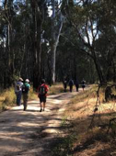

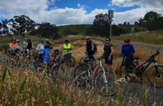

website: www.shepadventureclub.org.au

SHEPPARTON ADVENTURE CLUB inc. A0002706S

NEWSLETTER January - February 2024

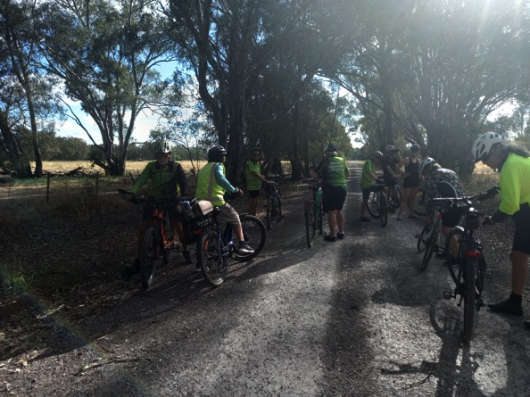

Late afternoon sunshine, December ride, Goorambat.

Members’ Meetings
Unfortunately our February SAC members’ dinner out at the Peppermill was cancelled due to the widespread power outage that followed the wild weather change.

So our next meeting will be on Tuesday April 9th. Watch out for the details in your emails.

The SHEPPARTON ADVENTURE CLUB Inc.

General Meeting: Usually 3rd Tuesday in February, April, June, August, October
Committee Meeting: Bi-Monthly at 7.30pm.
Correspondence to: The Secretary SAC, PO Box 264, Shepparton 3632
Email: sacvicau@yahoo.com.au

OFFICE BEARERS
President Greg Smith 0429045732 president@shepadventureclub.org.au

Vice President Bruce Gill 0409819704 tatgills@westnet.com.au
Secretary Jan Gregory 0438093668 jangregory4@outlook.com
Treasurer Scott Birchall 0548210604 scott@agsystems.com.au
(email distribution to members)

Equipment Officer Richard Graves 0408 547065 richsue@bigpond.au
Publicity/Newsletter Karen Speedy 0448046958 karenspeedy@iinet.net.au
Calendar Coordinator Philip Schultz 0448324792 harwinpark@gmail.com
Mid-week coordinator Dianne Hanna 0437 289 281 dhanna3@bigpond.com
Committee member Maartje Heuperman 0407849794 maartjeheup@bigpond.com

www.bushwalkingvictoria.org.au

PO Box 1007 Templestowe Vic. 3106
Phone: (03) 9846 1132
Email: admin@bushwalkingvictoria.org.au

Affiliated member

SAC MEMBERSHIP FEES (Due JULY 1 each year)

Adult Club Membership $40
Child Club Membership (0-18yrs) $10 (must be accompanied by parent/guardian)

Membership benefits
Your Bushwalking Vic membership card enables you to obtain discounts at a number of retailers including:
AJAYS Snow and Country Sports (Heathmont), Bogong Equipment (Melbourne), Fjall Raven (Melbourne Central), Paddy Pallin (Melbourne, Ringwood), Smitten Online Tasmania, Wilderness Shop (Box Hill), Woodslane Walking Guides, Eastern Mountain Centre (Deepdene), Discovery Holiday Parks (Cradle Mountain)

Full Moon 2024
24 Feb, 25 Mar, 24 Apr, 23 May, 22 Jun, 21 Jul, 20 Aug, 18 Sep, 17 Oct, 16 Nov, 15 Dec

President’s Piece - Greg

Hi members,
Even though I have been fairly active over the past few months, most it was water activities like snorkelling and body surfing so I was having trouble (as I often do) dreaming up some inspirational words for this latest newsletter. I then I thought, why not ask ChatGPT to write something for me? So here it is:

Dear Bushwalking [& cycling] Enthusiasts,
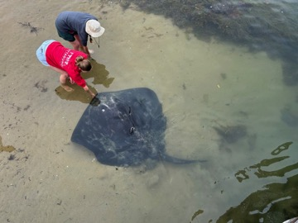
As we embark on another exciting year of exploration and adventure, I am filled with gratitude for each member of our vibrant community. Our passion for the great outdoors binds us together, driving us to seek new trails, conquer challenging terrains, and marvel at nature's wonders.
Let's continue to foster camaraderie, share knowledge, and inspire each other to embrace the beauty of our surroundings. Together, we'll traverse forests, scale mountains, and forge unforgettable memories.
Remember, safety is paramount. Stay equipped, heed weather warnings, and always leave no trace. Let's tread lightly, leaving only footprints and taking away cherished experiences.
Here's to another year of discovery and fulfilment on the trails!
What we did on our holiday: feeding stingrays at Inverloch
Warm regards,
Greg

PS. We are also looking for a new President to take over the reins from me later this year. You don’t have to be good at writing as I’ve just proved, just keen to keep the club going well. Plenty of support is provided by the committee.

Item for Sale

Katmandu men’s ankle high leather walking boots, with “Vibram” sole. Size UK11/EUR 45 $150.00.

Worn 4 times. In very good condition.

Purchase price $280.00. Current price for similar item $339.00

Phone Ted Mcintyre
0437956221
0458252923

Calendar of Activities Feb – June 2024

Date | Event | Activity | Leader | Rating
28th February  8 am | Walk | Ulupna Island/ Murray River | Ross and Judy  Taylor 0428 994654 | Easy
13th March  8.00am | AST Walk | Tom Collins Drive car park at the Southern end. | Di Hanna  0437289281 | Easy / brisk
16th March | Ride | Town and Country ride at Numurkah. | Graeme Betts  0458 216598 | Easy
18th - 22nd March | Camping, Walking  Riding | Harrietville camp  Mon – Fri, 3 days walking,  canoeing, bike riding, bird  watching, scenic driving etc. | Dianne Hanna  0437 289281 | Easy /  Mod
9th April | Club Meeting | SAC shed.  Vic Park Lake.  Time to be confirmed. | Jan Gregory  0438 093668
10th April  9.00am | AST Walk | Tom Collins Drive car park at the Southern end. | Di Hanna  0437289281 | Easy / brisk
21st April | Ride | Around Tungamah | Kerry Storer  0417115385 | Easy
24th April  9 am | Walk - Trek | Down Sevens Creek from Polly  McQuinns to Gooram Falls  Strathbogies | Dianne Hanna  0437 289281  Justus Hagan | Hard
8th May  9.00am | AST Walk | Tom Collins Drive car park at the Southern end. | Di Hanna  0437289281 | Easy / brisk
19th May | Ride | Avenel district | Maatje & Alfred 0407849794 | TBA
22nd May  9 am | Walk | Kinnaird’s Wetland and the Broken Creek Numurkah. | Valda and Richard  Dickins  0417 129 934 | Easy
11th June | Club Meeting | Venue TBC | Jan Gregory  0438 093668
12th June  9.00am | AST Walk | Tom Collins Drive car park at the Southern end. | Di Hanna  0437289281 | Easy / brisk
15th June | Ride | TBA | Geoff & Lyndall
26th June  9 am | Walk | Mt Samaria State Park | Karen and Richard  Speedy  0448 046 958 | Easy/Mod

PLEASE RING THE TRIP LEADER TO MAKE SURE IT IS WITHIN YOUR CAPABILITY AND CONFIRM THAT IT IS GOING AHEAD. REGISTRATION ALSO HELPS WITH PLANNING SUCH AS CAR POOLING NUMBERS.
You will see our activities are graded. Find out more information on the website activities page Activities - Shepparton Adventure Club (shepadventureclub.org.au).
Note: TRIP LEADERS – it is imperative for every trip that temporary members/visitors sign the “Acknowledgement of Risk Form”. These completed forms must be forwarded to the SAC Secretary for filing as soon as possible after the trip – otherwise, in the case of a claim, the insurer will not acknowledge the risk.
Form can be downloaded from www.bushwalkingvictoria.org.au under Members > Forms

Travel Cost Reimbursement
30 cents per km per car split between all trip participants (used when car pooling for Mid Week Walks.)

Change of Mid Week Walk and AST start time
During the months of Daylight Savings (October to April) the start time for Mid Week Walks and AST is 8.00am. This allows the majority of the walk time to occur in the cooler morning hours.

OTHER CLUBS’ ACTIVITIES
Nearby clubs share their newsletters with us and, as a member of SAC, you can attend their events (affiliated with BWV.)

Check out these clubs. You might be tempted by one of the events of offer.
Warby Ranges Bushwalkers Inc – warbybushwalkers.org.au
Bendigo Bushwalking and Outdoor Club - www.gobush.org.au/
Echuca-Moama Bushwalkers - www.echucamoamabushwalkers.org.au
and more can be found at www.bushwalkingvictoria.org.au

Meet your Committee Members

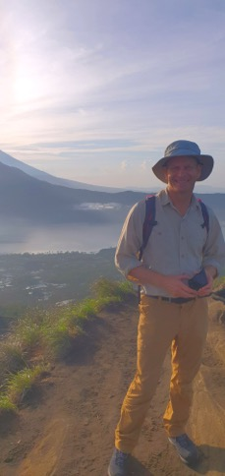
This time you get to meet our amazing Treasurer, Scott Birchall. He is a quiet achiever and we send him truckloads of gold stars as thanks for all he does for SAC

Tell us a bit about yourself
I grew up on a grain & beef farm near Tamworth in NSW before moving to QLD for undergrad (Toowoomba) and Master’s studies (Brisbane). Now I’m a consulting agricultural engineer and am fortunate to be able to work for myself from home – that’s why you get a lot of emails from me at AgSystems! Much of my work time is spent designing systems to manage wastewater from dairies and other livestock facilities, or training others to do so. In another life I might be a builder as my wife and I have owner-built two houses, unable to ignore the appeal of building an efficient, comfortable home. Tracy and I have 3 children; Wil, Jenna & Asha with Wil having just finished Yr 12 at GVGS last year.

What are your outdoor interests?
Cycling and kayaking. BC (before children) I enjoyed the Great Qld, NSW and Tas bike rides when they were held but I still haven’t done a Great Vic ride. My longest ride was a 2 week loop around Tassie. Most memorable was a week-long fund-raising ride for the Royal Flying Doctors Service around Broken Hill and White Cliffs in western NSW complete with broken rims and exhaustion, joy flights with daredevil pilots and campfire dinners at night.

How did you become involved with SAC?
I moved to Shepparton in 2001 after working in North Dakota for 3 years. While ND has a cold climate, it doesn’t have any significant mountains so cross-country skiing became one of my favourite ways to explore. As I’d moved here in the late autumn, my first SAC trip was a cross-country skiing weekend at Bright and Falls Creek. I met my lovely bride as a result of that trip; one of the other trip participants hosted a follow-up dinner party and invited her friend Tracy so thanks partly to SAC, we both put down roots in Shepp.

Tell us something that others might be surprised to know about you
I believe that I am correct in claiming that we’ve owner-built the first Passive House in Shepparton (& the GV). ‘Passive House’, or Passivhaus as it is known in it’s originating Germany, is a design standard that achieves thermal comfort with minimal heating and cooling by using super-insulation, airtightness, high performance windows and doors, a ventilation system with air filtration and heat recovery, and elimination of thermal bridges. It definitely works; our house rarely drops below 20ºC in winter or strays above 25 ºC in summer and our power bill over the last 12 months was just $200. A very useful adaption to our increasingly challenging climate.

Wonderful Wildlife with Marg

The Dollarbird
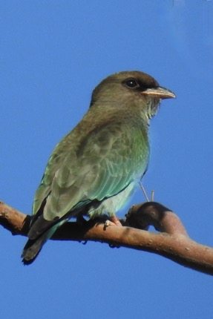
Dollarbirds are seen in the Goulburn Valley area between September and April. They fly from Indonesia and New Guinea for breeding and nest in tree hollows, usually near water. They are a stocky bird and mainly bluish green with a dark brown head and red beak.

They are called Dollarbirds because of large pale coloured spots, that resemble silver dollars, seen under the wings when in flight. They are mainly seen perched on high tree branches or in flight while looking for their prey of flying insects.They have a noisy grating call.

The bird pictured here with a dark beak is a juvenile, the other with the red beak an adult.

We always appreciate Marg’s knowledge of birdlife on SAC walks and thank her for sharing her excellent photographs and information about a particular bird in our Newsletters.
Thanks Marg

Trip Reports

AST December 14: by Dianne

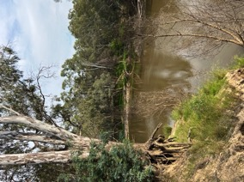
Six walkers, including a new member, had a most enjoyable 8 km walk on Yorta Yorta land in the Shepparton Regional Park bushland. The early 8 am start, plus the protection from the cloud cover and the tree canopy, meant we returned before the forecast heat and the hot north wind really set in.

This month we focused on the west side of the Goulburn River, heading downstream from our shed. We went under the Midland Highway and followed a narrow but very well-defined dirt bike track which meandered about, up and down, roughly following the river. We reached the point where the rock weir across the Goulburn River means the river flows both around Jordan’s Bend and straight ahead on the human made cut through.

On the way back we took the more direct route along the vehicular track to the Highway and then along the Mooroopna side the river, across the swing bridge and onto SAM for a very welcome hot or iced coffee. Once again it was a new area as

none of the group had been along these particular paths, north of the Highway. General consensus was that we could have been anywhere out in the bush yet in reality so close to the centre of town.

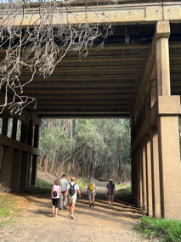
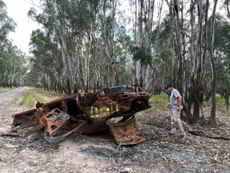

Len doing some detective work.

Heading under the bridge

Bike Ride December 16: Goorambat Loop by Jan

The final SAC ride for 2023 was held on Saturday 16 December. Seventeen riders met at Goorambat near the hotel ready to ride at 4.00pm. The ride meandered through the hills behind Devenish. These roads are usually very quiet but as it was harvest time we did encounter some wheat trucks.
We came back to Goorambat via the Devenish Goorambat Road before heading west. There was a little bit of excitement as there was a tree across the road. It was easy for the ordinary bikes to be carried over the tree and the e-bike riders bush bashed to find a track to negotiate the area. Then it was plain sailing into Goorambat.
Dianne joined us for dinner at the hotel and the bike rides for 2024 were discussed and a plan was established. It was a great way to finish of the year.

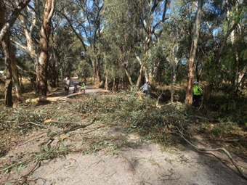
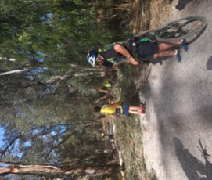

Around Shepparton Trails January 10: by Karen

Our unusual summer weather caused some challenges for the January AST. Brendan stepped up to lead this walk and, as all leaders do, he checked out the walk options the day before. We were expecting mild to moderate flood levels on the Goulburn River at this time but the trails were clear of water on the Tuesday.

Six keen walkers assembled at the SAC shed and we were pleased to meet Maureen, who has since become a SAC member. We didn’t get far along the walk before we encountered water over the path. The river had risen significantly overnight!

Not to be put off we changed direction and followed the railway line to re-join the trail near the rail bridge, crossing the bridge over the Broken River into the Botanic Gardens. The gardens also had water impacting its pathways so we walked as far as we could around the perimeter before retracing our steps, for a total of around 6km. SAM café provided a lovely venue for the past-walk coffee and chat.

Mid Week Walk January 24: Broken Creek, Nathalia by Karen

Eleven walkers joined the January Mid Week Walk. The weather definitely had an impact on this walk as the location had to be changed from the Mooroopna Common to the Broken Creek at Nathalia due to the recent flooding on the Goulburn River. We checked out the new location the week before and decided this was a good alternative with the option to shorten the distance if it became too hot. The day of the walk had threatened to be a scorcher but cloud cover, and even a sprinkle of rain, kept the morning temperature to a manageable 30 degrees.

Six walkers travelled from Shepparton and another five met us in the Weir St park. After a quick morning tea break, we travelled out to James’ Bridge Reserve along the Shepparton – Barmah Road. We left the cars there to head off on a 10km “out and back” walk along the Broken Creek. The track was on a flat gravel road and we enjoyed the majestic gums, some birdlife and interesting conversation as we walked along. The creek was running high and two rustic foot bridge, a weir and some historic buildings provided additional points of interest.

The early start saw us back to the cars by 12 and we returned to Nathalia for a picnic lunch in the park followed by a coffee or cold drink at the bakery. The 8.00am start was definitely a winner as the walk was completed before the heat of the afternoon set in.
Photos:
1. the walkers striding out
2. rustic footbridge
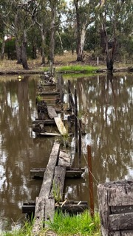

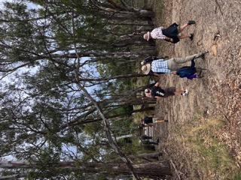

Bike Ride January 16: Stanhope to Girgarre Return by Jan

The first ride for 2024 was a very easy ride from Girgarre to Stanhope return. We met in the carpark of Gargarro Botanic Garden Café and set off on a very easy ride on the pretty flat rail trail with a total of 12km. We arrived at Stanhope and perused the market. A few bargains were made and it was interesting to see people carry their purchases on their bikes.

We then rode back to Girgarre and had breakfast at the Gargarro Café where Maarjte and Alfred’s daughter and her two children joined us. After breakfast many people took up the option of wandering around the Girgarre market. It was a fun morning and a great way to start the new year of riding.
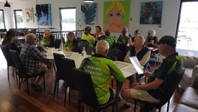
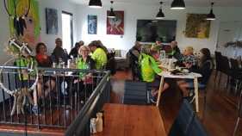
Photos of the hungry riders at the café for brunch after the ride.

Members’ Meanderings
Great (Wet) Victorian Bike Ride by Lyndall
Saturday 25 November to Sunday 3rd December saw 6 SAC members ride some or all of the 540km from Orbost to Wonthaggi via Buchan, Lakes Entrance, Paynesville, Sale, Yarram,/Port Albert & Fish Creek.
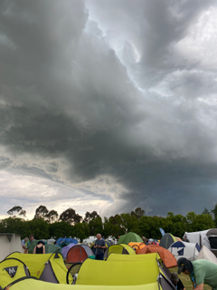
It’s said the indigenous peoples of far north Canada have over 50 different words to describe snow. You might think that the riders on the 2023 GVBR may have developed a similar nuanced vocabulary to describe the unrelenting precipitation eg easing, steady, drizzling, torrential. But no, in fact the opposite happened and only two four letter words were required. “M.O.R.E.” and “R.A.I.N.” Yep, ‘more rain’ was all that could be said. How stoic of them to put on wet gear, ride in wet gear, eat in wet gear and sleep in, well, pretty much wet gear. Add to that not knowing if the camp site will be flooded or the route changed - it’s all part of the challenge of being part of a huge event - going with the flow! (Pun intended!)

Marty, Wendy, Geoff and Genevieve enjoyed sunshine on Day 1 and Day 9 with rain in all its shapes and forms filling in most of the other days. Fiona and Richard signed up to the 3 day section from Sale to Wonthaggi - managing to snag the only 100+km day as their ‘Day 1 of riding’. The towns and communities turned on great displays and events, running shuttle buses to help the riders get around the various sites and venues. “The scenery and route was awesome”.

Some anecdotes from our resilient members:
- “Waiting in the rain in the shower queue, then walking back to a wet tent in the rain” - Wendy
- “The 100km from Sale to Yarram was much harder than the 100km event around Shepparton in the Tatura 200 last week - hills, wind and rain. We’re glad we were only doing 3 days, 8 days of rain would have been too much!” Fiona
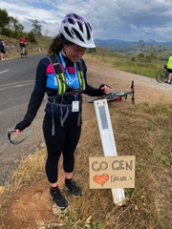
- “It pays to do some training in wet weather - you never know where/what will chafe - and pack some nappy rash cream, just in case”. Anonymous
Genevieve’s flat mate, whose parents farm in the area, got her dad to whip up this sign to give Gen a boost on the ride up, up , up to Buchan. Never ever underestimate the powers of texta and cardboard to brighten someone’s day!

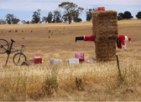

Locals join in the fun!

Out and About with SAC

The awards presented at the Christmas gathering were very thoughtful and entertaining so, if you missed the night, here are two of the awards for you to enjoy. Thanks Dianne for the time and effort that went into creating these awards, using a sports club approach.

The SAC Best First Year player …. There were 7 new midweek walkers this year, all eligible for this award. A strong field of contenders.
However, the adjudicators felt there was a standout winner of the Best First Year player ward. Since joining the club this person, despite missing the November walk, had an otherwise perfect 100% participation for every walk and camp, and in addition, he lead the AST Sept walk and has volunteered to lead a 2024 mid week walk …. So of course, The 2023 SAC Best First Year Player Award, for putting in 100% effort with enthusiasm and passion in his first year, is Brendan Espagne.
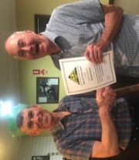
These awards are meant to be just a bit of fun but there is one very serious award which is the pinnacle of all the awards and that is The Best and Fairest award.
What qualities were the adjudicators looking for in giving this award? Someone held in high regard, who has made an enormous contribution to the club over many years, who has held office for years and been on the Committee for ever, who willingly and constantly puts his hand up and does hours of work behind the scenes fixing, organizing, and resolving problems, but who also leads from the front and uses his great organizational skills to plan and run activities and camps. Someone who is simply the best and the fairest.
There are not many people who have all those qualities, but the SAC is indeed very lucky to have one such person. The winner of The 2023 SAC Best and Fairest award, for his enormous contribution to the club over decades as a leader, facilitator, planner, fixer, club historian and all round good bloke, is Richard Graves.

