
If undelivered, please return to PO Box 264, Shepparton 3632

SHEPPARTON ADVENTURE CLUB inc. A0002706S
NEWSLETTER January - February 2018

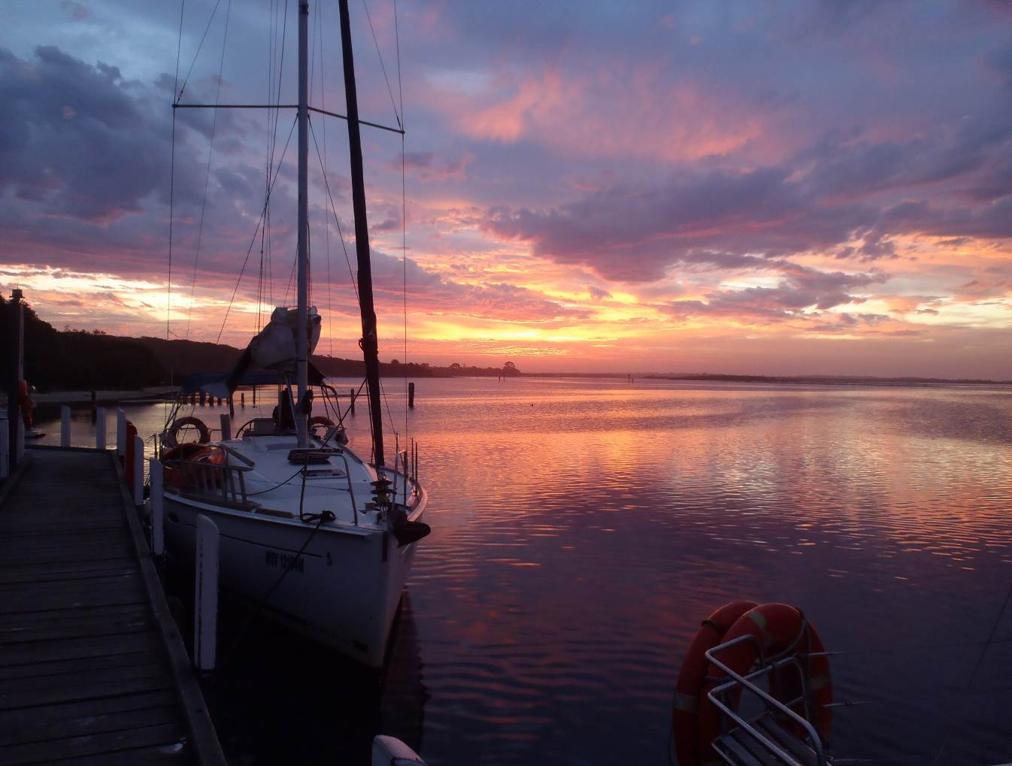

(Thanks to Bruce)

Next club meeting: Tuesday 27th February 2018
6.00pm Club Sheds Victoria Lake, Wyndham St, Shepparton.
BYO Food, drinks, chairs, insect repellant

Full Moon 2018:
2nd March, 16th April, 15th May, 14th June, 13th July, 11th August, 10th September, 9th October, 8th November, 7th December
(Courtesy of Calendar-Australia.com)

President’s Piece

While I have to admit that I'm not the most regular of participants in SAC activities and I sometimes wonder why I am a SAC member, I then remember all the activities over the years that I have been on, and I love the thought that I'll be able to go on some more in the future. Even if the priorities and pressures I have on me in the short term always seem to trump my participation in many SAC outings, I hope that one day, I'll have a lot less pressing matters to attend to, so then I'll be able head off into the outdoors on a more regular basis.....

Speaking of heading out, Susanne and I did manage to get out into the great Victorian outdoors for a week in January. Combining a small taste of alpine scenery with a road-trip over the Mt Hotham road (and a taste of the highest altitude beer in Australia from the Blizzard Brewing company at Dinner Plain), we passed through Omeo and Bruthen to get to Metung, where we had hired a small yacht for a week. While we had in the past been through Bairnsdale and Sale and even stayed at Lakes Entrance a couple of times, we'd never actually seen much of the Gippsland lakes, let alone boated on them, so we were keen to see them for ourselves.

Taking advice from Greg and Jill about where to head, we provisioned the boat and with the assistance of our cabin boy Rodney, set sail for places called Duck arm, Sperm Whale Head, Barrier landing, Bunga Arm and Ocean Grange, to name a few. With only one minor docking incident and one grounding, it was mostly a very relaxing way to spend a week, and we recommend having a canoe with you to explore once you've moored for the night. Ninety Mile Beach is spectacular, but does looks pretty much the same wherever you come out onto it, and if you want to see black swans and pelicans, they love living in the lakes in their tens of thousands. One highlight was watching some small bats flying around under the trees one evening while some kookaburras laughing, and having some of the unique lakes dolphin swimming only a few metres from our boat was magic. Another highlight was meeting and chatting with some of the other boaties on the lake, except for the 'Admiral', who was a bit of a dick.

Anyway, a week of holiday is soon over, and so the first one-sixth of 2018 will also be over by the time you read this. I hope 2018 is treating all SAC members very well so far, with not too many outrageous new years resolutions having been made and broken, and I definitely hope that I can catch up with as many of you as possible on some activities throughout this year.

Cheers,
Bruce

Calendar of Activities 2017

Date | Activity | Location | Leader | Distance/Rating
Wednesday  28th February | Walk | Note 8am start Dookie College area and will involve walks in two different locations, followed by coffee at Tallis Wine. The first walk will be approximately 3 km, an easy walk through the Bushland Reserve at Dookie College. The second, shorter walk will be the Rock Correa walk at Tallis wine which is a steep, short walk up Gentle Annie.  If walkers could meet at the usual spot in Shepparton opposite the library at 8am and travel out to Dookie College, we will meet you where you turn into North Drive at 8.30am. North Drive is the second entrance to the College campus when you travel from the Midland Highway. The temperature is expected to reach 36 on this day so the early start and delayed coffee break should enable us to enjoy a walk before it gets too hot. Don’t forget the sunscreen and plenty of water. | Richard/Valda Dickens  0427 285266 | Easy / Medium
Saturday 17th Sunday 18th March | Ride | Wodonga to Tallangatta | Jan 0438 093668  Ray 0438 591749 | tbc
Wednesday 21st March  (3rd Wed. to avoid Easter) | Walk | Ruffy area with Justus Hagan  Possibly Terip Terip Forest/Gobur Flora Reserve  (subject to fire restriction) | Howard Hanna  0437 628279 | Medium
Monday 16th – Friday 20th  April | Ride/ Walk | East Gippsland Rail Trail Bairnsdale to Orbost. Opportunity for bike rides or day walks for those not riding. Camping at a central position halfway along the trail. Details to be formalized in the New Year. Please call Richard to express interest or book your spot. | Richard Graves  0408 547 065 | Walks – easy/ medium  Rides - Forest/wilderness sections
Tuesday 24th April | Club & Committee Meeting | Shepparton Access room,  Mechanics Institute, Wyndham St. |  | Committee meeting prior
Wednesday 25th April | Walk | Anzac day. Will only go ahead if enough people express interest | TBA | tbc
Saturday -Sunday 28-29th April | Walk  Overnight | Lake Cobbler and Mt Cobber via Muesli Spur.  Plan: Drive from Shepparton leaving early Saturday morning. Meet in Mansfield with plan to leave by 8:30am.  The walk is a loop from King Hut, approached by the Mt Stirling circuit Road.  Up Muesli Spur, including some easy scrambling. Hit the road, then to Lake Cobbler to camp, swim and explore the waterfalls. About 10km in all to reach camp.  Sunday return with a side trip to Mt Cobbler before meeting the road. The rest of the return walk is a straightforward descent down the Speculation Road. | Neville  5831 1576  (nevillepaynter1@bigpond.com) | Medium – Pack carrying
Saturday 19th – Sunday 20th  (optional Monday 21st)  May | Ride | Newtown to Queenscliff on the Bellarine Rail Trail - approx. 40km one way. There is less than 1km on the road and the rest of the ride will be on a bike path following the Barwon River and then the Bellarine Rail trail. Stay overnight in Queenscliff.  On Sunday, there will be two options to chose from:  1. Catch the ferry to Sorrento to explore this area on our bikes for the day before heading back to Queenscliff to stay overnight. Ride back to Newtown on Monday morning via the Bellarine Rail Trail;  2. Those needing to return home on Sunday will ride back to Newtown via the Bellarine Rail Trail.  Free accomodation will be available in Newtown prior to the ride on Friday May 18th. For further information, contact Barb on 0408299497 | Barb  0408 299 497
Wednesday 23rd May | walk | Loch Garry | TBA | Easy
Tuesday 19th June | Committee meeting | TBC
Tuesday 26th June | Club Meeting | Shepparton Access rm.  Mechanics Institute, Wyndham St.
June | ride | TBA | TBA | TBA
Wednesday 27th June | walk | Ulupna Island | TBA | Easy
July | ride | TBA | TBA | TBA
Wednesday 25th July | walk | Thompson Bend Nth. Mooroopna | TBA | Easy
Saturday 18th August | ride | Yea to Tallarook | Ray  0438 591 749 | Easy family ride
Wednesday 22nd August | walk | Warbie Ranges | TBA | Easy/ Medium
Tuesday 21st August | Committee meeting | TBC
Tuesday 28th August | Annual General Meeting | Shepparton Access Rm.  Mechanics Institute, Wyndham St.
Saturday 15th September | ride | Glenrowan – winery bike road  Further information to follow | TBA | Fun
Wednesday 26th September | walk | Rocky Ned. Strathbogies | Richard Graves  0408 547 065 | TBA
Wednesday 10th October | walk | Whroo Forest Area – Mt. Black | Barb Brown  0409 178 091 | TBA
Tuesday 16th October | Committee meeting | TBC
Saturday 20th – Sunday 21st October | ride | Warburton Rail Trail  Further information to follow | TBA | TBA
Tuesday 23rd October | Club Meeting | Shepparton Access rm.  Mechanics Institute, Wyndham St.
Wednesday 24th October | Walk | Garden Reserve Mt. Wonbal area with Justus Hagen | Howard Hanna  0437 628 279 | TBA
November | ride | TBA
Wednesday 28th Nov. | walk | Seven Creeks Gorge from Gorram Falls to Polly MCQuinns | Jan Gregory  0438 093 668 | medium
Note: All riders to confirm attendance with event leaders prior to event.

Walksafe
TRIP LEADER PREPARATION LIST
Reconnoitre the activity
Seek assistance to run the activity if required
Assess participants' suitability for the activity eg. Fitness, skill, health

Essentials to take
- Trip Plan
- Maps
- Compass
- GPS
- Phone
- First Aid Kit

At the start of the activity
- Communicate the trip plan to the participants
- Communicate any safety or risky aspects of the activity to promote awareness
- Check participants for gear, food & water required for the activity
- Check participants for any medical issues (maintaining privacy)
- Note the number of participants
- Ensure one other participant has a map, compass and trip plan
- Take a GPS reading of the starting point of the activity
- Take a GPS reading of where the cars are parked.
- Designate one person to be whip


www.bushwalkingvictoria.org.au
PO Box 1007 Templestowe Vic. 3106
Phone: (03) 8846 4131
Fax: (03) 9846 7473 admin@bushwalkingvictoria.org.au

Newsletters follow the link below
Find them here: http://www.bushwalkingvictoria.org.au/what-we-do/publications/newsletters

- SAC is an affiliated member of Bushwalking Victoria
- Membership benefits
- Membership of Shepparton Adventure Club includes Bushwalking Victoria membership. Your Bushwalking Vic membership card enables you to obtain discounts at a number of retailers including Ajays (Heathmont), Bogong Equipment (Melb.), EMC (Deepdene), Melb Map Centre (Malvern East), The Wilderness Shop (Box Hill), Paddy Pallin, Smitten merino wear Tasmania, Woodslane Walking Guides.
- 5% on Outdoor Travel tours and all reservations made directly with the office at Bright. Check out their website or join their email newsletter list for tours and current deals: www.outdoortravel.com.au, 1800 331 582 info@outdoortravel.com.au
- Discovery Holiday Parks, Cradle Mountain 20% discount off shoulder and low season rates (16 April - 2 December)
- Contact Claire on 03 6492 1289, 1800 068 574 www.discoveryholidayparks.com.au

- Note: TRIP LEADERS – it is imperative for every trip that temporary members/visitors sign the “Acknowledgement of Risk Form”. These completed forms must be forwarded to the SAC Secretary for filing as soon as possible after the trip – otherwise, in the case of a claim, the insurer will not acknowledge the risk.
- Form can be downloaded from www.bushwalkingvictoria.org.au , under Members > Forms

- Emergency Contact Procedures
- All enquiries about the return of participants from club activities should first be directed to the activity leader, and then to the Emergency Contact Person (ECP) for the activity if the leader cannot be found.
- It is the activity leader's responsibility to organise an ECP and advise him/her (in writing) of trip & participant details and what to do if contact is not made by the nominated time.
- Travel Cost Reimbursement
- Option 1: Preferred. Fuel Cost per car plus 5 cents per km per car to be split equally between the numbers of people in the car including the driver. If appropriate, the cost of running all vehicles should be shared equally amongst all trip participants.
- Option 2: 25 cents per km per car split between all trip participants.

- Summary of Public Liability insurance coverage at 5-3-2014 (from www.bushwalkingaustralia.org.au )
- Bushwalking, Track/Hut Construction and Maintenance, Caving, Canyoning, Liloing, Abseiling, Alpine Walking (Summer and Winter),Snow Skiing, Canoeing, Kayaking, Boating, Rafting, Swimming, Cycling, Rock Scurrying and use of hand held ropes as part of a Bushwalk, Orienteering, Rogaining, Leader Training and other related instructions.
- Activities NOT COVERED include Rock Climbing, Water Skiing, overseas trips (except NZ) and any activities not listed above.

Trip Reports

24th January 2018 – Gemmill Swamp Conservation Reserve Mooroopna –Mid Week Walk

On Wednesday the 24th of January ten Midweek Walkers enjoyed a walk in the Gemmill Swamp Conservation Reserve.
The meeting place was at the Scout Hall carpark at 8am which worked well as we finished the approximately 7 kilometre walk before it became hot.
We circumnavigated the swamp detouring off the main track along the way to view the Goulburn River quite wide at that point. The height of the water in the swamp was near capacity and we stopped at one vantage point and observed some waterbirds. As we walked through the Red Gum forest, thankful for the shade the trees provided, we enjoyed the calls of a number of bush birds. Apparently there are an average of 140 species of birds observed annually which includes summer and winter migrants. A few kangaroos were also seen along the way.
It was a lovely area to walk through, disappointing though to see some loads of rubbish that had been dumped beside the track, good to hear that a group of locals had been collecting general rubbish a few days prior to our walk.
At the end of our walk we enjoyed morning tea and a chat at a cafe in Mooroopna.

Marg Clarke, walk leader for the day.

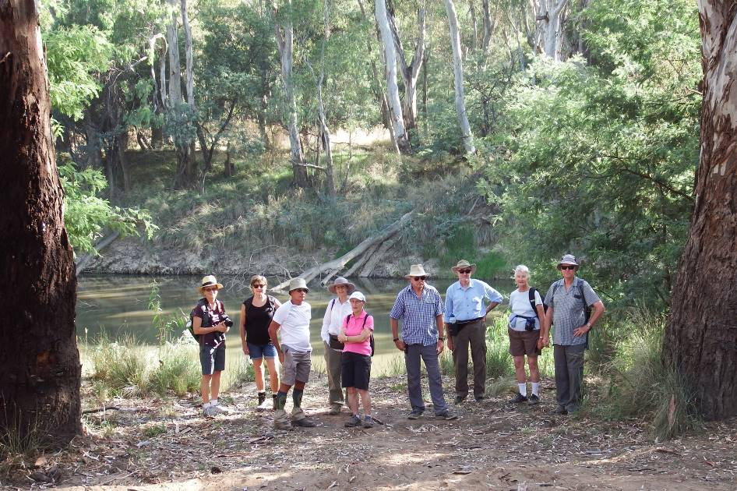

(Thanks Marg)

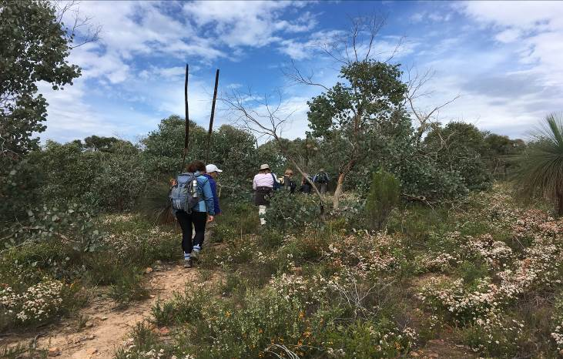
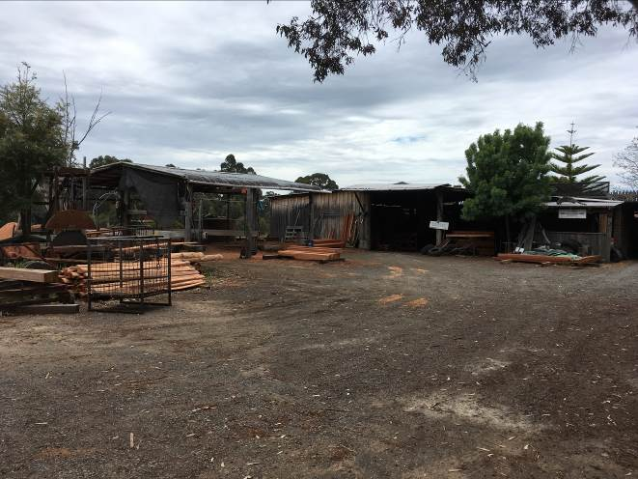
(Guess where & when)

Thinking of adding a “Buy and Sell” section, what do members think?

Thanks to all newsletter contributors for their articles and great photos.

Our newsletter printing is kindly sponsored by Hon. Wendy Lovell, MLC for Northern Victoria Region
Wyndham Street, Shepparton
The next newsletter will be out in April/May, but feel free to submit items at any time.

- The SHEPPARTON ADVENTURE CLUB Inc.
- General Meeting: 4th Tuesday of the months: February, April, June, August, October
- usually at: 7:30 pm at the Mechanics Institute, Wyndham St, Shepparton.

- Correspondence to: The Secretary SAC, PO Box 264, Shepparton 3632
- Email: sacvicau@yahoo.com.au

- OFFICE BEARERS
- President Bruce Gill 5824 2548 tatgills@westnet.com.au
- Vice President Karen Speedy 5825 1785 karenspeedy@iinet.net.au
- Secretary Howard Hanna 5828 9281 howard_hanna@yahoo.com
- Treasurer Scott Birchall 5831 6063 scottbirchall@aapt.net.au
- (for email distribution to members)
- Newsletter Editor Steve Jeffs 0402368751 stevesbluebmw@outlook.com
- Equipment Officer Richard Graves 5824 2929 richsue@bigpond.com
- Publicity Officer Rach Keen 0400 238276 rach_elkeen@hotmail.com
- Calendar coordinator Neville Paynter 5831 1576 Neville.Paynter@jacobs.com
- Mid-week coordinator Dianne Hanna 0437 289 281 dhanna3@bigpond.com
- Web Master Greg Smith 5824 1143 greg.smith@gmwater.com.au
- Facebook Richard Speedy 5825 1785

OTHER CLUBS’ ACTIVITIES
Benalla Bushwalking Club http://benallabushwalkingclub.org.au/
Border Bushwalking Club (Albury & Wodonga) - www.borderbushwalkingclub.com.au
Wangaratta Out and About Club - www.wangarattaoutandabout.org.au/
Bendigo Bushwalking and Outdoor Club - www.gobush.org.au/
Echuca-Moama Bushwalkers - www.echucamoamabushwalkers.org.au
and more can be found at www.bushwalkingvictoria.org.au.

