

**SAC Newsletter**

**February – March 2022** [www.shepadventureclub.org.au](http://www.shepadventureclub.org.au/)

**Ride From Costerfield to Heathcote Return - Saturday 19 February**

The ride was well attended with eighteen riders participating on the day. We started at the Costerfield Hall. We rode past an old church and an old miner’s hut before turning north along the Costerfield Redcastle Road. We continued to Old Coach Road where there were some steep and stony areas which everyone handled very well. The track continued to Pavey Road which was quite hilly and then onto bitumen at Plantation Road and then the Costerfield Heathcote Rd into Heathcote. Everyone was pleased to have arrived ready for lunch. There were a lot of options for lunch, and we reconvened at 2.00pm for the ride back to Costerfield. The route this time was much easier with a lot of downhill sections which were welcome as it was beginning to warm up. We rode a total or 40km and everyone seemed to enjoy the ride. Thank you to Phillip for recording ride on Relive which you can view via this link  <https://www.relive.cc/view/vwq1knj1oLO> 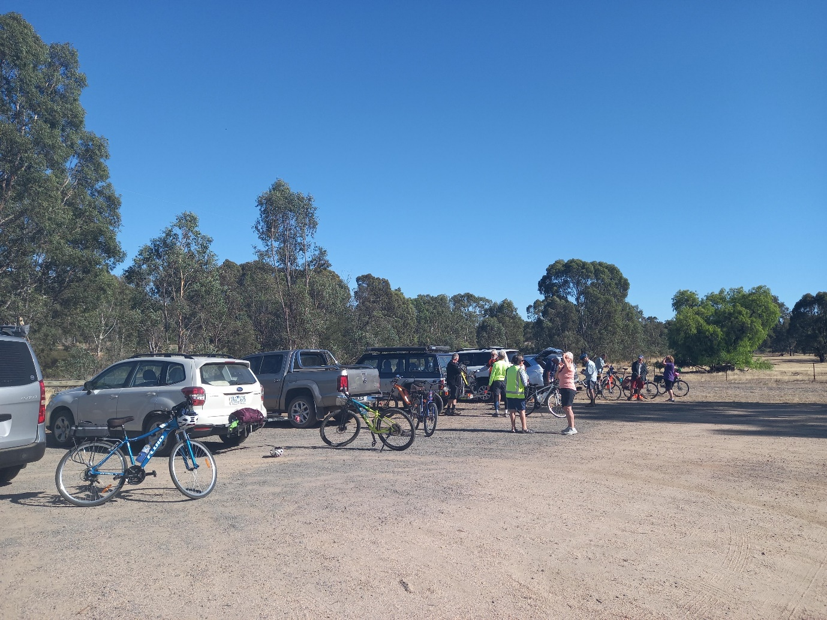

Getting ready for the ride at Costerfield.

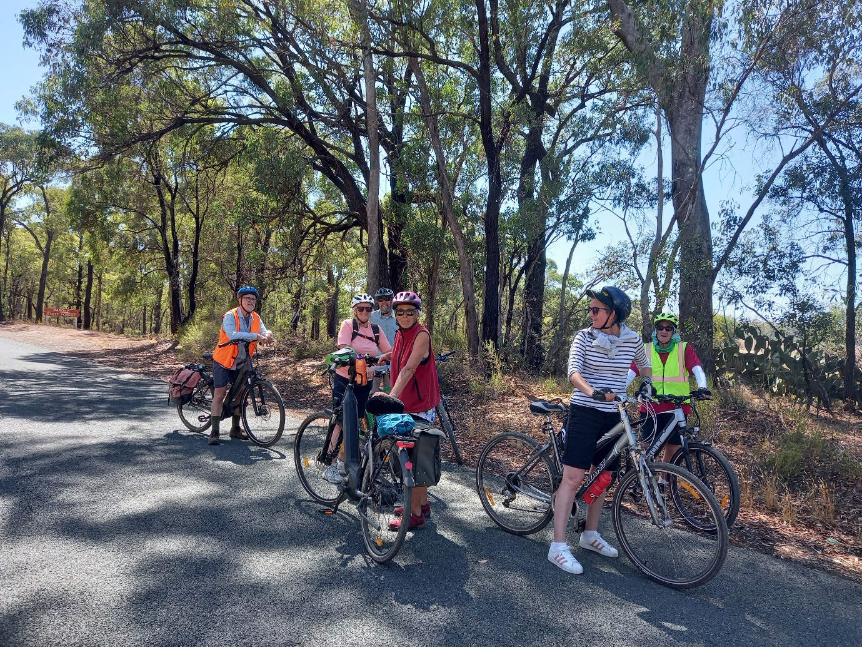

A bit of a rest in the shade.

**Midweek Walk at Katamatite – Feb 2022**

A hardy band of 6 undertook the midweek walk starting at Katamatite.  We followed the winding footpath along the Broken Creek's edge to the confluence with Boosey Creek where we stopped for morning tea. We continued on sighting different groups of ducks and other wild life including 3 hares and 1 wild cat.

We decided as the temperature rose to stop at the entrance to the Hodge's farm, a local farmer. We decided to turn back and ate our lunch in the shade on the banks of the creek.

As time was of the essence we chose to walk along the road (much shorter).  We came upon a "squabble'' of birds (as Marg Clarke explained) high up in the trees and watched them fly and squawk.  We concluded the walk through the historical Police Paddock,  past the History museum and the shed of old machinery including the restored cart that E W Kilgour who established a grocery and general store in Katamatite in 1933.  Over time he loaded his cart and travelled to his customers - a service appreciated by the farming community.

We finished with welcome drinks at the Boosey Cafe and then home.

Report by Barb Brown, photo by Marg Clarke

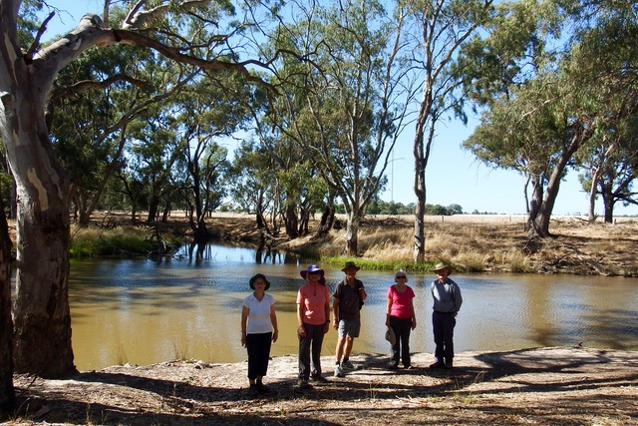

*Congratulations to Rosalie, completing her 250th Park run last month!!!*

**Vale Alex Chandler, founder of SAC**

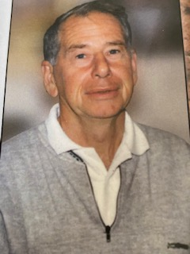

*Without Alex the SAC would not exist.  
  
Alex and his brother, Len, owned a shop in High St for a number of years "Chandler’s Hobbies and Toys". I remember it as a magical  place with rear winding stairs up to a sprawling mass of delights for a 10-12 year old boy with boats/planes and outdoor stuff around every corner.  
  
It wasn’t long before I was invited along on an outdoor trip with other boys.  
The group was just boys (apologies) with similar interests and we learned the skills of  bushwalking, orienteering, cross country skiing, rock climbing and  kayaking. Certainly different to footy, cricket or tennis that most boys of our age were playing at the time.  
  
We soon needed a larger place to store all the equipment that was needed  for these outdoor activities. I am sure that there’s a large group of people in the Shepparton community who still remember all the bottle drives and fund raising that ensued to enable us to buy the old Orange Lodge hall in Ashendon St and to form the Shepparton Adventure Club. My father even donated a caravan that was raffled to raise funds. We also applied for many funding grants. This was the basis on which the club was formed and it gave it the structure and strong financial footing that it has today.  
  
I will always remember early starts to travel to some adventure in Alex's old kombi van. It was a life changing experience for me.  
  
Alex was a kind and generous gentleman. by Craig Taylor*

**The importance of wearing a bike helmet!**

While we understand it is compulsory to wear helmets while on a SAC ride, it is just as important to wear the helmet even if just heading to the store!

Recently Ray was confronted with a small runaway dog with no notice, hence he rode over it and his bike landing head first onto the pathway, then rolling on to his face.

The impact was so strong that the helmet was cracked in several places and below you can see the impact on his face with his glasses smashed.

After spending 2 days in hospital, Ray was released with a full bill of health.

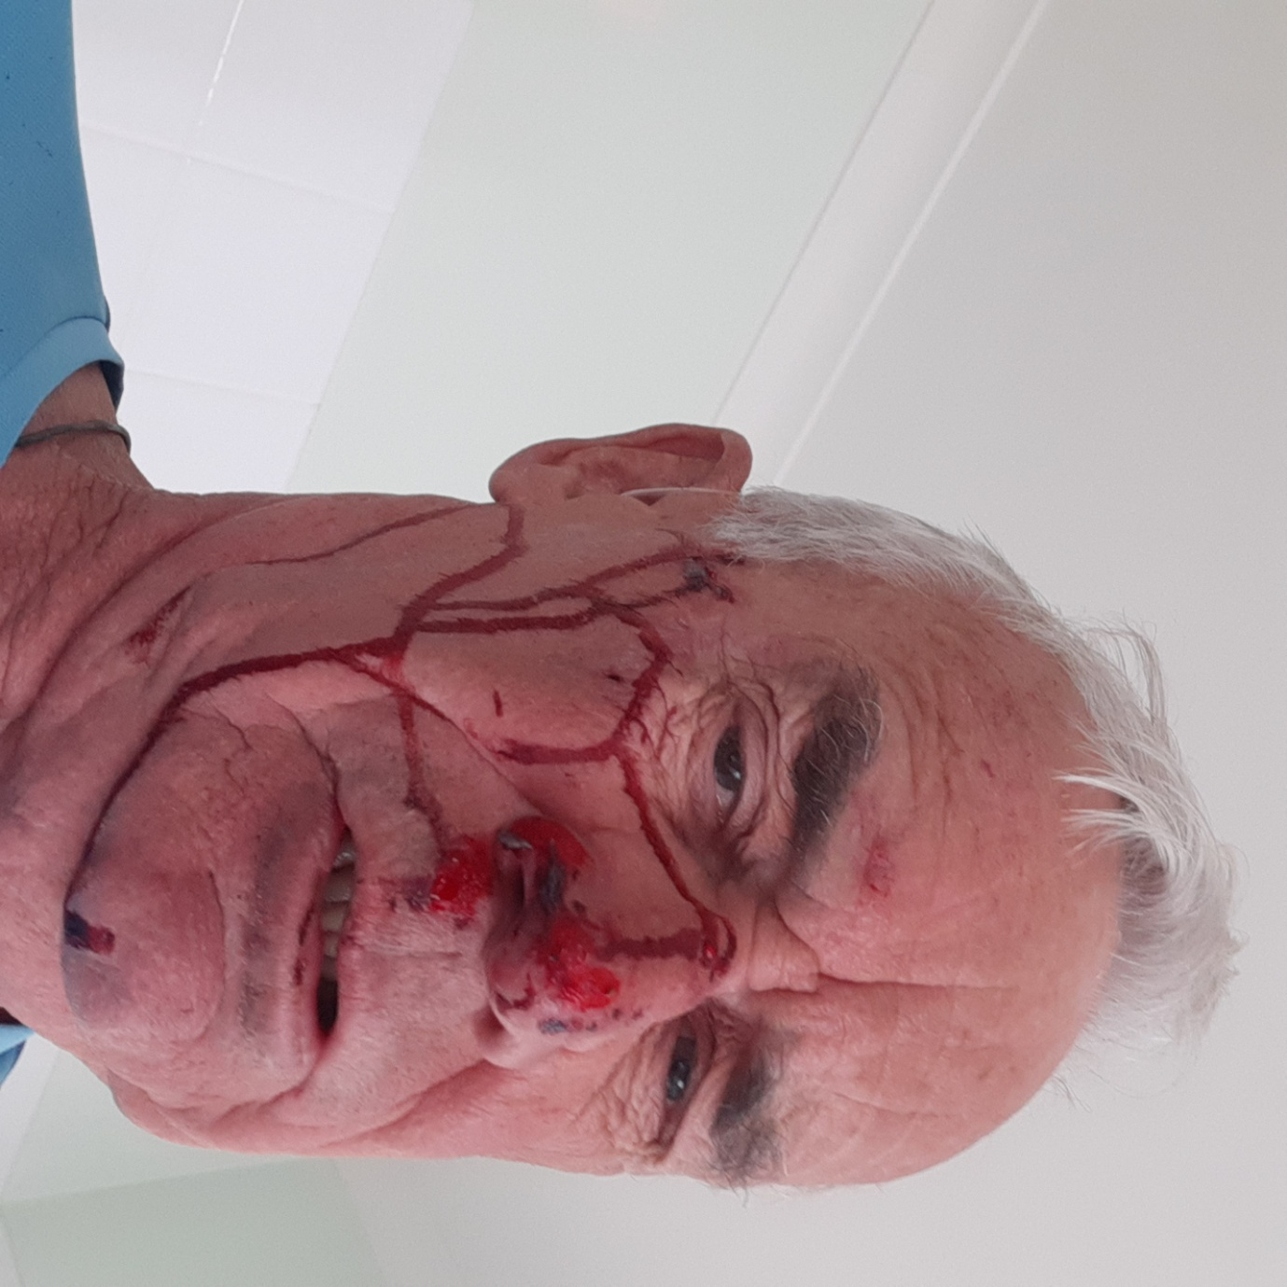

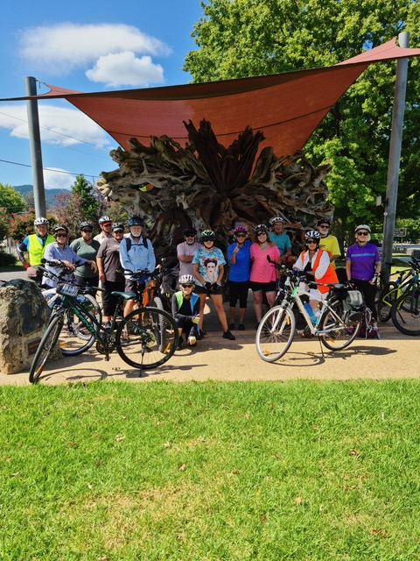

**A blast from the past photo**

**Anyone have any photos they wish to share of our group?**

**Send them to;**

**Shelley.wyllie@gmail.com**

Thanks Dallas for sharing this picture,

Love the location!!

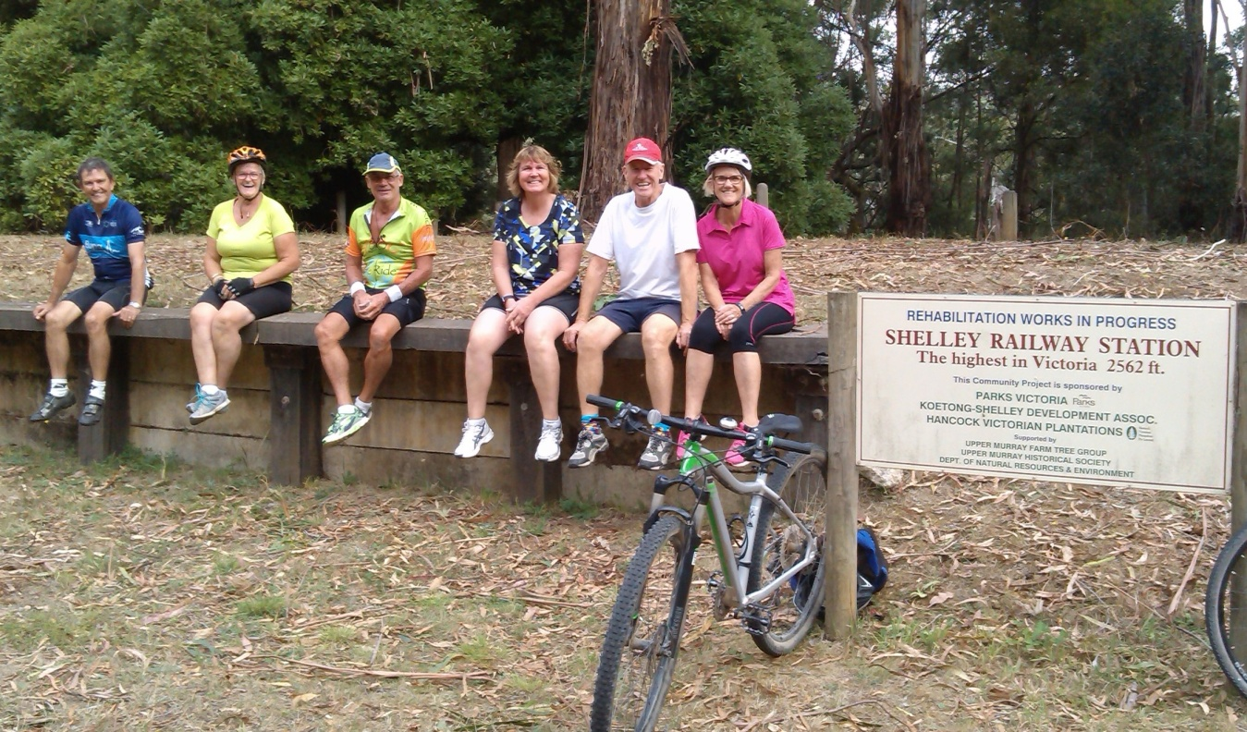

**President’s report**

Hi members,

Thanks to those who completed the recent survey about our club/members meetings. The responses were quite varied and didn’t show a clear preference for any format, time, day or content. With the advent of emails and social media the meetings are now less about sharing information and more another get together, on top of all the walks, rides and other activities that we socialize on. We were also seeing fewer members attend these nights and were thus finding it hard to justify inviting guest speakers. As a result, for this year we have decided on fewer formal meetings and more social evenings, with 28 June listed for dinner at the Aussie Hotel in Shepparton (more info to come).

The committee has recently reviewed the membership fees and structure in light of persistent low interest rates and increasing costs. We have come to the conclusion that fees need to rise and will shortly be calling an online Special General Meeting for mid-May seeking members approval for the proposed changes. More detailed information will be sent to you shortly.

Finally, a reminder to trip leaders to ask each visitor to sign the *Acknowledgement of Risk* form, which is available in the Members area of our [website](https://www.shepadventureclub.org.au/) under Leader Information (login as ‘member’, pwd ‘bushwalk’). Leaders should also discuss the fitness, skills and experience required with all participants beforehand to be sure they are capable and prepared. Any significant incidents on a trip should be reported to the committee via [president@shepadventureclub.org.au](mailto:president@shepadventureclub.org.au)

Happy adventuring,

Greg

President: Greg Smith 0429045732 president@shepadventureclub.org.au

Vice President: Bruce Gill 5824 2548 tatgills@westnet.com.au

Secretary: Karen Speedy 5825 1785 karenspeedy@iinet.net.au

Treasurer: Scott Birchall 5831 6063 scottb@agsystems.com.au

Newsletter: Shelley Wyllie Shelley.wyllie@gmail.com

Equipment Officer: Richard Graves 5824 2929 richsue@bigpond.com

Publicity Officer: Karen/Richard Speedy 5825 1785

Calendar coordinator: Neville Paynter 5831 1576 Neville.Paynter@jacobs.com

Mid-week coordinator: Dianne Hanna 0437 289 281 dhanna3@bigpond.com

Correspondence to: The Secretary SAC, PO Box 264, Shepparton 3632

Or email: [sacvicau@yahoo.com.au](mailto:sacvicau@yahoo.com.au)

Activity dates for 2022

| **Date** | **Type** | **Location** | **Leader** | **Rating** |
| --- | --- | --- | --- | --- |
| 26th – 30th April | Midweek Walk | Tree tops camp  Gunbower Island Tues - Sat  3 days walking, canoeing, bike riding, bird watching, scenic driving etc. | Richard Graves  0408 547 065 | Easy |
| 17 May 7.30pm | Online meeting | Special General Meeting at 7.30pm to vote on changes to the membership fees. More info to be sent to members. | Greg |  |
| 21st May | Bike Ride | O’Keefe Rail Trail | Dallas |  |
| 25th May  9am | Midweek Walk | Boathole to Mineral Springs Strathbogies | Howard Hanna  0437 628279  Justus Hagan | Easy/Mod |
| Sunday 19th June | Bike Ride | Waranga/Murchison | Geoff & Lyndall |  |
| 22nd June  9am | Midweek Walk | Rushworth, Whroo forest | Jan Gregory  0438 093 668 | Easy |
| 28 June 6pm | social | Dinner at the Aussie Hotel, Shepparton from 6pm | Karen? | social |
| Sunday 17th July | Bike Ride | tba | Wendy & Martin |  |
| 27th July  9am | Midweek Walk | Lima Creek | Judy & Ted McIntyre  0458 252923 | TBC |
| 20th Aug | Bike Ride | Moyhu | Maartje H |  |
| 24th Aug  9am | Midweek Walk | Warby Ranges | Maartje Heuperman  0407 849794 | Easy/Medium |
| 30 Aug  7.30pm | meeting | AGM from 7.30pm, possibly with dinner beforehand | Greg/Karen | social |
| 17th Sept | Bike Ride | Winton Wetlands | Ray/Dallas |  |
| 28th Sept  9 am | Midweek Walk | Terrick Terrick N.P | Dianne Hanna  0437 289 281 | Easy |
| 12th Oct  9. am | Midweek Walk | Mt Black (offroad) | TBC | Easy/Medium |
| 15th Oct | Bike Ride | TBC | TBC |  |
| 26th Oct  8 am | Midweek Walk | Euroa Seven Creeks / Balmattan Hill | TBC | Easy/Med |
| 19rd Nov | Bike Ride | Dookie + optional walk up Mt Major | Shelley |  |
| 23rd Nov  8 am | Midweek Walk | Mt Wombat Strathbogies | TBC | Easy |
| 17th Dec |  | Twilight Ride Kids Town/Gemmill Swamp & BBQ at shed | Ray |  |

**Trip Leaders:** *Please remember to ask visitors to sign an Acknowledgement of Risk form for Temporary Members and pass it on to our Secretary, Karen. This form is available on our website once you login (member, bushwalk) under Members>Leader Information. It is a requirement of our club insurance policy.*

**Everything BIRD’S**

**Marg Clarke**

                                        Rainbow Bee-eater

ZEBRA FINCH

The Zebra Finch is a small bird about half the size of a Sparrow and can be found throughout most of Australia.

Like other Finch species it has a short, conical bill and feeds on the seeds, mainly of native grasses and also on small insects.

Zebra Finches are usually seen in flocks that can be quite large especially when seen around waterholes.

Males have interesting patterning including a distinctive orange-brown cheek patch and have red bills. The female is plainer and has an orange-red bill while the juvenile has dull colouring and a black bill.

I photographed these male, female and juvenile birds beside an unmade road near Corop recently.

Marg Clarke

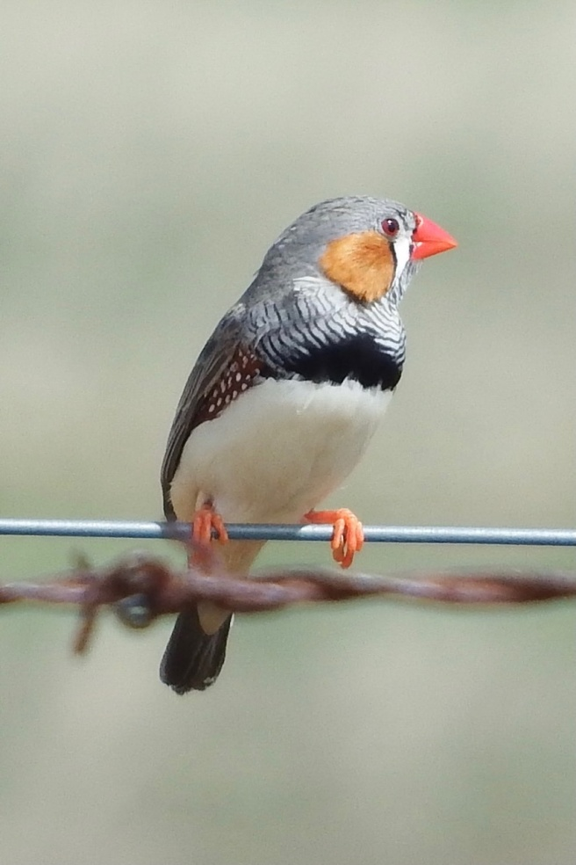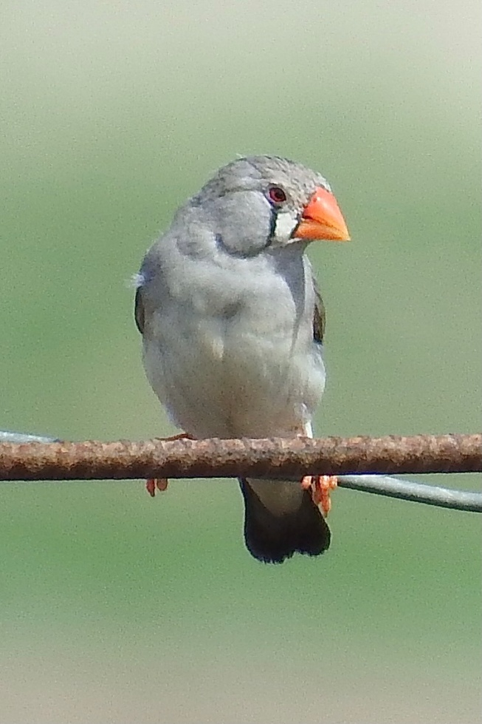

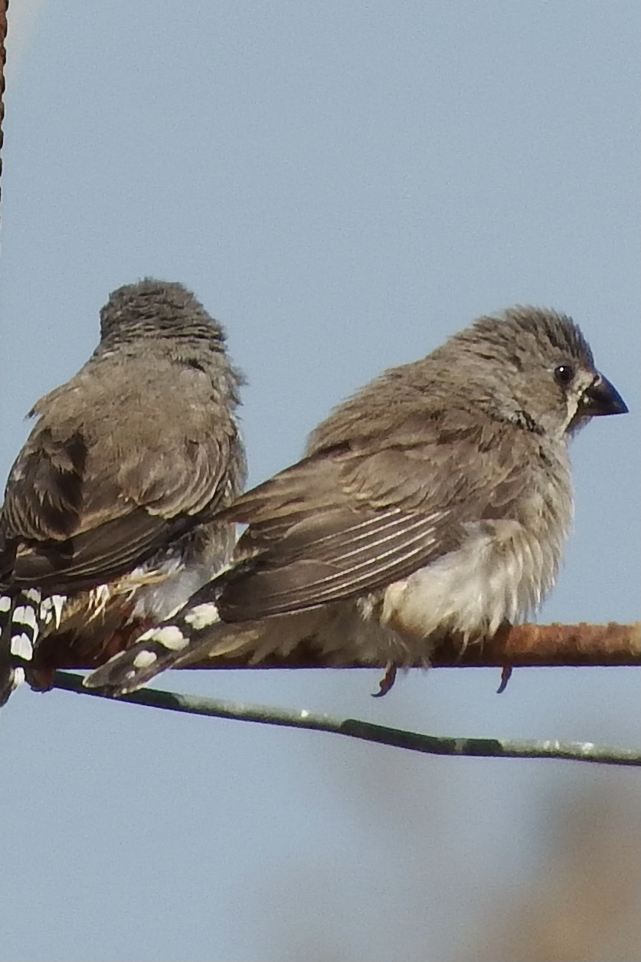

Article and photo - Marg Clarke

**Editors note**

Hi everyone, WELCOME to another issue of SAC, you will notice that we are missing a couple of reports in this issue, a reminder to all organisers to get your report through ASAP.

**Club T Shirts**

There has again been a delay in our club shirts, we have “one” company willing to take on our personal design shirts but need a minimum of 80 orders to proceed.

The original company is also back in the picture with our designs, so we will keep working on this and keep you informed

**Extra adventures**

There is talk amongst the tree tops that members want more than one walk or ride a month, as a club we can only offer as many adventures as leaders are willing to take on, so if anyone would like to lead an adventure and invite the group outside of the timetable simply email Scott and he will forward to us all.

Aditional rides/walks are always welcomed, different days, twilight or something unexpected is always an adventure!

**Your say**

Don’t forget, I’m always looking for YOUR adventure to share, so send in pictures and some information.

If anyone is interested on taking the Adventure Club back to the waters put your hand up and let us all follow your lead ☺