
If undelivered, please return to PO Box 264, Shepparton 3632

SHEPPARTON ADVENTURE CLUB inc. A0002706S

NEWSLETTER February – March 2016

website: www.shepadventureclub.org.au
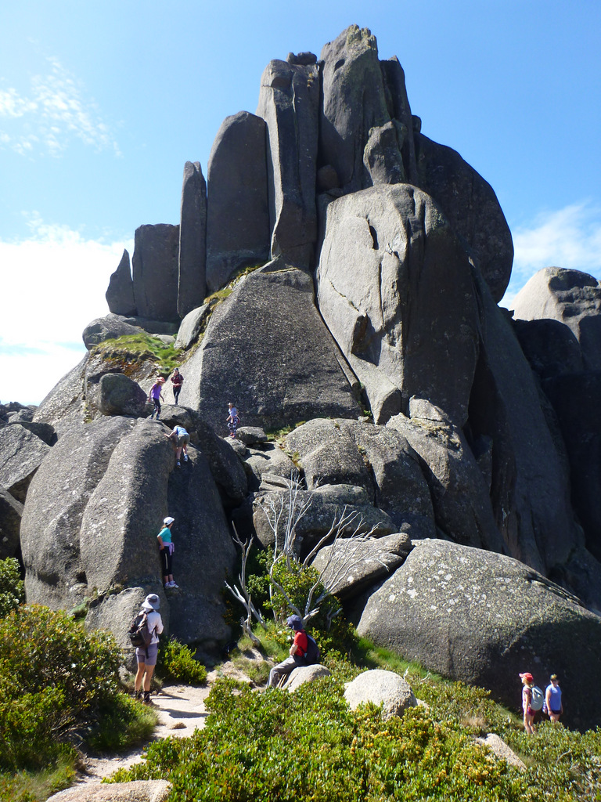
SAC members exploring Mt Buffalo

Next club meeting Tuesday 23 February 2016
at the SAC Shed from 6pm for a (byo) BBQ dinner and
canoeing on Victoria Lake.

Newsletter Printing

Our newsletter printing is kindly sponsored by Hon. Wendy Lovell, MLC for Northern Victoria Region
138 Welsford Street, Shepparton

We are still seeking a permanent Newsletter Editor, a good job to brush up on your computer skills and add your own touch. Contact Bruce or Greg if interested. Phone support provided!

The SHEPPARTON ADVENTURE CLUB Inc.
General Meeting: 4th Tuesday of the months: February, April, June, August, October
usually at: 7:30 pm at the Mechanics Institute, Wyndham St, Shepparton.
Committee Meeting: Monthly at 8pm.
Correspondence to: The Secretary SAC, PO Box 264, Shepparton 3632
Email: sacvicau@yahoo.com.au

OFFICE BEARERS
President Bruce Gill 5824 2548 tatgills@westnet.com.au
Vice President Karen Speedy 5825 1785 karenspeedy@iinet.net.au
Secretary Howard Hanna howard_hanna@yahoo.com
Treasurer Scott Birchall 5831 6063 scottbirchall@aapt.net.au
(for email distribution to members)
Newsletter Editor vacant (interim Greg Smith – see contacts below)
Equipment Officer Richard Graves 5824 2929 richsue@bigpond.com
Publicity Officer Rach Keen 0400 238276 rach_elkeen@hotmail.com
Calendar Coordinator Neville Paynter 5831 1576 Neville.Paynter@jacobs.com
Mid-week coordinator Dianne Hanna 0437 289 281 dhanna3@bigpond.com
Web Master Greg Smith 5824 1143 greg.smith@gmwater.com.au

Affiliated member of 

SAC MEMBERSHIP FEES - from 1 September 2015

Single Club Membership $35
Family Club Membership $60 (2 adults and children)
Concession – Single Membership $30 – Pensioner/Senior/Student Cardholders
Concession – Family Membership $45 – Pensioner/Senior/Student Cardholders

Membership benefits
Your Bushwalking Vic membership card enables you to obtain discounts at a number of retailers including Ajays (Heathmont), Bogong Equipment (Melb), EMC (Deepdene), Melb Map Centre (Malvern East), The Wilderness Shop (Box Hill), Paddy Pallin, Smitten merino wear Tasmania, Woodslane Walking Guides.
5% on Outdoor Travel tours and all reservations made directly with the office at Bright. Check out their website or join their email newsletter list for tours and current deals: www.outdoortravel.com.au, 1800 331 582 info@outdoortravel.com.au
Discovery Holiday Parks, Cradle Mountain 20% discount off shoulder and low season rates (16 April - 2 December)
Contact Claire on 03 6492 1289, 1800 068 574 www.discoveryholidayparks.com.au

Sunrise & Sunset (Melbourne GPO)
1 Feb 6.33am & 8.34pm | 1 Mar 7.05 & 8.00 | 1 Apr 7.34 & 7.13 | 1 May 7.01 & 5.33
15 Feb 6.49 & 8.19 | 15 Mar 7.18 & 7.39 | 15 Apr 6.47 & 5.53 | 15 May 7.13 & 5.19
Full Moon
2016: 24 Jan, 22 Feb, 23 Mar, 22 Apr, 21 May, 20 Jun, 19 Jul, 18 Aug, 16 Sep, 16 Oct 14 Nov, 14 Dec
Source: www.ga.gov.au

President’s Ramblings

Will I ever be able to carry a hiking pack again? That is a question I've asked myself in the past week (since Australia Day actually) when the straw that broke the camel’s back (mine) was picking up the esky. A proudly Aussie way to hurt your back (especially when done on the 26th of January) it also had the bonus of incapacitating me enough for 2 days off work. While I always endeavour to lift with bended knee, I don't think it was just the esky hefting that led to the pinching of the sciatic nerve. I must admit that in the previous fortnight I had spent some considerable time immobilised in metal transport canisters confined to not entirely ergonomic seats. This was all in the pursuit of the white stuff in Japan, to which the sedentary time in transit was suddenly interrupted by 5 days of vigorous and very enjoyable skiing, followed by 2 days of confinement again. I do now recall receiving some protests from my lower back during the 8 hour bus trip back to Tokyo that an improvised lumbar support in the form of my coat, could only partially relieve. So I'm guessing the week or so of back pain is just my aging body's way of telling me to take it easy? While I've missed out on Rachel's canoeing trip in the last few weeks, I'm looking forward to participating in as many SAC trips as possible throughout 2016 so that should the desire and opportunity arise again, I'll be fit enough to hoist a backpack and head off into the wilds again someday.
Once again, thanks to Greg for putting the newsletter together, he's still keen to train a willing apprentice in newsletter production - anyone?
Don't forget to come along to SAC activities throughout the year and get out there and enjoy our great outdoors.

Cheers,
Bruce Gill

Please let us know if you are happy to receive the newsletter via email only in the future, watch for an email from Greg.

WalkSafe: essential gear for a day walk
For a day walk the following items should be in everyone's pack:
- Plastic bag/liner, to keep things dry
- Raincoat
- Water bottle (minimum 1 litre)
- Hat (sun or warm depending on location & time of year)
- Sunscreen
- Whistle
- Toilet paper
- Personal First Aid kit containing:
  - Triangular bandage
  - Elastic bandage
  - bandaids
  - Personal medication
  - Matches
  - Insect repellent
Other useful items include a torch, toilet trowel, watch, phone, pencil & paper, compass, map.
And don't forget some food!

The leader should also have a map, compass, mobile phone – and know how to use them.

Clothing - dress for warmth or sun protection, comfort and whatever conditions the location and time of year could produce.
When it comes to clothing materials, there are advantages and disadvantages of all types.
Cotton (including denim) is cold when wet and slow drying, but usually cooler in sun than synthetics.
Synthetics readily get hot in sunny conditions but don't absorb moisture and are lightweight.
Wool is still warm when wet but heavy and slow to dry, although mixed with synthetics can be better.
Talk to fellow walkers and find a combination that suits you.

-----------------------------------------------

Calendar of Activities

Date | Activity | Location & details | Grade | Leader | Contact
23 Feb Tues | Club Meeting | Come along to the SAC shed on Victoria Lake for a BBQ and paddle and enjoy the long evening from 6pm
24th Feb | Mid-week walk | Kinnard’s Swamp | Easy | Barb Brown | 5831 8447
12-14 March | Overnght walk | Mount Speculation from King River.  A circuit starting on the King River, climb King Spur to Mt Koonica, then on to Mt Speculation to camp. Then to Horrible gap, Mt Buggery, and down Queens Spur.  This is normally a two day walk. Depending on who we get and how we feel, we can look at ways to lengthen it. Otherwise Monday will be a day of recovery or a day walk to Mt Cobbler. | Medium to hard | Neville Paynter | 5831 1576
18-20 March | Base camp & day walks | Base camp Walwa on the Murray River at a commercial caravan and camping park. We will be arriving Friday afternoon. Saturday: day walk to Pine Mountain in Burrowa-Pine NP. Approx 12km Medium-hard. Sunday: Pack up and head back to Burrowa-Pine NP, visiting Bluff falls and one or 2 of the lookouts nearby depending on time available. Max about 6 km. | M-H | Jill or Greg | 5824 1143
19 March | Kayak/canoe | Kayak trip on the Murray River from Thistle bend to Barmah town. 4.5 hour paddle plus breaks along the way, enjoying the diverse birdlife along the river. Moderate level of fitness required, and some kayak experience necessary. Kayaks and lifejackets provided. Meeting at 8:30am and back at 6:30pm. | M | Rach Keen | 0400 238276
23rd March | Mid-week walk | Mooroopna common | Easy | Cathie McMaster
25-27 March -Easter | Base camp & day walk | Travelling to Mitta Mitta on Friday. Staying at the Mitta Caravan Park on the river itself. Saturday: Day walk up Mt Wills. Steep. Medium-Hard. We will be returning to Albury by 11 am on Sunday, but others could stay on to explore the area further. |  | Jill or Greg | 5824 1143
3-6 April + 7-9 April | 4 day Hike + beaches | Wilsons Prom: Sun 3rd walk in to Little Waterloo Bay to camp. Mon hike to Refuge Cove and camp. Tue: hike to Sealers Cove. Wed: Hike out to Oberon Saddle and drive to Cape Paterson if you like, staying in house Thu-Sat swimming, snorkeling, beachcombing. |  | Jill or Greg | 5824 1143
23-25 April | Base camp | Camp on private property near Guilford. Relax & explore around the property or join us on some walks nearby in the goldfields. | Easy | Jill or Greg | 5824 1143
26 April | Club Meeting | Mechanics Institute?
27th April | Mid-week walk | Ruffy: Justus Hagen Walk | Medium | Howard Hanna | 0437 628279
25th May | Mid-week walk | Chesney Vale/Winton wetlands |  | Dianne Hanna | 0437 289281
22nd June | Mid-week walk | Warrenbayne: Winsome McCaughey/Snow Barlow property | Easy/ Medium | Dianne Hanna | 0437 289281
27th July | Mid-week walk | Nagambie /Tabilk |  | TBC
24th August | Mid-week walk | Warby Ranges; Wenhams? |  | TBC
Sun 11th – Fri 16th Sept | Walks | Grampians camp |  | TBC
28th Sept | Mid-week walk | Whroo forest |  | Richard Dickins | 58 285267
26th Oct | Mid-week walk | Strathbogies; Shean’s Creek? |  | TBC
23rd Nov | Mid-week walk | Barmah forest | Easy | TBC

PLEASE RING THE TRIP LEADER TO MAKE SURE IT IS WITHIN YOUR CAPABILITY AND CONFIRM THAT IT IS GOING AHEAD.

OTHER CLUBS’ ACTIVITIES
Benalla Bushwalking Club http://benallabushwalkingclub.org.au/
Border Bushwalking Club (Albury & Wodonga) - www.borderbushwalkingclub.com.au
Wangaratta Out and About Club - www.wangarattaoutandabout.org.au/
Bendigo Bushwalking and Outdoor Club - www.gobush.org.au/
Echuca-Moama Bushwalkers - www.echucamoamabushwalkers.org.au
and more can be found at www.bushwalkingvictoria.org.au

TOTAL FIRE BAN
If a day of TOTAL FIRE BAN is declared please contact the Activity Leader for confirmation whether the activity will go ahead or not.

Note: TRIP LEADERS – it is imperative for every trip that temporary members/visitors sign the “Acknowledgement of Risk Form”. These completed forms must be forwarded to the SAC Secretary for filing as soon as possible after the trip – otherwise, in the case of a claim, the insurer will not acknowledge the risk.
Form can be downloaded from www.bushwalkingvictoria.org.au , in
http://www.bushwalkingvictoria.org.au/forms/Risk_Management_Guidelines.pdf

Emergency Contact Procedures
All enquiries about the return of participants from club activities should first be directed to the activity leader, and then to the Emergency Contact Person (ECP) for the activity if the leader cannot be found.
It is the activity leader's responsibility to organise an ECP and advise him/her (in writing) of trip & participant details and what to do if contact is not made by the nominated time.
Travel Cost Reimbursement
Option 1: Preferred. Fuel Cost per car plus 5 cents per km per car to be split equally between the numbers of people in the car including the driver. If appropriate, the cost of running all vehicles should be shared equally amongst all trip participants.
Option 2: 25 cents per km per car split between all trip participants.

Summary of Public Liability insurance coverage at 5-3-2014 (from www.bushwalkingaustralia.org.au )
Bushwalking, Track/Hut Construction and Maintenance, Caving, Canyoning, Liloing, Abseiling, Alpine Walking (Summer and Winter),Snow Skiing, Canoeing, Kayaking, Boating, Rafting, Swimming, Cycling, Rock Scurrying and use of hand held ropes as part of a Bushwalk, Orienteering, Rogaining, Leader Training and other related instructions.
Activities NOT COVERED include Rock Climbing, Water Skiing, overseas trips (except NZ) and any activities not listed above.

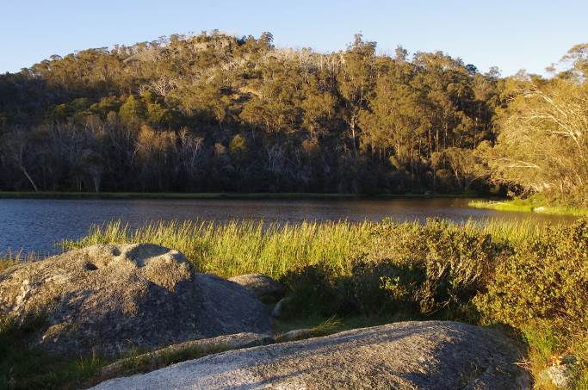 Lake Catani, Mt Buffalo

Trip Reports

Mount Buffalo camp 11-13 December 2015
Part 1: The Underground River
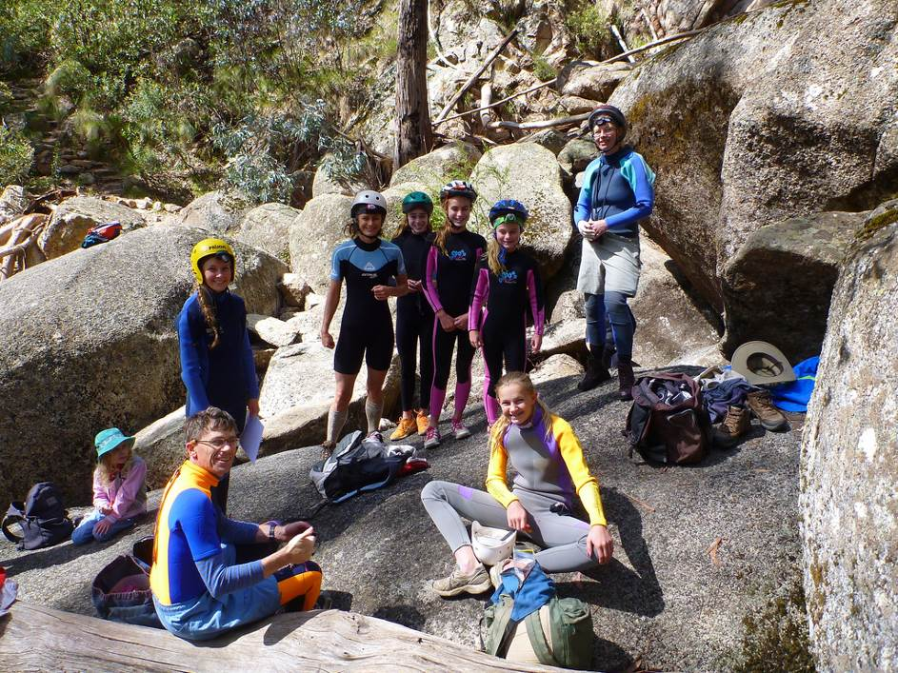
Water rushing with an icy chill and total darkness all sent a quiver up my spine, this was bound to be an adventure. We were all super excited and feeling totally fearless. We were at Mt Buffalo on the 11th of December and staying at Lake Catani for two nights. The main reason for coming this way was to do an underground river course. Lizzy had done it before and with our trusted guides, Jill and Greg we were all in good hands. However, nearing the tunnel I began to have second thoughts. The water was incredibly loud and then peering into the entrance I clearly noticed a sign telling us about just a few of the hazards. In big bold writing it read: This cave system poses a serious threat to personal safety. Next telling us all the features making this trip of ours’ life threating. Everyone was feeling slightly on edge but never or less still willing to give it a go.
After all getting inside we were set to begin. The first obstacle we faced with was a little head hole above the water. We had fit our head through the gap and go inside the next chamber which Greg had found. This obstacle wasn’t too bad because the water only came up to my stomach, but I still had to get drenched so as to fit through the hole, I had to crouch down low and get the water up to my lips to fit through. This was mild compared to the other one we did. We had to swim through the gap and continue swimming to the rocks, it was very deep. This meant that everyone felt rather fresh after. In this chamber there were a lot of glow worms and when we turned our lights off you could even see their tentacles. It was pitch black and you could not see your hand in front of your face. This made them seem even brighter. In this chamber we had some difficulty working out where to go. The group was told to stay put while Greg and Lizzy went to see were we go next. 10 minutes later when we were still waiting everyone was beginning to feel a bit uncomfortable. Teeth clattering and no signs to guide us back to the start everyone was feeling slightly anxious.
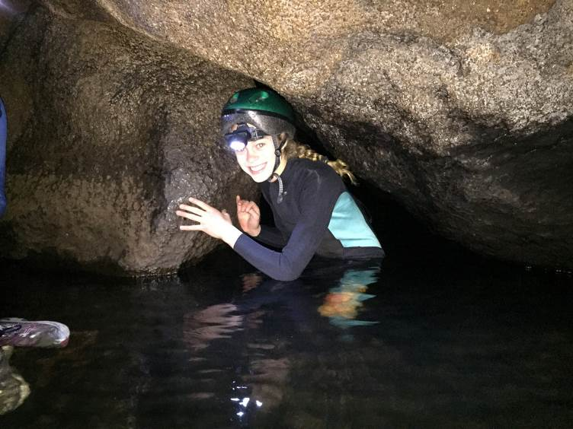
Eventually it was found and was virtually right in front of us, this was to everyone’s great relief. It was a very challenging bit of rock climbing and needed two people to help one person up. One at the bottom to buck you up and another at the top to pull you the rest. This took a while but was extremely fun. By now we were starting to see some light through the ceiling in some tiny holes. Some of us (Mum) were very glad to see this. The water seemed to be getting louder and louder and you had to yell to be heard. Sure enough the next section was crossing a water fall. With the water pushing us sideways in the wrong direction this proved to be challenging. We leapt off the safety of the rocks into the deep, black, freezing water to get to the other side. We struggled against the push of the current and with arms flying tried to grip the most slippery of rocks. Having shaking bodies and only one foot hole available made it all the harder. With much reassurance and assistance everyone made it past. We could all feel the surface close and were getting impatient. When we were told that the exit point was not exactly clear we were told to wait again. Time seemed to tick very slowly and again I got that terrible feeling. As I watched Greg climbing into these little cracks and then disappear into the darkness, I thought we were totally stuck. With blue fingers and tired bodies everyone’s’ hope was beginning to fade.
When they reappeared with smiles on their faces a load was lifted off my shoulders. What a relief. With new found energy we were determined to face whatever came next. After climbing up several rocks we saw sun light streaming through this body sized crack. This turned out to be our exit. We had to climb up these rocks on our hands and knees and sometimes our stomachs. Just as well for our long leg and arm wetsuits as the rocks still pocked us through them. It was well worth the effort and we all really enjoyed the trip. Thanks to Jill and Greg for organising it.
By Taryn Cameron
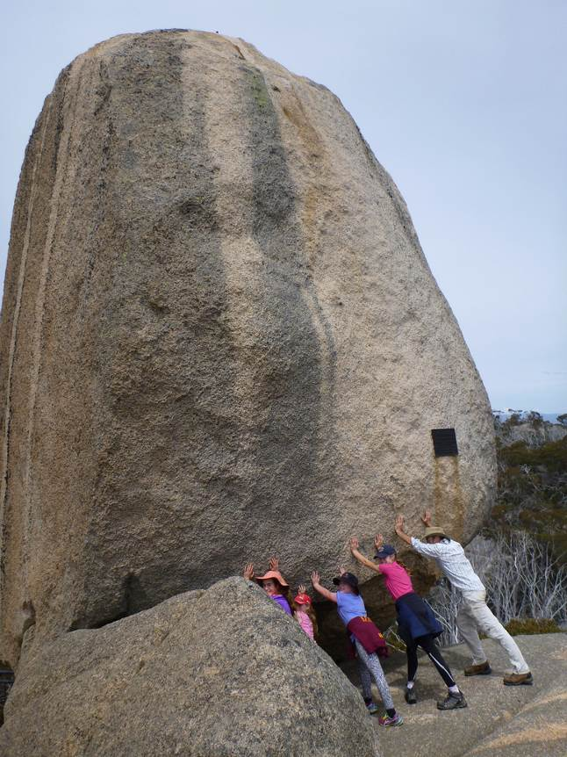
Part 2: The rest of the weekend
After Saturday mornings underground aquatic adventure we refueled and went on a few walks. First up the Cathedral … Second up the Horn, with it’s steps & handrails.
Saturday evening was much warmer than Friday night so after dinner we watched the sunset over Lake Catani and sat/stood around chatting with a port or two.
Sunday morning required another underground adventure for those who turned up too late on Saturday due to trailer problems. This time we knew where to go and did the same section in half the time, so decide to explore a bit further. The entailed another squeeze and waterfall but much easier than on the first section. We came back to same way to exit the same point as the previous day, which on the surface was only 50 or so metres from the start.
Othe way home we climbed the Monolith and had a walk around the Gorge lookouts and deserted Chalet, which was undergoing major maintenance so it can be used again.
Thanks to the Cameron, O’Brien, Birchall and Gill families for their company and adventurous spirit.
by Greg Smith

Goulburn River canoeing Eildon to Alexandra 30 January 2016
One overcast Saturday morning 7 people gathered at the club sheds to embark on an epic kayak journey from Eildon weir to Alexandra. There was rain in the forecast but everyone was in good spirits and after checking out the new info centre at Alexandra we were on our way!
The river was running fast and high after recent rains and the water was a pleasant emerald green and clear. Our first obstacle after entering the water was a tricky rapid near the caravan park. 'Not a problem' declared our fearless trip leader, 'take a straight line and follow the current in'. After a pleasant paddle and getting used to our water craft, A Great Wall of water faced our kayakers as we rounded the corner to face the RAPID. Taking a deep breath , the first boat went in and was promptly swamped. What to do ?
Looking to shore, there were people that seemed strategically placed with rescue ropes in their hands, looking stunned. "Throw the rope over here" our hapless kayakers called out.
With a well-practiced arm, the lifesaving rope was thrown and each boat was hauled out of the current. Our heroic rescuers even helped empty the boats of water.
After taking time to collect ourselves (and a rogue paddle!) it was a relief to find that most things were able to be salvaged from the water. Our rescuers were actually practicing swift water rescues and were delighted to have a 'real life' situation to deal with. That's the shepparton adventure club, always ready help!
The rest of the journey was uneventful and pleasant. A mix of fast water and flat water paddling and the ever changing scenery and wild life to keep things interesting. Thanks rachel for hosting a great day!
by Judith Wong

Goulburn River canoeing Shepparton 8 February 2016
Five SAC members met at the club shed for an afternoon paddle down the Goulburn. We carried the kayaks down the steep steps behind Lake Victoria and set out for a peaceful trip downstream. There were a few people in their tinnies relaxing with their fishing rods in the shade. A few colourful tents were up high on the banks. We got down to Jordan's Bend and paddled through a narrow waterway until we were back on the main part of the Goulburn River. Then it was time to turn back and paddle upstream again to our starting point. It was a peaceful afternoon on the water. Thanks for the company of Helen, Steve, Ray and Graham.
by Rachel Keen

www.bushwalkingvictoria.org.au
PO Box 1007 Templestowe Vic. 3106
Phone: (03) 8846 4131
Fax: (03) 9846 7473 admin@bushwalkingvictoria.org.au

From the February 2016 BWV News

Key issues BWV will be focusing on in 2016, and probably beyond, are influencing decision makers, access versus conservation and feral plants & animals. Bushwalking Victoria is also pursuing a number of projects aimed at strengthening bushwalking clubs and helping them to grow.

Forest Explorer
Aside from parks & reserves managed by Parks Victoria, DELWP also manages many other sites of interest to walkers and adventurers. Do a search on State forest places to visit and open up the DEPI Places to visit page. There is information on walking tracks, camp sites, picnic areas, mountain bike tracks, photos and more.

More news can be found at http://www.bushwalkingvictoria.org.au/what-we-do/publications/newsletters

BWV is on Facebook … search in the usual manner or go here: https://www.facebook.com/bushwalkingvictoria/

Several brochures on walking safely & softly are available at: www.bushwalkingvictoria.org.au/brochures.htm

The Bushwalking Australia website at http://www.bushwalkingaustralia.org also has some useful information and links.

Trail Hiking is a website that provides detailed information on 157 hikes in Victoria, plus some walks
in other states. Darren and Julie Edwards have been recording their hikes for the past few years,
writing trail notes and taking photos. The website includes trail descriptions, key features, maps, gpx
files, elevation profiles, and picture. Darren and Julie also ask the hiking community to submit their
favourite trails and gpx files for inclusion. For more information, go to http://www.trailhiking.com.au

And if you are planning to added a walk to this website also add it to BWV’s where2walk facility.
where2walk lists 216 walks in Victoria. Three new walks have recently been added and 79 walks
updated. To access the full details of each walk, log in using your Club Voucher Code (ask Greg).

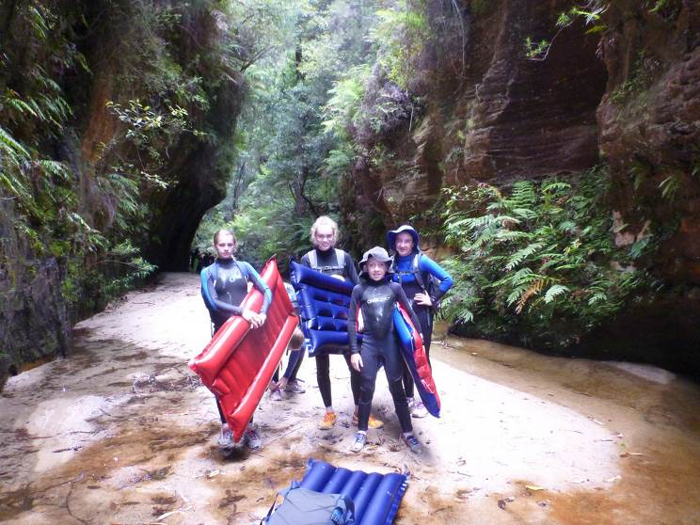 Blue Mtns canyon, Dec 2015

