
If undelivered, please return to PO Box 264, Shepparton 3632

SHEPPARTON ADVENTURE CLUB inc. A0002706S

NEWSLETTER December-January 2017

website: www.shepadventureclub.org.au

Safe, happy and enjoyable 2017 to all members and friends of the Shepparton Adventure Club

Next club meeting Tuesday 28 February 2017
Club's shed, at the South West corner of Victoria Lake, (6:00pm).

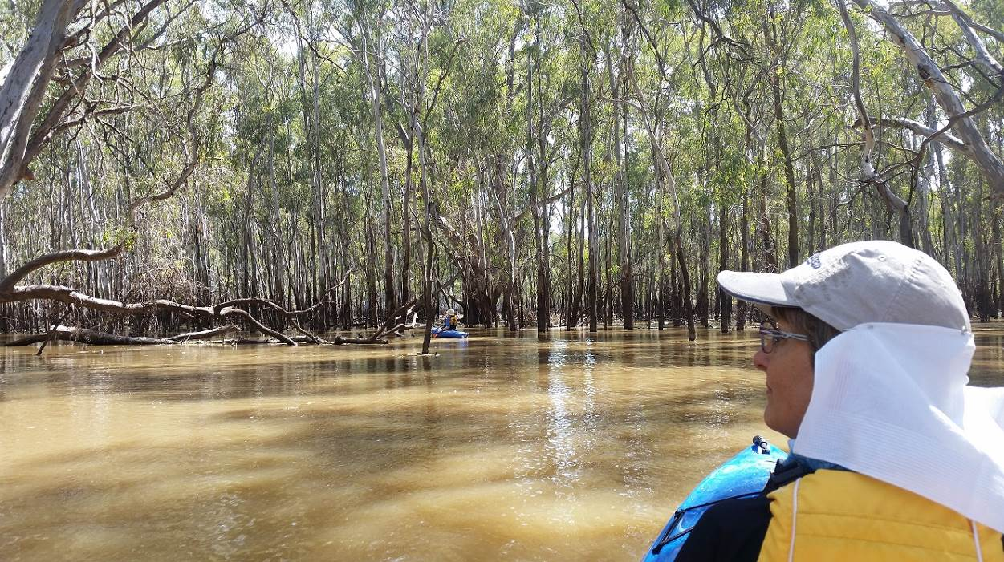
Barmah Forest November 26th 2016

Newsletter Printing

Our newsletter printing is kindly sponsored by Hon. Wendy Lovell, MLC for Northern Victoria Region
138 Welsford Street, Shepparton

Full Moon
2017: 12 Jan, 11 Feb, 12 Mar, 11 Apr, 10 May, 9 Jun, 9 Jul, 7 Aug, 6 Sep, 5 Oct 4 Nov, 3 Dec
Source: www.moongiant.com.au

The SHEPPARTON ADVENTURE CLUB Inc.
General Meeting: 4th Tuesday of the months: February, April, June, August, October
usually at: 7:30 pm at the Mechanics Institute, Wyndham St, Shepparton.

Correspondence to: The Secretary SAC, PO Box 264, Shepparton 3632
Email: sacvicau@yahoo.com.au

OFFICE BEARERS
President Bruce Gill 5824 2548 tatgills@westnet.com.au
Vice President Karen Speedy 5825 1785 karenspeedy@iinet.net.au
Secretary Howard Hanna 5828 9281 howard_hanna@yahoo.com
Treasurer Scott Birchall 5831 6063 scottbirchall@aapt.net.au
(for email distribution to members)
Newsletter Editor Steve Jeffs 0402368751 stevesbluebmw@outlook.com
Equipment Officer Richard Graves 5824 2929 richsue@bigpond.com
Publicity Officer Rach Keen 0400 238276 rach_elkeen@hotmail.com
Calendar Coordinat or Neville Paynter 5831 1576 Neville.Paynter@jacobs.com
Mid-week coordinator Dianne Hanna 0437 289 281 dhanna3@bigpond.com
Web Master Greg Smith 5824 1143 greg.smith@gmwater.com.au

SAC is an affiliated member of 

SAC MEMBERSHIP FEES - from 1 September 2016

Single Club Membership $35
Family Club Membership $60 (2 adults and children)
Concession – Single Membership $30 – Pensioner/Senior/Student Cardholders
Concession – Family Membership $45 – Pensioner/Senior/Student Cardholders

Membership benefits
Membership of Shepparton Adventure Club includes Bushwalking Victoria membership.Your Bushwalking Vic membership card enables you to obtain discounts at a number of retailers including Ajays (Heathmont), Bogong Equipment (Melb), EMC (Deepdene), Melb Map Centre (Malvern East), The Wilderness Shop (Box Hill), Paddy Pallin, Smitten merino wear Tasmania, Woodslane Walking Guides.
5% on Outdoor Travel tours and all reservations made directly with the office at Bright. Check out their website or join their email newsletter list for tours and current deals: www.outdoortravel.com.au, 1800 331 582 info@outdoortravel.com.au
Discovery Holiday Parks, Cradle Mountain 20% discount off shoulder and low season rates (16 April - 2 December)
Contact Claire on 03 6492 1289, 1800 068 574 www.discoveryholidayparks.com.au

President’s Piece

Watch this space for next issue. President enjoyed a well deserved break and the editor forgot to ask him for a report
Have a copy of the Waverly Bushwalking Clubs December Newsletter if anyone would like an interesting read. Also the Echuca-Moama group January Newsletter
Steve on behalf of Bruce

Facebook
November 28th saw the creation and launch of The Shepparton Adventure Club Facebook page. Thanks and enquiries re article submission etc to Rachel. Jump on and “like It”

Equipment Update – 12 place bike rack
After many months in gestation, the club’s new 12 place bike rack has finally come together. With lots of help from my brother (and welder) Heath, we now have 2 separable frames - each carrying up to 6 bikes using commercial single bike carriers.
The frames mount to the top of our canoe trailer (after lifting out the canoe frames) and are bolted in place. The bikes are secured on each carrier with straps over both rims and an arm that grips each side of the down tube (between bottom bracket and headset) keeping them in place. No more bikes bumping against each other removing precious paintwork!
The bike rack is now available for club trips. I have a few tips on getting bikes onto it so let me know if you intend to use it and I can get you started.
Scott Birchall
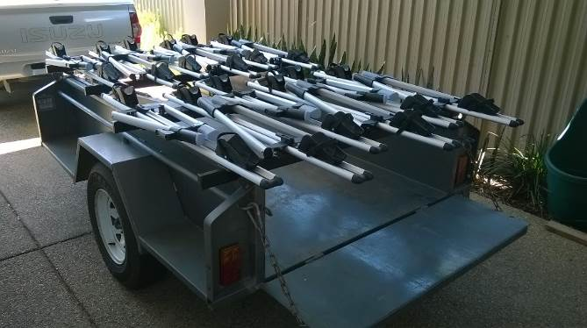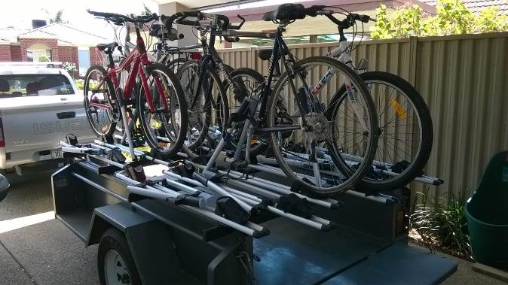

(from Walksafe booklet, by VicWalk/BWV)

Here’s a few safety points all participants should follow on outdoor trips:
- Carry sufficient food and especially water for the conditions and duration.
- Advise the trip leader of any medical issues that may affect your capacity to complete the activity.
- Tell the leader or others in the group if you are having difficulties.
- Wait at track junctions for the group to catch up.
- If you get lost STAY STILL and call out or whistle at regular intervals.
- Walk with experienced leaders.

www.bushwalkingvictoria.org.au
PO Box 1007 Templestowe Vic. 3106
Phone: (03) 8846 4131
Fax: (03) 9846 7473 admin@bushwalkingvictoria.org.au

Newsletters follow the link below

Find them here: http://www.bushwalkingvictoria.org.au/what-we-do/publications/newsletters

A small sample to whet your appetite:

Vice President resignation – will be replaced in early 2017

National Risk Management Guidelines were approved at the Bushwalking Australia AGM.
Response received from SRV regarding AAAS.
New resource for clubs: Starting and Running a Bushwalking Club now available

Welcome to Two New Affiliated Clubs
Mitchell Bushwalking Group and Escaping Your Comfort Zone Inc join Bushwalking Victoria

Tracks and Conservation Activities
New project and area - Peatland recovery on the Mt Buffalo Plateau - added to BTAC activities

Falls to Hotham Alpine Crossing 2016 Draft Master Plan
The draft master plan has been released. This is the final stage of the consultation process and your last opportunity to influence the final plan

Walks Books Bucket List
1001 Walks You Must Experience Before You Die by Barry Stone
The BBC’s Unforgettable Walks to Take Before You Die by Steve Watkins and Clare Jones
Classic Hikes of the World: 23 Breathtaking Treks by Peter Potterfield
Fifty Places to Hike Before You Die: Outdoor Experts Share … compile by Chris Santella
Trek! The Best Trekking in the World by Claes Grundsten

Great Ocean base camp walk

Dates: Sunday 26th – Fri 31st March 2017 (Last week term 1, 2017)
Base Camp: Bimbi Park
90 Manna Gum Drive, Cape Otway, Great Otway National Park, Victoria 3233,
http://www.greatoceanwalk.com.au/accommodation/bimbi-park/

Transport: Everyone organise their own transport to and from Bimbi Park on Sun 26th and Fri 31st March.

Accommodation: Everyone organise their own booking with Bimbi Park. There is a full range of options from a bush non powered site to deluxe cabins. Advice is to book ASAP to ensure that you are able to have the accommodation option of your choice.
Itinerary: Mon- Thurs. 4 days of walks, with walkers being transported to the walk area and return to base camp for the night. It is anticipated that the walks will be minimum of 14 kms each day on a variety of terrains with various degrees of difficulty. Participants would not have to walk each day.

Meals: Either self catering or catered by Bimbi Park. To be decided.
Planning meeting: 7.30 pm Sunday Jan 22nd
at Noella O’Keefe’s home 37 Heysen Ave. Shepparton.
Agenda: Discuss which sections of the walk will be done each day.
Self catering or catered?

Calendar of Activities

Shepparton Adventure Club Mid week walks 2017

Date | Location | Leader | Distance and rating
25th Jan | Reedy Swamp  Shepparton  NOTE: 8 am start. | Marg Purcell  0438 214 362 | Easy
22nd Feb | Ruffy area with Justus Hagan  NOTE: 8 am start.  Subject to no fire risk. | Howard Hanna  0437 628279 | Med
22nd March | Barmah Forest | TBC. Will only go ahead if enough people not going on Great Ocean Walk express interest. | Easy
Sun 26th – Fri 31st March | Great Ocean Walk.  Base Camp: Bimbi Park  http://www.greatoceanwalk.com.au/accommodation/bimbi-park/ | Richard Graves  0408 547 065 | 4 days of walks from base camp
26th April | Murchison | Patricia McDonough  0408 664949 | Easy
24th May | Euroa; Seven creeks and Balmattum Hill | Ray Mustey (0438 591 749) and Noella O’Keeffe (0408 218 639) | Easy to med
28th June | Kamarooka Forest | Richard Graves  0408 547 065 | Easy
26th July | Dookie: Saddleback and rail trail. | Barb Brown  0409 178091 | Easy to med
23rd August | Warbie Ranges: exact trail TBC | TBC | Easy to med
27th Sept | Chiltern/ Mt Pilot | TBC | Easy
11th Oct | Rushworth area Mt Black? | Richard Graves  0408 547 065 | Easy to Med
25th Oct | Benalla area | Jan Gregory
22nd Nov | Rocky Ned. Strathbogies | Richard Graves  0408 547 065 | Easy to Med

Bike rides
18th March Yea Rail trail Jan Gregory 0438 093 668
10th May Whroo midweek bike ride Jan Gregory 0438 093 668
Kayak trips
Tuesday 10th January beginners kayak on Lake Victoria from 5:30-6:30pm. Contact Rachel on 0400238276 if interested in coming. Children/adults welcome. Kayaks and lifejackets provided.
Tuesday 17th January beginners kayak on Lake Victoria from 5:30-6:30pm. Contact Rachel on 0400238276 if interested in coming.
Tuesday 7th February beginners kayak on Lake Victoria from 5:30-6:30pm. Contact Richard on 0408547065 if interested in coming.
Tuesday 14th February beginners kayak on Lake Victoria from 5:30-6:30pm. Contact Richard on 0408547065 if interested in coming.
Saturday 21st January kayak from Spences Bridge (near Cohuna) to Koondrook on Gunbower Creek. Some experience necessary (moderate level). Meet at 8am, back by 6pm. Kayaks and Lifejackets provided. Contact Rachel on 0400238276 if interested.
Saturday 11th February moderate kayak. Meeting at 8:30am and back at 6:30pm. Kayaking along the Murray River from Thistle bend to Barmah town. 4.5 hour paddle plus breaks along the way, enjoying the diverse birdlife along the river. Moderate level of fitness required, and some kayak experience necessary. Kayaks and lifejackets provided. Please contact Rach on 0400238276 if you are interested in coming along. (3rd time lucky with this one! blue green algae followed by closed roads!)
Thanks, Rach

PLEASE RING THE TRIP LEADER TO MAKE SURE IT IS WITHIN YOUR CAPABILITY AND CONFIRM THAT IT IS GOING AHEAD.

OTHER CLUBS’ ACTIVITIES
Benalla Bushwalking Club http://benallabushwalkingclub.org.au/
Border Bushwalking Club (Albury & Wodonga) - www.borderbushwalkingclub.com.au
Wangaratta Out and About Club - www.wangarattaoutandabout.org.au/
Bendigo Bushwalking and Outdoor Club - www.gobush.org.au/
Echuca-Moama Bushwalkers - www.echucamoamabushwalkers.org.au
and more can be found at www.bushwalkingvictoria.org.au

TOTAL FIRE BAN
If a day of TOTAL FIRE BAN is declared please contact the Activity Leader for confirmation whether the activity will go ahead or not.

Note: TRIP LEADERS – it is imperative for every trip that temporary members/visitors sign the “Acknowledgement of Risk Form”. These completed forms must be forwarded to the SAC Secretary for filing as soon as possible after the trip – otherwise, in the case of a claim, the insurer will not acknowledge the risk.
Form can be downloaded from www.bushwalkingvictoria.org.au , under Members > Forms

Emergency Contact Procedures
All enquiries about the return of participants from club activities should first be directed to the activity leader, and then to the Emergency Contact Person (ECP) for the activity if the leader cannot be found.
It is the activity leader's responsibility to organise an ECP and advise him/her (in writing) of trip & participant details and what to do if contact is not made by the nominated time.
Travel Cost Reimbursement
Option 1: Preferred. Fuel Cost per car plus 5 cents per km per car to be split equally between the numbers of people in the car including the driver. If appropriate, the cost of running all vehicles should be shared equally amongst all trip participants.
Option 2: 25 cents per km per car split between all trip participants.

Summary of Public Liability insurance coverage at 5-3-2014 (from www.bushwalkingaustralia.org.au )
Bushwalking, Track/Hut Construction and Maintenance, Caving, Canyoning, Liloing, Abseiling, Alpine Walking (Summer and Winter),Snow Skiing, Canoeing, Kayaking, Boating, Rafting, Swimming, Cycling, Rock Scurrying and use of hand held ropes as part of a Bushwalk, Orienteering, Rogaining, Leader Training and other related instructions.
Activities NOT COVERED include Rock Climbing, Water Skiing, overseas trips (except NZ) and any activities not listed above.

Trip Reports

Barmah Forest Kayak trip November 26th 2016
Led fearlessly by Rachel, Ray Helen and Steve finally braved the dangers of the overwatered and fisher person crowded Barmah Forest on a beautiful Saturday morning. Quick hints on local highlights were given freely by the local charter boat operator (Kingfisher Cruises) and with loaded kayaks we entered the water for what eventuated into a 13.6km relaxing paddle. Walking tracks were replaced by waterways and it was fun to ride the wakes of the many power boats on the main channel. Fortunately we were led off the beaten track into a watery wonderland of piece, quiet and awe inspiring scenery. Unable to find safe dry land we enjoyed lunch on the water. Unfortunately the waiters were a bit slow and service was nonexistent. However we paddled on and had a very enjoyable day.
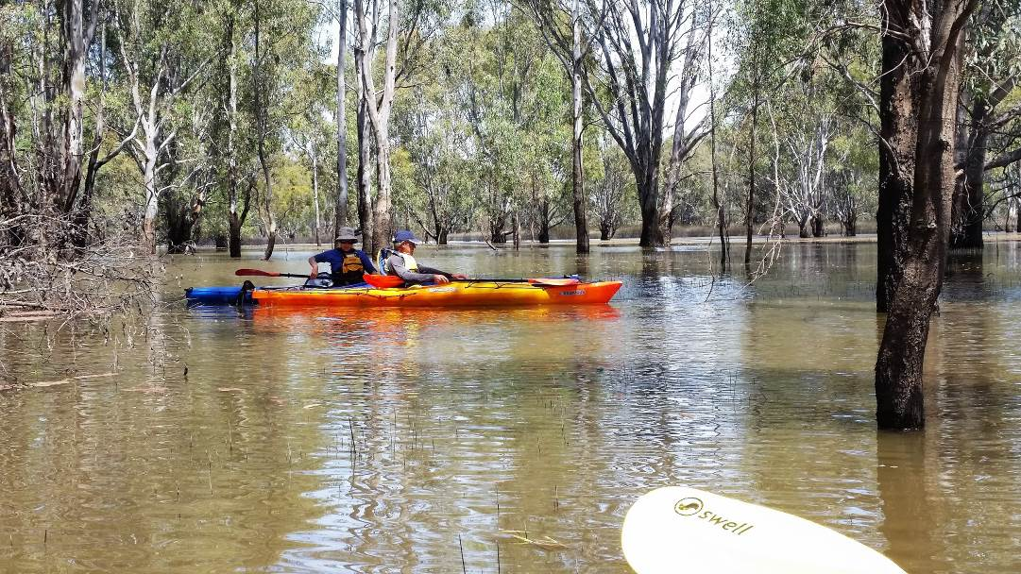

In November eleven Midweek Walkers enjoyed ideal weather conditions for our walk at Winton Wetlands in North East Victoria.
On arrival we had some morning tea at the picnic tables near the Mokoan Hub where we had views of the wetlands with plenty of water in it. It had been quite dry on our recent visits. Dianne had prepared a draft copy of proposed walks for 2017 which we were pleased to examine and comment on.
For our walk we set off in a westerly direction along the ‘Woodland Walk’ then continued on until we had walked about three kilometres. We then headed back walking closer to the edge of Winton Swamp.
After our picnic lunch we walked to the Observation area then followed the tree line on the edge of the swamp in a Northeasterly direction for about two kilometres before returning to the Hub Cafe for refreshments. We decided to go indoors because of the flies (no mosquitoes, thankfully) where we enjoyed lovely views across the water to the hills and mountains in the distance through the large windows. While drinking our coffee etc some of us saw a beautiful Diamond Firetail, feeding on the grass, one of the 180 bird species recorded at the location. During the day we saw waterbirds, bush birds, birds of prey as well as kangaroos and a wallaby. As we set off for home Ray kindly stopped and helped a turtle across the road to avoid the traffic.
Thanks to Dianne and Howard for their organisation and to those who drove. Another great day.

Marg Clarke
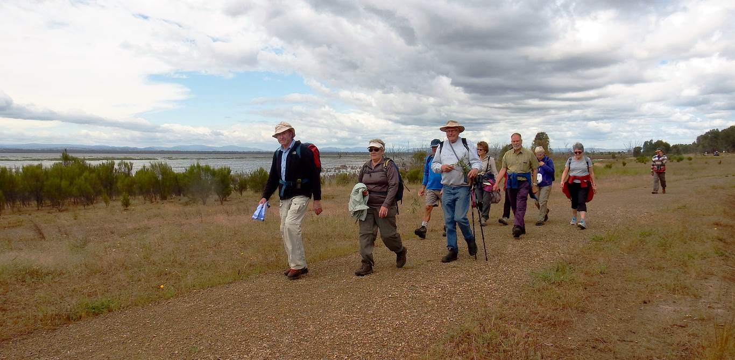

Mt Buffalo 2 day hike 29-30 Oct 2016
Saturday morning, Lizzy drove some of the way to Myrtleford where we met up with Rachel. From there we headed up Mt Buffalo, carefully avoiding all the cyclists, to start our walk from the Reservoir (a few km off the sealed road). Our path weaved around the hills and boulders, through snowgums and snow grass plains to impressively named rocky features such as Og, Gog and Magog. Eagle Point had a series of steel ladders to help us reach the top and impressive views over the Rocky Creek valley and Southern Buffalo area. Much of the bush has been burnt in relatively recent years and in places there are ghostly white, skeletal trunks lording over ( or frequently falling into) very thick regrowth underneath, but our track was clear. Late in the afternoon we reached Mollisons Galleries and explored the little caves and overhangs and admired the views straight down to Buffalo Reservoir. Our track from the Galleries turnoff was much smaller, less well defined and dropped sharply down to Rocky Creek. From there it was a short stroll along the fire track to Rocky Creek Camp area. It was a bit too late for lounging about and paddling in the creek, although the creek looked very inviting, so instead we hurried to set up camp and eat before our weary bodies called us off to bed. Late at night a huge storm passed over, with exceptionally strong winds roaring through the forest around us. I was glad we weren’t too close to any of the massive, Alpine Ash trees (dead or alive), as the area was already littered with these fallen giants.
Next morning was much cooler and a bit drizzly, but fine for climbing a big hill as we zig zagged back up the Rock Creek Fire trail to Wild Dog Plains and on to The Reservoir Picnic area.
Thanks to Greg, Lizzy, Moara and Rachel for making this a lovely weekend,
Jill Clapperton
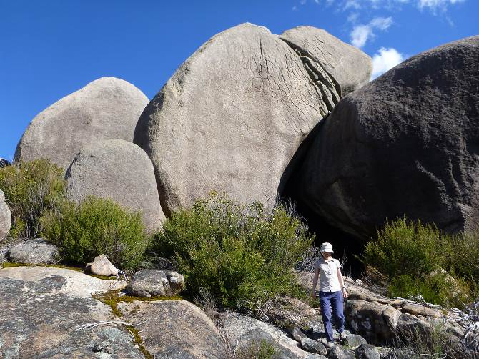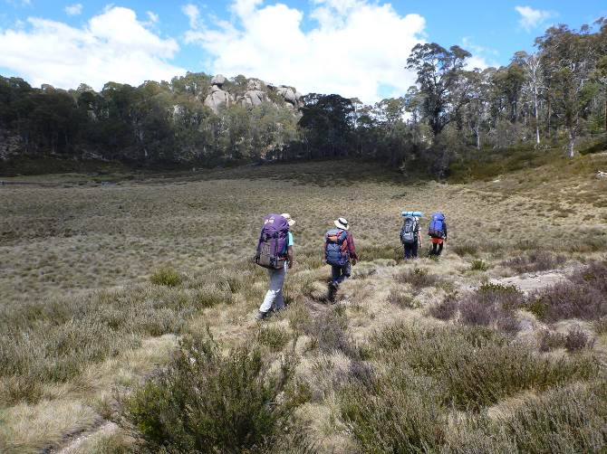

Bogong High Plains. 3 day hike 9-11th December 2016
The forecast for Thursday night was atrocious, so we chickened out of camping at Rocky Valley Pondage and found cabins at Tawonga instead. The overnight snow had disappeared by the time we reached the pondage on Friday morning, but a bitterly cold wind was whipping across the snow grass plains. After a brief climb up the Fainter Fire Track we stopped to play in a patch of remnant snow left over from winter and shelter from the wind for morning tea No 1. Shortly afterwards, we met with a large group carrying someone out on a stretcher. This explained the large number of ambulances and police vehicles in the car park. Fortunately, the patient was very cheerful and they were all on a training exercise, enacting a series of emergency scenarios located around the High Plains.
While we were munching on morning tea no 2 at Tawonga huts, a couple of rangers arrived and headed off along the track we were to follow carrying chainsaws. We had our own personal track clearers until lunchtime, when we overtook them and had to put up with the fallen branches ourselves. The track out to the Fainters has become much more like a walking track than a road since I last walked it, but it was being cleared enough for 4 wheel motorbikes to access the area for deer and weed control programs. With the track out of the wind and the sun shining, we were able to appreciate more the magnificent wildflowers on show. It was the best display I have seen up on the High Plains. We also had great views of Mt McKay.
Little Plain was absolutely beautiful, covered in snow grass, wildflowers, and snow gum regrowth with dead white stems above containing crows nests; but there was no time for rest, as we still had Mt Fainter South to climb. Our track was fairly easy and it was nowhere near as cold as it had been in the morning, so it wasn’t long before we were standing on top admiring the views to Mt Feathertop, Mt Bogong and all around.
Next morning, in perfect weather, we began by climbing up onto the Jaithmathangs (or Niggerheads). A few of us had the pleasure of saying hello to a rather large snake along the way! The top was a little bit scrubbier than I remembered, probably regrowth after fires, but fine to navigate, with constant impressive views across to Mt Feathertop. Morning tea No 2 was on the summit of Mt Jaithmathang, followed by lunch on the ridge behind Tawonga Huts. We saw lots of deer foot prints, but no animals although we did surprise a huge flock of crows having a convention, who loudly protested their disruption as they flew away.
After lunch we met some deer hunters out scouting with their gorgeous dog, before climbing to snow pole 333 and continuing along the track to Young’s Hut. Near where the Cobungra Gap track tuned off we came across a small herd of brumbies who eyed us warily but didn’t move far away. After a bit of scouting around, we found Young’s Hut still in existence and well cared for, in it’s own personal snow plain beside a lovely little creek.

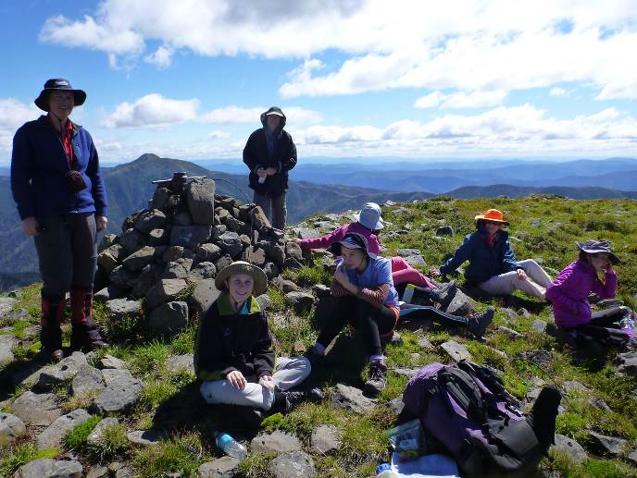
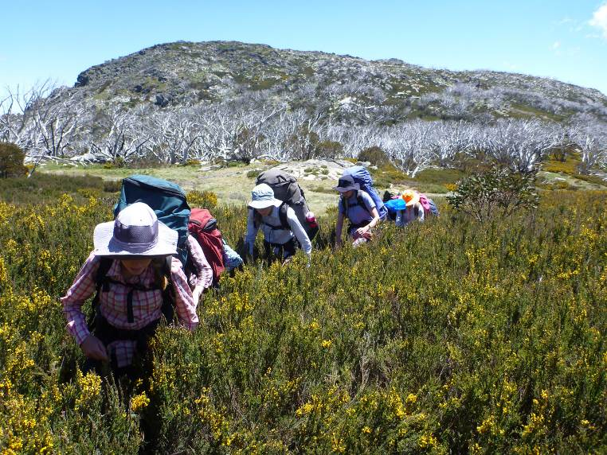
Thanks to all newsletter contributors for their articles and great photos.

The next newsletter will be out in FebruaryOctober, but feel free to submit items at any time+.+
=

