

**SAC Newsletter**

**December – January 2021/2022**

**Yea-Cathkin Bike Ride 20th Nov.2021 – Trip Report**

Big turnout on the day, weather was perfect for cycling.

14 people arrived at the Yea station ready for 10am departure. Total distance was 42km, so it was a good effort for those not regular cyclists.

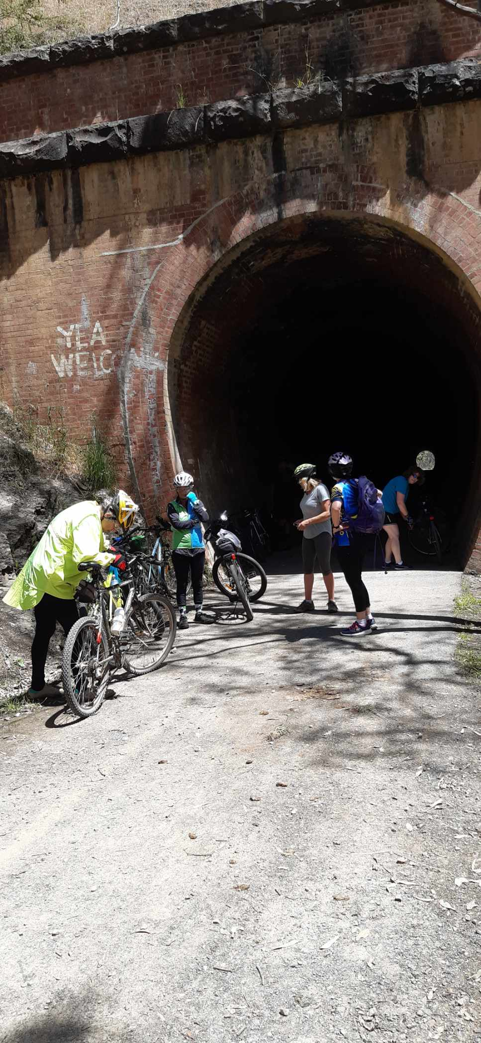First 5km from station easy going before the slow gradual climb to Cheviot tunnel at the 10km mark. The next 5km all downhill with little pedal power needed. As it was a big group we spread out, catching up at various places on the way. Plenty of other walkers and riders on the trail, at one stage 3 young boys arrived from nowhere joining our team for a few km.

Repairs required for one bike with a loose stand but not from our group! One of the joys of cycling is to meet strangers and help with repairs when possible. Good old insulation tape to the rescue soon had the stand temporarily secured and a fellow traveller grateful for help.

This section of the great Vic rail trail is particular good with plenty of scene changes, open fields, creek crossings, embankment cuttings and shady gum tree, oak and willow lined pathways and the highlight of course being Cheviot tunnel.

Crossing the Goulburn at Molesworth we arrived at Cathkin.

Lunch among the gum trees with more talk and stories before returning to Yea for a well earned rest and cool drink at the Peppercorn pub.

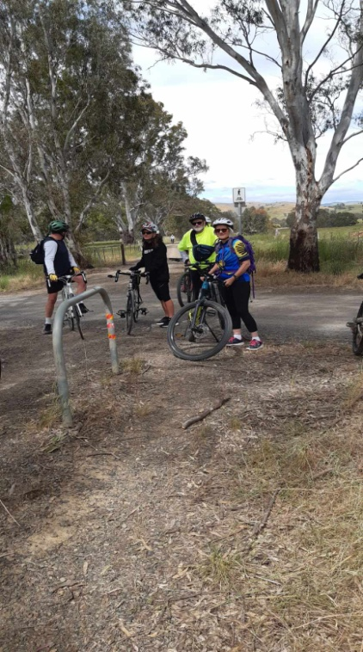 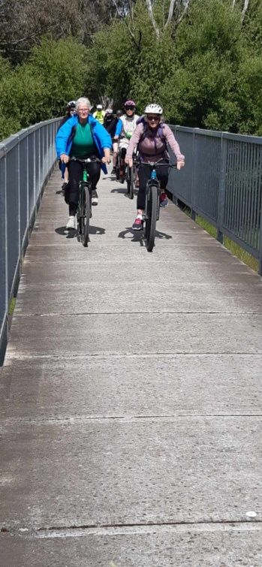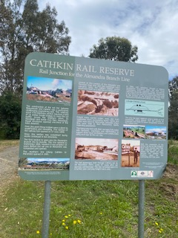

Dallas James

**Twilight Ride at Rushworth – Trip report**

Twenty riders turned out for the twilight ride at Rushworth. We left at about 4.00pm and headed off towards the old railway line and then through the gully to cross the Murchison Bendigo Road to Jones Road.

It was perfect weather for riding through the bush and enough breezes generated to keep the mozzies at bay. We arrived at the Whroo visitors’ Centre and some riders decided to ditch the bikes temporarily and walk up to the Balaclava Mine.

Unfortunately it is still closed so we could not venture down to the bottom of the mine. We walked around and looked through the tunnel, some reminiscing when we had walked through it times gone by.

We then remounted and headed back to Rushworth via Cheongs Road it was mostly downhill which was welcomed after quite a bit of uphill previously. We all adjourned to the Criterion Hotel for dinner.

It was a great way to end the year.

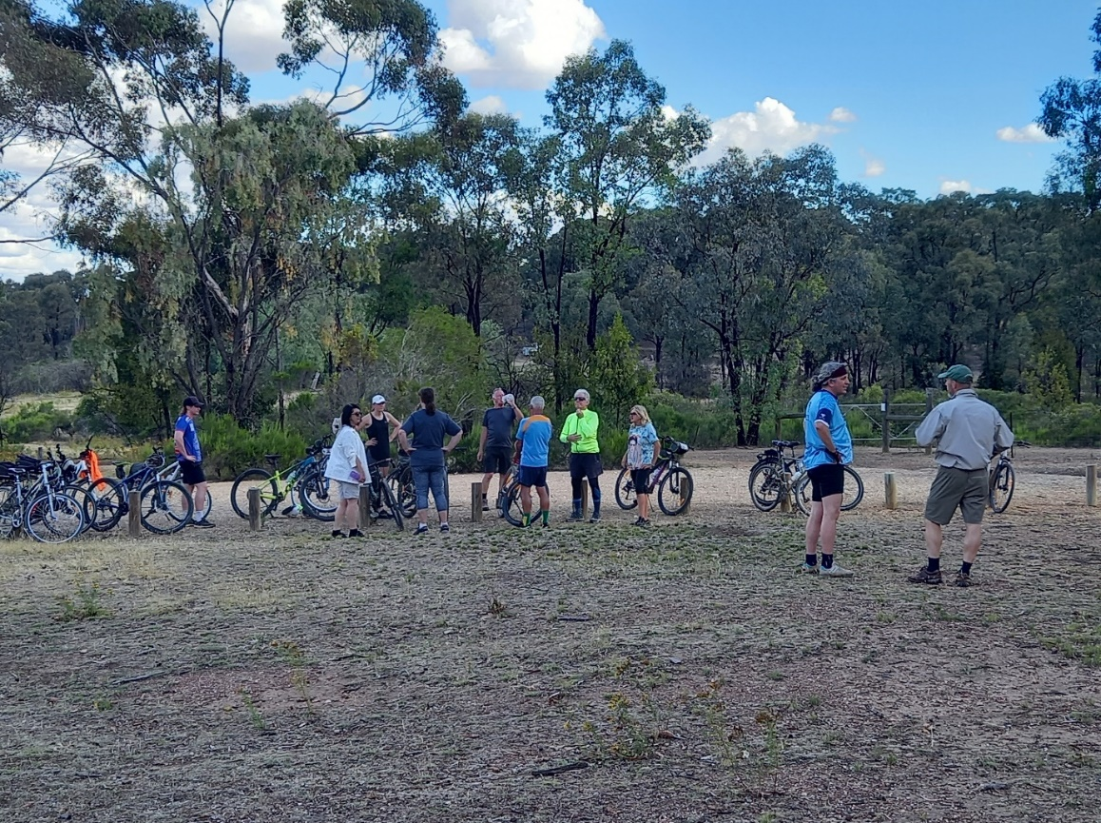

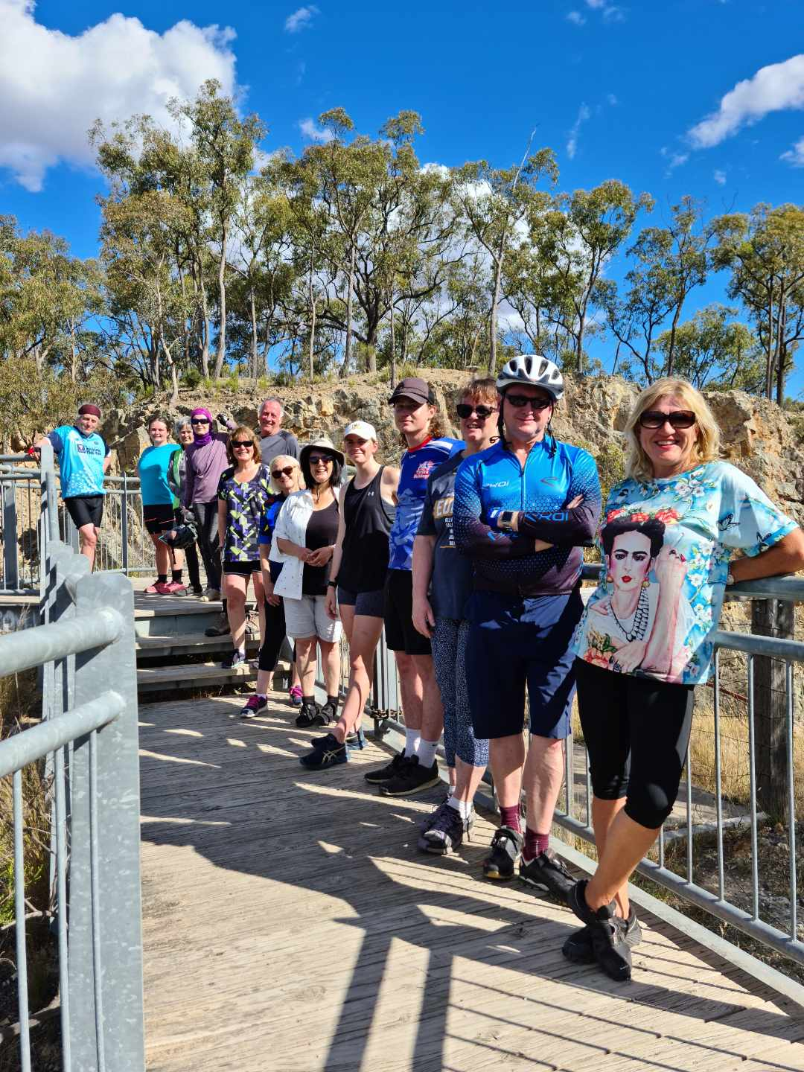

**1st ride for 2022 – Trip report**

**Botanic gardens - Kialla 3 lakes and return (Lazy 20kms)**

The day started with 4 cancellations “thanks COVID” but left a healthy 10 members for our excursion which began with a paddle on the lake a couple took the opportunity to even have a dip in the water!

Orders were taken and our delicious food arrived from the Macintosh fish and chip shop. After the dishes were done with we began our bike ride over the newly completed bridge into the botanical gardens.

The Bike path is different to the walker’s path to start with showing some lovely dense forest, and then we end up on the shared paths.

Only one snake was encountered by the first rider Genevieve, luckily she was watching out and stopped giving the big brown time to get off our path!

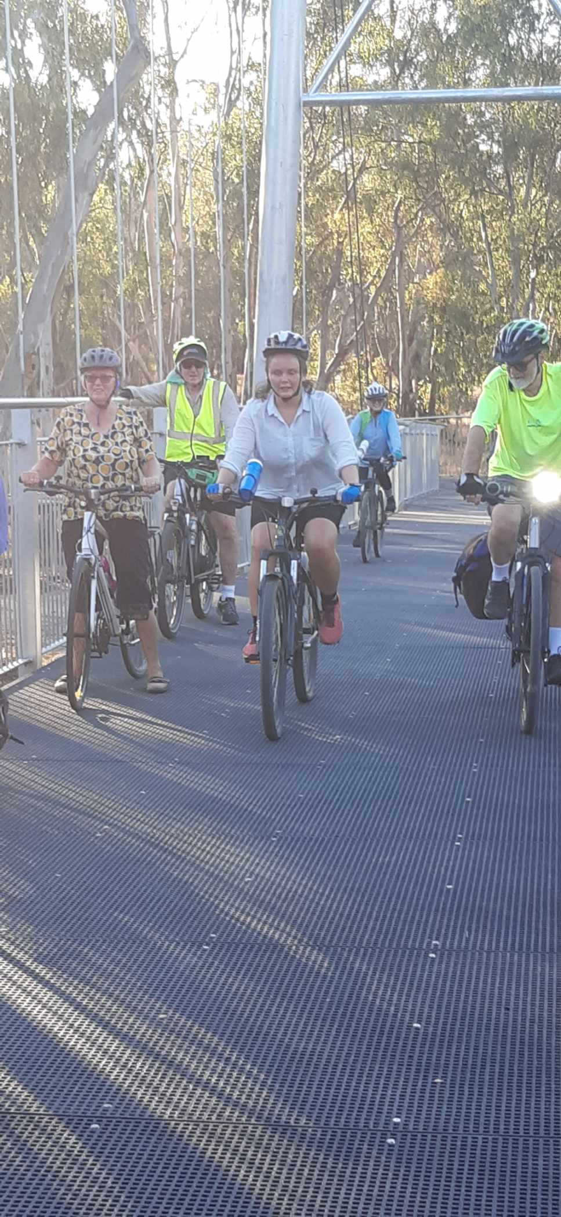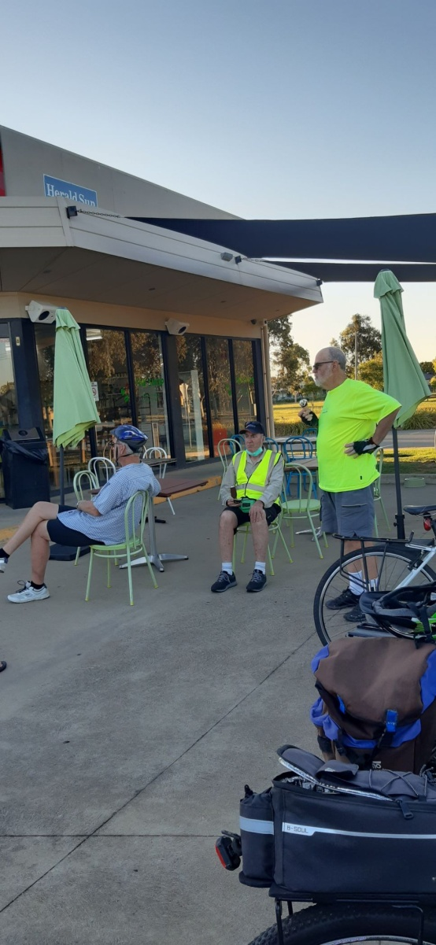From here we headed back over the bridge on to the path to Kialla lakes, after the first lake we veered off to the corner store were we indulged in an ice cream dessert! After riding the remaining lakes we arrived right on 9pm back at the shed.

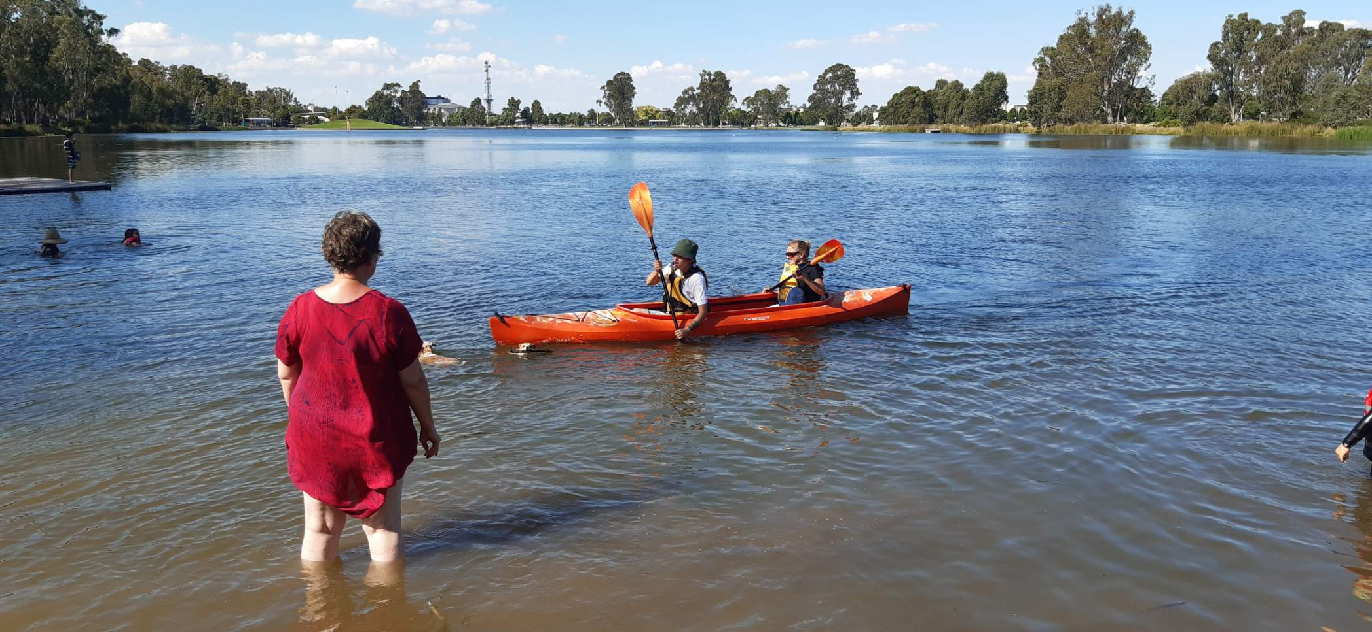

Midweek Walk to Botanic Gardens – Trip report

Wednesday 26th Australia Day we had five people who braved the heat to join the walk to the Botanic Gardens.

We met at the library car park and walked along the shared pathway under the bridge and along the river; walked on past Aquamoves and admired the view at the conjunction of the Goulburn and Broken Rivers.

There was lots of traffic on the path as we dodged bike riders and other walkers or probably more accurately they dodged us!

We loved the new bridge across the Broken River and then we were at the gardens which are always delightful. We wandered back the same way. We could smell smoke which was worrying but the emergency app stated that there was a fire near the causeway at Cemetery Rd nowhere near us.

However, there were a few campers situated on the river in different places and at one camp there was a fire with CFA in attendance, but we arrived back at the cars without any mishap.

We saw lots of birds on the walk and as always to be in the bush and near the river was wonderful.

**Tatura run for fun**

On a warm Sunday Dallas, Ray, Wendy and Shelley decided to ride to Tatura for lunch and back. While 3 of us had done this run before Wendy had not.

There are three points were it is so steep it’s safest to dismount and walk the bike down and back up the embankments.

That was until Wendy shows up!

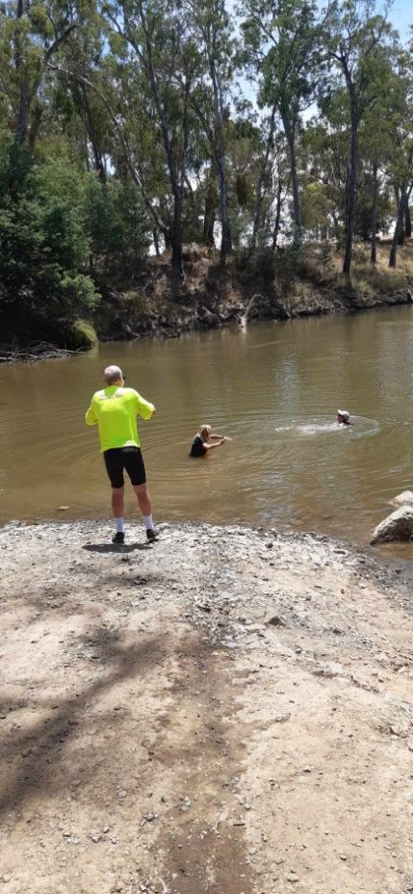So 2 grown men who previously were walking their bikes up and down were now suddenly riding up and down to keep up with Wendy!!

The ride itself is great, mostly flat with a very diverse scene from stage to stage. Sunday’s most of the stores in Tatura are closed so the local IGA supplied our DIY lunch before making the return trip.

As the temperatures were starting to rise Dallas wanted to go to the boat ramp to wet his top. While there Miss Adventure and Shelley went for a swim!

The trip is roughly 2 hours each way, but worth the ride!

**Funnies**

* 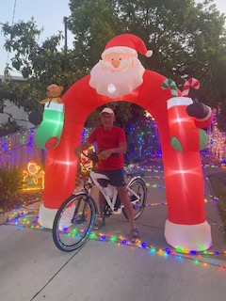“I’m sick of following my dreams, man. I’m just going to ask where they’re going and hook up with em later.”
* Bob: “Looks like you have been missing a lot of work lately.”

Peter: “I wouldn’t say I’ve been missing it, Bob”

* “Before you marry a person, you should first make them use a computer with slow internet to see who they really are”
* What has 4 wheels and flies? *A garbage truck!*
* Why did a scarecrow win a Nobel prize? *He was outstanding in his field!*
* What do sprinters eat before a race? Nothing*. They fast!*
* How does the moon cut his hair? *Eclipse it!*
* What’s worse than finding a worm in your apple? *Finding half a worm!*
* Why did the tomato blush? *Because it saw the salad dressing!*
* Why are fish so smart? *Because they live in schools!*
* Knock, Knock. *Who’s there?* Scold. *Scold who?* Scold outside let me in!

**President’s report**

Hi members,

Welcome to 2022, I hope you are all safe and well.

I was surprised to read of heavy rain in outback South Australia recently that covered roads and trapped some travellers. We’ve certainly had a wetter spring & summer than normal and it is a timely reminder to take care when conditions change during a trip.

Don’t try to cross floodwaters in a vehicle or on foot - How deep is it? Can you see the other side? Ensure you take a good raincoat on multi-day trips and even on day trips in the mountains and all but the warmest days – hypothermia can quickly come on if you are in wet clothes during cool, windy weather.

Check the weather forecast to decide whether to go and what to bring. Tell someone where you are going. Don’t be afraid to shorten or cancel a trip if weather or terrain conditions make progress difficult or risky.

Other useful tips can be found in [Bushwalking Victoria’s brochures](https://bushwalkingvictoria.org.au/brochures).

Hopefully we can enjoy a year full of activities in line with our calendar this year. Please follow the guidance of trip leaders to ensure we are operating covid safe.

Happy adventuring,

Greg

Activity dates for 2022

| **Date** | **Type** | **Location** | **Leader** | **Rating** |
| --- | --- | --- | --- | --- |
| 15th Feb  6 pm | Social | BBQ at SAC shed by Victoria Lake | Richard G  0408 547 065 | All |
| 19th Feb | Bike Ride | Huntly – Whipstick Forest | Jan |  |
| 23rd Feb | Kayak/Canoe | (Tentative – contact for interest)  Beginners skills  SAC Shed Victoria Park Lake | Neville  0428 311 576  Greg | Easy |
| 23rd Feb  8 am | Midweek Walk | Boathole to Mineral Springs Strathbogies | Howard  0437 628279 | Easy/Med |
| 9th Mar | Kayak/Canoe | (Tentative – contact for interest)  Beginners skills  SAC Shed Victoria Park Lake | Neville  0428 311 576  Greg | Easy |
| 19th Mar | Bike Ride | Katamatite | Kerry |  |
| 23rd March  8 am | Midweek Walk | Toolamba Bushland | Jenny  0407 556639 | Easy |
| 2nd – 3rd April | Overnight walk | Feathertop – Razorback  (Beginners pack carry) | Neville  0428 311 576 | Easy/Medium |
| 26th – 30th April | Midweek Walk | Tree tops camp  Gunbower Island Tues - Sat  3 days walking, canoeing, bike riding, bird watching, scenic driving etc. | Richard G  0408 547 065 | Easy |
| 21st May | Bike Ride | O’Keefe Rail Trail | Dallas |  |
| 25th May  9 am | Midweek Walk | Lima Creek | Judy & Ted  0458 252923 | TBC |
| 18th June | Bike Ride | Waranga/Murchison | Geoff & Linley |  |
| 22nd June  9 am | Midweek Walk | Rushworth Whroo forest | Jan  0438 093 668 | Easy |
| 16th July | Bike Ride | Everton to Myrtleford | Wendy & Martin |  |
| 27th July  9 am | Midweek Walk | Broken Creek  Nathalia or Katamatite to Dip Bridge. | Barb  0409 178091 | Easy |
| 20th Aug | Bike Ride | Moyho | Ray |  |
| 24th Aug  9 am | Midweek Walk | Warby Ranges. | Maartje  0407 849794 | Easy/Medium |
| 17th Sept | Bike Ride | Winton Wetlands | Ray/Dallas |  |
| 28th Sept  9 am | Midweek Walk | Terrick Terrick N.P | Dianne  0437 289 281 | Easy |
| 12th Oct  9. am | Midweek Walk | Mt Black (offroad) | TBC | Easy/Medium |
| 15th Oct | Bike Ride | TBC | TBC |  |
| 26th Oct  8 am | Midweek Walk | Euroa Seven Creeks / Balmattan Hill | TBC | Easy/Med |
| 19rd Nov | Bike Ride | TBC | TBC |  |
| 23rd Nov  8 am |  | Mt Wombat Strathbogies | TBC | Easy |
| 17th Dec |  | Twilight Ride TBD & BBQ at shed |  |  |

**Trip Leaders:** *Please remember to ask visitors to sign an Acknowledgement of Risk form for Temporary Members and pass it on to our Secretary, Karen. This form is available on our website once you login (member, bushwalk) under Members>Leader Information. It is a requirement of our club insurance policy.*

**Everything BIRD’S**

**Marg Clarke**

                                        Rainbow Bee-eater

**ROYAL SPOONBILL**

There are two species of Spoonbills that are found on waterways throughout Australia, the Royal Spoonbill and the Yellow-billed Spoonbill.

This photo was taken locally and shows the Royal Spoonbill in breeding plumage.

The red mark on the black forehead and flowing head plumes are usually absent in the non breeding season.

The Royal Spoonbill feeds by walking through shallow water and moving it’s opened long spoon-shaped bill from side to side. The head is thrown back to swallow the prey which includes fish, crustacean and aquatic insects. This is an interesting large white water bird to observe.

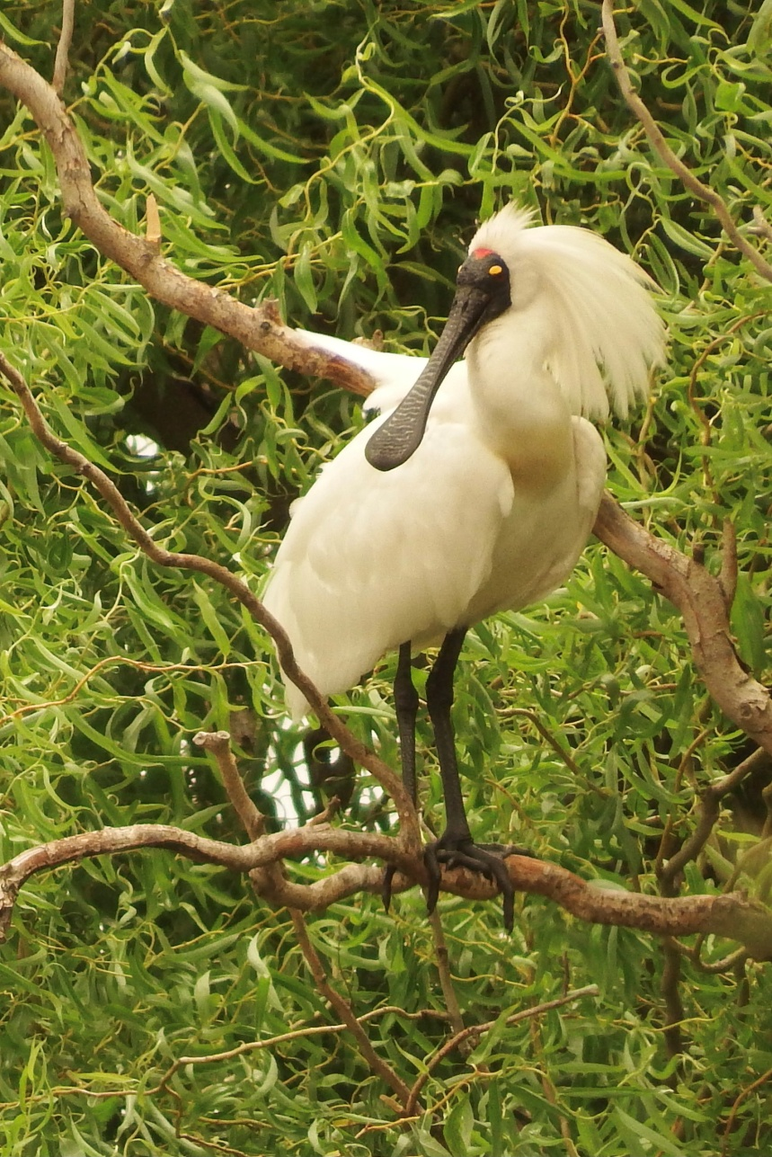

Article and photo - Marg Clarke

**Editor’s note**

Hi everyone, happy new year and happy Australia day to you all ☺

Firstly a couple of updates for you all;

There has been a delay in our club shirts, as such I have taken on the project and am perusing a local supplier. They have said it will be 6 weeks from design sign off. At this stage we can look at getting our short and long sleeve tops in time for Easter. *Fingers crossed*

Both twilight rides were very successful and has encouraged members who have previously been unable to attend our normal days due to work, hours or other commitments, as such this is something we could look into at as a group. For there to be more adventures we need Leaders!

Who has a great ride/walk that they would like to lead us on?

If anyone is interested on taking the Adventure Club back to the waters put your hand up and let us all follow your lead ☺

#### President: Greg Smith 5824 1143 president@shepadventureclub.org.au

#### Vice President: Bruce Gill 5824 2548 tatgills@westnet.com.au

#### Secretary: Karen Speedy 5825 1785 karenspeedy@iinet.net.au

#### Treasurer: Scott Birchall 5831 6063 scottb@agsystems.com.au

#### Newsletter Shelley Wyllie Shelley.wyllie@gmail.com

#### Equipment Officer: Richard Graves 5824 2929 richsue@bigpond.com

#### Publicity Officer: Richard Speedy 5825 1785

#### Calendar coordinator: Neville Paynter 5831 1576 Neville.Paynter@jacobs.com

#### Mid-week coordinator: Dianne Hanna 0437 289 281 dhanna3@bigpond.com

Correspondence to: The Secretary SAC, PO Box 264, Shepparton 3632

Or email: [sacvicau@yahoo.com.au](mailto:sacvicau@yahoo.com.au)