SAC Newsletter
April-May 2023

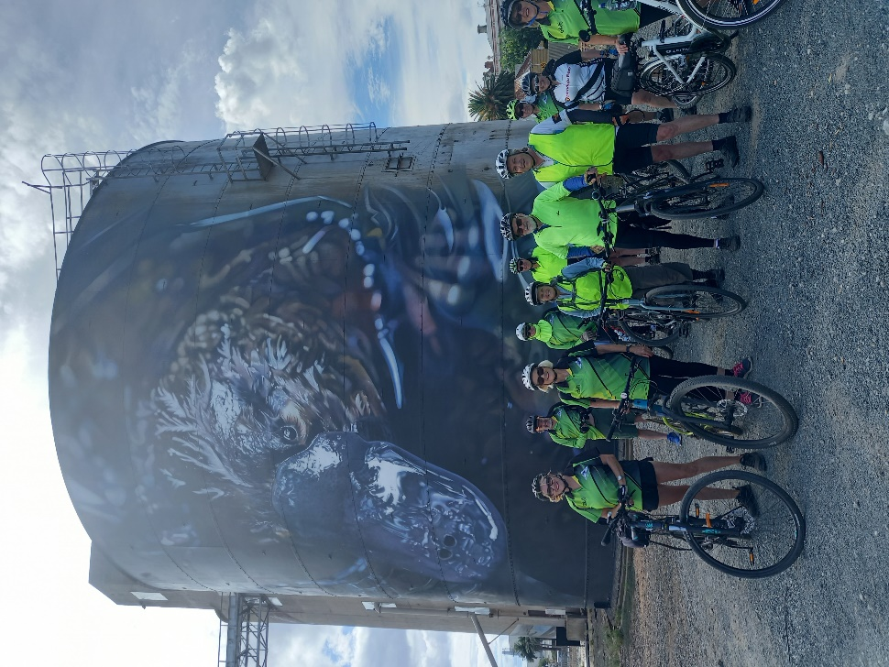

Elmore to Rochester Return Ride 11th March 2023
Thirteen riders fronted up on a beautiful Autumn day at Elmore for the start of the ride. It was easy riding mainly on a gravel road and fairly flat. We passed some very big impressive farms as we chatted and rode along. We arrived at Rochester and stopped for a group photo at the new silo painting which features a platypus. It was very impressive.

It was here that we caught up with some of the walkers from the Echuca Moama Bushwalking Club who were walking along the Campaspe River and like us were planning to have lunch to support the
Recently flood ravaged town.
As it was too early for lunch we rode along the river path where there was evidence of where the floods had impacted the area although the river was very low now. Arriving back into town we went our own way for lunch – the café , the bakery and the Rochester Hotel. After lunch we reconvened at the ‘Platypus Silo’ and headed back to Elmore. It was a pleasant day, a good ride and great company.

Jan Gregory

Wangaratta to Boorhaman return Saturday 15 April
Ten people fronted up at the Apex Park in Wangaratta to ride to Boorhaman. The weather was a little bit risky with rain forecast. We rode along the rail trail to Bowser and then crossed the highway and then took a dirt road that followed the old railway line to Peechelba. The countryside was farming land and a herd of cows were very interested in these strange creatures.
We arrived in Boorhaman and the hotel was very hospitable allowing people who had brought their lunch in the lounge where it was very cosy. Others indulged in a pub lunch before we headed back to Wangaratta. We had planned to go along the bitumen road but as it was quite busy the consensus was to return the way we had come. We arrived back at Wangaratta at about 3.30pm in time for a coffee before heading home. We were lucky and just beat the rain.

Thank you to Phil for the Relive video which can be viewed here. https://www.relive.cc/view/vJOKxn7kj56

April Mid week walk : Winton Wetlands
On a beautiful autumn day 19 walkers had a very pleasant walk along Boggy Creek road to the historic and scenic Greens Hill area. As always the wetlands gave us a great experience in its special environment. It was a different perspective to walk along Boggy Creek Road over the creek and past several historic sites rather than usually driving this section to another walking place. We turned off Boggy Creek Road into the Greens Hill area and first stop was the camping area with information boards, signage, toilets and picnic tables amidst the marked camping sites. (You can book online to camp at this lovely spot). Beyond this a more formal road/track has been added out to Greens Spit which provided great panoramic views across the main wetland. At the moment there is still considerable water from last October’s rainfall event and the more recent rainfalls. This made for very special views. As one walker commented “you’d be rapt to go to Kakadu and see sights like this and it is so close to home”.
The group then walked to the historic site of the Green family homestead and read and saw evidence of the life once lived by the early non indigenous farmers. After pondering these historic harsh living conditions we walked to Greens Hill and found a suitable lunch spot looking out across the wetland. After lunch we headed past the information site/car park area to the Boggy Creek road and then back to our cars.
Before our usual coffee stop we had a quick walk through the impressive LotjPatj Natjan Danak, Sculpture walk; a creation of cultural works by 15 Yorta Yorta artists. Several of the group said they would like to return when they had more time to fully appreciate the information provided about these quite amazing works.
While enjoying our coffee in the Mokoan café we were fortunate to have Graeme Domm, the Winton Wetlands Marketing, Media and Communication Project officer give a most interesting overview of this restoration project and many were surprised to learn that it is the largest wetland restoration project in the southern hemisphere.
All up we walked nearly 10kms before driving back across the Broken River Valley to Shepparton; another most enjoyable day for our mid week walkers. Dianne Hanna.

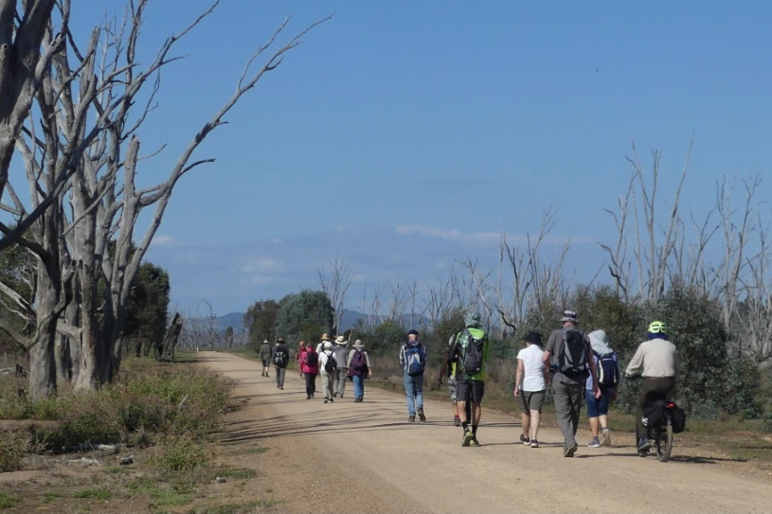
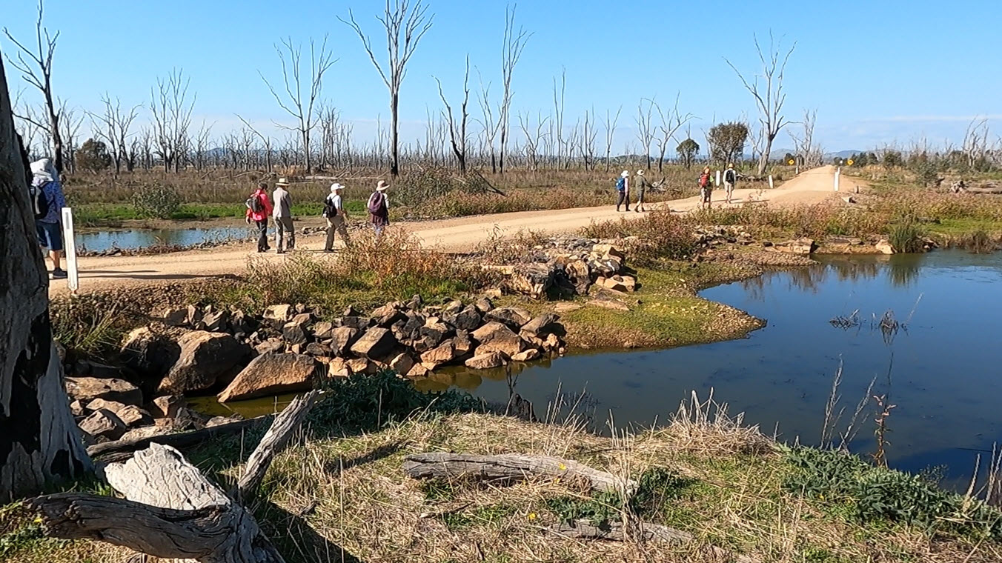

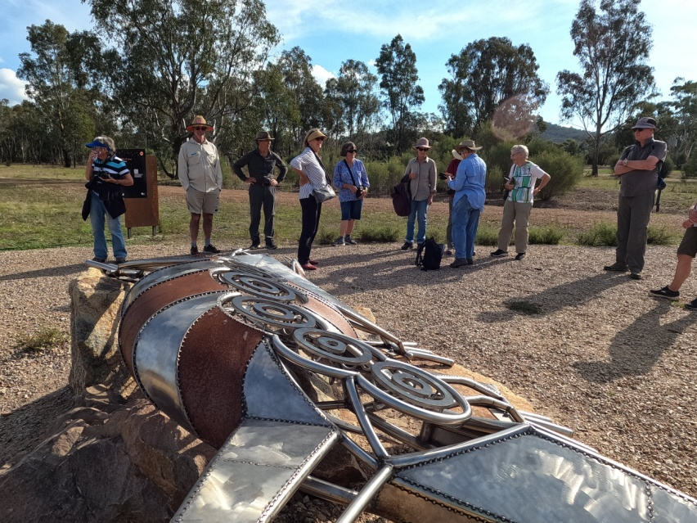

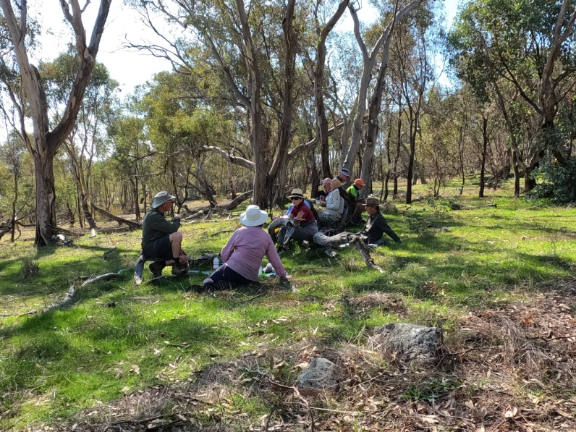

Midweek Walkers Camp at Treetops Scout Camp

Gunbower Island.

27 - 31 March 2023

There were sixteen campers who had a fabulous time at this beautiful spot on the Gunbower Creek. The facilities were excellent with a great camp kitchen and hot showers. Richard and Rosie (his dog) did the security check each morning and evening and one morning discovered a turtle laying eggs. There was evidence of other turtle nests but unfortunately they had been raided by foxes. (See Richard’s report below)
Each day there was the decision to walk, bike ride or canoe and many people did a combination of these. Thanks to Ray for bringing the canoe trailer and for taking some novices on tranquil paddles up the creek. Each evening and some mornings the colourful canoes could be seen on the water.

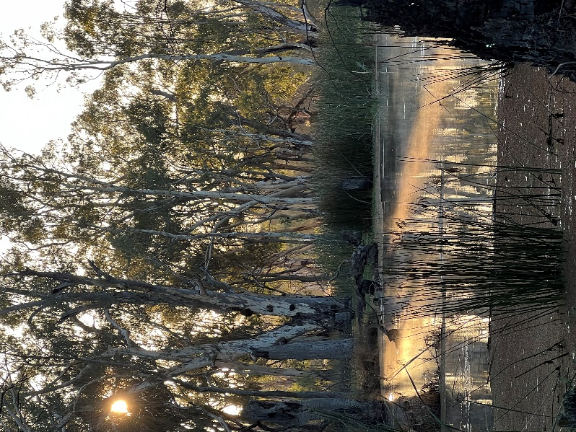

.

Bushwalking - Jan Gregory
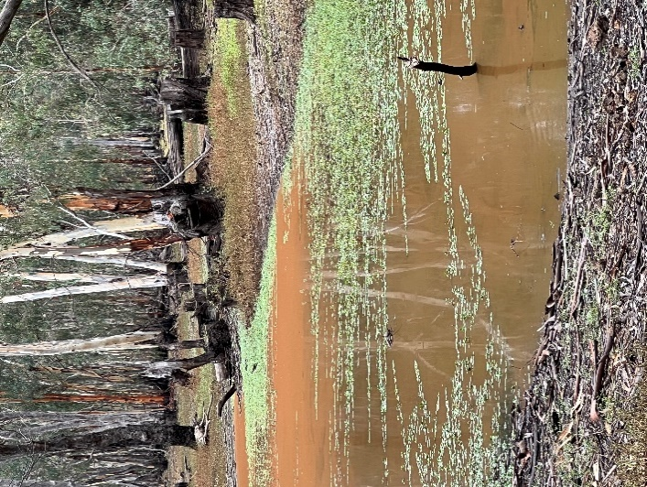
There were three walks over three days. For the first walk, the group headed out along Hudson track which initially followed the Gunbower Creek. The views along the track were quite stunning, especially so, as the dampness from the overnight rain highlighted the forest colours. A few kms further on, the track left the creek and crossed through the forest until Horseshoe lagoon. The subtle changes in the habitats meant a variety of flora and we sighted many different birds. After lunch we completed circumnavigating the lagoon before retracing our steps to return to camp mid afternoon.
The second day we walked along the Reedy Swamp lagoon where there again many bird sightings. On the lagoon we saw a large family of black swans as well as a variety of other water birds The walk was leisurely with beautiful vistas of the water especially pretty as it was covered with green water weed. We saw some ruins of bygone eras and where trees had been planted in earlier days. It was strange to see trees in the bush all lined up in rows. The whole loop was eight kilometres, and we were back at camp in time for lunch and a leisurely afternoon.
Upon returning home we discovered that a distinctive spider we spotted on several occasions, was actually a Red headed Mouse Spider who have a very toxic venom which is potentially as dangerous as that of a Sydney Funnel-web spider. Fortunately, at the time we didn’t make too close an acquaintance.

The third day we were joined by Dianne and Howard’s friends Stephen and Margot who were locals and hence very knowledgeable about the area. We drove to Koondrook along the Koondrook Road which was very picturesque with lots of beautiful trees alongside the road. We also had fun watching an emu family trying to get away from us – they certainly have an interesting gait! There were many kangaroos as well, and on the way back to camp Howard rescued a turtle on the road. So we certainly had a fill of wild life.
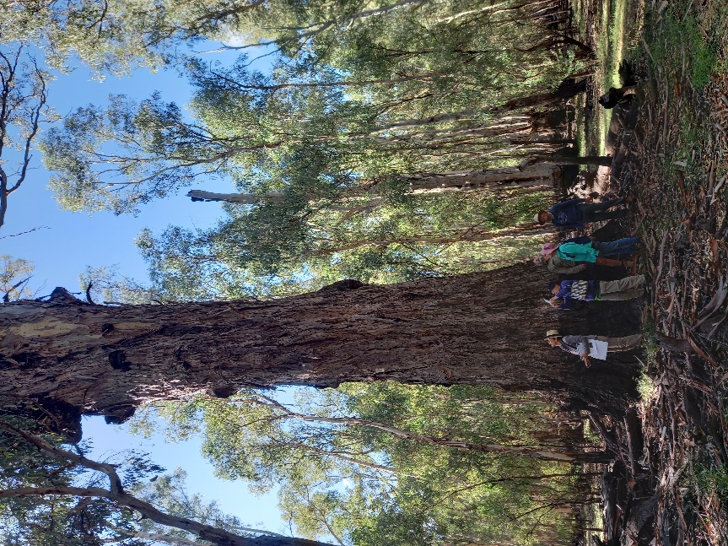

We walked the Eagle Loop which had many interesting things to see. We could see how high the flood had come up as the bottom metre of the trees was a black colour. There were many big, dead, ring-barked trees. The theory was that if you killed these very big trees more trees would grow. A shame to see so many of these scattered throughout the bush. One highlight was Sentinel Tree which was huge! The six walkers stood around it holding hand and we could not meet up. During the millennial drought the locals placed sandbags around the base of the tree and filled it with water from tankers to ensure that it would survive. Dianne led us successfully along this loop of approximately seven kilometres and we then went into Koondrook for a well-earned lunch.

Tree Top Camp Bike Rides - Ray Musty

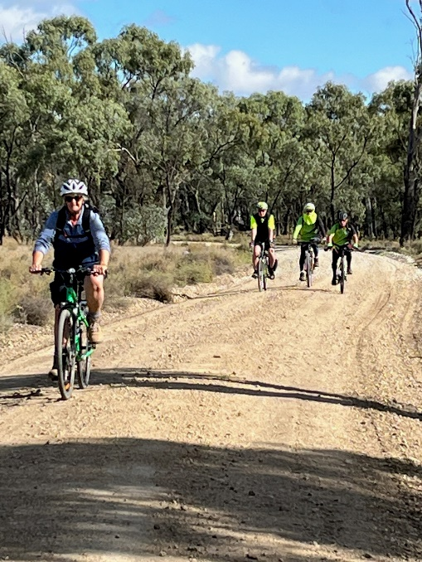
One the Tuesday, the second day of our Camp, the weather was fine so four of us decided to ride to Koondrook via the inland Gunbower to Koondrook Trail. This section of the trail was a bit of a challenge in places as to the surface was corrugated most of the way… the up side was coming across kangaroos, emus and some bird life. We had lunch at the Koondrook General Store. Our return ride was by the main road from Koondrook to Cohuna to Tree Tops Camp.
Great Day Great Ride.
Wednesday, we rode from Tree Tops Camp to Cohuna. Again we rode the inland trail to Cohuna. This was a much easier ride as the trail surface was in much better condition. Our lunch break was at a place called Waffles and a great meal was had by all. Plus, we had a waffle! Our return ride again by road back to Tree Tops Camp… another Great Day's Ride.

Kayaking Report -Ray Mustey
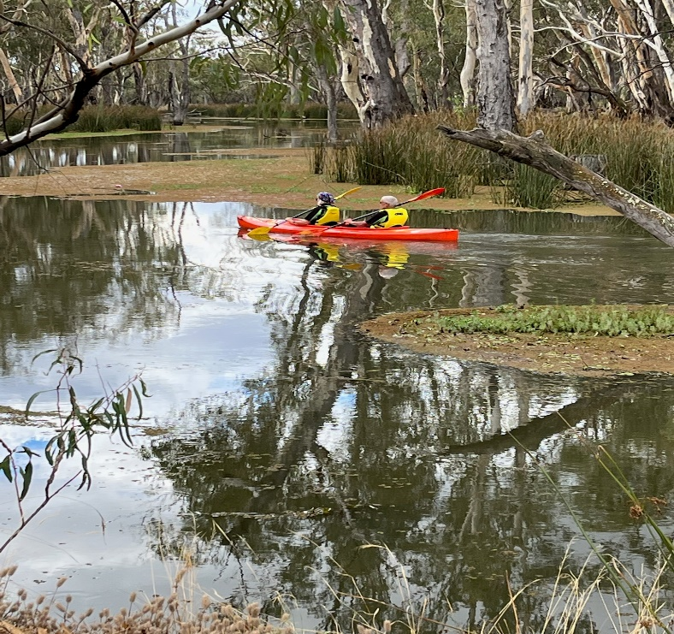

It was good to see a number of people take advantage of the Kayaks
The Gunbower Creek is a really nice Creek to paddle down with it's changing Vegetation and the Bird life ( I was told not to mention that Barbara Brown and Jan Gregory had a paddle with L Plates on so I didn't mention it of course)
Just another part of a wonderful few days away at the Camp. Cheers Ray.

Birdwatching at Gunbower Island -

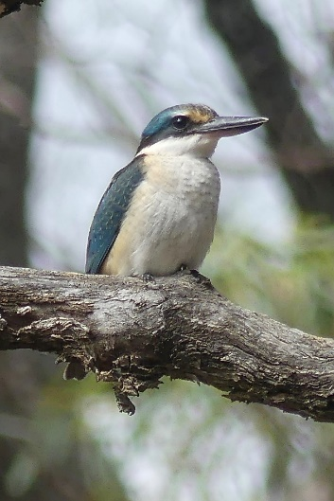
Marg Clarke
During our stay 65 bird species were seen on bird watching walks and at other times.
With the varied habitat we saw waterbirds along the creek and on billabongs, while bush birds were seen in the mainly black box forest, in River red gums and on grassy areas.
Those kayaking enjoyed seeing Azure Kingfishers along the Gunbower Creek.
On walks a variety of birds were seen including Sacred Kingfishers and Nankeen-Night Herons.
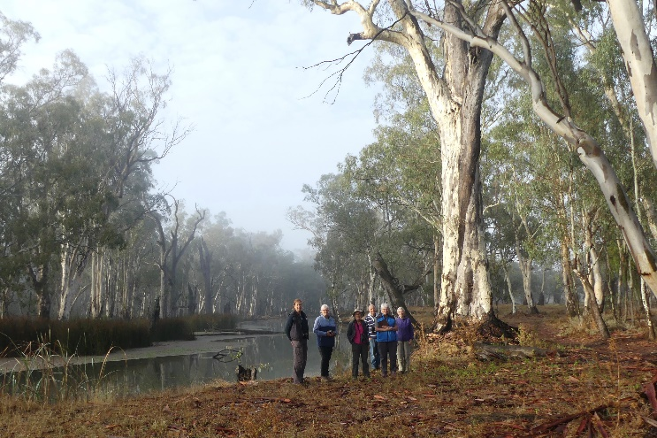
Around the campsite we saw small birds including Hooded and Red-capped Robins and Jacky Winters.
As we were enjoying sitting around the campfire one evening an owl was seen feeding on rain moths that were attracted to the lights on the buildings. BooBook Owls were heard calling in the night.
It is always interesting seeing different birds when travelling to another area.

Turtle Report - Richard Graves.

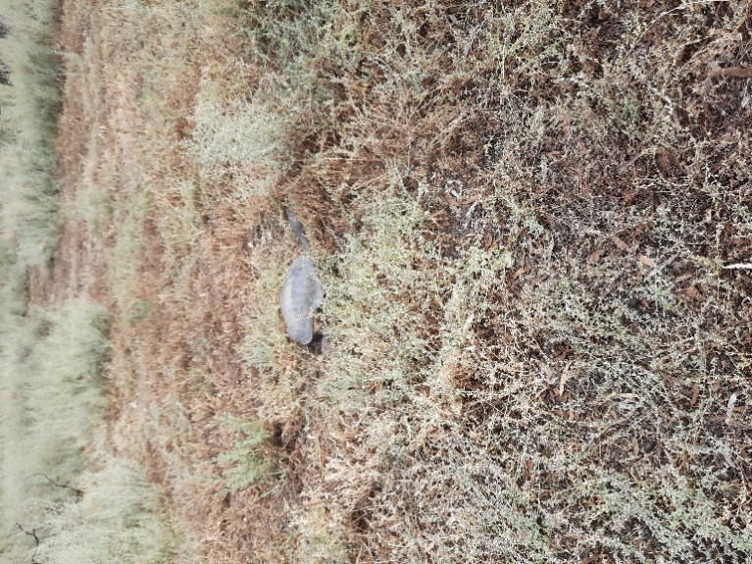
The timing of this year’s camp coincided with the annual nesting by the many Long Neck Turtles on this inland island. Consequently the conservation group Turtles Australia Inc. were actively seeking out nesting turtles on the island with a view to covering the nests with wire mesh to protect the eggs from predators, largely foxes, from digging them up.

Whilst my dog Rosie & I were on one of her numerous daily walks, I was fortunate to witness a large turtle in the process of laying her eggs. She had not seen me initially and it was a privilege to quietly witness nature at work. I took photos and marked the site and after mentioning what I had witnessed, Dianne contacted Turtles Australia and gave them details of the location of the nest. The Turtles Australia representative called into the camp site early the next day and confirmed that it was indeed a nest with eggs. He covered the area with protective mesh and said that the eggs will take about twelve months to hatch. He mentioned that a significant percentage of the hatchlings will not survive as they become prey to birds as well as other predators as they make their way to the nearby Gunbower Creek, which in this instance was some two hundred meters from the creek.

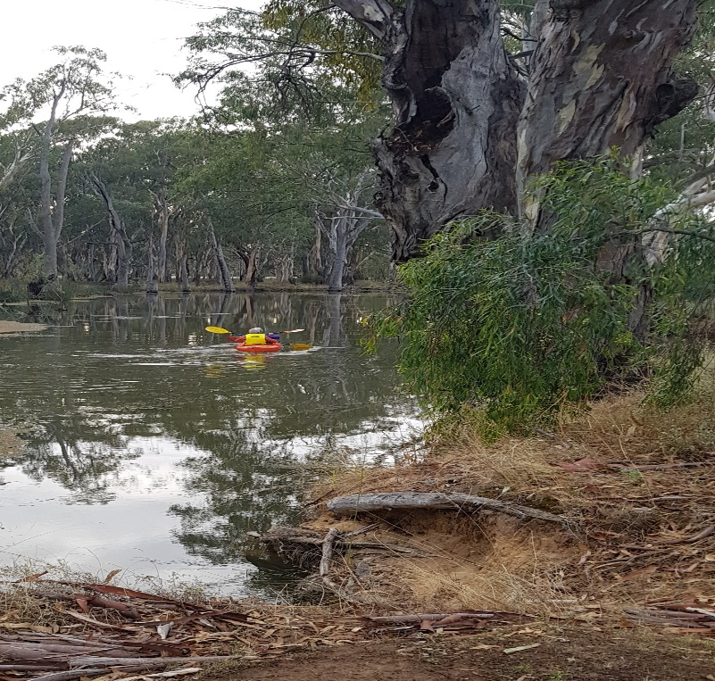
Kerry Storer
Most of the campers took advantage of the club kayaks bought to the camp by Ray. The Gunbower Creek was delightful to paddle on with very little current. Nearly everyone was lucky enough to see the beautiful little Azure Kingfishers who live on the banks of the creek and some people saw other birds and turtles. Barb Brown had her first kayaking experience thanks to the ever obliging Ray. All in all another wonderful part of our time at Treetops Camp. -Kerry

Everyone voted this a wonderful time away in a beautiful location which ticked all the boxes for our midweek walkers camp.
Finally, thank you, Richard Graves, for your planning and organisation for such a successful camp.

May AST (Around Shepparton Trails) walk.

This new monthly walk got off to an excellent start when on a glorious autumn morning, eight walkers met at our SAC shed for our two-hour walk. The decision was made to head over the foot bridge towards Mooroopna and to follow the dirt trails along the west and north sides of the river. Surprisingly we met a couple of vehicles and cyclists and at one point turned back and detoured around some weed spraying operations, before coming close to the highway near Mooroopna. We then headed back and crossed the river via Dainton’s Bridge and returned along the formed path behind the Welsford St buildings. In this area we noted some historic features including the dilapidated old wharf and the old river course, and then met a group from the Benalla walking group doing an historical walk around this part of Shepparton. We stopped off at Aquamoves for a coffee before we returned to our cars.

This proved to be a very pleasant 8 km walk and we were pleased to welcome a new SAC member on the walk and to the club. It was good to see that this new monthly walk is a goer. So if you are interested in a monthly two-hour walk around the great pathways of Shepparton, pop the second Wed of the month into your diary and turn up at our shed at 9 am. (8 am in daylight saving time).
Dianne Hanna.

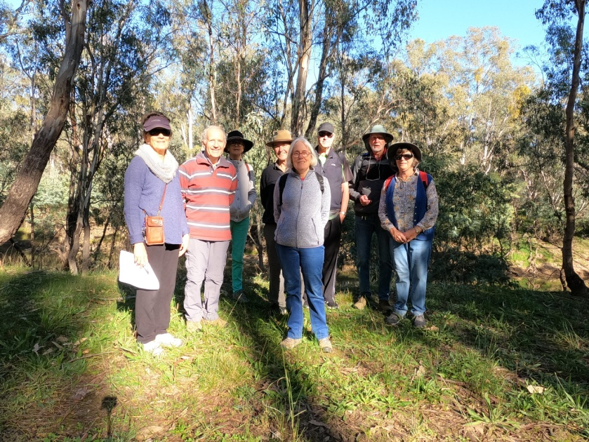
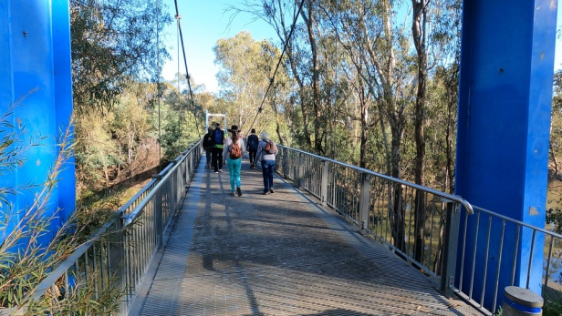

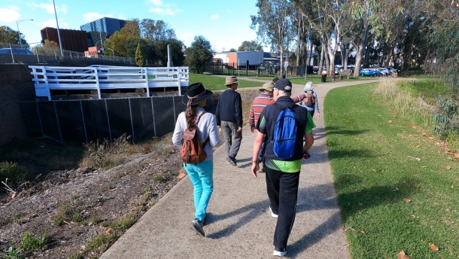

Walking and Foodie Tour in the Dordogne Region France
This tour was a combination of walking and enjoying the culinary delights of the Dordogne Region. We stayed in the small village of Monpazier for the entire tour in a beautiful hotel.
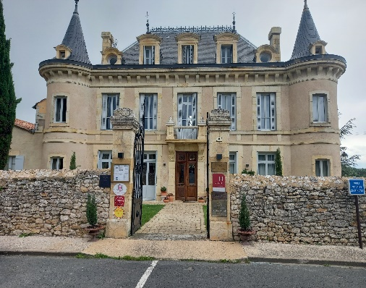
The Hotel and flower market in Monpazier

Each day we were bussed to the start of a walk and they varied from 4kms to 13kms walking from village to village and through beautiful oak forests. We saw many castles and beautiful homes and attended some great markets in Monpazier and in Issigeac. We visited a truffle farm (no truffles) and a caviar farm where we got to taste the caviar with champagne. On the last day we attended a cooking school where we were shown the art of French cooking and then afterwards did a 8km walk.

Many of the walks were on part of the French Camino. By Jan G

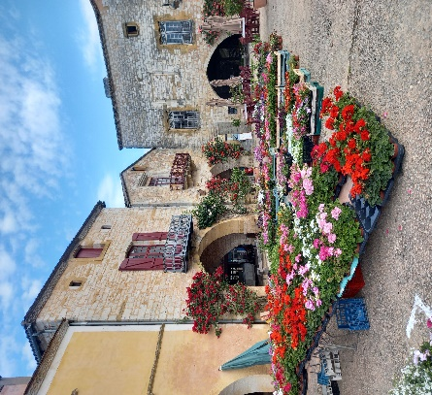
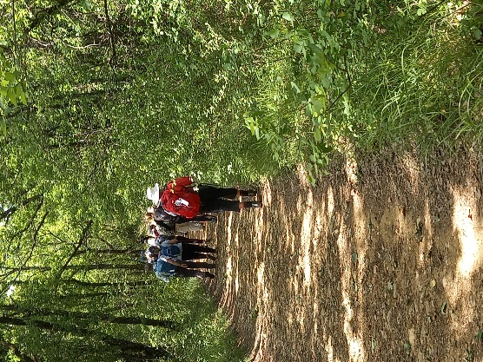

SAC Ride Mulwala - Corowa 20-21/5

Fast Facts
- Organisers: Wendy Kennedy and Marty Harper
- Ride leader: Wendy Kennedy
- What: 2 day overnight ride 20/5-21/5
- Where: Mulwala to Corowa return - relatively new $3.6M shared path.
- Distance: 45km approx each way.
- Terrain: bitumen shared path, and state of the art 200m ‘boardwalk’; gently undulating beside Lake Mulwala, the Murray River and past cropping/grazing land.

Day 1. Mulwala to Corowa
- Participants: 12 (50% more than I thought would turn up - well done Wendy and Marty!)
- Departure: Mulwala Bakery at 12.30pm
- Arrival: Corowa 4.30pm
- Weather: Cool temp, partly sunny, tail wind, short shower of rain at Corowa.
- Entertainment:
  - Drinks at Corowa Golf Club
  - Dinner at the Newmarket Hotel (aka the Newie}
  - Accommodation in various hotels and caravan parks.
- Injuries: nothing reported

Day 2. Corowa to Mulwala
- 9am: group breakfast at Corowa Distillery
- Departure: 10.10am
- Participants: 11 riders headed back to Mulwala; the 12th was last seen driving off in their car in search of the perfect muscat.
- Arrival: Mulwala: 2.30pm
- Weather: partly sunny, screaming head wind the WHOLE WAY back. E-riders were closely monitoring their batteries - one bar left, 5km still to go……
- Injuries observed/reported: sore knee/s; skinned arm and probably sore other bits from a WTFH moment (where a rider lined up a turn onto a concrete footpath-gravel nature strip interface and have no idea what went wrong!).

Learnings:
- Lamington fingers should be the official rider reviver food.
- Keep still at the breakfast table in case a waiter is stealthily sliding an unclaimed latte-in-a-mug on to the table next to your elbow; and make sure you leave a wide enough gap between you and the next person so that the knocked over said latte-in-a-mug doesn’t splash on to either of you.
- People in a group larger than 6 cannot be trusted to pay attention to the wait staff to know if their drink/meal/latte-in-a-mug order has arrived.
- People in a group larger than 6 cannot expect kitchen and wait staff to pay attention to menu-messing orders by individuals in a group larger than 6.
- The trail is awesome to ride - it should soon prove as popular as the Tallarook-Yea rail trail.

Poetic Licence
The Ryders
(Strongly influenced by ‘The Tyger’ by William Blake, 1794)

12 SAC ryders pedalling bright,
Keeping the river on their right;
What elevation low or high,
Could tame thigh fitness symmetry.

In what distant wineries
Burnt the fire of 12 pairs of eyes.
And when their hearts began to beat,
What dread knee, and what dread seat?

What the chatter? What’s to claim.
In what furnace was thy frame?
What the voice that starts to rasp?
With the lungs that start to gasp.

When the wind blew threw the trees,
And batteries had low energy,
Did Wendy smile, her work to see
Us safely back to the bakery.

11 SAC ryders - what a sight,
Heading home before the night;
What adventure possibility
Could tame thigh fitness symmetry.

MARG’S BIRD WATCHING TRIP

Early in May I was pleased to go, with three fellow bird watchers, for a two week bird watching trip. We flew to Cairns where we spent three days before taking a bird watching tour that started at Cairns and went to the Gulf of Carpentaria area and finished at Mt Isa.
There were plenty of birds to be seen in a variety of habitat that included rainforests, along beaches, mangrove lined rivers, inland lakes, rocky outcrops and in grasslands.
I was glad to see 26 bird species that I hadn’t seen before and some that I had only had a glimpse of previously.
These are my photos of a Cassowary, Sarus Crane, (similar to the Brolgas we see locally) a Red-headed Honeyeater and Varied Lorikeet, all new sightings for me.
We saw over 200 different bird species while away.
I was thankful for safe travel, good weather and to be taken by a tour leader who knew where to find a large variety of bird species and who organised accommodation, meals and drove us in a 4WD vehicle.
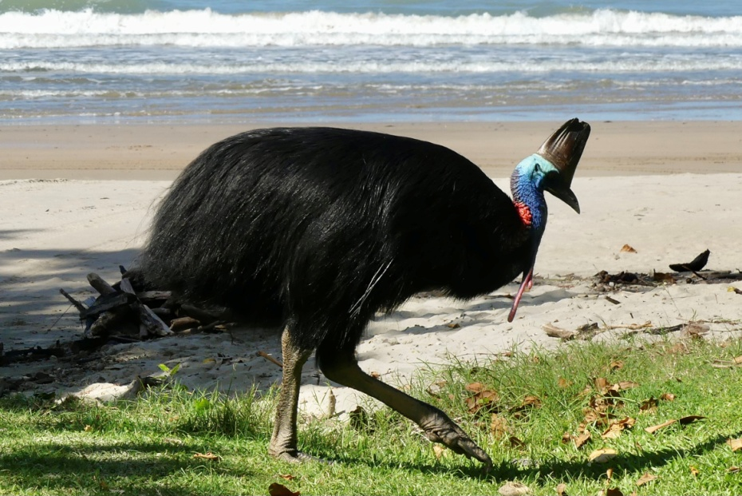

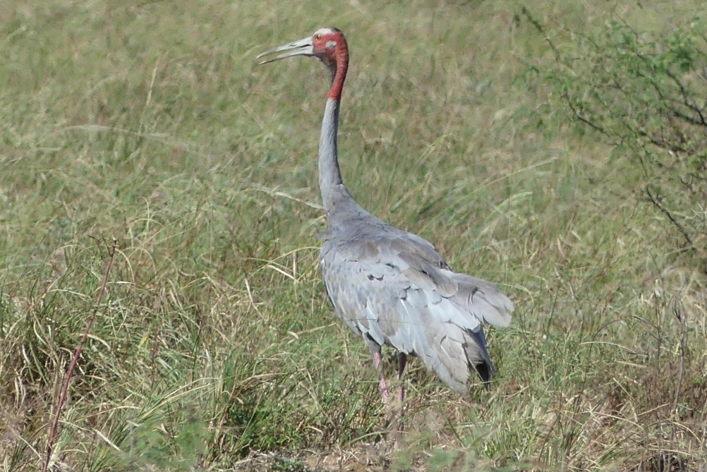

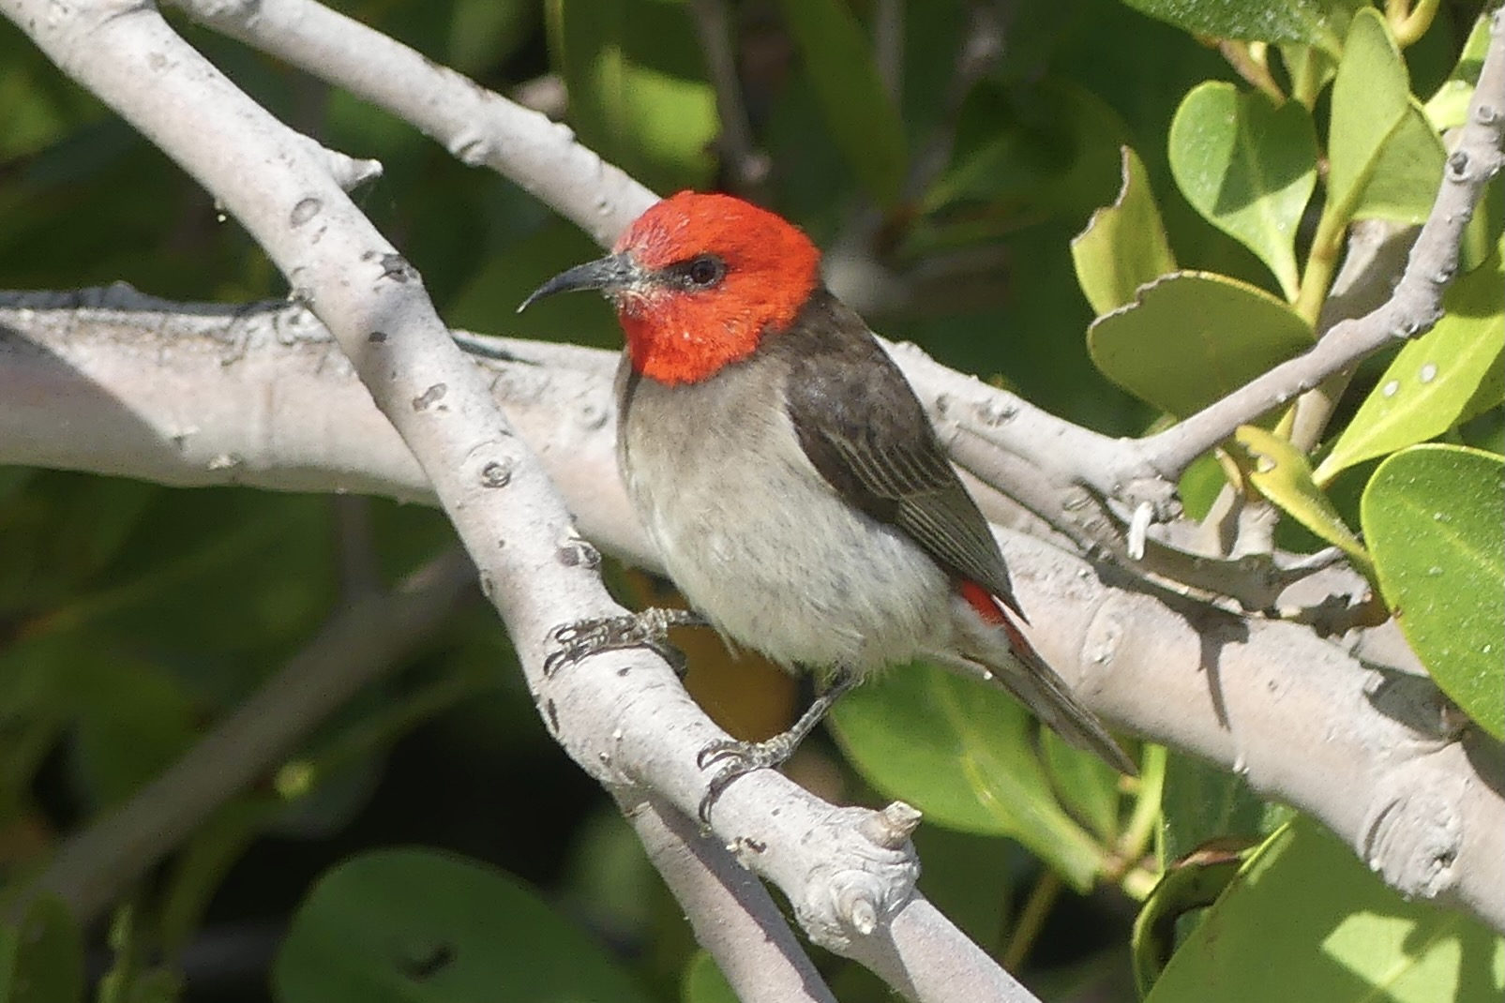
Club Calendar
Date |  | Location | Leader | Rating
21 Jan | Ride | Local Bike paths from shepp to Mooroopna | Shellie Wyllie  0422268102 | Easy  Flat
25 Jan  8am | Walk | Goulburn River walking tracks of Shepparton | TBC | Easy
13 Feb |  | Committee Meeting 7.30pm  11 Nillahcootie Cres Kialla | Scott Birchell
18 Feb | Ride | Axedale to Heathcote O’Keefe Rail Trail | Ray  0438591749 | Easy-Mod
22 Feb  8am | Walk | Cussen Park Tatura | TBC | Easy
28 Feb  6pm |  | Club Day BYO, BBQ, Food, drink, Chair  Canoeing from earlier time
11 March | Ride | Beechworth to Yackandandah or Elmore to Rochester | Ray  Peter and Jan
27-31 March |  | Tree tops camp Gunbower Island Mon-Fri 3 days walking. Canoeing, bike riding, bird watching and scenic driving | Richard Graves  0408547065 | Easy
15 April | Ride | Wahgunyah to Rutherglen | Peter and Jan  0438093668 | Easy
18 April |  | Club Meeting
26 April | Walk | Winton wetlands walk | Dianne Hanna  0437289281 | Easy
10 May | Walk | AST Walk 9am start for 2hr walk meet at bike shed | Di Hanna  0437289281 | Easy
20 May | Ride | Mulwala to Corowa  42km each way  Overnight ride | Marty and Wendy  0421050880 | Mod-H
24 May  9am | Walk | Boat Hole to Mineral Springs Strathbogie | Dianne Hanna  0437289281  Justus Hagan | Easy - Mod
14 June | Walk | AST Walk 9am Start for 2hr walk meet at bike shed | Di Hanna  0437289281 | Easy
17 Jun | Ride | Bike Ride TBA | Geoff and Lyndall  0429036658
20 Jun |  | Club Meeting
28 Jun | Walk | Murchison Area Walk | Jenny Stammers  0407556639 | Easy
12 July | Walk | AST Walk 9am start for 2hr walk meet at bike shed | Di Hanna  0437289281
15 July | Ride | Murchison Bike Ride | Maarjte and Alfred  0407849794
26 July  9am | Walk | Yundool | Kerry Storer  0417115385 | Easy
9 Aug | Walk | AST Walk 9am start for 2hr walk meet at bike shed | Di Hanna  0437289281 | Easy
15 Aug |  | AGM 7.30
19 Aug | Ride | Bike Ride TBA | Geoff and Lyndall
23 Aug  9am | Walk | Taylor’s Surprise | Ross and Judy Taylor  0428994654
13 Sept | Walk | AST Walk 9am start for 2hr walk meet at bike shed | Di Hanna  0437289281 | Easy
16 Sept | Ride | Melbourne Ride | Susan and Bruce  Rodney and Lee
27 Sept  9am | Walk | Whroo Forrest Rushworth | Karen and Richard Speedy  0448046958 | Easy
11 Oct  8am | Walk | AST Walk 8am start for 2hr walk meet at bike shed | Di Hanna  0437289281 | Easy
13 – 15 Oct |  | Weekend Camp Melville Caves | Maartje Heuperman  0407849794 | Easy - Mod
17 Oct |  | Club Meeting
21 Oct | Ride | Tocumwal Bike Ride | Peter and Jan  0438093668
25 Oct  8am | Walk | Warbies Spring time Flower walk and pine gully nature trail | Dianne Hanna  0437289281 | Easy
8 Nov  8am | Walk | AST Walk 8am start for 2hr walk meet at bike shed | Di Hanna  0437289281 | Easy
18 Nov | Ride | Bright to Harrietville  (Possible weekend) | Maarjte and Alfred  0407849794
22 Nov  8am | Walk | Gemmill Swamp | Barbra Brown  0417364985 | Easy
5 Dec |  | Club Meeting
13 Dec  8am | Walk | AST Walk 8am start for 2hr walk meet at bike shed | Di Hanna  0437289281 | Easy
16 Dec | Ride | Tatura Twilight Ride with dinner at the pub | Ray  0438591749 | Easy

President’s report

Hi all,
If you are looking for local walk destinations, the Strathbogie Ranges has some active conservation groups that also run walks and post information on a few websites. One site is Strathbogie Ranges Nature View https://strathbogierangesnatureview.wordpress.com and another is the Conservation Management Network www.strathbogieranges.org.au, which has walking brochures. Many of these walks are in small reserves and not well known (to me at least) but are quite interesting and spectacular nonetheless with rock features, creeks and waterfalls plus a variety of wildlife.

As winter approaches so does our membership renewal and the AGM! Scott has been working on an online form for membership renewal, as an option for the majority that have internet access. This will speed up his job and make it a little easier for the members I hope, so watch out for the email from him.
Our Annual General Meeting is set for 15 August at 7.30pm in person and in Shepparton. More details to come, but now is your chance to consider contributing to the running of the club as all positions will be declared vacant. Many of the committee have been involved for a long time, so new input is welcome to help share the duties, which aren’t very onerous. Talk to me or another committee member about what you could contribute.
Cheers, Greg

President: Greg Smith 5824 1143 president@shepadventureclub.org.au

Vice President: Bruce Gill 5824 2548 tatgills@westnet.com.au

Secretary JaN 0438 093 668 jangregory4@outlook.com

Facebook COoridantor Karen Speedy 0448 046 958 karenspeedy@iinet.net.au

Treasurer: Scott Birchall 5831 6063 scottb@agsystems.com.au

Newsletter Shelley Wyllie Shelley.wyllie@gmail.com

Equipment Officer: Richard Graves 5824 2929 richsue@bigpond.com

Publicity Officer: Richard Speedy 5825 1785

Calendar coordinator: Wendy 0431 274 810 wendykennedy01@outlook.com

Mid-week coordinator: Dianne Hanna 0437 289 281 dhanna3@bigpond.com

Trip Leaders: Please remember to ask visitors to sign an Acknowledgement of Risk form for Temporary Members and pass it on to our Secretary, Karen. This form is available on our website once you login (member, bushwalk) under Members>Leader Information. It is a requirement of our club insurance policy.
Editors note

Wow what a great contribution to this edition, thank you Marge for those amazing photos from your trip. And Jan, France really???? You can hear my jealousy coming through!
Ray is now off to Japan for 5 weeks, looking forward to his stories in the next newsletter.

Please continue to share your adventures with us

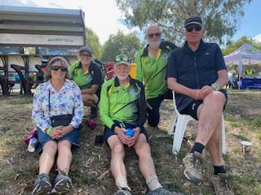

A few of us joined little Vic on a bike ride from Mansfield to Bonny Doon and back in March. Fantastic trail. Highly recommend.

Share your adventure with the club!
Shelley.wyllie@gmail.com.au

