SAC Newsletter
April - May 2022 www.shepadventureclub.org.au

Gunbower Island Camp – 26-30 April 2022

This year the Midweek Walking Group decided to hold our annual camp at the Tree Tops Scout Camp on Gunbower Island. Gunbower Island is the largest inland island in Australia, bordered by the Murray River to the north and Gunbower Creek to the south.

It was to this location that 19 Shepparton Adventure Club members ventured on the 26th April for 4 days of walking, bike riding, kayaking, bird watching, car touring and relaxing.
Usually we could expect pleasant fine autumn weather at this time of the year, but that proved not to be this year as Mother Nature had other ideas and we encountered mist, drizzle, showers, rain, cloudy days and some sunshine.

Our accommodation at the camp site was a mixture of caravans, campervans, car camping, tenting and caravan park cabin in Cohuna. The camp facilities were quite amazing with a well equipped large log cabin with an open fireplace, hot showers and flush toilets. The site is immediately alongside the very high flowing Gunbower Creek which meanders through the river red gum forest. Bird life and kangaroos were in abundance. What a photographer and bird watchers paradise.

Day one was cloudy but fine and saw us arrive and settle into our various modes of accommodation and explore the camp site area. At 5pm we gathered around the blazing fire pit outside the log cabin to discuss the agenda for the coming days. We were somewhat nervous as the next few days weather forecasts were for wet days. Those who socialised around the fire after dinner were forced indoors at about 9pm when the first of the fronts of the forecast weather reached us.

Day two dawned drizzling, misty and wet with only a few breaks between showers all day. Margaret and a few hardy souls set off at 8.00am for two hours of bird watching in their wet weather gear. Following their return and with the wet muddy tracks becoming slippery, we either relaxed or some went to Koondrook & Barham to do the shops and coffee places and Jan and John walked the river track between Koondrook and Barham in the drizzle. Both are historically very interesting Murray River towns. Our 5.00pm gathering that night was spent sitting in a semicircle around the quite large open fire in the log cabin whilst it rained outside.

Day three was fine all day. Marg ran her bird watching; various groups went walking around the forest track near Koondrook and also the tracks from the camp site. Ian and Barb went off bike riding on the muddy tracks and found it was better off walking at times. Ray, wearing his wet weather gear, was seen heading off at about 7.00am upstream in his kayak for a few hours paddling. He later did a further paddle downstream and back. In the afternoon the kayaks were taken down from the cars for those who wished to go for a paddle. Mal, Ellen, Ross & Richard took up this challenge and explored up stream from our camp. The 5.00pm happy hour was again spent sitting around the outside fire pit with the fire blazing.

Day four Dawned fine and sunny But as the weather forecast was not looking too good for later in the day, a number of the group had decided to head off towards home so that they would not be packing up in the rain or had other previous commitments to meet. The remaining nine of us either went car touring or track walking whilst the sun was out. That was to change and the rain started around dinner time. We sat around the fire in the cabin that night and went to bed with heavy rain falling, which lasted to the early hours of the morning.

Day five Much to our delight and surprise the rain had stopped and the sun was shining, although the ground was extremely wet with large puddles in every depression. We tidied up the camp, removed all our accrued rubbish, locked up the camp, returned the keys and headed home. I would like to thank to Ian and Barb Stansfield for disposing of our bags of rubbish and to everyone who assisted in cleaning and leaving the camp in the condition, or better, than we found it.

Altogether another enjoyable SAC activity which we made the best of the conditions put upon us by nature. The large onsite cabin was greatly appreciated by all. I received many compliments expressed about how good the camp facilities were.

I have spoken to the Tree Tops camp bookings committee and have rebooked the camp again next year for the period Monday 27th to Friday 31st March 2023. Hopefully the weather will be more congenial then. There is plenty to explore in this area. The dates will go down on our club calendar of activities for next year,
by Richard Graves
Participants: Ian & Barbara Brown, Ian & Barb Stansfield, Margaret Clarke, Richard & Sue Graves, Graeme & Kerry Betts, Ross & Judy Taylor, Ray Mustey, Len Taylor, Ted & Judy McIntyre, Ellen Sanders & Mal Marsden, Jan & John Dickinson.

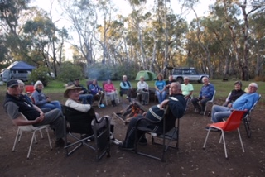

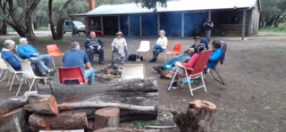

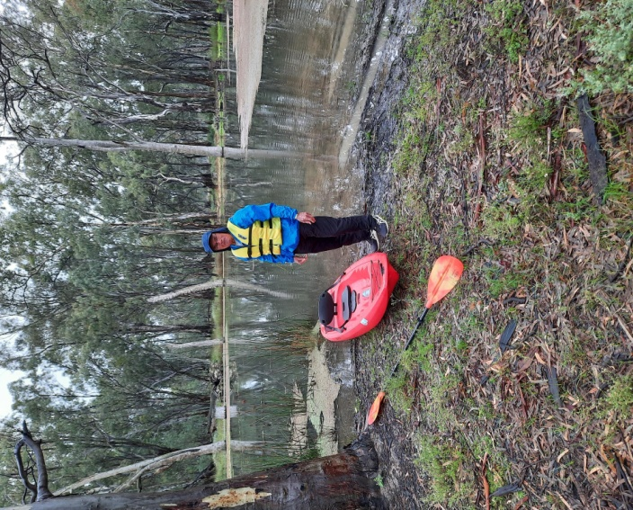
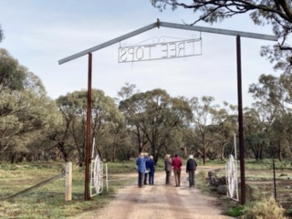

Bird watching and nature appreciation - Marg Clarke

Bird watching walks were enjoyed near the campsite most mornings with some late afternoon walks as well.
36 bird species were seen or heard. There were species seen for the first time by some people that included Hooded Robins, Jacky Winters and Brown-headed Honeyeaters. We woke to the sound of the morning chorus each day. The clear call of the Pied Butcherbird always a delight along with Laughing Kookaburras, Superb Fairy-wrens and others. At Koondrook another 11 bird species were added to the list of birds seen during our time in the area, so 47 species seen overall.
Kangaroos, Wallabys and a Yellow-footed Anticinus were also seen near the campsite. Sharing the ablution block were some moths including large Cicada Moths also some Perons tree frogs that were interesting to see.
Among a variety of vegetation types we noticed a group of weeping pittosporum/native apricot that had orange fruit on them, near our campsite. The trunks of River red gums were colourful and looked particularly attractive when wet. The other main Eucalyptus was Black Box.
On Thursday some of us did the 9 km Eagles Loop Walk that is part of the Red Gum Forest Walk near Koondrook. Highlights were seeing the vulnerable, freshwater turtle, the broad shelled turtle and the huge 40 metre tall River red gum that Wedge-tailed Eagles had nested in and later the nest had been used by White-bellied Sea-Eagles.
Gunbower Island is a Ramsar listed Wetland and an important natural area that we were privileged to spend time in.
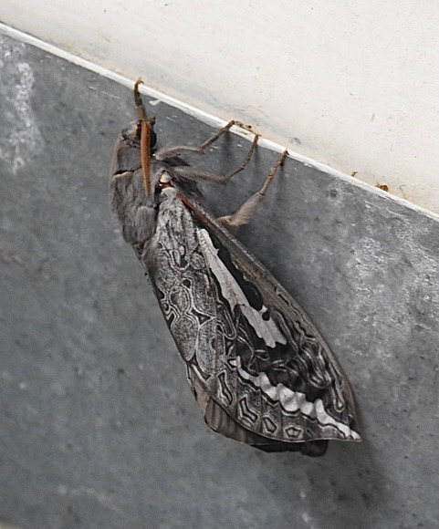
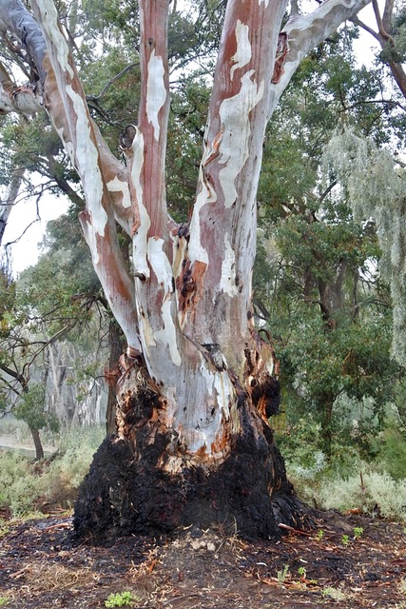

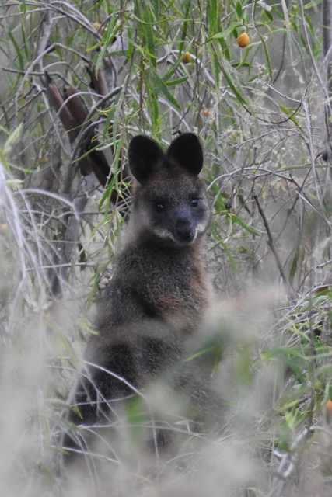

Saturday 21st May Bike Ride at Winton Wetlands

It was a rather nice day weather wise to do this Ride ten riders turned out for today's ride.

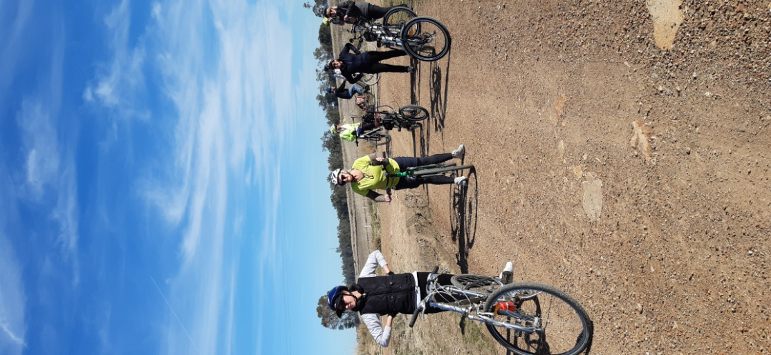
Our Ride started out at the lake Mokoan Hub Cafe we followed the foreshore Trail to the Dam Wall then going left riding along Sergants Trail then connecting to the Wetlands Trail with a short stop at Bill Friday Swamp After a short break we Rode along the Winton North Trail with a group photo on the way at the end of the Winton north Trail we connected to the Lake Mokoan road which lead us back to the Mokoan Hub Cafe

Followed by the usual snack and Coffee a total of around 32klm for the Day it is always nice to Ride with such lovely Bike Riders

Cheers to all Ray ..

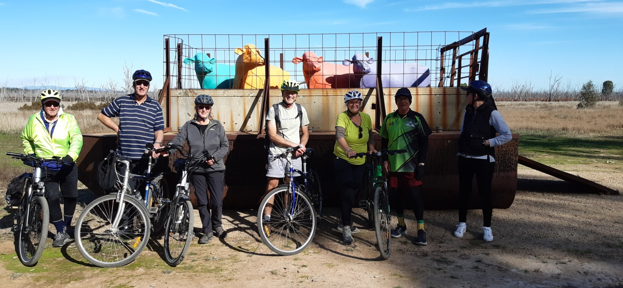

Bike ride reminders

Wednesday midweek walk 23rd March 2022. -Jenny Stammers
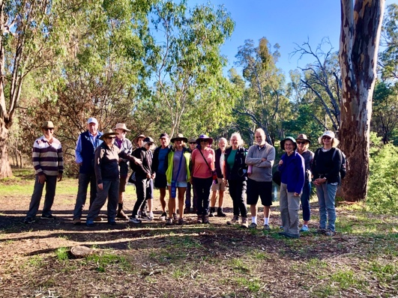
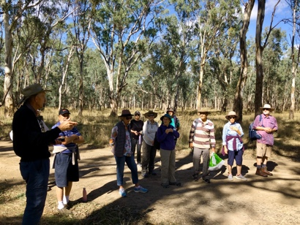
It was a pleasure to take 16 walkers into the Toolamba bushland on Wednesday. We had the most perfect day for a walk, blue skies, light breeze and mild temperature. The group meet up at the Memorial Park in Toolamba where we carpooled before driving a short distance to the Cemetery Bend, parking near Paws track. The river was up and flowing strongly and we had several views of the river during the walk. We headed right, down Mad Jack’s Track and were able to enjoy an easy approximately 6.5km walk along Shady track via Maritz bend (This was a family favourite swimming and picnic spot when my children were young, however it has deteriorated and there are now better alternatives) and then back to the cars. Derek Edge, who farmed land adjacent to the forest for many years and ran cattle in the forest, accompanied us on the walk and was able to give us some background information on the area, the naming of the track’s and the trials of farming near a flooding river. A relaxing lunch was had on the bank of the Goulburn River before heading back to the park in Toolamba. With the lure of cake and coffee ten walker stayed on for the afternoon walk through the bush on the edge of town know locally as Daunt’s bend. We walked to Lil’s track and returned back along Fitt’s track to Wren street. Once back at the park we were able to indulge in chocolate cake, without guilt, having completed a walk of about 11.5 km. Toolamba residents are very lucky to have access to a lovely bush area on their doorstep. This was the first walk I have been responsible for and I was pleased to introduce many of the group to this rivergum forest for the first time.
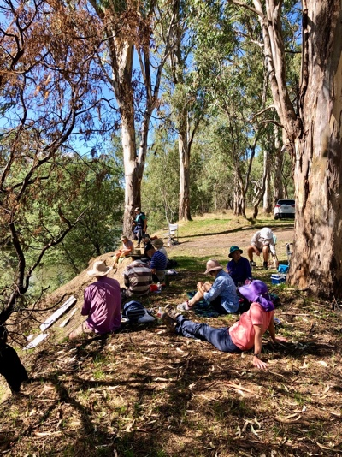
Adventure Calendar 2022
Date | Type | Location | Leader | Grading
Sunday 19th June | Bike Ride | Waranga/Murchison | Geoff & Lyndall 0429 036 658
22nd June  9am | Midweek Walk | Rushworth, Whroo forest | Jan Gregory  0438 093 668 | Easy
28 June 6pm | social | Dinner at the Aussie Hotel, Shepparton from 6pm | Karen? | social
Sunday 17th July | Bike Ride | tba | Wendy & Martin
27th July  9am | Midweek Walk | Mt Wombat, Strathbogies | TBC
20th Aug | Bike Ride | Moyhu | ?
24th Aug  9am | Midweek Walk | Warby Ranges | Maartje Heuperman  0407 849794 | Easy/Medium
30 Aug  7.30pm | meeting | AGM from 7.30pm, possibly with dinner beforehand | Greg/Karen | social
17th Sept | Bike Ride | Winton Wetlands | Ray/Dallas  0438 591749
28th Sept  9 am | Midweek Walk | Terrick Terrick N.P | Dianne Hanna  0437 289 281 | Easy
12th Oct  9. am | Midweek Walk | Mt Black (offroad) | TBC | Easy/Medium
15th Oct | Bike Ride | TBC | TBC
26th Oct  8 am | Midweek Walk | TBC | TBC | Easy/Med
19rd Nov | Bike Ride | Dookie + optional walk up Mt Major | Shelley 0422268102
23rd Nov  8 am | Midweek Walk | Boathole to Mineral Springs Strathbogies | Howard Hanna  0437 628279  Justus Hagan | Easy/Mod
17th Dec | Bike ride | Twilight Ride Kids Town/Gemmill Swamp & BBQ at shed | Ray 0438 591749

Trip Leaders: Please remember to ask visitors to sign an Acknowledgement of Risk form for Temporary Members and pass it on to our Secretary, Karen. This form is available on our website once you login (member, bushwalk) under Members>Leader Information. It is a requirement of our club insurance policy.

President’s report

Hi all,
A nice early start to the ski season this week with snowfalls down to 600 metres, but it’s quite cold outdoors for any other reason as I write this.
With this newsletter/email you should find a membership renewal for 2022/23 attached. It has the updated fee structure, following the unanimous acceptance of the proposal at the special meeting on 17 May. Please note that fees are due by 1 July and we also need the signed form.
Our Annual General Meeting is scheduled for 30 August at the Mechanics Institute and fingers crossed we can meet in person this year. All committee positions will be declared vacant and I encourage you to offer your time to help run the club. We haven’t had much change for several years and I’m sure some of the committee would like a break. Feel free to call me or another committee member to find out more.
Safe travels, Greg

President: Greg Smith 0429045732 president@shepadventureclub.org.au

Vice President: Bruce Gill 5824 2548 tatgills@westnet.com.au

Secretary: Karen Speedy 5825 1785 karenspeedy@iinet.net.au

Treasurer: Scott Birchall 5831 6063 scottb@agsystems.com.au

Newsletter: Shelley Wyllie Shelley.wyllie@gmail.com

Equipment Officer: Richard Graves 5824 2929 richsue@bigpond.com

Publicity Officer: Richard Speedy 5825 1785

Calendar coordinator: Neville Paynter 5831 1576 Neville.Paynter@jacobs.com

Mid-week coordinator: Dianne Hanna 0437 289 281 dhanna3@bigpond.com

FOR SALE
Mens “Masi Nouva Strada” 56cm Road / Triathlon Bike

Aluminium frame & Carbon Fibre Forks & Seat Post
Weight 10.2 kgs.
In Very Good to Excellent condition.
Asking price $450.00 Negotiable.
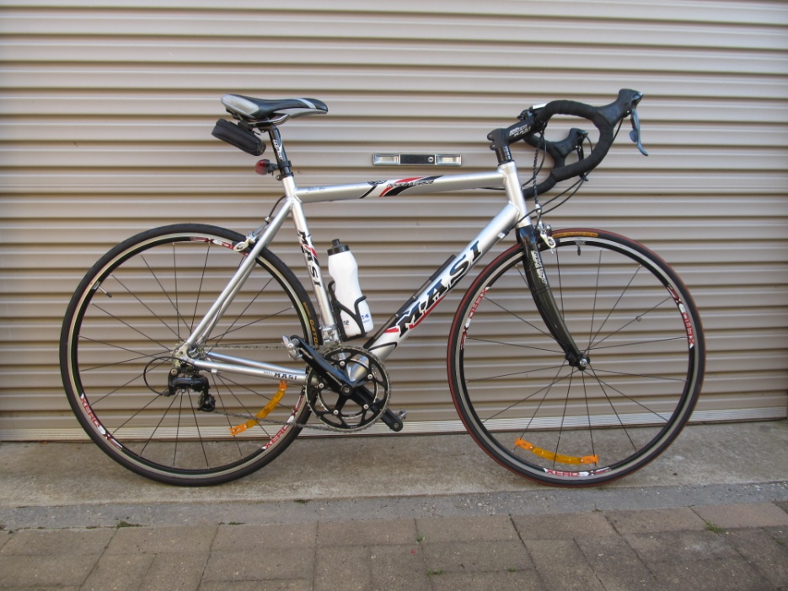
Contact: Richard Graves on mobile 0408 547 065

To Give Away to a good home

“Wild Magazines”

Richard has been collecting “Wild” Magazines since the 1st edition in 1981 and
has every copy since, all 180 of them.
Regretfully it’s now time to de clutter, so if anyone is interested in all or just a few copies
give Richard Graves a ring on 0408 547 065 to arrange collection.
If there is no interest then they will all go to council recycling.

Share your adventure with the club!
Shelley.wyllie@gmail.com.au

Editors note

Committee is calling all members to contribute to our newsletter. We are able to insert “for sale” items that are relevant to Adventures, Birthday celebrations, personal adventure stories, recipes and much more. Simply email Shelley.

We are still looking for volunteers to take the lead in both the ride and walks for October, if you’re interested please let Scott know ASAP.

Club T Shirts
Are finally here and already we have 30 orders! How amazing will our trips be when we are all wearing our club T Shirts as a group!
Tops are sized from XS to XXL.
Men’s sizes are pretty accurate, while the ladies XS is equivalent to a size 10, S-12, Med- 14 ETC
All enquires to Marty on 0421 050 880
