
If undelivered, please return to PO Box 264, Shepparton 3632

SHEPPARTON ADVENTURE CLUB inc. A0002706S
NEWSLETTER November - December 2017

Merry Xmas and a safe and Happy New Year to all

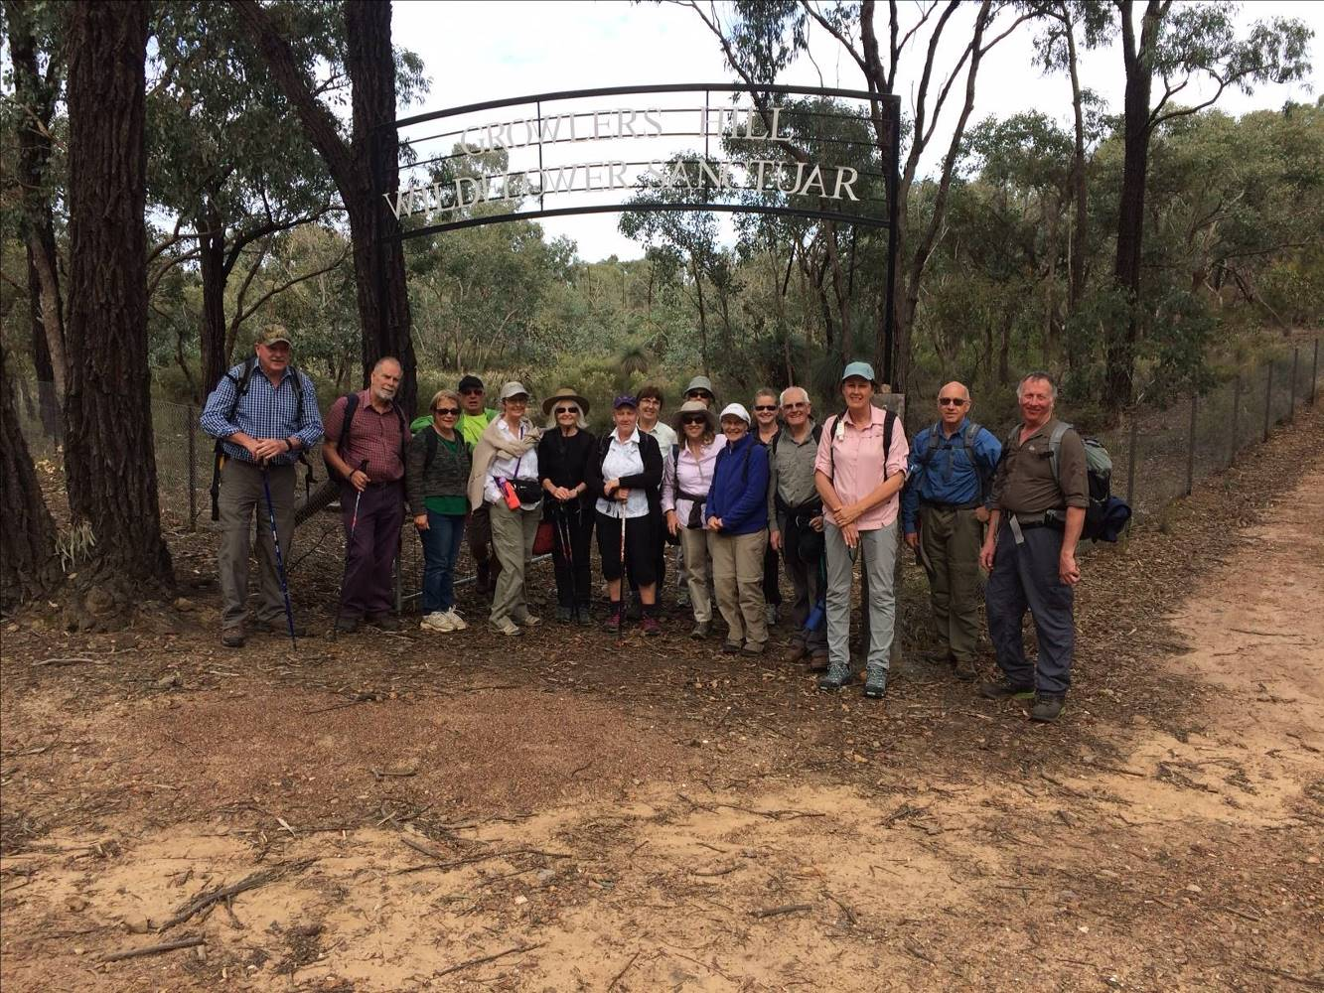

Next club meeting: Tuesday 27th February 2018
6.30pm Club Sheds Victoria Lake, Wyndham St, Shepparton.

Full Moons 2017/2018:
3rd December, 2nd January, 1st February, 2nd March, 16th April, 15th May, 14th June, 13th July, 1th1 August,
10th September, 9th October, 8th November, 7th December
(Courtesy of Calendar-Australia.com)

President’s Piece

Ho, Ho, Ho! Wishing all SAC members and families a happy and relaxing 2018 festive season.
As another year draws to a close, it is easy to get the feeling that it has flown by and we wonder where it has gone?
I've found that a good antidote for that is to have a look back at my diary / calendar and spend a few moments reflecting on some of the things that I've done in the past year. So apart form work, all the gaps throughout the year have been filled in with a number of significant events, holidays, or something or other else. Remembering these and the time I've spent doing them reminds me that the year has not rushed past like an empty express train, rather it has been filled with numerous activities, including a number of SAC activities. Notably for me, the overnight walk up to Mt Bogong in March was my second visit to Victoria's highest peak. At the time I wasn't sure, but now I've concluded that the pleasure of the alpine scenery, my sense of achievement, the great company and that my aging body was able to do it has outweighed the sweat and pain of the exercise - a highlight of 2017.
Our recent weekend camp to Mount Buffalo was another memorable points and highlights of that weekend included:
- Taking three attempts to relearn some basic boy scout skills to eventually achieve a camp shelter that shed the rain, had head-room and didn't bend the tent poles.
- Having a very enjoyable walk in the rain and thunder-storm to the summit of Mt Dunn.
- Finding that our lilo pump and the bent tent pole made a very effective way of getting much needed oxygen into the heart of the reluctant campfire to get it roaring.
- Refreshing the lungs and sole with our walks to the Chalet and through the giant eucalypts to View Point.
- Sharing some 14 year old Rutherglen muscat around the campfire with great company, conversations and laughs.
Thank you SAC committee for your efforts throughout the year too; your efforts are much appreciated by me and the members.
If you're out and about over the coming summer months, be safe and check out the BWV website for summer safety tips (http://mailchi.mp/bushwalkingvictoria/k2xjksva40?e=91f31d6067)
So if you're planning, participating, or writing about a trip or activity in the coming year, lets make a new batch of memorable events in 2018.
cheers,
Bruce.

OTHER CLUBS’ ACTIVITIES
Benalla Bushwalking Club http://benallabushwalkingclub.org.au/
Border Bushwalking Club (Albury & Wodonga) - www.borderbushwalkingclub.com.au
Wangaratta Out and About Club - www.wangarattaoutandabout.org.au/
Bendigo Bushwalking and Outdoor Club - www.gobush.org.au/
Echuca-Moama Bushwalkers - www.echucamoamabushwalkers.org.au
and more can be found at www.bushwalkingvictoria.org.au.

Calendar of Activities 2017

Date | Activity | Location | Leader | Distance/Rating
Wednesday January 24 | Walk | Gemmil Swamp, Shepparton Regional Park  Note 8am start | Margaret Clarke  0429350875 | Easy
Friday 19th - Sunday 21st January | Music Festival | Mt Hotham Cool Summer Festival  Come join us for the highest independent music festival in the country, boasting some of the finest artists ever to tread amongst snow daisies! Three days of music and indulgence, on two stages, in the middle of nowhere with the luxury of everything. An opportunity to escape the heat in the lowlands and enjoy some walking, relaxing, bike riding or attend one or more events at the festival….the choice is yours. Accomodation available at Wongungarra Alpine Ski Lodge. | Barb  0408 299 497
Saturday  17th February | Ride | O’Keefe Rail Trail – Bendigo to Heathcote | Jan 0438 093668  Ray 0438 591749 | Easy family ride
Wednesday  28th February | Walk | Dookie  Note 8am start | Richard/Valda Dickens  0427 285266 | Easy / Medium
Saturday 17th Sunday 18th March | Ride | Wodonga to Tallangatta | Jan 0438 093668  Ray 0438 591749 | tbc
Wednesday 21st March  (3rd Wed. to avoid Easter) | Walk | Ruffy area with Justus Hagan  Possibly Terip Terip Forest/Gobur Flora Reserve  (subject to fire restriction) | Howard Hanna  0437 628279 | Medium
Monday 16th – Friday 20th  April | Ride/ Walk | East Gippsland Rail Trail Bairnsdale to Orbost. Opportunity for bike rides or day walks for those not riding. Camping at a central position halfway along the trail. Details to be formalized in the New Year. Please call Richard to express interest or book your spot. | Richard Graves  0408 547 065 | Walks – easy/ medium  Rides - Forest/wilderness sections
Wednesday 25th April | Walk | Anzac day. Will only go ahead if enough people express interest | TBA | tbc
Saturday 19th – Sunday 20th  (optional Monday 21st)  May | Ride | Newtown to Queenscliff on the Bellarine Rail Trail - approx. 40km one way. There is less than 1km on the road and the rest of the ride will be on a bike path following the Barwon River and then the Bellarine Rail trail. Stay overnight in Queenscliff.  On Sunday, there will be two options to chose from:  1. Catch the ferry to Sorrento to explore this area on our bikes for the day before heading back to Queenscliff to stay overnight. Ride back to Newtown on Monday morning via the Bellarine Rail Trail;  2. Those needing to return home on Sunday will ride back to Newtown via the Bellarine Rail Trail.  Free accomodation will be available in Newtown prior to the ride on Friday May 18th. For further information, contact Barb on 0408299497 | Barb  0408 299 497
Wednesday 23rd May | walk | Loch Garry | TBA | Easy
June | ride | TBA | TBA | TBA
Wednesday 27th June | walk | Ulupna Island | TBA | Easy
July | ride | TBA | TBA | TBA
Wednesday 25th July | walk | Thompson Bend Nth. Mooroopna | TBA | Easy
Saturday 18th August | ride | Yea to Tallarook | Ray  0438 591 749 | Easy family ride
Wednesday 22nd August | walk | Warbie Ranges | TBA | Easy/ Medium
Saturday 15th September | ride | Glenrowan – winery bike road  Further information to follow | TBA | Fun
Wednesday 26th September | walk | Rocky Ned. Strathbogies | Richard Graves  0408 547 065 | TBA
Wednesday 10th October | walk | Whroo Forest Area – Mt. Black | Barb Brown  0409 178 091 | TBA
Saturday 20th – Sunday 21st October | ride | Warburton Rail Trail  Further information to follow | TBA | TBA
Wednesday 24th October | Walk | Garden Reserve Mt. Wonbal area with Justus Hagen | Howard Hanna  0437 628 279 | TBA
November | ride | TBA
Wednesday 28th Nov. | walk | Seven Creeks Gorge from Gorram Falls to Polly MCQuinns | Jan Gregory  0438 093 668 | medium
Note: All riders to confirm attendance with event leaders prior to event.

Walksafe

Here’s a few safety points all participants should follow on outdoor trips:
- Carry sufficient food and especially water for the conditions and duration.
- Advise the trip leader of any medical issues that may affect your capacity to complete the activity.
- Tell the leader or others in the group if you are having difficulties.
- Wait at track junctions for the group to catch up.
- If you get lost STAY STILL and call out or whistle at regular intervals.
- Walk with experienced leaders.


www.bushwalkingvictoria.org.au
PO Box 1007 Templestowe Vic. 3106
Phone: (03) 8846 4131
Fax: (03) 9846 7473 admin@bushwalkingvictoria.org.au

Newsletters follow the link below
Find them here: http://www.bushwalkingvictoria.org.au/what-we-do/publications/newsletters

Ambulance Cover

Lastly, it's vital that we stress the importance of Ambulance cover to you all. Although most of us have private health insurance, not many are made aware that their policy may not cover everything that an Ambulance Victoria membership would cover. If you should require emergency services, you could still be left with a big bill.
Ambulance Victoria Membership cover gives you protection against the cost of world-class emergency treatment and transport services delivered by our highly skilled and dedicated paramedics and aided by state-of-the-art equipment and resources. Specifically, it includes:
- All emergency road ambulance transport.
- All MICA (Mobile Intensive Care Ambulance) attendance and treatment.
- All emergency air ambulance and clinically necessary non-emergency air ambulance.
- All ambulance treatment when transport is not required.
- The same level of cover for ambulance treatment and transport services provided interstate as are covered back in Victoria*.
- All clinically necessary non-emergency patient transport.
For a yearly membership, it's $46 however, a full list of membership details and pricing is here.
One final reminder, If you're hiking remotely or alone, please ensure you carry a PLB (Personal Locator Beacon).

Be safe this Summer, Happy walking!

Dehydration

With respect to health and safety, not drinking enough water may well be the most common mistake made by bushwalkers. Whether you are walking in the heat or the cold, at sea level or at altitude, adequate hydration should always be a priority. The best way to prevent dehydration is to consciously drink water slowly over several hours before intense exercise. During periods of heavy exercise, you should drink about one and a half cups per hour. If your urine is clear and copious, then you know you are well-hydrated.
- When the weather is brutally hot and your body sweats profusely, water by itself is not enough. Sweating out salts diminishes your body’s ability to regulate liquids. Munching on raisins and peanuts, aka trail mix or another salty snack can help avoid this problem, but sometimes you need a little extra help. Sports drinks containing salts, potassium and electrolytes are effective at staving off this problem, but be wary of drinking too much since they often contain large amounts of sugar. In a quick pinch, a dash of salt and sugar can be added to a water bottle for similar results.
Before your walk, be sure to drink one or two cups of water, juice or a sports drink. Ensure that you are limiting the number of caffeine drinks you consume, as caffeine increases fluid loss. Also, avoid alcohol as it can cause dehydration. During your walk (especially when it's hot), ensure you drink at least 800 milliliters of fluid per hour. Continue drinking after bushwalking to replace any fluid losses - thirst always underestimates fluid needs, so drink more than you think is necessary.

- SAC is an affiliated member of Bushwalking Victoria
- Membership benefits
- Membership of Shepparton Adventure Club includes Bushwalking Victoria membership. Your Bushwalking Vic membership card enables you to obtain discounts at a number of retailers including Ajays (Heathmont), Bogong Equipment (Melb.), EMC (Deepdene), Melb Map Centre (Malvern East), The Wilderness Shop (Box Hill), Paddy Pallin, Smitten merino wear Tasmania, Woodslane Walking Guides.
- 5% on Outdoor Travel tours and all reservations made directly with the office at Bright. Check out their website or join their email newsletter list for tours and current deals: www.outdoortravel.com.au, 1800 331 582 info@outdoortravel.com.au
- Discovery Holiday Parks, Cradle Mountain 20% discount off shoulder and low season rates (16 April - 2 December)
- Contact Claire on 03 6492 1289, 1800 068 574 www.discoveryholidayparks.com.au

- Note: TRIP LEADERS – it is imperative for every trip that temporary members/visitors sign the “Acknowledgement of Risk Form”. These completed forms must be forwarded to the SAC Secretary for filing as soon as possible after the trip – otherwise, in the case of a claim, the insurer will not acknowledge the risk.
- Form can be downloaded from www.bushwalkingvictoria.org.au , under Members > Forms

- Emergency Contact Procedures
- All enquiries about the return of participants from club activities should first be directed to the activity leader, and then to the Emergency Contact Person (ECP) for the activity if the leader cannot be found.
- It is the activity leader's responsibility to organise an ECP and advise him/her (in writing) of trip & participant details and what to do if contact is not made by the nominated time.
- Travel Cost Reimbursement
- Option 1: Preferred. Fuel Cost per car plus 5 cents per km per car to be split equally between the numbers of people in the car including the driver. If appropriate, the cost of running all vehicles should be shared equally amongst all trip participants.
- Option 2: 25 cents per km per car split between all trip participants.

- Summary of Public Liability insurance coverage at 5-3-2014 (from www.bushwalkingaustralia.org.au )
- Bushwalking, Track/Hut Construction and Maintenance, Caving, Canyoning, Liloing, Abseiling, Alpine Walking (Summer and Winter),Snow Skiing, Canoeing, Kayaking, Boating, Rafting, Swimming, Cycling, Rock Scurrying and use of hand held ropes as part of a Bushwalk, Orienteering, Rogaining, Leader Training and other related instructions.
- Activities NOT COVERED include Rock Climbing, Water Skiing, overseas trips (except NZ) and any activities not listed above.

Trip Reports

11th October 2017 -Rushworth Forest Wildflower Loop –Mid Week Walk
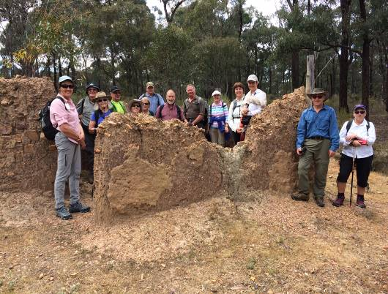
Seventeen Shepparton Adventure Club walkers fronted up for the additional Mid Week Walk for October. The seven and a half kilometre loop walk started and ended at the Rushworth town centre. Initially heading west along the now discontinued railway line walking track, the route then headed south past the Hospital & the wildflower reserve through which we wandered enjoying the prolific wildflowers which were well in bloom. It was interesting to note that as this area was fully fenced in to deter animals from grazing, the plants growth & blooms were much more prolific than any other part of the walk. Some more adventurous of us climbed the fire tower on Growlers hill. The route then meandered along bush tracks through the forest. We were indeed fortunate to locate the partially intact remanets of an old mud brick miner’s hut which was tucked in the bush away from the track, after which we passed the still operational eucalyptus distillery. After strolling off track for a short distance, lunch was enjoyed near the “Whistle Stop” just off the Whroo Road, where in earlier times traction steam engines were required by law to sound their whistle to warn horse drawn vehicles of their arrival. The route back meandered east and then north past the original Rushworth cemetery, then past an area where Chinese miners had plentiful market gardens to grow their food and a dam that serviced a stomper battery used to crush ore. We were then back into the Rushworth built up area passing one of the last remaining Ironbark timber mills in existence. We then followed the old rail line back into town after which we enjoyed relaxing conversation with coffee and cakes at the Moto Café.

Richard Graves.
(Thanks to Richard for the front page photo of this walk) 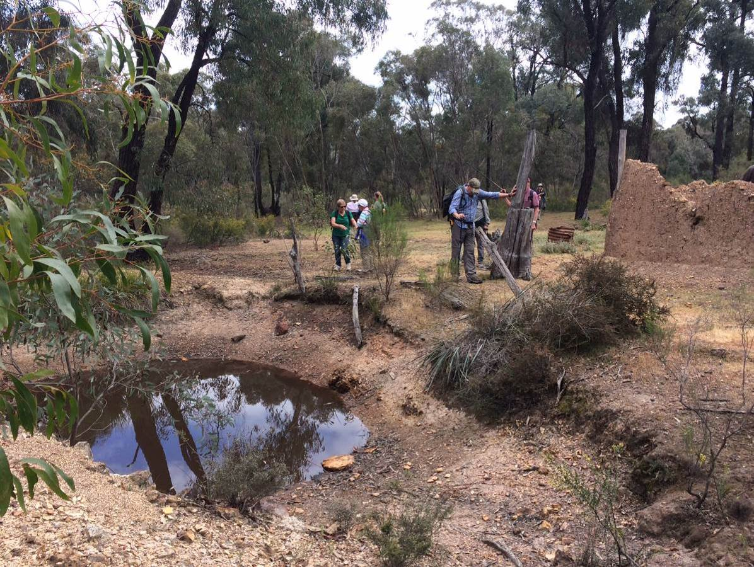

October 25th 2017- Lima Creek Falls Midweek Walk.

10 Midweek walkers set off for Toorour in the SE section of the Strathbogies on a lovely mild day for our Oct walk. The drive itself added to the enjoyment of the day as we travelled through the spectacular landscape of rugged outcrops, granite boulders and towering gums to the rolling green hills of the Strathbogie uplands and then on through the dense native forests and pine plantations of the Toorour area.

This 3 – 3.5 km walk to the beautiful Lima Creek Falls, started at the carpark off Police Track at Toorour and followed the tracks beside the creek to the beginning of the steeper formed walking trail down to the falls. After a short descent, the top of the falls were reached and a few of the more adventurous ones crossed the creek to explore the huge smoothed boulders and to admire the wonderful views both down the falls and across to the distant mountain ranges. Everyone then descended to the base of the falls where the numerous rocks provided seats and tables for our lunch. After lunch and a short discussion about possible walks for our 2018 itinerary of walks, the group retraced their steps and climbed up to the tracks before making the gradual uphill climb back to the cars.

This was a new walk for the group and required getting permission from Handcock Victorian Plantations to walk on their land. (Which was readily given once the leader completed the simple and quick online induction course!) . It was quite a surprise to see just how much of the eastern section of the Strathbogies is actually owned by this company. Hopefully this segment abutting pine plantations will not be replaced with pine trees in the future as we found a very special section of native forest. We found a gem in the beautiful falls, the steep sided creek valley, the towering gums with a thick understorey of bushes and a forest floor sprinkled with a large number of different flowering wildflowers subtly scattered through the area; many birds were heard, a kangaroo bounded through and an echidna quickly headed for the bush as we came upon it.
The conclusion was that this was a great walk and definitely was “a good one to add to our list of walks”.
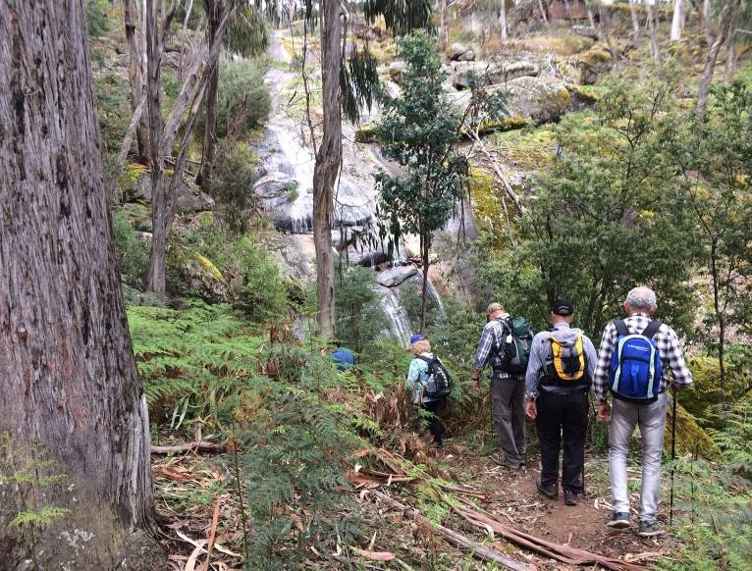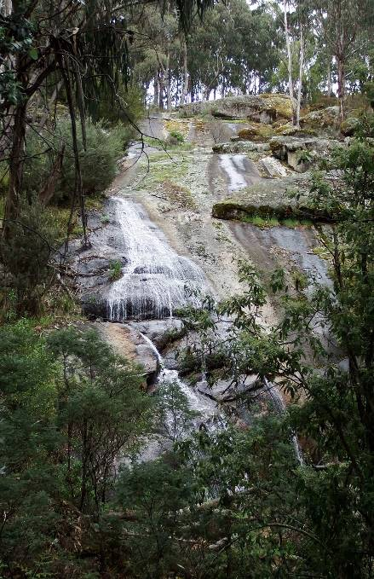

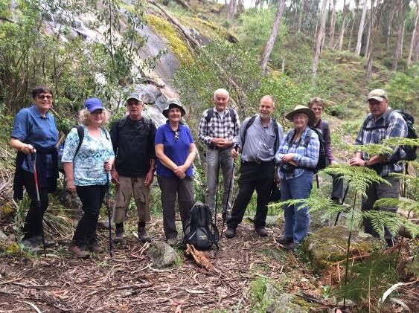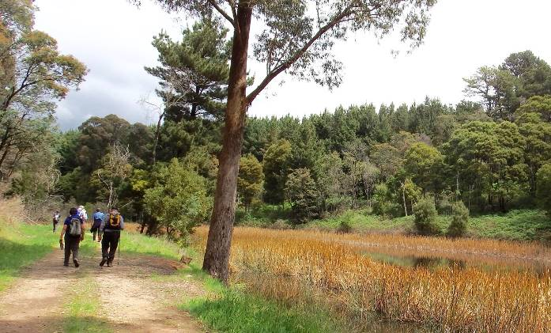

Dianne Hanna

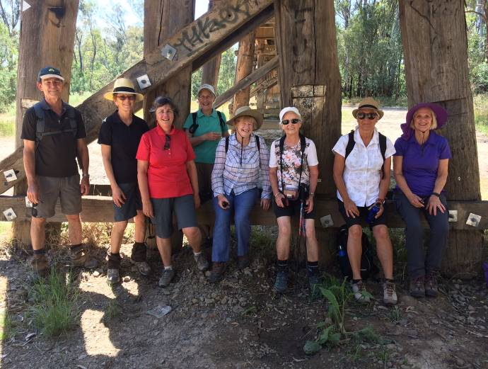
23rd Nov 2017 - Goulburn River: Pyke Rd to Mooroopna and back – mid week walk

Nine intrepid mid-week walkers set off on a pleasant morning to walk the Goulburn River tracks from Pyke Rd to Mooroopna. Luckily the track was mostly shady as, before long, the sun had a bit of heat in it. This also meant that birds and animals were few and far between. We were fortunate however to see treecreepers, a kingfisher, kookaburras, wood ducks and cockatoos.
The six km walk was easy going on the flat and the walk to Mooroopna took about an hour and a half. Bill and Beats were happy to see so many customers come in at once and we were all grateful for the refreshing lattes, iced coffees and milkshakes.
During our break one of the walkers regaled us with stories about her trips on 'steam rail'. None of us had heard of this before but these are tours on authentically restored steam trains with beautiful timber panelled carriages and some with Edwardian pressed tin work on the ceilings. Some trains are up to 127 years old! And some have sleepers and a licensed car. Various tours are conducted around the state. (See steamrail.com.au for further information).
Two walkers left us in Mooroopna and the rest of the group returned via an unintentional shorter route. Yes we lost our way getting out of Mooroopna and had to walk alongside the railway track to rejoin the original river track to Pyke Rd!
After about 45 minutes we found a beautiful spot overlooking the river where we stopped to have our lunch. We were fortunate to spot a turtle rising to the surface of the water every now and then.
The weather was now quite warm, about 34 degrees, and we decided to move on to get out of the heat of the day. We were all relieved to see our cars and get into the air conditioning.
Thank you Richard for the planning and leading of this walk. It was another lovely day out with the mid week walkers!

Ellen Sanders
(Thanks to Ellen Sanders, Richard Graves and Dianne Hanna for the photos)
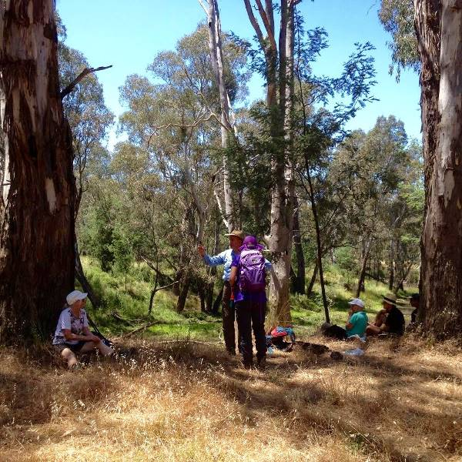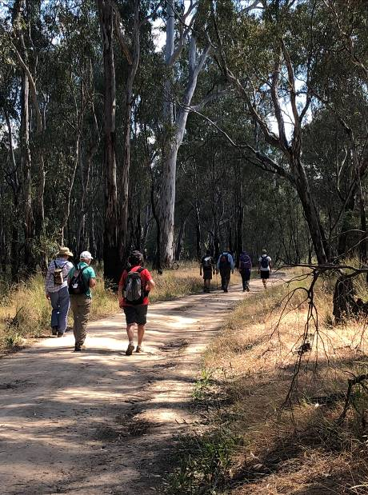

17-19th November 2017 Mt. Buffalo overnight Camp and walk

On the weekend of the 17-19th November eight SAC members made their way to Mt Buffalo for a weekend of camping and walking. Tents and one caravan were set up in the Lake Catani campground.
Mt Buffalo was at its glorious best with recent rain making for green grass, colorful wildflowers and plenty of water coming over any waterfalls. On Saturday morning the group walked to the Chalet. Those interested in their morning coffee were disappointed to find the coffee van closed! Spectacular views and a wander around the outside of the restored Chalet made up for the lack of coffee. Part of the group returned via the Underground River track.
During the afternoon the group took on a walk from The Reservoir to Mt Dunn. Some rain caught up with us part way along the walk but did not detract from the beauty of the snow gums, wildflowers and massive granite boulders. The view from the top was brief due to strong wind and rain.
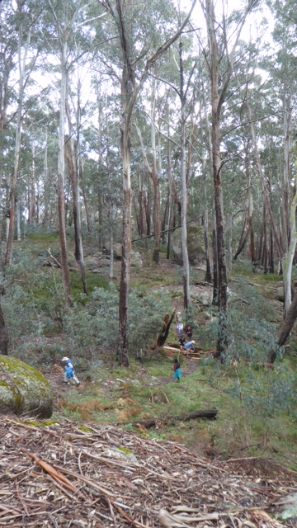
There was plenty of chat around mealtimes. The constant effort to keep the campfire burning provided entertainment for those watching as well as those tending it. Sunday was clear and sunny and the walkers were rewarded by spectacular views over the Alps from the Viewpoint. Back to the campsite and time to pack up and head home after a most enjoyable weekend. 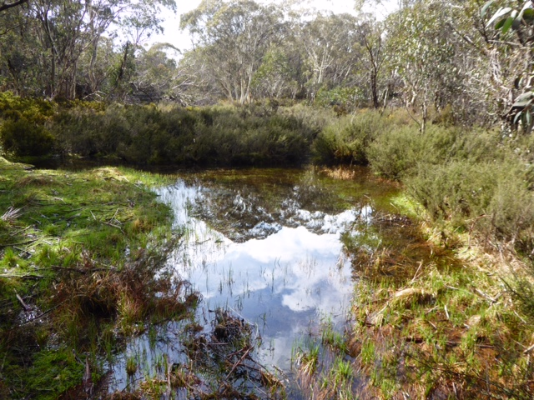
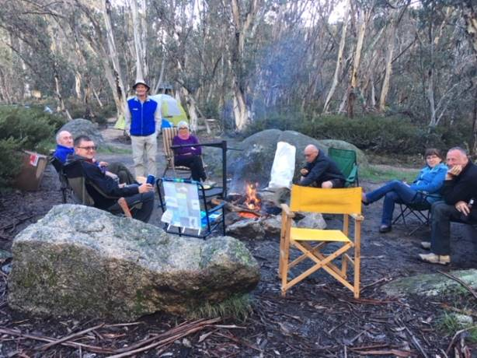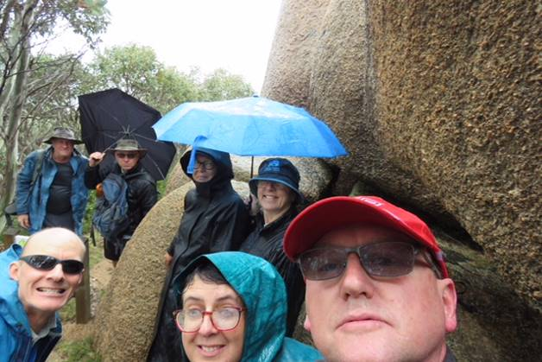

hanks to Margaret Cl
Thanks to Margaret Clarke and Bruce Gill for the photos

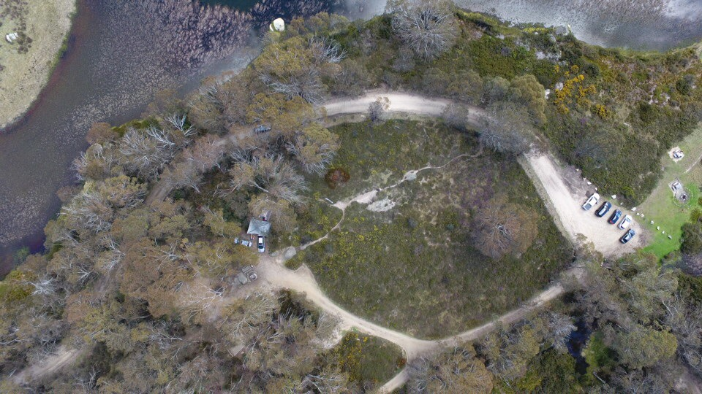

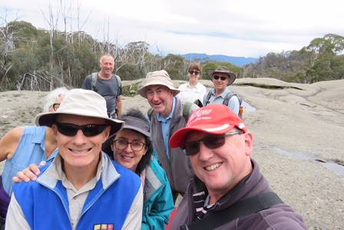
SAC Mid week walkers report 2017.

2017 saw another very successful program of 12 midweek walks to a variety of places from Lima East to Barmah and Chiltern Mt Pilot to Kamarooka. Thank you very much to the 10 different leaders who planned and lead the walks. For the year there was a record number of 46 different people participating, with 12 regulars who competed 5 or more walks. Noella O’Keeffe completed the most walks (8) which was a great effort. The average number of participants was 12, with 17 being the highest number.

In addition to our monthly walks 10 walkers participated in four days walking along sections of the Great Ocean Walk. Thank you to Richard Graves for facilitating this great activity.

This shows that this has certainly been a very successful program and we look forward to another great year in 2018. You will see from the itinerary that another really interesting year of walks is being planned. Do continue to spread the word and encourage interested people to join us.

Dianne Hanna

- Thanks to all newsletter contributors for their articles and great photos.

Our newsletter printing is kindly sponsored by Hon. Wendy Lovell, MLC for Northern Victoria Region
138 Welsford Street, Shepparton
The next newsletter will be out in September, but feel free to submit items at any time.

- The SHEPPARTON ADVENTURE CLUB Inc.
- General Meeting: 4th Tuesday of the months: February, April, June, August, October
- usually at: 7:30 pm at the Mechanics Institute, Wyndham St, Shepparton.

- Correspondence to: The Secretary SAC, PO Box 264, Shepparton 3632
- Email: sacvicau@yahoo.com.au

- OFFICE BEARERS
- President Bruce Gill 5824 2548 tatgills@westnet.com.au
- Vice President Karen Speedy 5825 1785 karenspeedy@iinet.net.au
- Secretary Howard Hanna 5828 9281 howard_hanna@yahoo.com
- Treasurer Scott Birchall 5831 6063 scottbirchall@aapt.net.au
- (for email distribution to members)
- Newsletter Editor Steve Jeffs 0402368751 stevesbluebmw@outlook.com
- Equipment Officer Richard Graves 5824 2929 richsue@bigpond.com
- Publicity Officer Rach Keen 0400 238276 rach_elkeen@hotmail.com
- Calendar coordinator Neville Paynter 5831 1576 Neville.Paynter@jacobs.com
- Mid-week coordinator Dianne Hanna 0437 289 281 dhanna3@bigpond.com
- Web Master Greg Smith 5824 1143 greg.smith@gmwater.com.au
- Facebook Richard Speedy 5825 1785

Bogong High Plains Dreamtime (Thanks Greg Smith)



