
If undelivered, please return to PO Box 264, Shepparton 3632

SHEPPARTON ADVENTURE CLUB inc. A0002706S
NEWSLETTER January – February 2020

Next meeting: Tuesday 25th February General Meeting. This is a club meeting with all welcome. 6 pm start for social catchup and picnic tea prior to the meeting. See you at the SAC Shed, Victoria Park Lake. BYO picnic dinner and chair. BBQ available for your use.

Full Moon Dates2019- 2020:
10th March (Super Full Moon), 8th April, 7th May, 6th June, 5th July, 4th Aug, 2nd Sept, 2nd Oct, 1st Nov, 30th Nov, 30th Dec.
Point of Interest: When a Full Moon takes place when the Moon is near its closest approach to Earth, it is called a Super Full Moon. When there is a New Moon around the closest point to Earth, it is known as a Super New Moon. A Micro moon, on the other hand, is when a Full or a New Moon is near its farthest point from Earth, around apogee. It's also known as a Mini moon, Mini Full Moon, or a Mini New Moon. TimeandDate.com

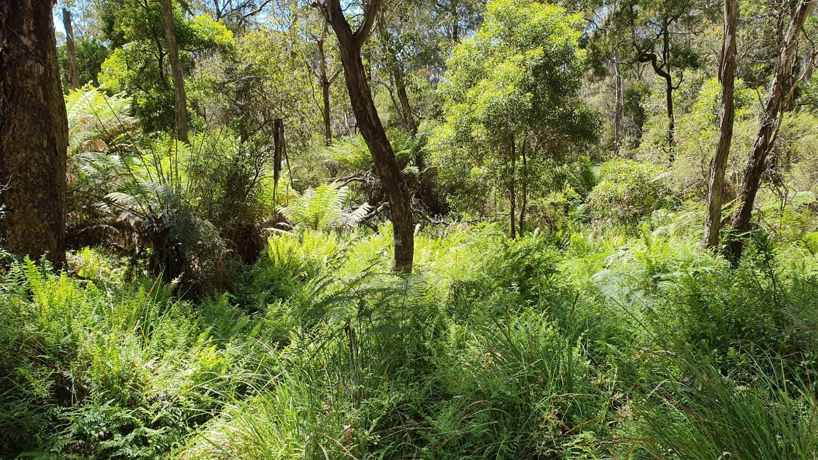

Patch of Tree Ferns - Rocky Ned. Photo courtesy of Philip Schultz

President’s Piece

Hi members,
I hope you have been coping with the hot summer we’ve been having. I managed a few weeks on the coast in January with my family, which was a nice change in temperature. While there Jill and I ducked down to Wilsons Prom for a quick 2 day walk into Refuge Cove and Sealers Cove, both beautiful beaches that we were fortunate to only share with a few other people.
Fires have burnt many walking areas in the eastern ranges but there are still plenty of untouched places we can visit, particularly those closer to home. See www.parks.vic.gov.au for national and state parks or DELWP for state forest information. The mid-week walk calendar is now set for 2020 and includes many localities not far from Shepparton.
Our shed lease, along with those of two neighbouring sheds, was advertised in December for public comment “by any persons affected …” (closed 24 January). It should now be in the process of finalising and going back to council, if necessary.
Finally, on the morning of Saturday 28 March a few SAC members are leading a walk up Mt Major as part of local activities for This Girl Can, which is a series of activities being run by GV Community Health to encourage women to become more active. If you’d like to join us let me know, there are more details in the calendar.

Cheers, Greg

- The SHEPPARTON ADVENTURE CLUB Inc.
- General Meeting: 4th Tuesday of the months: February, April, June, August, October, December
- usually at: 7:30 pm at the Mechanics Institute, Wyndham St, Shepparton.(Winter) and
- The SAC shed, Victoria Park Lake Shepparton (Summer)

- Correspondence to: The Secretary SAC, PO Box 264, Shepparton 3632
- Email: sacvicau@yahoo.com.au
- OFFICE BEARERS
- President: Greg Smith 5824 1143 greg.smith@gmwater.com.au
- Vice President: Bruce Gill 5824 2548 tatgills@westnet.com.au
- Secretary: Karen Speedy 5825 1785 karenspeedy@iinet.net.au
- Treasurer: Scott Birchall 5831 6063 scottb@agsystems.com.au
- Newsletter Editor: Lea Watts lea.watts63@outlook.com
- Equipment Officer: Richard Graves 5824 2929 richsue@bigpond.com
- Publicity Officer: Richard Speedy 5825 1785
- Calendar coordinator: Neville Paynter 5831 1576 Neville.Paynter@jacobs.com
- Mid-week coordinator: Dianne Hanna 0437 289 281 dhanna3@bigpond.com

Upcoming Activity – next midweek walk, 26th February Mt Samaria

Newsletter Notes:
Welcome to the first edition of the newsletter for 2020. Happy New Year to all! Nearly the end of February and I’ve not yet got out and about at a club event but am looking forward to the February walk to Mt Samaria. I love it that I’m still learning about places and walks which are so close to home. Our midweek walks and bike rides have been organized for the year (thankyou to the wonderful members who organize these events for us), what the calendar is lacking is alternative activities. If you have any ideas for other activities i.e. canoeing, winter sports, overnight camps or extended walks, drop a line to Greg or Neville. When I first joined the club I was introduced to overnight hikes. These events have provided amazing memories, the scope to extend myself way past my comfort zone, lasting friendships and opportunity for personal development. Isn’t it great what our club activities and membership enables! Happy and safe adventuring. Lea

Calendar of Activities 2020

Date | Activity | Location | Leader | Rating/Distance
22nd Jan  8 am | Walk | Shepparton Walking path  Morning walk | Dianne Hanna  0437 289281 | Easy
25th Feb  6pm | Members Meeting | SAC Clubroom Victoria Park Lake  BYO picnic tea and chair | Greg Smith | Very Easy
26th Feb  8 am | Walk | Mt Samaria | Dianne Hanna  0437 289281 | Easy/medium
1st – 6th March | Walk | The coastal walk  Pt. Nepean to Cape Shanck Base Camp | Dianne Hanna  0437 289281 | 3 days walk total up to 30 kms.
21st March  Saturday | Bike Ride | Bonnie Doon to Mansfield return | Dallas  0413 910 018 | Rail Trail
25th March  8 am | Walk | Boathole to Mineral Springs  Strathbogies | Howard Hanna  0437 628279  Justus Hagan | Easy/ Medium
28th March  9am – 12 noon | Walk | Mt Major – Meet cnr Ryans and Cashel Road, Dookie.  Public Event led by SAC | Greg Smith  5824 1143 | Medium
18th April  Saturday | Bike Ride | Wahgunyah District | Peter  0438 093 668 | tba
21st April  7.30pm | Committee  Meeting | Host -Bruce Gill - Tatura | Greg Smith  5824 1143 | Easy
22nd April  9 am | Walk | Turrumbarry Weir/Murray River | Phil and Lottie  Schultz  0448 324 792 | Easy
28th April  7.30pm | Members Meeting | Mechanics Institute  227 Wyndham Street | Greg Smith  5824 1143 | Very Easy
16th May | Bike Ride | Everton to Beechworth  return | Ray  0438 591 749 | Rail Trail
27th May  9 am | Walk | Winton wetlands. | TBA | Easy
20th June | Bike Ride | Maldon to Castlemaine | Philip 0448 324 792 | tba
23rd June | Members Meeting | Shepparton Mechanics Institute | Greg Smith  5824 1143 | Very Easy
24th June  9 am | Walk | Tatura | Maartje Heuperman  0407 849 794 | Easy
18th July | Bike Ride | Dookie Circuit | tba | tba
22nd July  9 am | Walk | Benalla Lake | Jan Gregory  0438 093 668 | Easy
15th Aug | Bike Ride | Cathkin to Alexandra return | Ray  0438 591 749 | Rail Trail
25th Aug | Members Meeting | Shepparton Mechanics Institute | Greg Smith  5824 1143 | Very Easy
26th Aug  9 am | Walk | Dookie. | Richard and Valda Dickins  0427 285 266 | Easy/Medium
19th Sept | Bike Ride | Kamarooka Forest  Day Ride | Ray/Richard  04387 591 749 | tba
23rd Sept  9 am | Walk | Warbie ranges; Wenham’s or Sunrise walking tracks? | TBA | Easy/medium
Oct tbc | Bike Ride | Weekend Ride  Day 1 Wangaratta to Everton  Day 2 Wangaratta to Milawa | Ray  0438 591 749 | Rail Trail
14th Oct  8 am | Walk | Whroo forest | TBA | Easy
27th Oct | Members Meeting | SAC Clubroom Victoria Park Lake  BYO picnic tea and chair | Greg Smith  5824 1143 | Very Easy
28th Oct  8 am | Walk | Kamarooka | Richard Graves  0408 547 065 | Easy
27th Nov  8 am | Walk | Boulevard Reserve to Reedy Swamp  Morning walk | Dianne Hanna  0437 289 281 | Easy
Dec 2020 | Members Meeting | Christmas Social TBA | Greg Smith  5824 1143 | Very Easy
Note: All riders/walkers to confirm attendance with event leaders prior to event.

Your ideas please: Members we are looking for additional items for the calendar. If you have any ideas please send them on to Neville Paynter our Calendar Coordinator. If you have an idea for an activity and don’t want to lead the event yourself contact Greg or Neville and we can look at finding a trip leader. Neville.Paynter@jacobs.com

Note: For other Clubs events please refer to their websites listed below:
Clubs around the area:

Benalla Bushwalking Club http://benallabushwalkingclub.org.au/
Border Bushwalking Club (Albury & Wodonga) - www.borderbushwalkingclub.com.au
Wangaratta Out and About Club - www.wangarattaoutandabout.org.au/
Bendigo Bushwalking and Outdoor Club - www.gobush.org.au/
Echuca - Moama Bushwalkers - www.echucamoamabushwalkers.org.au

Additional clubs and events can be found at www.bushwalkingvictoria.org.au

Thanks to all newsletter contributors for their articles and great photos.
Our newsletter printing is kindly sponsored by Hon. Wendy Lovell, MLC for Northern Victoria Region
Wyndham Street, Shepparton

The next newsletter will be out in April 2020, feell free to submit items at any time.

Trip Reports

Rocky Ned Creek and Falls, 9 kms - 27th November 2019.
On a glorious November day 12 members headed over to Swanpool to tackle the Rocky Ned Creek and Falls walk. Our club had walked to Rocky Ned mount itself back in 2018 but I among others had not seen the falls, so was looking forward to seeing what the day would present. Ably lead by Philip Schultz we walkers headed up the normal route past the plantations with our first stop for a regroup at the turn off to Rocky Ned peak. The decision was made to stick to the original plan and not divert to have a look at the peak so to keep the day to its advertised length. As we continued on, the road tested us at times as it was well rutted in places especially where there were excessive gradients, so this slowed our pace at times. It was great to be doing some hill work (I’m sure they would rate it easy). We enjoyed spotting wild flowers as there had been some recent rainfalls but we weren’t sure if the creek or falls would be running. Our lunch break was taken at the falls which much to our surprise had plenty of water flowing. We were provided the added pleasure of sharing our lunch site with a stunning brown snake which slid into camp and kept us entertained for a few minutes until it decided to head back to the scrub. The walk out was not as carefree as the wall in from the road! There had been major reclamation works completed to keep the trailbike riders out of the falls area and we had some distance of tree scrambling to cover on the way in and out to the falls themselves. Once back on the main track we had more encounters with the local wildlife, this time in the form of a bee hive whose home had blown down in the winds from recent storms. A massive tree had fallen across the road, it was so large that it wasn’t probable to climb up or down the hill to scout around it due to the incline, so it was over and through the debris we headed. The bees were too busy sorting themselves out to be bothered with us. The afternoon was heating up and most of the route on the way back to the main plantation track was up hill as well (or so I felt). All participants made it back to the cars without event - it was a great day, great weather, great leader and co walkers. I’m looking forward to our next outing! Thanks Philip

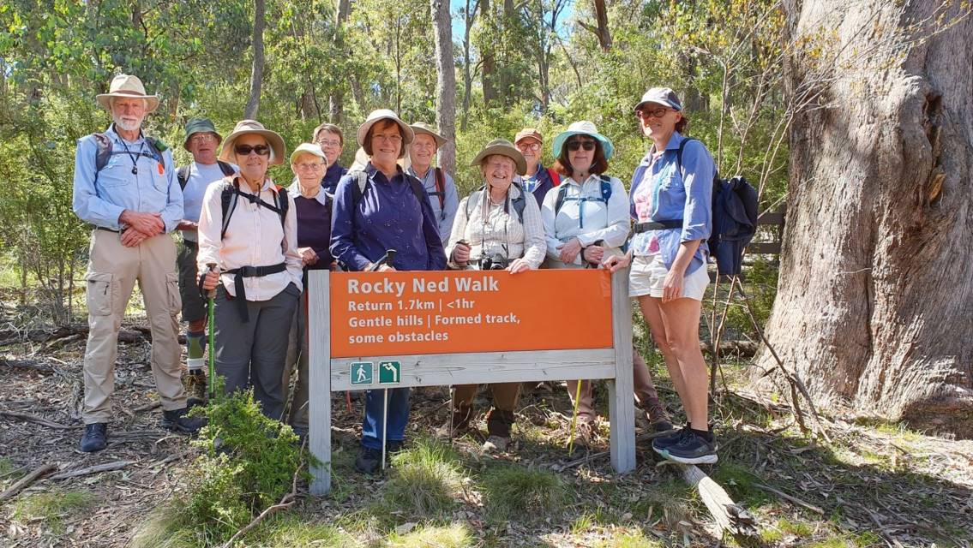
Starting out on the way to the Rocky Ned Falls

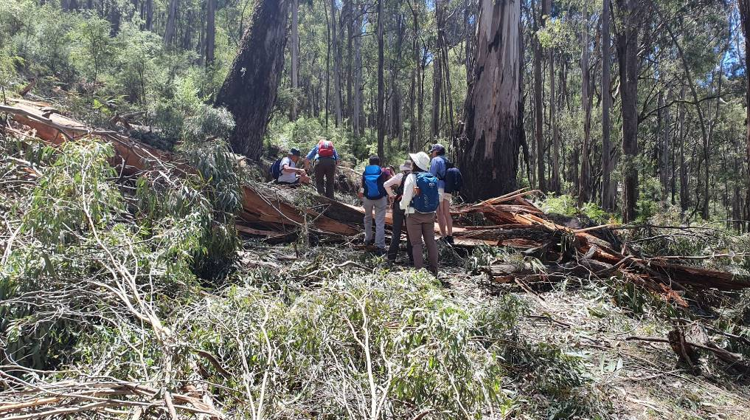 The tree scramble

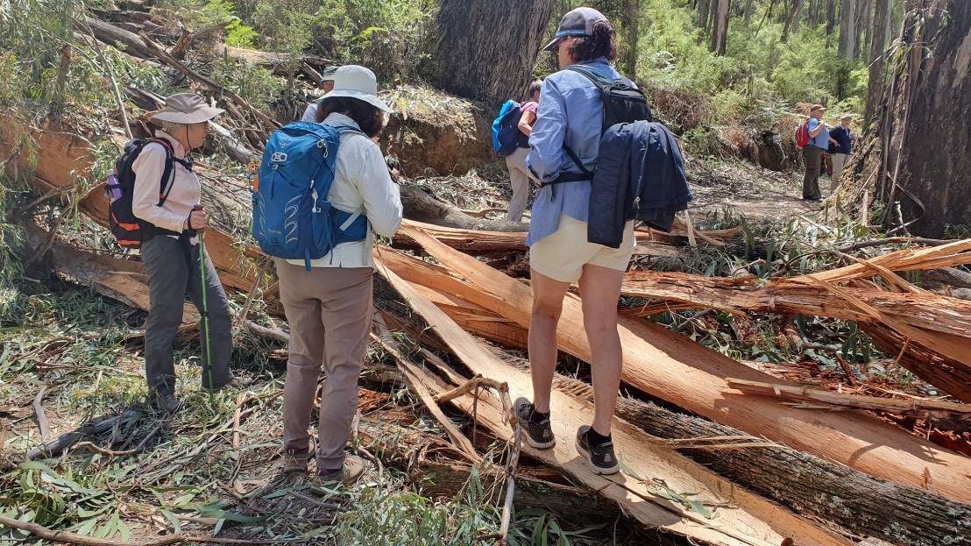

PS – Yes, we did find a coffee shop on the way home ☺

Twilight Ride at Nathalia – December 2019

There were twelve bike riders who met on the bank of the Broken Creek at Nathalia to ride to Picola and back. The weather was perfect and we headed off following the creek for most of the way and arrived at Picola to have a rest in the park. The park has history boards depicting times of the railway and timber cutting, which people found interesting reading. The pub was closed (re-opening on 13 December) so no quenching our thirst there!
We rode back to Nathalia and enjoyed a picnic/barbecue on the river bank. It was a lovely balmy evening and a good finish for the ride.
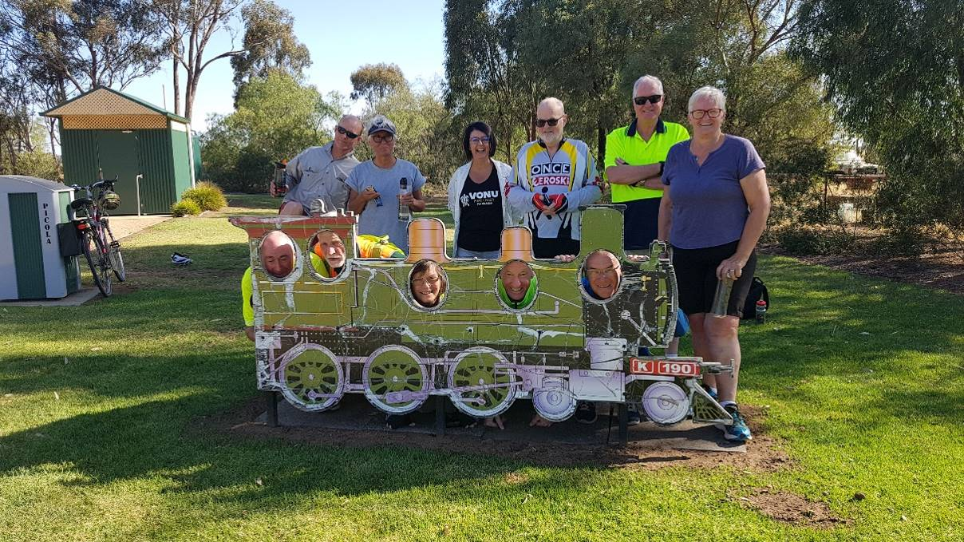

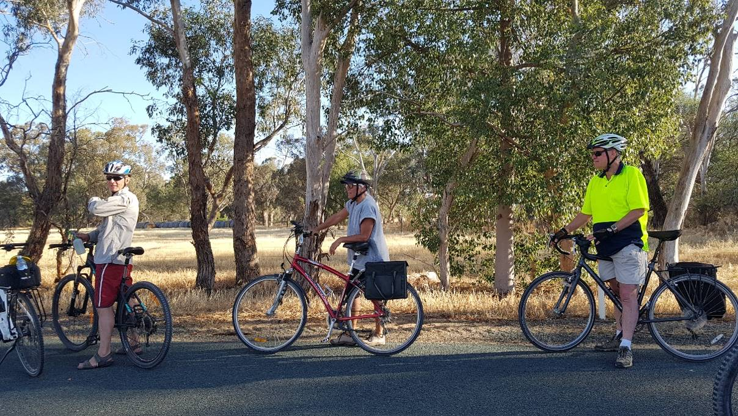

We have been a busy. See next page for January and February event reports!

Shepparton Adventure Club January Midweek Walk - January 22nd

Fourteen members participated in the January midweek walk along the Broken and Goulburn Rivers in Shepparton. The group started at the Archer Road end of the walking/bike trail and followed the path along the wooded verge of the rivers, under the Goulburn Valley Highway, under the Melbourne Shepparton Railway bridge, past the confluence of the two rivers and onto Aquamoves. While enjoying a coffee the group discussed plans for the coming year. The final stage of the walk took the group across the foot bridge and onto the floodplain towards Mooroopna, before joining the path back to Shepparton.

It was a very enjoyable walk with some members having never walked those paths. We are most fortunate to have such a lovely bush /forest floodplain so close to the heart of the city.

A varied program of monthly walks was put together for the coming 10 months. It was agreed to start the walks in summer at 8 am and to continue to have an extra walk in Oct to enjoy the spring weather and wild flowers of this season. The group also discussed the forth coming Mornington Pensinsula Coastal walk scheduled for the first week of March. Old and new members are very welcome to participate in these walks…. in great countryside, gaining good exercise and with wonderful company!
Dianne Hanna.

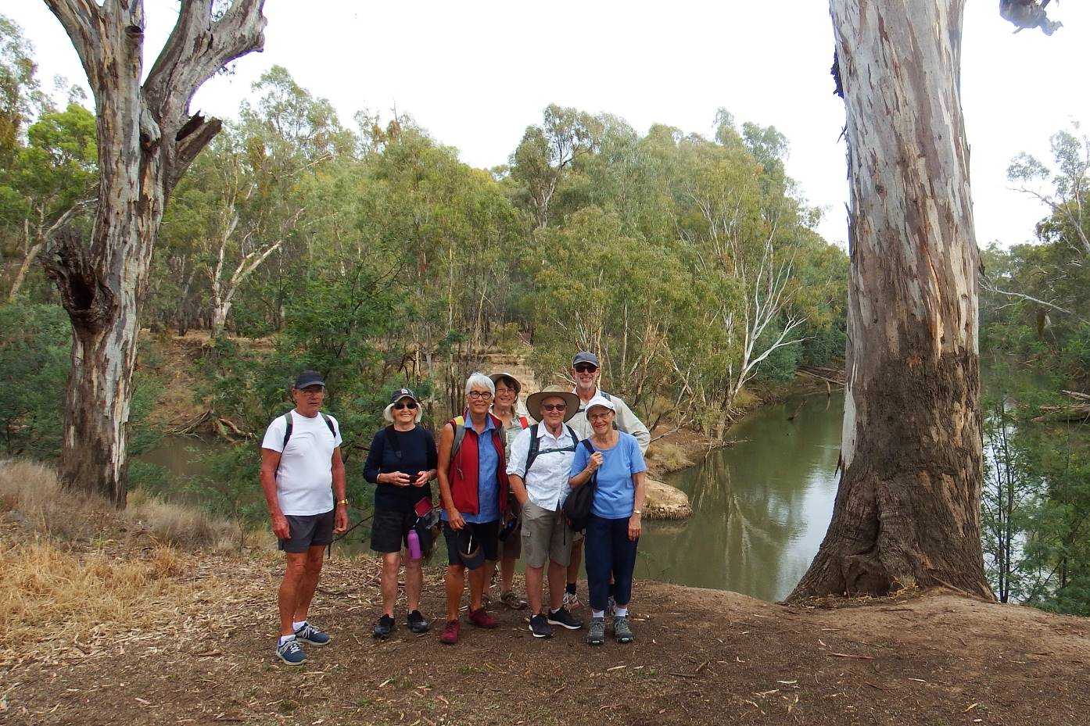

Some of the happy walkers at the confluence of the Broken and Goulburn Rivers Courtesy Marg Clarke

It is fact that being outdoors is good for the spirit as well as….
- BEING OUTDOORS BOOSTS YOUR ENERGY. ...
- IT FEELS EASIER TO EXERCISE OUTDOORS. ...
- THE OUTDOORS IS GOOD FOR YOUR VISION. ...
- NATURAL SUNLIGHT HELPS MITIGATE PAIN. ...
- THE OUTDOORS BOOSTS YOUR IMMUNE SYSTEM. ...
- THE OUTDOORS PROVIDES YOU WITH FREE AROMATHERAPY. ...
- THE OUTDOORS ENHANCES CREATIVITY. And much more. Mentalfloss.com

The Jodie Ridges Bike Trail
Friday gave us great concern as we had 15.2 mm of rain but Saturday morning arrived and an early morning recie on track conditions was completed and the all clear was given; let the ride begin. Six riders started off from the Shed in a westerly direction with all focus on climbing the only hill of the day - swing bridge- with all 6 riders safely traversing the hill, things flattened out for the run into Mooroopna. About half way to Mooroopna some of our riders lost focus on our westerly push to Mooroopna. I can only put it down to the coffee aroma coming from the cafe at Kids Town!
With all minds back on the ride we ploughed into Mooroopna past the Royal Mail Hotel, off the bitumen and on to the dirt track, stopping under the rail way bridge to plan how to best to tackle the descent and climb out of the 25ft deep mostly dry river tributary. The strategy didn’t always go to plan; nevertheless everyone made it safely to the other side. We were now in the forest following the Goulburn up stream with all of her twists and turns.
Just after traversing the river tributary we were joined by another member who was delayed because of bike issues. He put in a Herculean effort to get the repairs done then set out after us. At one point I saw him going like the wild. We now had seven riders in the group. Towards the edge of the forest (Pyke Rd end) two deep river billabongs crossings had to be tackled. With the experience of the first ravine under our belt the descent and accent of these two went well. There was even a bit of skylarking in good nature.
After leaving the forest and onto Pyke’s Rd the yellow dragon came into view. After crossing the railway line, it was a straight run all the way to Tatura. On reaching the northern end of Tatura, Phil piloted us through/around the Wetland/Cussen Park and then brought us out at (you guessed it a Bakery), not just a bakery an award-winning vanilla slice bakery!
Lunch was had under a large gum tree in the Mactier Gardens (very nice area) After food, drink, rest and bit of natter it was time to turn the pedals on the homeward journey. Again, Phil led as back to Pyke’s Rd. From there we retraced our outbound track finishing the ride at Aquamoves, with refreshments in hand we talked and laughed of the day's adventure. Peter Gregory
Special Note: The Jodie Ridges Bike Trail.
This trail is a memorial to Jodie Ridges, a young mother of four. While riding for fitness along the Midland Highway in 2010 she was involved in a collision with a motor vehicle and later died tragically from her injuries.
Watch a video of our ride here: https://www.relive.cc/view/vPv4Jnm3p36 (thanks to Phil Shultz)
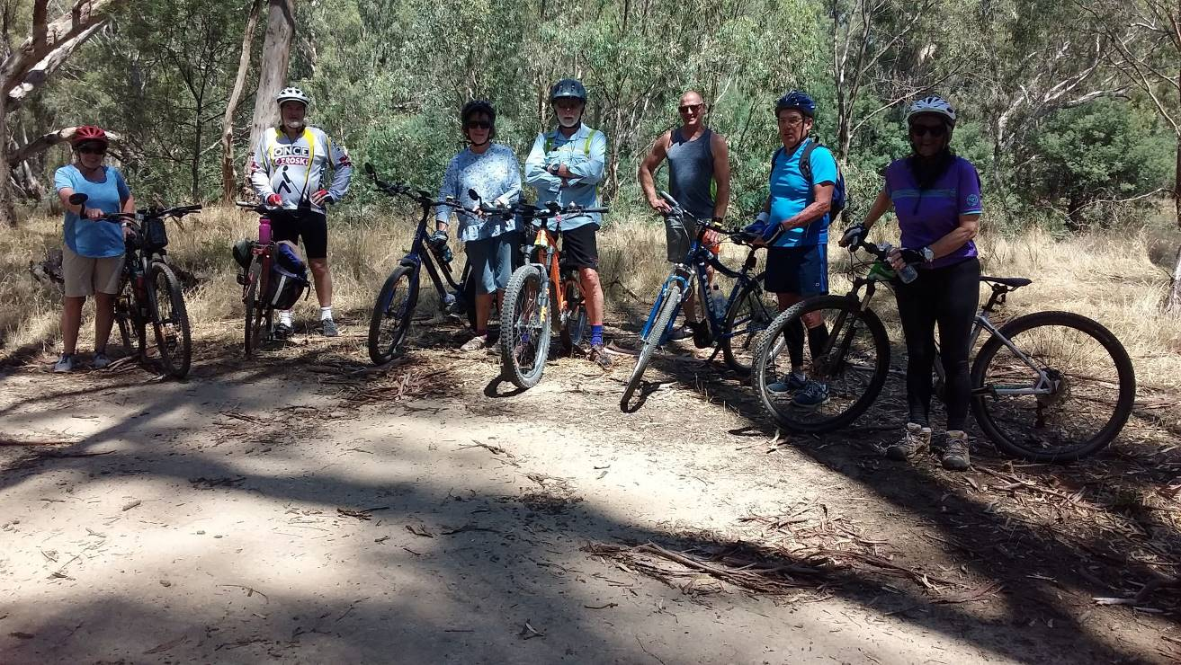

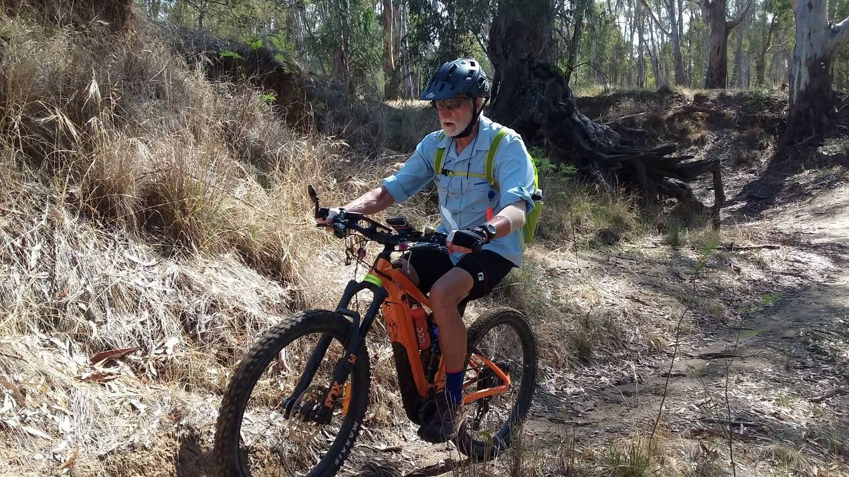

Philip on the trail!
Till next month!

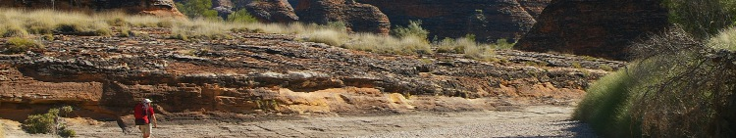


www.bushwalkingvictoria.org.au
PO Box 1007 Templestowe Vic. 3106
Phone: (03) 8846 4131
Fax: (03) 9846 7473 admin@bushwalkingvictoria.org.au

Newsletters follow the link below
Find them here: http://www.bushwalkingvictoria.org.au/what-we-do/publications/newsletters

- SAC is an affiliated member of Bushwalking Victoria
- Membership benefits
- Membership of Shepparton Adventure Club includes Bushwalking Victoria membership. Your Bushwalking Vic membership card enables you to obtain discounts at a number of retailers including Ajays (Heathmont), Bogong Equipment (Melb.), EMC (Deepdene), Melb. Map Centre (Malvern East), The Wilderness Shop (Box Hill), Paddy Pallin, Smitten merino wear Tasmania, Woodslane Walking Guides.
- 5% on Outdoor Travel tours and all reservations made directly with the office at Bright. Check out their website or join their email newsletter list for tours and current deals: www.outdoortravel.com.au, 1800 331 582 info@outdoortravel.com.au
- Discovery Holiday Parks, Cradle Mountain 20% discount off shoulder and low season rates (16 April - 2 December)
- Contact Claire on 03 6492 1289, 1800 068 574 www.discoveryholidayparks.com.au

Bushwalking Victoria Bulletin 25 - Oct 2019 – Snippets of interest
PAPER MAPS for BUSHWALKING – Where to find paper maps for bushwalking and how to print them.
Recent press reports have highlighted the decision by Geoscience Australia to cease printing its 1:250,000 topographical maps in December 2019, but this should not be a major problem for bushwalkers in Victoria. 1:250,000 (1cm to 2.5km) is not a scale most walkers use, as these maps provide insufficient detail. Good detailed maps covering Victoria at 1:25,000 (1cm to 250m) and 1:50,000 (1cm to 500m) are available in electronic form and many are also available as paper maps. These scales are far more useful out on the track.
Paper maps can be purchased from suppliers such as Vicmap (mainly 1:50,000), Spatial Vision and Meridian – see Finding Maps for Walking in Victoria for a detailed list of sources, including shopfront and online suppliers.
If, rather than purchasing a paper map, you want to print one of the many electronic maps which are available from a variety of sources (including any of the Geoscience 1:250,000 maps) it’s relatively easy.Many maps are produced in geopdf format. This allows the maps to be displayed and used in navigation software and apps. It also allows them to be easily printed to the correct scale using free software e.g. Adobe Acrobat reader. A walk leader can use an electronic map for navigation with their smartphone and carry the identical paper map.
See the website for detailed description on printing geopdf maps- in full or part thereof.
Bushwalking Manual Update – comments are welcome. The Bushwalking Manual is now live at bushwalkingmanual.org.au. Articles published to date include:
Trip Planning: Planning contributes to the enjoyment and safety of trips. This section includes information on planning bushwalks, safety, forming a group, route planning, maps and guidebooks and designating a Trip Emergency Contact.
The Trip: Skills, techniques, communication, camping and other topics while on a bushwalk or ski trip.
Ski touring: Day tours, multi-day ski tours, techniques for skiing uphill and downhill and ski skins.
Emergencies: Information about handling emergencies, including emergency communications and devices, first aid and helicopter rescues.
State information: General information, notable bushwalks, safety considerations, emergency services information and links for each State and Territory.
Feedback and suggestions are welcome and can be provided using links on the feedback page.
Sections to be published next include leadership, the elements, environment, specialist topics and resources.
Bushwalking Victoria Calendar of BTAC Track Maintenance and Training Opportunities
22 - 23 February: BTAC Track Maintenance Project - Great Otway’s National Park
7-9 March: BTAC Track Maintenance Project - AAWT Buckwong Creek
4 & 5 April: Day Walk Leader Training - Westerfolds Park (A notice with details and a link to register will be sent in early February).
9-12 April: BTAC Track Maintenance Project - AAWT Philack Saddle to Stronachs Camp
2-3 May: BTAC Track Maintenance Project - Grampians National Park
16-18 May: BTAC Track Maintenance Project - McMillians Walking Track
6-8 June: BTAC Track Maintenance Project - Bendoc - Snowy
9 November: Smartphone Navigation Course
16 & 17 November: Day Walk Leader Training
23-24 November: BTAC Team: Track Maintenance - Alpine National Park (Mt Howitt and Stanly Name Spur tracks)

That’s it!

