
If undelivered, please return to PO Box 264, Shepparton 3632

SHEPPARTON ADVENTURE CLUB inc. A0002706S
NEWSLETTER June 2019

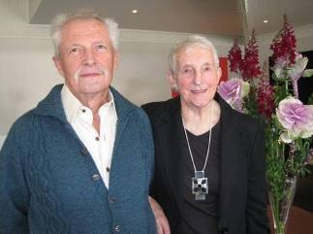
(Peter & Lexie 60th Wedding Anniversary)

Vale – Peter Abbey -- (3/6/1929 – 6/5/2019)

We were all very saddened to hear of the passing of one of SAC’s older members on the 6th May.
Peter had been a very active member of SAC for many years although his age had caught up with him in the past few years. His wife, Lexie, passed away a few years ago and Peter had been living at Banksia Lodge up until his death. Peter had quite a number of diverse interests and can be remembered for his passion for photography, cross country skiing, bushwalking, canoeing and general outdoor pursuits, of which he gave his all. He had literally walked and skied over a significant portion of the Victorian high country & Snowy Mountains. I have vivid memories of us being confined to a tent during a howling snow storm after skiing to Mount Kosciusko and in driving rain on Mount Jagungal when he was photographing snow gums & where we swapped many of life’s stories. He joined our MidWeek Walkers group and led many of the group’s monthly walks. Quite a few SAC members can thank Peter for honing their navigation skills. He used to run courses both within the club and at Tafe. Up until recent years Peter could regularly be seen running around Victoria Park Lake to help keep his fitness level up. Peter told me a few years ago that one of his objects in life was to celebrate his 100th birthday. Sadly this did not eventuate, but he certainly led a very full life and his significant contribution to the club was very much appreciated by all who knew him. The club is all the better for his input. Vale Peter Abbey.

(Richard Graves).

Next meeting: Tuesday 25th June 7.30pm, dinner before from 6pm at Vic Hotel
Mechanics Institute Wyndham St. Shepparton
Member Neville to speak and show pics of Scotland walking trip.

Notice of Annual General Meeting for Shepparton Adventure Club (SAC)
The SAC AGM shall be held at 7.30pm on 27 August 2019 at the Mechanics Institute/Shepparton Access, 227 Wyndham Street, Shepparton
The ordinary business is to confirm the minutes of previous AGM, receive reports & statements and elect committee members.
A committee nomination form is included with this newsletter.

President’s Piece

President’s Piece
Hello everyone and welcome to winter.
You may have noticed a new walking path constructed near the SAC shed in May and there is some more work to come with plantings to the south-east of the shed over part of the current walking track. This is all part of council’s plan to separate walkers from the busy boat movements between sheds and the lake boat ramp, by redirecting them around the back of the sheds. SAC (and Sailability) will still be able to access the boat ramp via the current route from our shed but walkers will be discouraged from using this path. Richard G and I met with council and Sailability to go over the plan and we are satisfied it won’t be an inconvenience.
I recently joined a few local mountain bikers for a cycle along the Goulburn River bushland from Shepparton to Toolamba and return. This route is being promoted by a group of residents from area (Murchison, Toolamba, Tatura, Mooroopna and Shepparton) for both recreation and commuting purposes. The ultimate goal is a link through to Murchison, along the river all the way on crown land. From Murchison you could then cycle to Heathcote via the Heathcote-Graytown National Park and forest tracks. This then connects you to the O’Keefe rail trail into Bendigo. Maybe don’t try it all in one day, but it would open up more possibilities for cycling trips from Shepparton.
The SAC Annual General Meeting will be held on 27 August, where you have the chance to join the committee as all positions are up for election. This year we are particularly looking for a new editor of the newsletter as Steve has decided to step down after 3 years – thanks Steve! This is a good opportunity to develop or brush up on your word processing skills, with guidance available from past editor(s). We are now putting out the newsletter approximately every 2 months and the committee meets on a similar frequency, so it’s not very onerous. Please give it some thought.
Enjoy your adventures,
Greg

Calendar of Activities 2019

Date | Activity | Location | Leader | Distance/Rating
15th June | ride | Nathalia. Further information to follow
25th June | Club Meeting 7.30pm | Mechanics Institute Wyndham Street Shepparton. Dinner prior to meeting at The Victoria Hotel Shepparton from 6pm | Guest Speaker: Adventures of Neville in Scotland
26th June | walk | Cobram/Numurkah/Barmah | Barb Brown  0417 364985 | Easy
July | ride | Benalla. Further information to follow
24th July | walk | Kamarooka Rail Trail | Richard Graves  0408 547065 | Easy
17th – 18th August | ride | Dunolly Trail, Waanyarra Trail, Moliagul Trail | Ray Mt Samaria 0438591749
24th August | walk | Mt Samaria | TBA | Easy/medium
27th August | AGM | Mechanics Institute Wyndham Street Shepparton. Dinner prior to meeting at The Victoria Hotel Shepparton from 6pm | Greg Smith
21st September | ride | Woodend Wombat Forest Trail | Maartji 58241543
25th September | walk | Boathole to Mineral Springs  Strathbogies | Howard Hanna  0437 628279  Justus Hagan | Easy/medium
9th October | walk | Rocky Ned Base walk | TBA
19th October | ride | Cathkin to Alexandra Rail Trail
22nd October |  | Club meeting – SAC sheds Victoria Park Lake Shepparton
23rd October | walk | Mt Meg Conservation Park | Dianne Hanna  0437 289281 | easy
16th – 17th November | ride | Old Beechy Rail Trail | Ray 0438591749 | Dallas 0413910008
27th November | walk | Heathcote McIvor Range | Philip and Lottie Schultz
December | Xmas party | TBA

Note: All riders to confirm attendance with event leaders prior to event.

Note: For other Club events please refer to their websites listed below:
Benalla Bushwalking Club http://benallabushwalkingclub.org.au/
Border Bushwalking Club (Albury & Wodonga) - www.borderbushwalkingclub.com.au
Wangaratta Out and About Club - www.wangarattaoutandabout.org.au/
Bendigo Bushwalking and Outdoor Club - www.gobush.org.au/
Echuca-Moama Bushwalkers - www.echucamoamabushwalkers.org.au
and more can be found at www.bushwalkingvictoria.org.au.

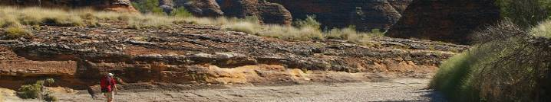


www.bushwalkingvictoria.org.au
PO Box 1007 Templestowe Vic. 3106
Phone: (03) 8846 4131
Fax: (03) 9846 7473 admin@bushwalkingvictoria.org.au

Newsletters follow the link below
Find them here: http://www.bushwalkingvictoria.org.au/what-we-do/publications/newsletters

- SAC is an affiliated member of Bushwalking Victoria
- Membership benefits
- Membership of Shepparton Adventure Club includes Bushwalking Victoria membership. Your Bushwalking Vic membership card enables you to obtain discounts at a number of retailers including Ajays (Heathmont), Bogong Equipment (Melb.), EMC (Deepdene), Melb Map Centre (Malvern East), The Wilderness Shop (Box Hill), Paddy Pallin, Smitten merino wear Tasmania, Woodslane Walking Guides.
- 5% on Outdoor Travel tours and all reservations made directly with the office at Bright. Check out their website or join their email newsletter list for tours and current deals: www.outdoortravel.com.au, 1800 331 582 info@outdoortravel.com.au
- Discovery Holiday Parks, Cradle Mountain 20% discount off shoulder and low season rates (16 April - 2 December)
- Contact Claire on 03 6492 1289, 1800 068 574 www.discoveryholidayparks.com.au

Walksafe : - means equipped to be able to enjoy bushwalking
-
Walksafe booklet published by Bushwalking Victoria

Full Moon Dates2019:
17th June,16th July,15th August, 14th September, 13th October, 12th November and 12th December
Courtesy of MoonGiant.com)

- The SHEPPARTON ADVENTURE CLUB Inc.
- General Meeting: 4th Tuesday of the months: February, April, June, August, October, December
- usually at: 7:30 pm at the Mechanics Institute, Wyndham St, Shepparton.(Winter) and
- The SAC shed, Victoria Park Lake Shepparton (Summer)

- Correspondence to: The Secretary SAC, PO Box 264, Shepparton 3632
- Email: sacvicau@yahoo.com.au
- OFFICE BEARERS
- President: Greg Smith 5824 1143 greg.smith@gmwater.com.au
Vice President: Bruce Gill 5824 2548 tatgills@westnet.com.au
- Secretary: Karen Speedy 5825 1785 karenspeedy@iinet.net.au
- Treasurer: Scott Birchall 5831 6063 scottbirchall@aapt.net.au
- Newsletter Editor: Steve Jeffs 0402368751 stevesbluebmw@outlook.com
- Equipment Officer: Richard Graves 5824 2929 richsue@bigpond.com
- Publicity Officer: Richard Speedy 5825 1785
Calendar coordinator: Neville Paynter 5831 1576 Neville.Paynter@jacobs.com
- Mid-week coordinator: Dianne Hanna 0437 289 281 dhanna3@bigpond.com
- Committee member: Howard Hanna 5828 9281 howard_hanna@yahoo.com

Snippetts from the past

Ruffy Ramble - 27 May 2015
A stormy weather forecast did not diminish the determination of the Shepparton Adventure Club mid week walkers with three vehicles loaded with hardy folk, their rain gear and day packs.
Endorsing the popularity of SAC walks in the Strathbogie Ranges, fourteen members were keen to again visit this strikingly beautiful region that forms the headwaters of Hughes Creek, a Goulburn River tributary.
Our trip leader Howard had arranged for local identities and landholders Justus and Neil to be our walk guides for the day meeting the group at the former Ruffy Primary School for a welcoming morning tea. Our group was also joined by two local ladies keen for adventure with us.
Being long term residents and Strathbogie devotees, Justus and Neil shared their local knowledge of current goings on and history of this spectacular yet little known area of central Victoria with passion and enthusiasm.
Our walk took us from Donovans Lane across lush paddocks past interested cattle and down along Hughes Creek for a few kilometres to our lunch spot on a large granite platform deep in a secluded part of the valley. Light drizzle threatened for a few moments, however the storm threat quickly passed to reveal clear skies which remained for the rest of the day.
A creek crossing on fallen log 'bridges' gave some walkers a couple of nervous moments. This provided the rest of the watching group entertainment waiting for a slip into the cold clear waters, they were disappointed as all remained smiling and dry.
Following our creek crossing adventure the group split into two parties, one group following the small meandering creek along the valley floor, while a larger group climbed high up to the ridge line. Those in the valley experienced some exciting and wet creek crossings. The group who climbed to the ridge were rewarded with spectacular views across the region from the granite outcrops.
Our SAC walkers and our friendly guides met in the valley end near Tarcombe to conclude the hike, with all agreeing that we had experienced a very enjoyable day. All vowed to return.
The Shepparton Adventure Club would like to thank our guides, Ruffians Justus and Neil for dedicating their day to our group and the private landholders who allowed our walkers access to this beautiful part of Victoria.
Thanks to Howard for arranging another succesful Ruffy Ramble.
by Peter H

Trip Reports

Seven Creeks Gorge: Midweek walk March 27th 2019

Seven Mid week walkers met Justus and Paul at Euroa full of anticipation for yet another of Justus’ adventurous walks in the Strathbogies. After organising the car shuffle, the group headed for Polly McQuinns. After a warming coffee in the crisp autumn air we set off to follow Seven Creeks downstream for approx. 9 kms to Gorram Falls.
This really was a very special walk…… with low water levels in the creek we were able to walk along the stream bed and experience the grandeur of the bolder strewn gorge with its steep rock faces and heavily vegetated riparian zone.
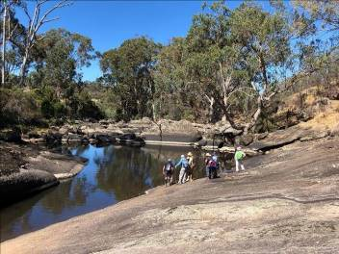
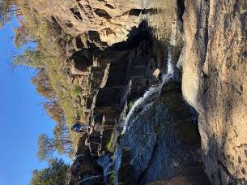

The scenery was quite spectacular with many rock pools, several waterfalls (not much water), braided streams, exposed rock platforms, and the odd small sandy bar.
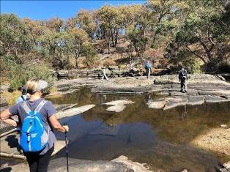
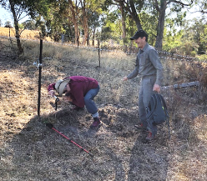

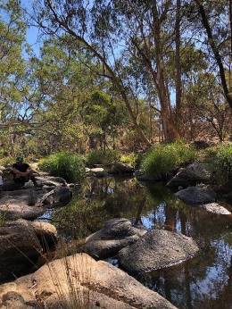

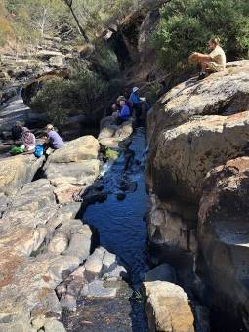

There were lots of rock scrambling, climbing through, over or under fences, and rock hopping across the creek as we zigzagged downstream.

We found the perfect lunch spot…. perched beside Seven Creeks Falls, overlooking the gorge below.
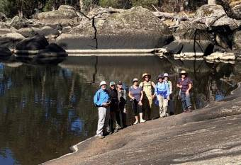
Native wildlife were our only companions. We saw several rather huge kangaroos, disturbed a couple of wallabies, made aquaintance with two black snakes (one more closely than we liked), spotted several lizards as they sunbaked on the hot rocks, had glimpses of a fox and a water animal that we liked to think was a platypus and observed at least 12 different bird species.

We arrived back at the car by 3.30pm and while the drivers did the car shuffle the rest of us completed the last 800m to the lower car park below Gorram Falls.

The coffee stop at Euroa was much appreciated and we arrived back in Shepparton tired, but very grateful to be able to experience such a walk in such perfect weather.
As always Justus once again delivered. We thank him for leading us on yet another great walk and look forward to the next Justus Strathbogie walk in the spring. .

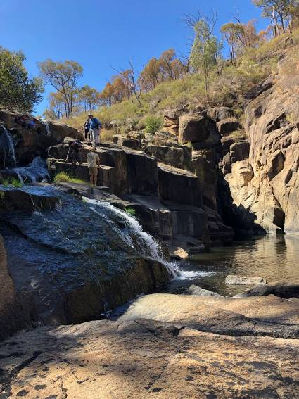

Mid week walk April 24th: Tallarook to Trawool

Upon our arrival at Trawool there was a very light shower however it only lasted a minute or two.
After a brief walk we had our morning tea before continuing on. The hills were in need of rain but the Goulburn River was its usual picturesque self. On the way again after a break for lunch we saw an echidna and a wombat who had managed to find some green grass.
A nice day had by all.
Cheers
Ray
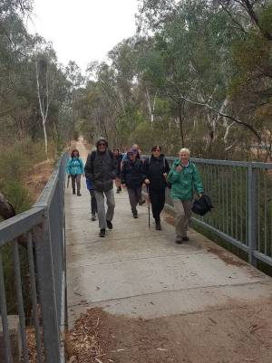

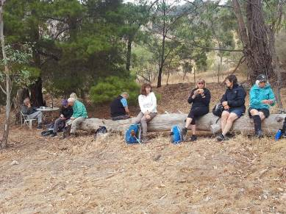

Mid week walk to Mt Terrick Terrick National Park May 22nd 2019

We were again blessed with a perfect day for a walk, blue skies overhead and a warming sun. After meeting at the library we made our way to Mt Terrick Terrick via Echuca and Mitiamo. What a difference a month can make to the colour of the landscape. As we drove Mt Terrick Terrick the green tinge had replaced the very dry brown landscape of the previous months. After the drive, that took us about 90 minutes, we were ready for our morning tea stop at the entrance to the park, 4 km north of Mitiamo. With map in hand Di then lead the group through the White Cypress Pines towards the granite boulders that make up Mt Terrick Terrick. After the easy walk to the base of the mountain we had a short steep walk to the pinnacle of Mt Terrick Terrick. Our reward was a spectacular 360-degree view of the entire park and surrounding farmland. Pyramid Hill was also visible to the west. Unfortunately we had not walked far enough or long enough to enjoy the view while eating lunch so, after a group photo opportunity, we descended and headed towards Bennetts Rock. The area is home to 100 species of birds however; the fauna was light on the ground during our walk. With the expert bird watching skills of some of the Adventure Club members, we were able to identify and view the black and white Hooded Robin at our lunch stop. We also saw the flash of a Black Wallaby bounding away. After we were all feed and watered we headed towards the sun and a bit to the left until we found the road that lead us to Bennetts Rock. This was also an easy walk with a short climb up the granite outcrop to the top. Again we had great views including Mt Terrick Terrick and the surrounding area. The cool granite outcrops provided shelter for the Dja Dja Wurrung Aboriginal people and associated clans of central Victoria. When walking through the woodlands we found evidence of their existence in the form of curving scars on a number of old Grey Box trees. Time was moving on and in order to return back to Shepparton at a suitable time we had to keep moving to complete the circuit back to the cars.
Unfortunately time prevented us having the coffee stop on our way home. A distance of approximately 13 km was covered on this walk. Thank you Dianne for organising a most enjoyable walk to Mt Terrick Terrick. The first time for many of us.

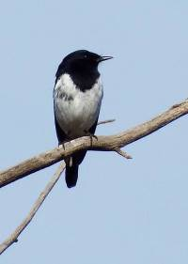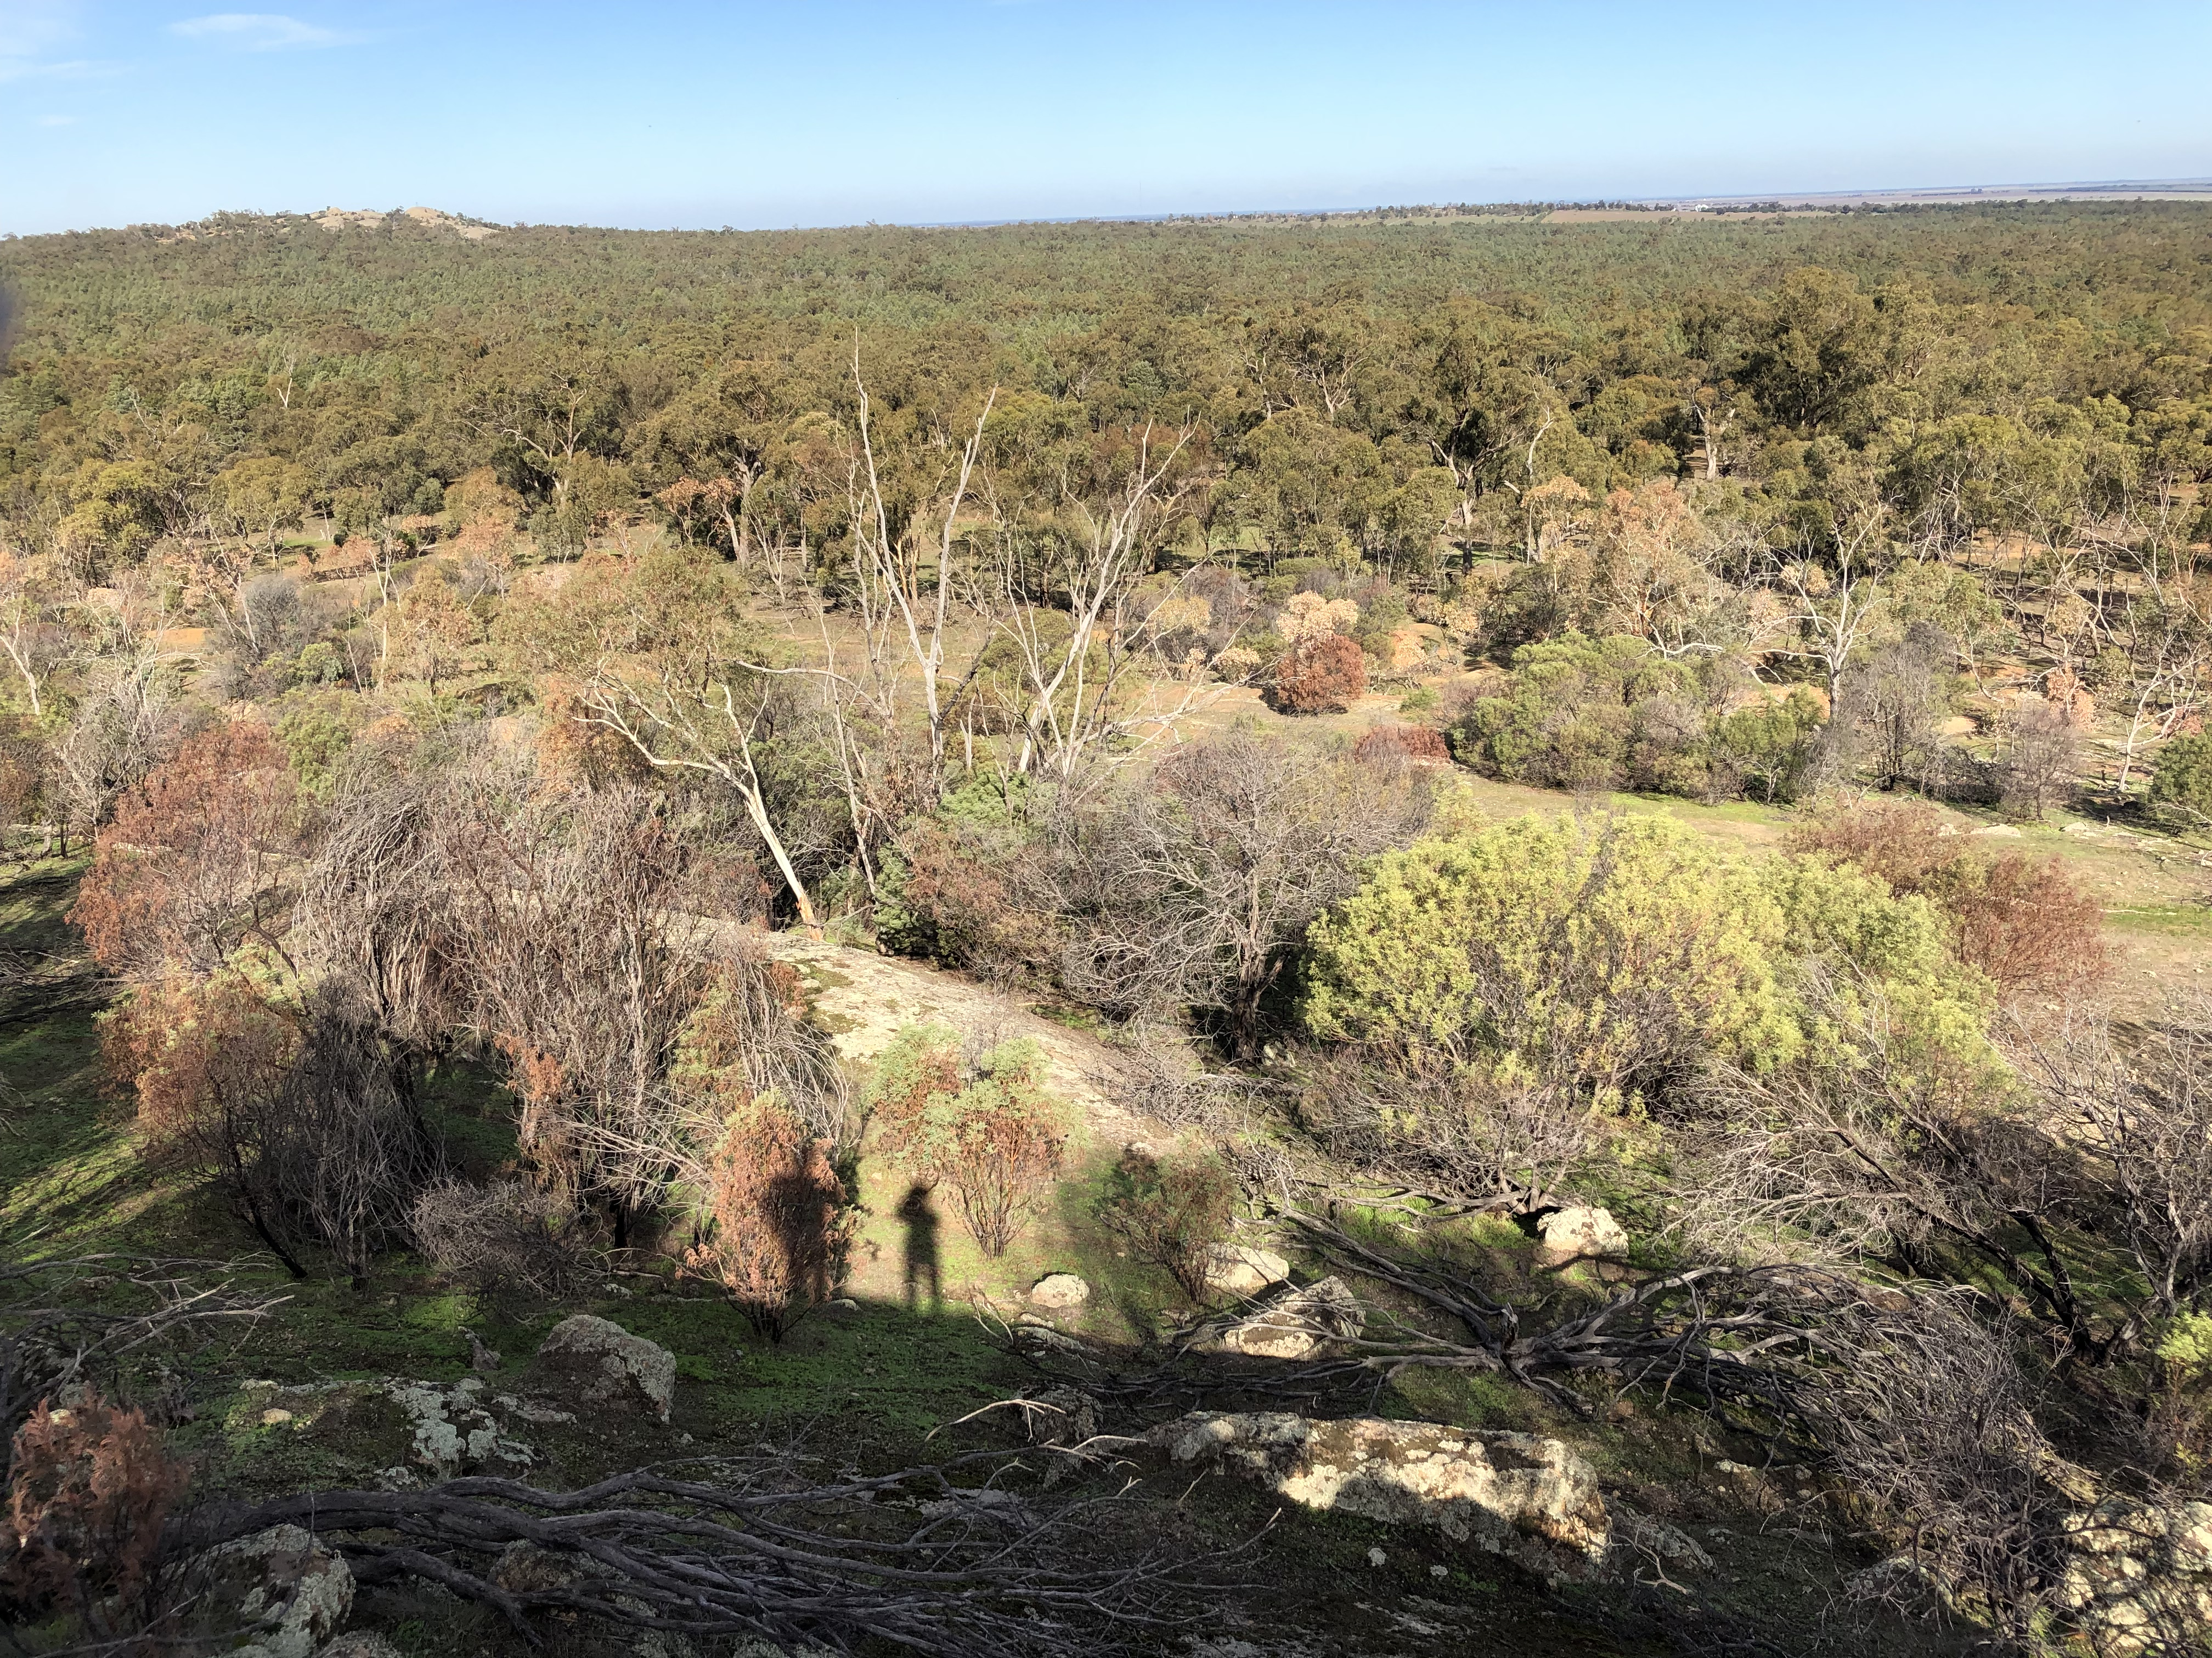
The Hooded Robin View from Bennet’s Rock

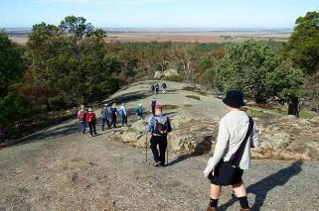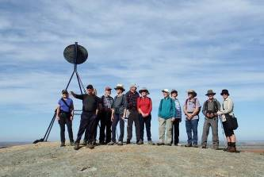
Descent from Mt. Terrick Terrick On top of Mt. Terrick

Thanks to all newsletter contributors for their articles and amazing photos.

Our newsletter printing is kindly sponsored by Hon. Wendy Lovell, MLC for Northern Victoria Region
Wyndham Street, Shepparton
The next newsletter will be out in August 2019, but feel free to submit items at any time.

Wanted: Mature person with time on their hands and a good sense of humour.
Hours negotiable. Computer literacy a definite advantage. Ability to talk with oneself and agree on an outcome desirable. Communication skills an advantage but not essential.
SAC is looking for a Newsletter editor to commence in the position September 1st 2019.
For more information contact Steve (0402368751) or Greg (5824 1143)

MEMBERSHIP FORM SHEPPARTON ADVENTURE CLUB Inc. A0002076S

Membership Fees for the 2019 / 2020 year are due on 1st JULY 2019. Please return this form with your payment to: The Treasurer, Shepparton Adventure Club Inc. 6 Holland St, Shepparton. Vic 3630.

Please list name of each person and circle their age group (Insurance underwriting categories)

Name _________________________________________ U16 16-17 18-34 35-54 55-94 95+

Name __________________________________________ U16 16-17 18-34 35-54 55-94 95+

Name _________________________________________ U16 16-17 18-34 35-54 55-94 95+

Name _________________________________________ U16 16-17 18-34 35-54 55-94 95+

Name __________________________________________ U16 16-17 18-34 35-54 55-94 95+

Address: __________________________________________________________________

__________________________________________________________________

Phone: BH _____________________________ AH ________________________________

Mobile _______________________ Email Address: ___________________________________

Single Club Membership $35 ________

Family Club Membership $60 ________

Concession (Single Membership)* $30 ________

Concession (Family Membership)* $45 ________ *Concession applies to Pensioner/Senior/Student Cardholders

TOTAL $ _________

ACKNOWLEDGEMENT OF RISK - ALL Adults must sign I acknowledge that when I am participating in any activity of the Shepparton Adventure Club Inc, I am doing so as a volunteer in all aspects and as such I accept all responsibility for loss of property or bodily injury to me however it may occur. I acknowledge that my participation in this activity may expose me to hazards and risks that could lead to injury, illness or death or to loss of or damage to my property. In particular when participating in abseiling, caving or above the snowline activities I am aware that these activities expose me to additional hazards and risks. I will make all reasonable effort to avoid or minimise these risks by : • only participating in activities within my capabilities, • carrying food, water and equipment appropriate for the activity, and • advising the leader if I am taking any medication or have any physical or other limitation that might affect my participation in the activity.

I acknowledge that the payment of my (renewal) subscription will be deemed as full acceptance and understanding of the above. I agree to be bound by the rules of the Shepparton Adventure Club Inc. (which are available from the secretary).

Signed ………………………………………………………………………… Date ………………………………

Signed ………………………………………………………………………… Date ………………………………
Payment options (please circle):

1. Mail cheque or Money Order to 6 Holland St, Shepparton 3630

2. Direct deposit to Bendigo Bank BSB 633 000 Account No. 129 076 972 Please add your name as the reference and post the signed membership renewal form back.

2019/20 COMMITTEE ELECTIONS

New And Enthusiastic Volunteers Needed

Shepparton Adventure Club committee elections will be held during the Annual General Meeting at the Mechanics Institute/Shepparton Access, Wyndham St, Shepparton on
Tuesday 27th August 2019, 7.30pm start.

All positions will be declared vacant and new volunteers are eagerly sought. Please consider offering your services to keep our club going for the benefit of our members.

Elected positions are: President, Vice President, Secretary, Treasurer and up to 6 ordinary members, which can include Newsletter Editor, Publicity Officer, Calendar Co-ordinator, Mid-Week Activity Coordinator and Equipment Officer. No particular skills are needed, just a willingness to participate and learn.

Our committee meetings are held every 2 to 3 months and believe it or not it make for a good night out. Join the committee to find out why.

Nominations should be made on the form below and submitted to any committee member at least 1 day before the AGM. Nominees must be paid up members and be nominated by another member.



SHEPPARTON ADVENTURE CLUB COMMITTEE 2019/2020

NOMINATION FORM

I _______________________________________________________________________

wish to nominate ___________________________________________________________

for the position of ___________________________________________________________

for the 2019/2020 year.

I hereby accept the nomination (nominees signature) ……………………………………………

Signed by the Nominator ……………………………………………………………………………

