
If undelivered, please return to PO Box 264, Shepparton 3632

SHEPPARTON ADVENTURE CLUB inc. A0002706S
NEWSLETTER Vol: 38 No: 3
Published January 2019

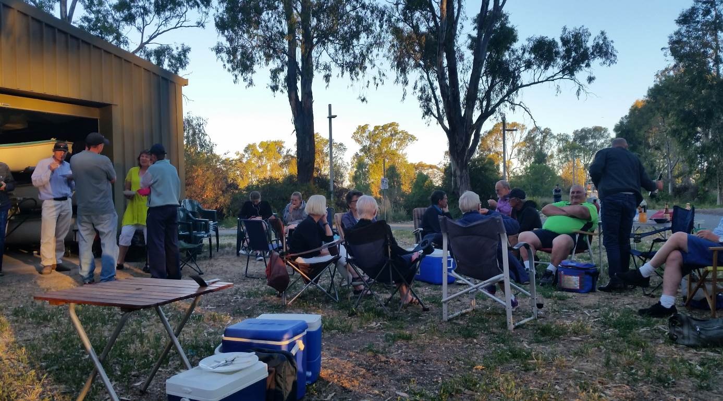

SAC Sheds December 4th. Approximately 30 members enjoying the fellowship of the final meeting for 2018

Next meeting: Tuesday 26th February SAC Shed Victoria Park Lake Shepparton

Welcome to 2019
I trust you enjoyed a safe and happy festive season with family and friends.
From February 5th it is the Chinese year of the Earth Pig, a time of enjoyment for all signs. The atmosphere is festive and relaxation widespread, Earth is the dominant influence on the year ahead.
Let’s make it a goal to get out there, relax and enjoy all that is on offer in this amazing country of ours.
Steve

President’s Piece

President’s Piece
Hi all,
Welcome to 2019 and a very hot summer, is there any other sort in northern Victoria? The Border Bushwalkers recently put out a reminder about options to consider as a leader when the weather for a trip is forecast to be very hot or the fire danger is getting to the top of the scale. While SAC doesn’t have a particular rule, it would be prudent to cancel or relocate activities on days classified as Extreme or Code Red fire danger rating. This avoids heat stress on participants and the risk of being caught in fires, either on the track or on roads when travelling to walking areas.
Our Christmas gathering in early December, on a reasonably cool night, was again a good chance to catch up with members and see what everyone had been doing either with the club or outside it.
Since then my family has climbed Mt Cobbler, swum in Lake Cobbler and camped on its shore. Two weeks later we walked out to Mt Feathertop with the O’Brien family and camped at Federation Hut on what turned into a very windy night. While no tents blew away, next time we’ll set up a bit further back in the shelter of snowgums, a lesson I’d forgotten from my last trip there.
In January it was time for the beach with snorkelling, body surfing and rock pool rambling on the east coast around Bunurong Marine Park near Wonthaggi. Thankfully it was much cooler than northern Victoria, but still warm enough for a dip in the sea most days. Jill and I also did a 3 day walk in the northern area of Wilson’s Prom across to 5 Mile Beach and Johnny Souey Cove, in one of the rare heatwaves the Prom gets. While it’s a wilderness zone, the walk in was 17km along a management vehicle track/firebreak, so not too ‘wild’ although the vegetation was quite varied and the track had plenty of up and downs. We only saw 2 other people, at the 5 Mile Beach campsite in the evening, and had the rest to ourselves – beaches, black cockatoos, wallabies, kangaroos, banksias, soldier crabs, surf and estuaries. You can do a full loop of this northern area but each day is very long and fresh water is fairly limited, hence not many people go there.
Happy hiking, riding, canoeing and other adventures in 2019,
Greg

Calendar of Activities 2019

Date | Activity | Location | Leader | Distance/Rating
19th January | Ride | Jodie Ridges Trail Shepparton | Richard 0408547065
23rd January | Mid week walk | NOTE: 8 am start.  Toolamba Bridge towards Mooroopna | Richard Graves  0408 547065 | easy
9th February | canoe | Murchison to Arcadia | Richard Graves 0408547065 | Canoe day trip
16th Feb. | ride | Tarrawingi Winery | Philip Lotty 0448324792
24-27th February | walk | Mt Hotham base camp walks  Accommodation: Wangaratta Ski Club. Book by 25th Jan. | Valda Dickins  0417 129930  & Wendy Batey | 2 + days of walks from base camp.  Range to suit abilities
26th February | chat | Club meeting SAC shed Victoria Park Lake Shepparton |  | Easy
Labor Day Weekend  Sat 9th Mar-  Mon 11th Mar | Walk  ****** see note below | Falls Ck Hut bagging expedition. The aim of this trip is to visit lots of huts on the Bogong High Plains, and introduce folks to overnight pack carrying. Camping out two nights, visit eight huts. | Neville 58311576 | Bushwalk. Beginners two night pack carry. Easy
16^{th -17th} March | ride | Warburton Rail Trail | Dallas 0413910018
27th March | walk | NOTE: 8 am start.  Polly McQuinns to Gooram Falls. Strathbogies. | Howard Hanna  0437 628279  Justus Hagan | medium
April | ride | TBA
23rd April | chat | Club meeting
24th April | walk | Tallarook to Trawool | Ray Mustey  0438 591749 | Easy
18th May | ride | Beechworth Rail Trail | Jan, Peter 0438093668
22nd May | walk | Mt Terrick Terrick National Park | Margaret Clarke  0429 350875  & Dianne Hanna  0437 289281 | Easy
15th June | ride | Nathalia. Further information to follow
25th June |  | Club meeting
26th June | walk | Cobram/Numurkah/Barmah | Barb Brown  0417 364985 | Easy
July | ride | Benalla. Further information to follow
24th July | walk | Kamarooka Rail Trail | Richard Graves  0408 547065 | Easy
17th – 18th August | ride | Dunolly Trail, Waanyarra Trail, Moliagul Trail | Ray Mt Samaria 0438591749
24th August | walk | Mt Samaria | TBA | Easy/medium
27th August |  | Club meeting
21st September | ride | Woodend Wombat Forest Trail | Maartji 58241543
25th September | walk | Boathole to Mineral Springs  Strathbogies | Howard Hanna  0437 628279  Justus Hagan | Easy/medium
9th October | walk | Rocky Ned Base walk | TBA
19th October | ride | Cathkin to Alexandra Rail Trail
22nd October |  | Club meeting – SAC sheds Victoria Park Lake Shepparton
23rd October | walk | Mt Meg Conservation Park | Dianne Hanna  0437 289281 | easy
16th – 17th November | ride | Old Beechy Rail Trail | Ray 0438591749 | Dallas 0413910008
27th November | walk | Heathcote McIvor Range | Philip and Lottie Schultz
December | Xmas party | TBA

******* Beginners Pack Carry – Falls Creeks Huts Walk (9-11 March)
Day 1 – 9th March
Meet at Mt Beauty Bakery at 10am. Leaving a car at the Heaphy Spur on the Bogong High Plains road for our return joining, we will continue to Cope Hut. From Cope Hut we will walk approx. 11Km to Fitzgerald Hut, visiting Wallaces Hut, Rover Lodge, Langford Gap SEC hut along the way. We will be camping at Fitzgerald Hut for the night.

Day 2 – 10th March
From Fitzgerald Hut we will walk to Johnston Hut via Kelly Hut (approx. 6km) were we will set up camp and have an early lunch to explore the remainder of the huts as a day walk (Edmonson and Ropers) (approx. 12km return)
Day 3 – 11th March
Today is a short walk from Johnston Hut back via Heaphy spur to our waiting car (approx. 6km) so will be back on Mt Beauty for lunch.

Note: All riders to confirm attendance with event leaders prior to event.

Note: For other Club events please refer to their websites listed below:
Clubs around the area:

Benalla Bushwalking Club http://benallabushwalkingclub.org.au/
Border Bushwalking Club (Albury & Wodonga) - www.borderbushwalkingclub.com.au
Wangaratta Out and About Club - www.wangarattaoutandabout.org.au/
Bendigo Bushwalking and Outdoor Club - www.gobush.org.au/
Echuca-Moama Bushwalkers - www.echucamoamabushwalkers.org.au
and more can be found at www.bushwalkingvictoria.org.au.

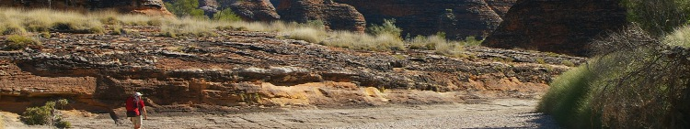


www.bushwalkingvictoria.org.au
PO Box 1007 Templestowe Vic. 3106
Phone: (03) 8846 4131
Fax: (03) 9846 7473 admin@bushwalkingvictoria.org.au

Newsletters follow the link below
Find them here: http://www.bushwalkingvictoria.org.au/what-we-do/publications/newsletters

- SAC is an affiliated member of Bushwalking Victoria
- Membership benefits
- Membership of Shepparton Adventure Club includes Bushwalking Victoria membership. Your Bushwalking Vic membership card enables you to obtain discounts at a number of retailers including Ajays (Heathmont), Bogong Equipment (Melb.), EMC (Deepdene), Melb Map Centre (Malvern East), The Wilderness Shop (Box Hill), Paddy Pallin, Smitten merino wear Tasmania, Woodslane Walking Guides.
- 5% on Outdoor Travel tours and all reservations made directly with the office at Bright. Check out their website or join their email newsletter list for tours and current deals: www.outdoortravel.com.au, 1800 331 582 info@outdoortravel.com.au
- Discovery Holiday Parks, Cradle Mountain 20% discount off shoulder and low season rates (16 April - 2 December)
- Contact Claire on 03 6492 1289, 1800 068 574 www.discoveryholidayparks.com.au

where2walk

Directory of Bushwalks across Victoria ( www.bushwalkingvictoria.org.au )
Welcome to Bushwalking Victoria's Directory of Bushwalks. The bushwalks featured in this directory have been provided by Bushwalking Victoria member clubs. Before undertaking any walk listed in this directory please ensure you read the Disclaimer and Information for Walkers.

Fire Danger Period
During the high fire danger period that generally applies from November to March, bushwalkers should avoid forest areas when a Total Fire Ban is declared, and should cancel any planned walks on any Code Red day. All w2w walks include details of the fire ban region as used by the Bureau of Meterology and the CFA. Bushwalkers are also encouraged to downlaod and use the Vic Emergency app on their smartphone that provides access to timely, relevant and tailored warnings and information.
Before undertaking any walk in a national or state park, bushwalkers are strongly encouraged to check the Parks Victoria web site for details of local closures or access restrictions. Each w2w walk includes a link to the applicable park on the Parks Victoria web site.

Bush Search & Rescue Victoria
Search and rescue in Victoria is the responsibility of Victoria Police. But when people are lost in the bush the Victoria Police Search and Rescue Squad may request assistance from Bush Search and Rescue Victoria (BSAR).
Bush Search and Rescue Victoria is a dedicated group of bushwalkers and ski tourers that assist Victoria Police in searching for lost people, often in rough terrain. Bush Search and Rescue Victoria was formed in 1949 after the Police were impressed by the professionalism of volunteer bushwalkers who were involved in an extended search. Since then, Bush Search and Rescue Victoria has provided volunteer search and rescue services to the people of Victoria on over 90 occasions.
Bush Search and Rescue Victoria volunteers can be asked to participate in searches at short notice, in adverse weather conditions and in rough and extreme terrain. The community needs bushwalkers, ski tourers, snowboarders and other people experienced in the bush for this role.
Bush Search and Rescue Victoria has the ability to send out small, self-sufficient search groups, which can navigate accurately without landmarks and stay out overnight. This is what sets Bush Search and Rescue Victoria apart from most other volunteer search and rescue organisations.
To join Bush Search and Rescue Victoria you must be a member of Bushwalking Victoria, either as a member of a club or as an individual member.
Visit the Bush Search and Rescue Victoria website for further information and details about entry guidelines and training events.
Walksafe : - means equipped to be able to enjoy bushwalking
-
Walksafe booklet published by Bushwalking Victoria

Being a Child Safe Club
Bushwalking is a safe and enjoyable activity for young people; with their family, friends, school or with a bushwalking club.
Bushwalking Victoria strongly supports clubs that welcome young people on their trips through junior or family memberships, or as visitors.
We applaud clubs’ efforts to encourage the next generation of bushwalkers. Those clubs will know that having young people on trips brings with it additional responsibilities for the club; the club committee, trip leaders and all members.
In Victoria, any organisation that provides services for children (everyone under 18) is required by law to implement Child Safe Standards to protect children from harm. This includes bushwalking clubs.

- Emergency Contact Procedures
- All enquiries about the return of participants from club activities should first be directed to the activity leader, and then to the Emergency Contact Person (ECP) for the activity if the leader cannot be found.
- It is the activity leader's responsibility to organise an ECP and advise him/her (in writing) of trip & participant details and what to do if contact is not made by the nominated time.
- Travel Cost Reimbursement
- Option 1: Preferred. Fuel Cost per car plus 5 cents per km per car to be split equally between the numbers of people in the car including the driver. If appropriate, the cost of running all vehicles should be shared equally amongst all trip participants.
- Option 2: 25 cents per km per car split between all trip participants.

- Summary of Public Liability insurance coverage at 5-3-2014 (from www.bushwalkingaustralia.org.au )
- Bushwalking, Track/Hut Construction and Maintenance, Caving, Canyoning, Liloing, Abseiling, Alpine Walking (Summer and Winter),Snow Skiing, Canoeing, Kayaking, Boating, Rafting, Swimming, Cycling, Rock Scurrying and use of hand held ropes as part of a Bushwalk, Orienteering, Rogaining, Leader Training and other related instructions.
- Activities NOT COVERED include Rock Climbing, Water Skiing, overseas trips (except NZ) and any activities not listed above.

Full Moon Dates2019:
21st January, 19th February, 21st March, 19th April,18th May, 17th June,16th July,15th August, 14th September, 13th October, 12th November and 12th December (Courtesy of MoonGiant.com)

- The SHEPPARTON ADVENTURE CLUB Inc.
- General Meeting: 4th Tuesday of the months: February, April, June, August, October, December
- usually at: 7:30 pm at the Mechanics Institute, Wyndham St, Shepparton.(Winter) and
- The SAC shed, Victoria Park Lake Shepparton (Summer)

- Correspondence to: The Secretary SAC, PO Box 264, Shepparton 3632
- Email: sacvicau@yahoo.com.au
- OFFICE BEARERS
- President: Greg Smith 5824 1143 greg.smith@gmwater.com.au
Vice President: Bruce Gill 5824 2548 tatgills@westnet.com.au
- Secretary: Karen Speedy 5825 1785 karenspeedy@iinet.net.au
- Treasurer: Scott Birchall 5831 6063 scottbirchall@aapt.net.au
- Newsletter Editor: Steve Jeffs 0402368751 stevesbluebmw@outlook.com
- Equipment Officer: Richard Graves 5824 2929 richsue@bigpond.com
- Publicity Officer: Richard Speedy 5825 1785
Calendar coordinator: Neville Paynter 5831 1576 Neville.Paynter@jacobs.com
- Mid-week coordinator: Dianne Hanna 0437 289 281 dhanna3@bigpond.com
- Committee member: Howard Hanna 5828 9281 howard_hanna@yahoo.com

Snippetts from the past

Mid week Whroo Historic Reserve Walk September 2014
The Shepparton Adventure Club’s Mid Week Walk for September was around the Whroo Historic Reserve. With showers and possible thunder storms forecast, our group of eight set off in light rain in our wet weather gear to the Balaclava open cut mine, including venturing down the steep stairs to the mine shaft tunnel. Access to the tunnel has now been closed to the public. New fencing and locked steel doors at both ends of the mine tunnel have been erected since we were last in this area. We then meandered through the historic reserve to the Whroo Cemetery and the Aboriginal Rock Well on Spring Hill. We attempted to follow an old walking track which petered out and we spent some time walking off track admiring the plentiful show of seasonal wild flowers and bird life and disturbed the occasional kangaroo. The rain had eased off and wet weather gear stored in our back packs. Many of the directional signs are in a bad state of repair and/or are missing altogether. The Park Notes map we were using did not seem to be accurate at times. On our way back to the picnic area and our cars we did a short side walk to have a look at the Greens Road Camping Area, which some of the group were not aware was there. This area has been improved with pit toilets and fencing to stop campers straying into the surrounding bush. After some two & a half hours walking and six klms later, according to our GPS, we arrived back at our cars and lunch. We finished a very pleasant day at the Rushworth Café for coffee and cakes.

Richard Graves
Trip Reports

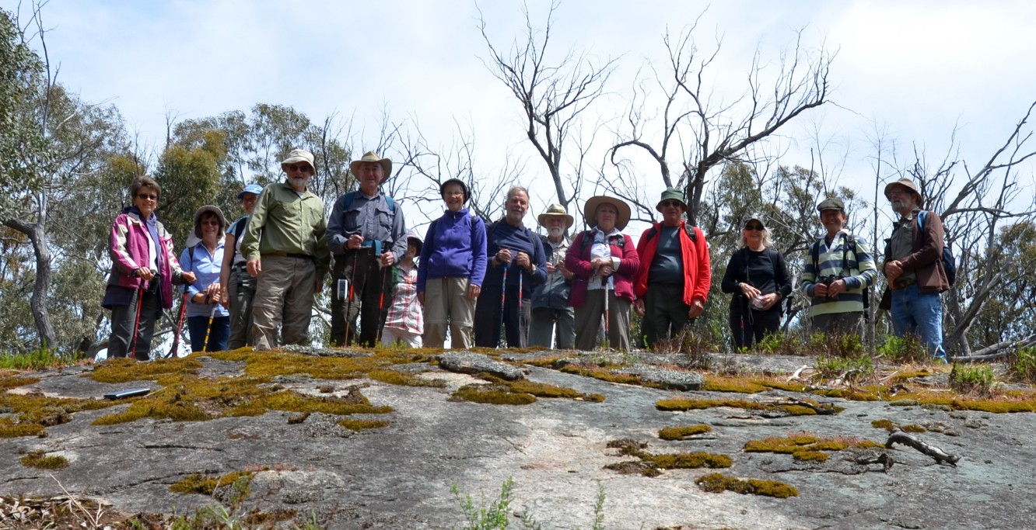
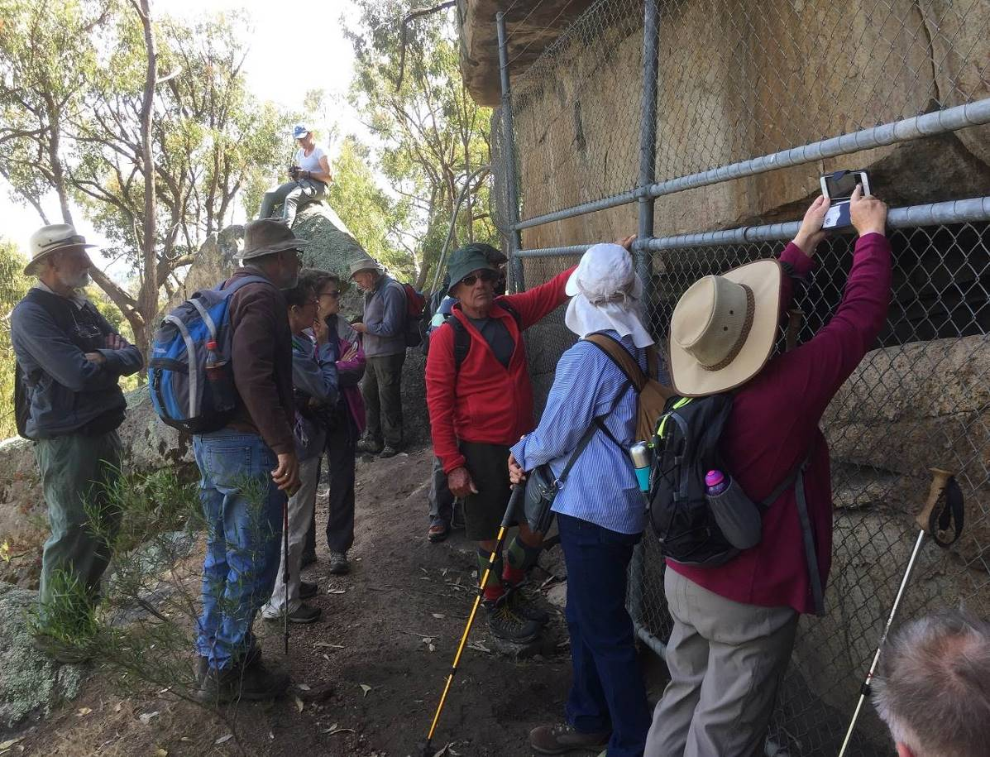

Mount Wombat Garden Range Flora & Fauna Reserve 24 October 2018.

Fourteen of us assembled at the Reservoir on the Euroa Strathbogie Road after a short morning tea stop at Euroa on the way from Shepparton. Our guide for this walk was Justus, a local identity from the Ruffy area, and who has guided us on a number of excellent previous walks in the Strathbogies. The plan for this walk was to try and locate the Garden Range Aboriginal rock shelters and art sites. Whilst they are marked on the map, the route is torturous, steep and rough. After the first kilometre or so there are virtually no tracks. Keep approximately to the 200meter contour Justus said with a wry smile. Much easier said than done as we went up and around and over rocks and scrambled up and down steep slopes in the scrub. But thanks to Justus’s navigational skills and local knowledge, low and behold there they were behind a well fenced off area hidden in the scrub. Following a relaxing lunch to gain our breaths sitting on what must have been a nearly thirty degree slope, we headed back to the cars traversing a different route to that to which we came in on. The GPS told us that we had covered 6.1 kilometres over a period of four hours. We all enjoyed our usual afternoon tea and social chat in Euroa on our way back to Shepparton.
Thanks to Justus for another stimulating, albeit slightly challenging walk.

Richard G.
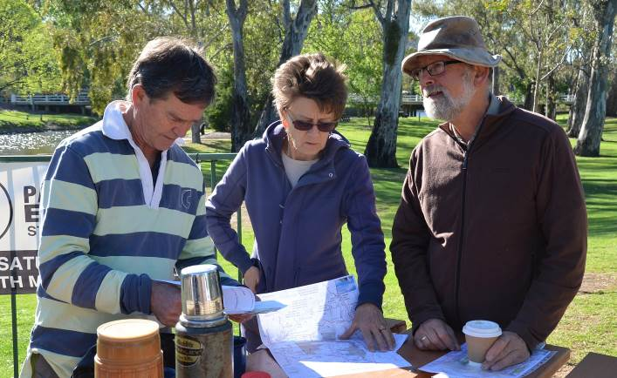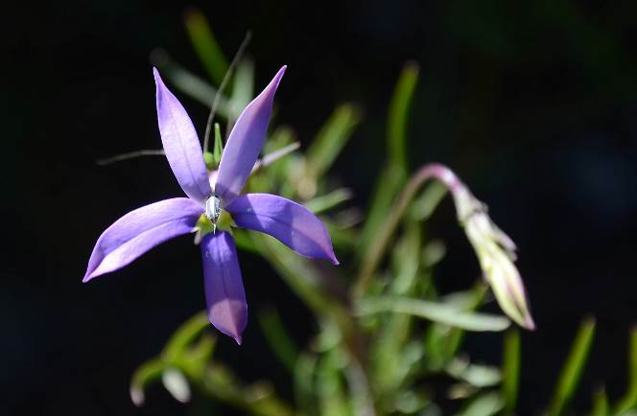

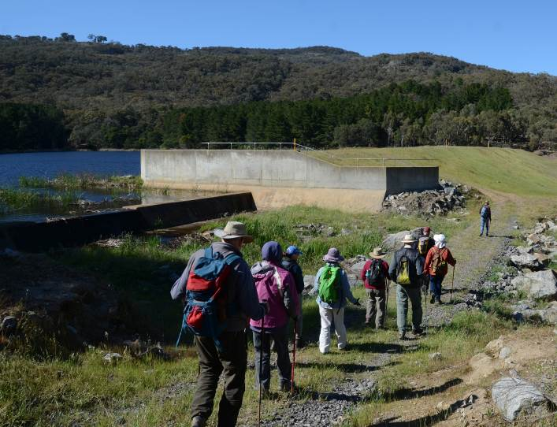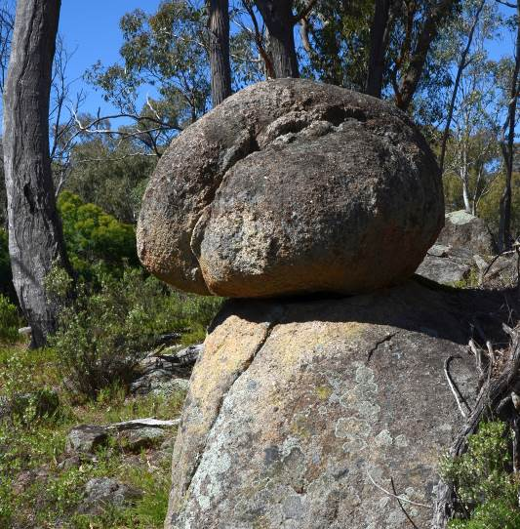

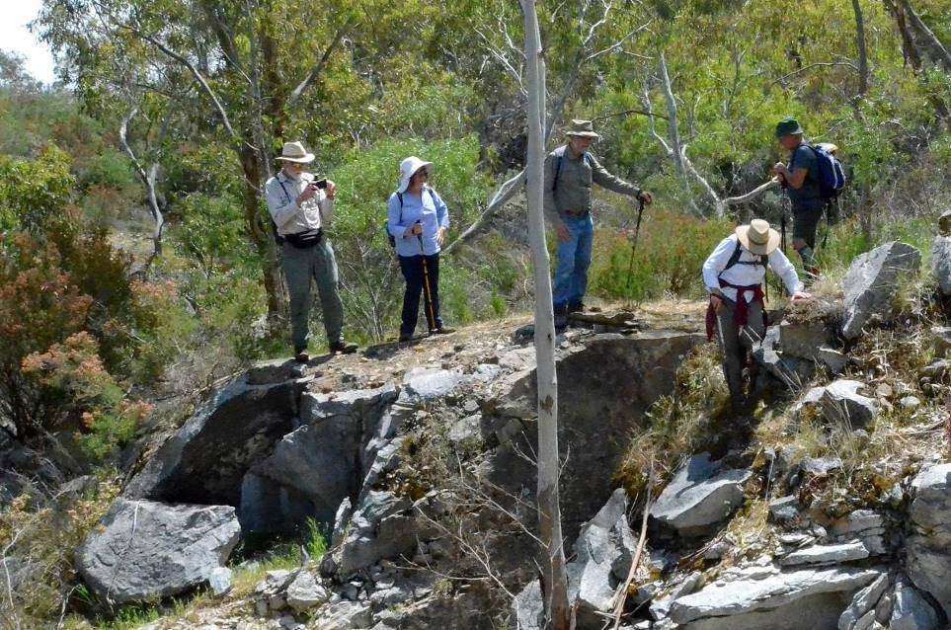
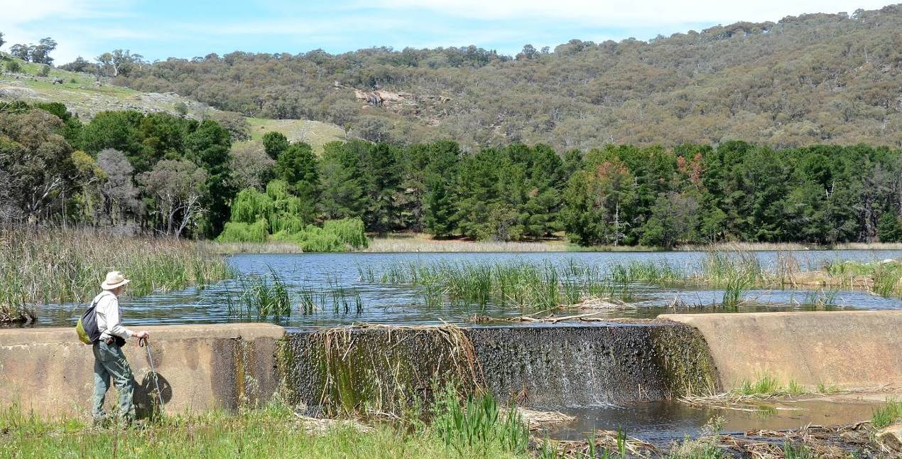

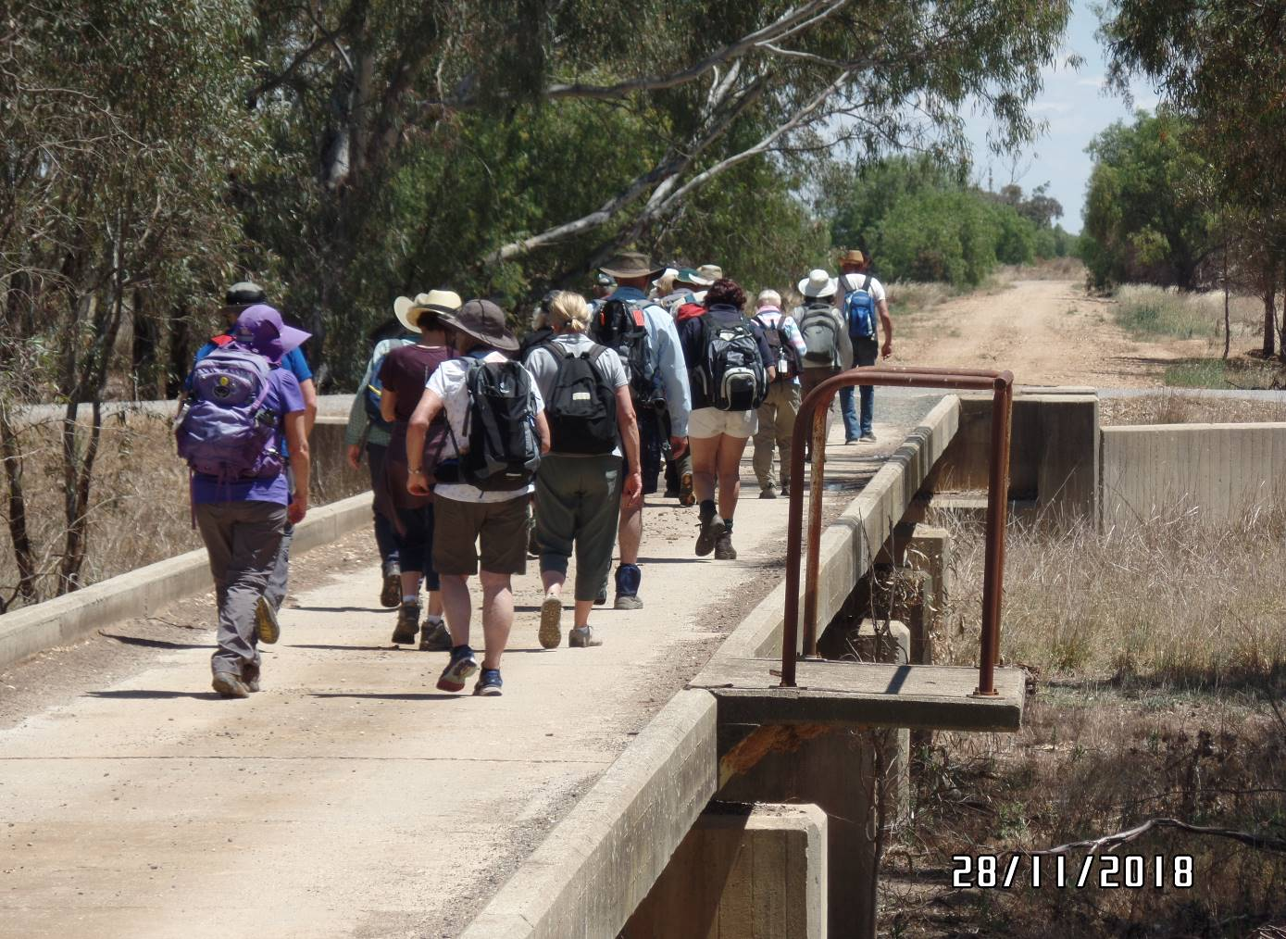

Broken Creek Nathalia - Wednesday 28th November 2018

The final Mid Week Walk for 2018, organised by Jan, was a 12.5km walk along the banks of the Broken Creek at Nathalia. Twenty walkers - a possible all time record – gathered for the walk which took us out of the township, along quiet country lanes through farmland until we rejoined the creek, which was running high with irrigation water.
The shade provided by the eucalypts along the bank was appreciated, as the day was warm and sunny. Lunch was enjoyed beside the creek at the disused railway bridge then we crossed to the other side for the walk back into Nathalia. The highlight of the birdlife was an Azure Kingfisher. As always, many different conversations were shared as we walked.
We returned to the cars and the Nathalia bakery provided the post-walk coffee, which has become a popular addition to our walks.
One of the tasks of the last walk of the year is to settle on a schedule of walks for the coming year and the range of walks suggested looks fantastic. So keep an eye out for the notices and we look forward to seeing regular and new Mid Week Walkers join us in January 2019.

Karen Speedy
(Photos thanks to Phil Schulz)

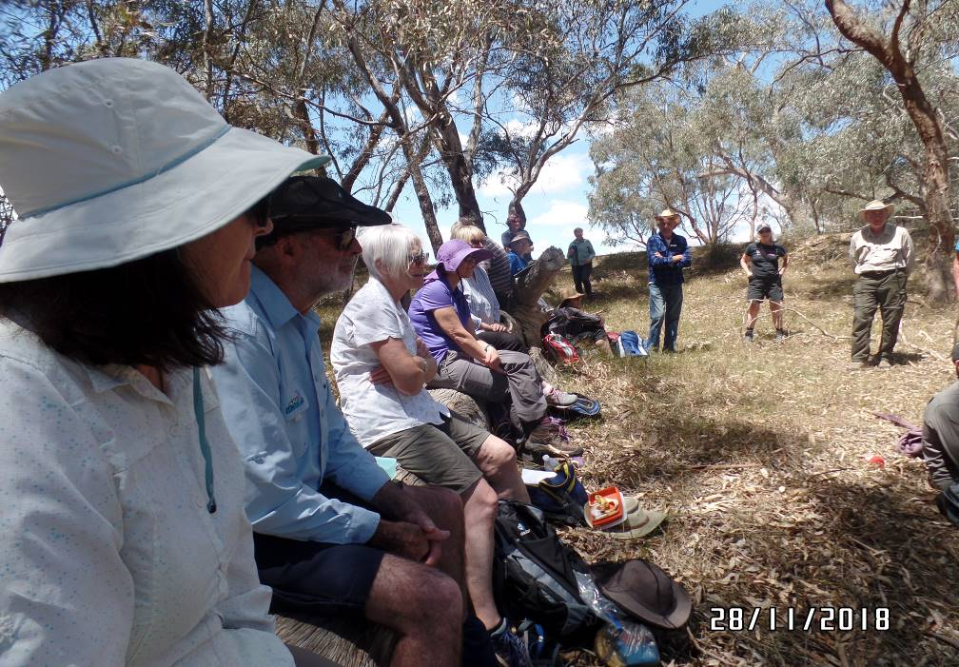

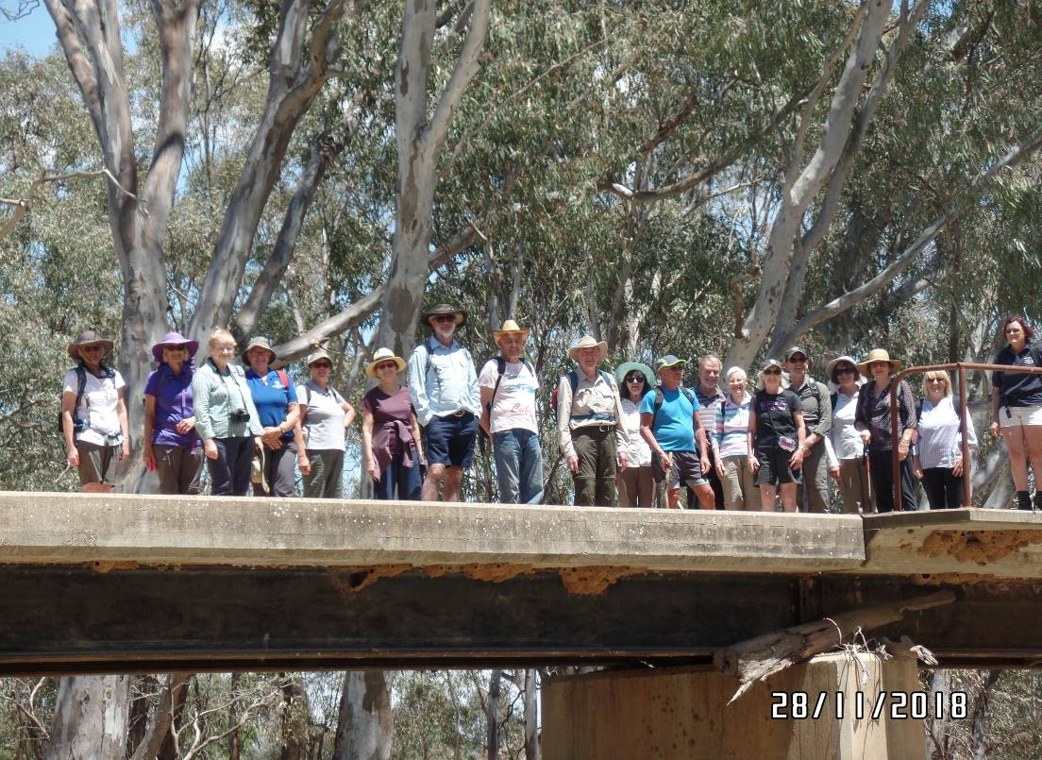
Thanks to all newsletter contributors for their articles and great photos.
Our newsletter printing is kindly sponsored by Hon. Wendy Lovell, MLC for Northern Victoria Region
Wyndham Street, Shepparton
The next newsletter will be out in March/April 2019, but feel free to submit items at any time.

