
If undelivered, please return to PO Box 264, Shepparton 3632

SHEPPARTON ADVENTURE CLUB inc. A0002706S
NEWSLETTER July – August 2019

Next meeting: Tuesday 27th August 2019.
ANNUAL GENERAL MEETING
Mechanics Institute Wyndham St. Shepparton..
Guest speaker: Steve Wilson GBCMA

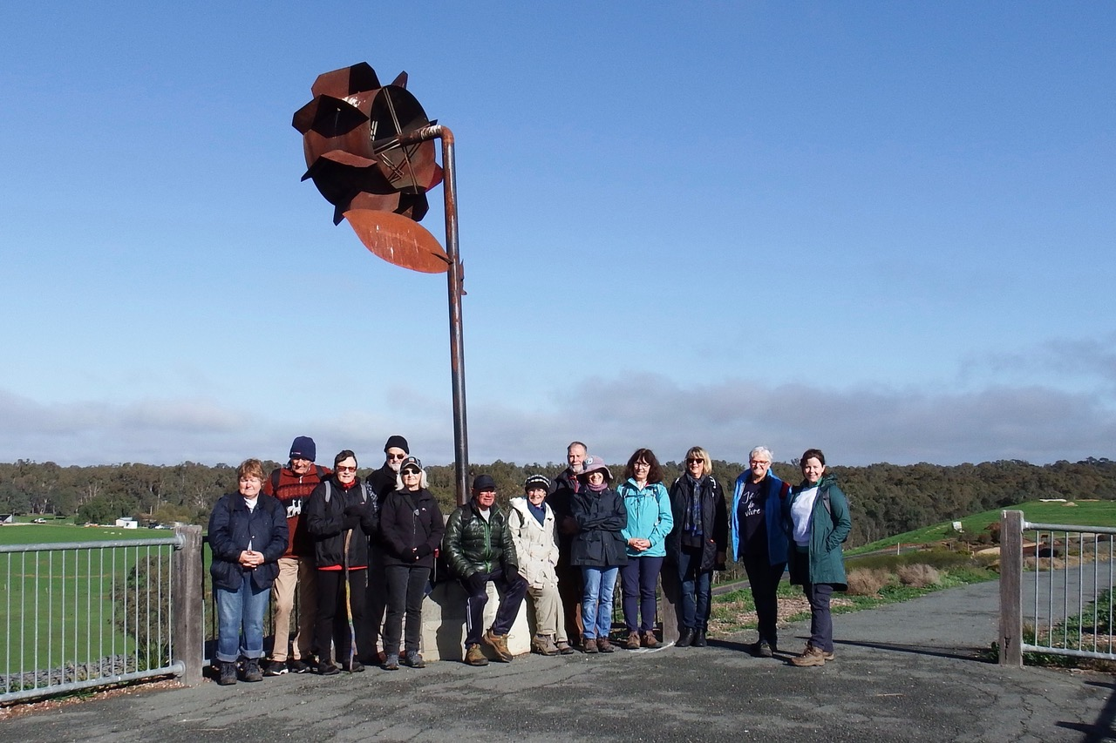
Honeysuckle Rise Shepparton Australian Botanic Gardens (thanks Karen)

Full Moon Dates2019:
15th August, 14th September, 13th October, 12th November and 12th December
Courtesy of MoonGiant.com)

A reminder to all those busy members:- Membership fees are now overdue (see page 9 for how to pay) Thanks to those who have paid.

President’s Piece

Hello everyone.
My family recently had a short, enjoyable trip to Washington state in northwest USA, visiting relatives and seeing many of the natural features. This included snow-clad volcanoes and mountain ranges, pebbly beaches, the massive Columbia River and wildlife including orcas, chipmunks, squirrels, marmots, deer and coyotes. The wildlife is very cute and active during the day, unlike most Australian wildlife. The western part of the state is obscenely green and there is a very sudden change to desert east of the ranges, where irrigation occurs on a big scale. The USA is so different to Australia and there is so much to see, a visit is highly recommended if you get the chance.
Remember that the SAC Annual General Meeting will be held on 27 August, where you have the chance to join the committee as all positions are up for election. This year we are particularly looking for a new editor of the newsletter. You can contact me if you would like to find out more or talk it over.
Our guest speaker for the AGM evening will be Steve Wilson from Goulburn Broken Catchment Management Authority. He will present on our regions flora & fauna and answer any questions you may have, so if you’re wondering why we don’t see pythons or how some marsupials fly come along and ask him.
Spring isn’t far away, I’m looking forward to seeing wildflowers and getting out in the bush a bit more.
Cheers, Greg

From Bushwalking Victoria: Vic Police trip intentions form

Try the Open Spaces website (shop) for Australian bushwalking guidebooks and related publications.

- The SHEPPARTON ADVENTURE CLUB Inc.
- General Meeting: 4th Tuesday of the months: February, April, June, August, October, December
- usually at: 7:30 pm at the Mechanics Institute, Wyndham St, Shepparton.(Winter) and
- The SAC shed, Victoria Park Lake Shepparton (Summer)

- Correspondence to: The Secretary SAC, PO Box 264, Shepparton 3632
- Email: sacvicau@yahoo.com.au
- OFFICE BEARERS
- President: Greg Smith 5824 1143 greg.smith@gmwater.com.au
Vice President: Bruce Gill 5824 2548 tatgills@westnet.com.au
- Secretary: Karen Speedy 5825 1785 karenspeedy@iinet.net.au
- Treasurer: Scott Birchall 5831 6063 scottbirchall@aapt.net.au
- Newsletter Editor: vacant
- Equipment Officer: Richard Graves 5824 2929 richsue@bigpond.com
- Publicity Officer: Richard Speedy 5825 1785
Calendar coordinator: Neville Paynter 5831 1576 Neville.Paynter@jacobs.com
- Mid-week coordinator: Dianne Hanna 0437 289 281 dhanna3@bigpond.com
- Committee member: Howard Hanna 5828 9281 howard_hanna@yahoo.com

Wanted: Mature person with time on their hands and a good sense of humour.
Hours negotiable. Computer literacy a definite advantage. Ability to talk with oneself and agree on a desirable outcome. Ability to read a definite advantage. Communication skills an advantage but not essential.
SAC is looking for a Newsletter editor to commence in the position September 1st 2019.
For more information contact Steve (0402368751) or Greg (5824 1143)

Calendar of Activities 2019

Date | Activity | Location | Leader | Distance/Rating
Sat/Sunday  17th – 18th August | ride | Dunolly Trail. 2 day event with 2 different rides, do both or just one day. Rides commence approximately 10 am | Ray 0438591749 | Bush trails & mine fields
Saturday 24/8/19 | walk | Mt Samaria | TBA | Easy/medium
Tuesday  27/8/19 | Annual General Meeting 7.30pm. | Mechanics Institute Wyndham Street Shepparton  Steve Wilson – Goulburn Broken Catchment Management Authority. Flora & Fauna of the region |  | Dinner from 6pm Victoria Hotel
Saturday 2/9/19 | ride | Woodend Wombat Forest Trail | Maartji 58241543
Sunday 2/9/19 | Kayak or walk | River Clean Up  World Rivers Day | Meg Pethybridge | River Connect  0400 231269
Wednesday 25/9/19 | walk | Boathole to Mineral Springs  Strathbogies | Howard Hanna  0437 628279  Justus Hagan | Easy/medium
Wednesday 9/10/19 | walk | Rocky Ned Base walk | TBA
Saturday 19/910/19 | ride | Cathkin to Alexandra Rail Trail
Sat/Sunday  19th-20th  October | Federation Walks | Lorne area. Apollo Bay toAnglesea | Bushwalking Victoria | See BWV website for details and contacts
Tuesday 22/10/19 | Club meeting | SAC sheds Victoria Park Lake Shepparton
Wednesday 23/10/19 | walk | Mt Meg Conservation Park | Dianne Hanna  0437 289281 | easy
Sat/Sunday 16th – 17th November | ride | Old Beechy Rail Trail | Ray 0438591749 | Dallas 0413910008
Wednesday 27/11/19 | walk | Heathcote McIvor Range | Philip and Lottie Schultz
Tuesday 3rd December | Xmas BBQ/party | SAC Shed Victoria Park Lake Shepparton | TBA | Byo

Note: All riders to confirm attendance with event leaders prior to event.

Note: For other Club events please refer to their websites listed below:

Clubs around the area:

Benalla Bushwalking Club http://benallabushwalkingclub.org.au/
Border Bushwalking Club (Albury & Wodonga) - www.borderbushwalkingclub.com.au
Wangaratta Out and About Club - www.wangarattaoutandabout.org.au/
Bendigo Bushwalking and Outdoor Club - www.gobush.org.au/
Echuca-Moama Bushwalkers - www.echucamoamabushwalkers.org.au
and more can be found at www.bushwalkingvictoria.org.au.

Thanks to all newsletter contributors for their articles and great photos.
Our newsletter printing is kindly sponsored by Hon. Wendy Lovell, MLC for Northern Victoria Region
Wyndham Street, Shepparton

The next newsletter will be out in October 2019, but feel free to submit items at any time.

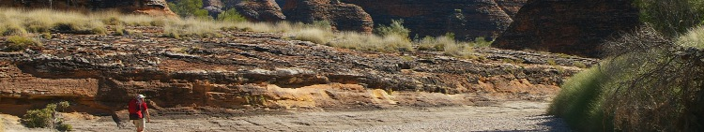


www.bushwalkingvictoria.org.au
PO Box 1007 Templestowe Vic. 3106
Phone: (03) 8846 4131
Fax: (03) 9846 7473 admin@bushwalkingvictoria.org.au

Newsletters follow the link below
Find them here: http://www.bushwalkingvictoria.org.au/what-we-do/publications/newsletters

- SAC is an affiliated member of Bushwalking Victoria
- Membership benefits
- Membership of Shepparton Adventure Club includes Bushwalking Victoria membership. Your Bushwalking Vic membership card enables you to obtain discounts at a number of retailers including Ajays (Heathmont), Bogong Equipment (Melb.), EMC (Deepdene), Melb Map Centre (Malvern East), The Wilderness Shop (Box Hill), Paddy Pallin, Smitten merino wear Tasmania, Woodslane Walking Guides.
- 5% on Outdoor Travel tours and all reservations made directly with the office at Bright. Check out their website or join their email newsletter list for tours and current deals: www.outdoortravel.com.au, 1800 331 582 info@outdoortravel.com.au
- Discovery Holiday Parks, Cradle Mountain 20% discount off shoulder and low season rates (16 April - 2 December)
- Contact Claire on 03 6492 1289, 1800 068 574 www.discoveryholidayparks.com.au

Walksafe : - means advance planning of the group
-
Article reprinted from Bushwalking Victoria Walksafe booklet

Becoming Lost
Some little used routes are indistinct on the ground and rely on track markers such as metal plates or plastic ties usually fixed to trees. Particularly when markers are sparse, they have a habit of disappearing altogether when walkers fall into deep conversation or rush ahead enthusiastically on a downhill stretch. All the more reason for everyone in the party to be aware and participating in the navigation. Look back on your route occasionally so that you can more easily retrace your steps to yourlast marker if you find you have inadvertently strayed from the track. Global positioning systems (GPS) can provide navigational assistance but should not be considered a substitute for skill with a compass since they are neither fail safe nor operational in all terrain, particularly in mountainous areas where they are most likely to be used when walking. Nor do they remove the bushwalking need to be able to interpret a map and translate it to features in the surrounding terrain for route selection. They are likely to be of most assistance when visibility is compromised by weather or featureless terrain. Keeping the Party Together It is important to regroup at track junctions and maintain sight contact on untracked or poorly marked routes. With larger groups it is advisable that responsibility for keeping the party together is taken by both a leader and an appointed whip. The latter is a person who brings up the rear and keeps track of all the party to ensure that no- one is left behind, a particularly important role when the leader is heavily occupied with navigation or the party has mixed physical abilities. It is generally safer to encourage slower members to walk toward the front of a group, and special care is needed with children who inevitably like to run ahead. Fitness Begin with short bushwalks and as your fitness improves so too can your aspirations of completing more demanding walks. You can easily increase your fitness by treating your day to day activities as training. When you walk, choose to walk briskly, take the stairs rather than the lift, leave the car in the garage for the trip to the local shops and refuse the second helping of desert. Keep in mind that enjoyable bushwalking is more difficult to achieve if there is a wide range of fitness and expectation.

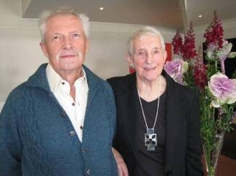

In Memoria: Peter Abbey

Pops
Hi Barb and Ian.
I’m peter Abbey’s grandson.
Dad asked if I could put a few details together for you.
Whilst sorting through his belongings dad found a mountaineering book with a small article of words, unsure who it was written by.
We thought these words were very fitting for your article in regards to Peter.
Ive attached two photos of the book, and the words.
To follow are the details of spreading his ashes; I travelled with a very special friend of mine towards the mountains (bright/mt beauty area) with the intention to take Peter back to his home, the place where he found solace. Nature.
He had an affinity with it, as I do, I guess this is why I was chosen in the family as the one to take the honours of releasing him.
We travelled through the night in wild weather (26th of May) with trees falling on the roads, rains pelting down, and wind blowing the land cruiser all over the place. A very fitting journey for the one side of pops, the wild side.
Arriving at ‘mountain creek campground’ Tawonga to have a few hours rest before the day to follow.
The sun poked through for a beautiful morning, this felt like the other side of peter, the calm side, nature at rest.
Attempting to travel to cope hut, over the other side of falls creek, until we become lodged in a foot of snow. Peter seemed to be having a ball, taking us on an adventure.
We admitted defeat before constructing plan B.
Toms hut popped out as we scanned the rooftop map that we had purchased. Tom was his fathers name, it felt fitting.
Somewhere between Mt Beauty and Mitta Mitta is where the hut can be found.
Arriving just on the set of the sun, to light a fire in the hut, out of the drizzling rain.
Red wine and chocolate was chosen as a send of, another fitting ingredient.
On the morning trip out we ran into a cattle drover from the area. I asked who is Tom. It was an old friend of his who’d built the hut and since passed away. Tom Hodgkin was his name. He then mentioned that it was an Ex- S.E.C hut. The company Peter had worked under for the majority of his working life.
Peter was a talented man in many ways. As I passed him on I spoke the words. “To the teacher”, and that was the end of an innings of a teacher that taught many in a variety of different ways.
I hope this can help with your article, for those people who would’ve like to attended his funeral.
Peter was a unique man, and we respected his decision to go out ‘without a fuss’ as he would say.
From the Abbey family
Snippets from the Past
Goulburn River Paddling - January 2015
Forty-two degree heat. Sounded like the perfect day to go swimming all day, splashing each other while paddling along and just enjoying the scenery from the vantage point of our kayaks. Well, it was a perfect day, but not for the swimming part. The water was frigid! They must have let it out of the depths of Antarctica, not just the bottom of Lake Eildon! Those who were brave enough put their feet in, or went in up to the waist, and then quickly jumped out. It certainly took the bite out of the heat.
The day went well with lots of chatter and no mishaps as we kayaked along from Alexandra to Molesworth. The day was enjoyed by all. There were a few new members who came, along with some regulars. Richard enjoyed trying out the new kayak; Bonny and I had a bit of an adrenalin rush as we went under the willows, but made it out after bumping into a few branches. We cruised into Molesworth caravan park. Richard looked like he wanted to paddle further, but he did pull in at the last moment, and we all got ready for the trip back to Shepp.
The second trip, a month later, was as different in temperature as you could get for two summer trips. Jumpers necessary at breaks, but I neglected to put any in my bag for the day. Sufficed with my picnic blanket wrapped around me at lunch time. The others were a little wiser, with some warmer layers.
However once again the company was lovely and the next section of the river from Molesworth was delightful with a few exciting spots where the water rushed over rocks or logs. Bonny was honing her steering skills and Richard did a great job remaining upright in his borrowed kayak which was not all that stable. After many bends in the river (Richard's map showed just how many there were...) and the many nice picnic sites we saw along the way, we made it to Ghin-Ghin bridge near Yea. Another successful day with a group of friendly people.
by Rach K
Trip Reports

Wednesday 26th June. Numurkah Broken Creek and Kinnairds Wetland midweek walk
We can’t complain about the wintry weather when we have glorious sunny days hinting at Spring, as we did for June’s midweek walk. The smell of warmer weather may have been what prompted 18 of us to venture out or maybe it was the close proximity to home that brought so many together, regardless as to why it was one of the biggest groups I’d participated with in my short history of mid-week walks. Some of our walkers joined us on location in Numurkah, the remainder car pooled in four vehicles. I enjoy the banter and conversation of the road trip as much as I do the walk and 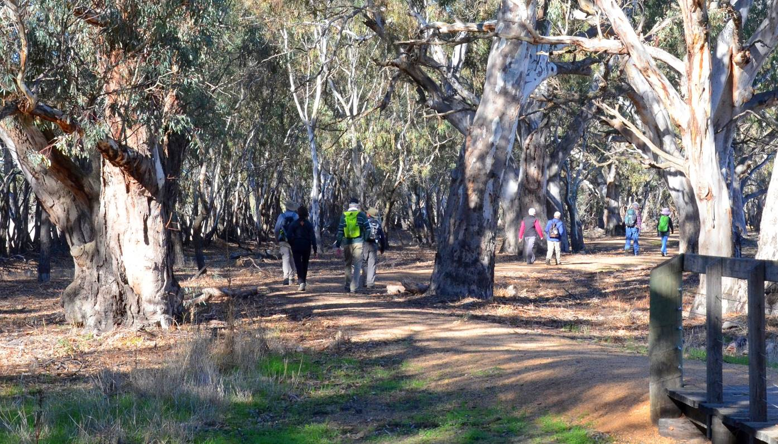landscapes we visit. Such an easy and enjoyable way to learn what’s happening locally, who’s tripping where and hearing about wonderful locations to add to the wish list. Something I think our walk organisers do very well is to offer great variety in the length of duration of walks, their locations and the fitness levels required. Barb Brown did a great job of stretching us out over a level course but pushing the distance out to over approx. 11kms, I felt like I’d put in some effort.
Barb had purposely added to the normal hike around Kinnaird’s Wetland by commencing the walk from the Numurkah Lake carpark, Quinn Street from where we ambled along Kinnaird’s Road to the entrance of the Wetlands. As our numbers were so great it was easy to deter the would be bush terrorist on his dirt bike who came tearing along the road just as we reached the entrance , he did a quick loop of the carpark thought better of it and headed out again. Yippee peace and quiet, we’ll be able to hear the birds. As expected there wasn’t much water in the wetlands but as I can’t recall having walked this site previously I look forward to returning in the future to see how it will look after some decent rain. I’ll leave it to our proof reader to add a list of the birds we did see and hear over the course of the day’s walk. Definitely out of my league in that area.
(We saw quite a few birds, mostly the common urban/rural ones but the Numurkah Lake and the Broken Creek provided quite few waterbirds including Cormorants, Black and wood ducks, Coots, Australian white ibis, Purple Swamphen, Black Swans, Pelicans and a little more uncommon bird, a female Darter. We were quite pleased that the hundreds of very noisy corellas that had been annoying Numurkah residents and golfers had moved on.)
Having enjoyed a cuppa and morning tea prior to entering the wetlands we continued on after a quick break for the mandatory photo shoot, heading back the way we came to, venturing over the Broken Creek foot bridge to enjoy the bush walk around the edge of the golf course and football oval. Many remarks were passed on the new football clubrooms, the impressive parklands and walking paths. Numurkah has a lot to offer! We continued our walk along the Broken Creek back along the southern side of the creek, crossing the main street at the caravan park, then heading along the road to access the walking path to the McNamara Drive Reserve Parklands and Gardens. After completing the circuit of the ponds we returned to our vehicles along much the same route this time on the northern side of the creek. Driving back into town we enjoyed lunch at the Melville St Park in the centre of shopping precinct. Some of our walkers dispersed for home after a much welcome lunch, the remainder staying on to enjoy a coffee and/ or cake at the Numurkah Bakery & Tiffany's Coffee & Gift Shop. A very enjoyable day; good company and opportunity for exercise in the great outdoors. Thanks to Barb Brown for a well-rounded walk. We missed our regulars, Richard who is recovering from an operation and Ray who is travelling overseas. Hope to see you out and about soon.
Lea Watts
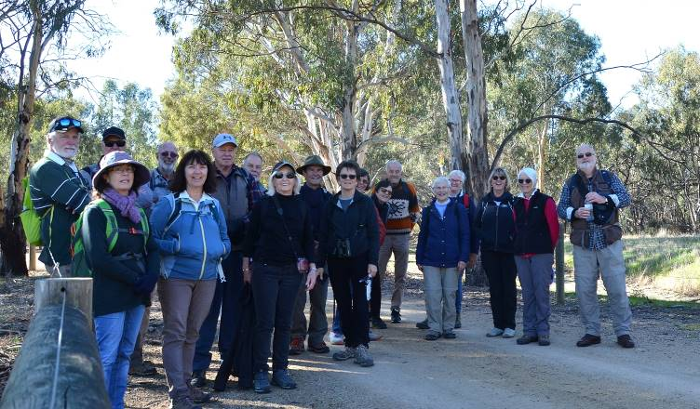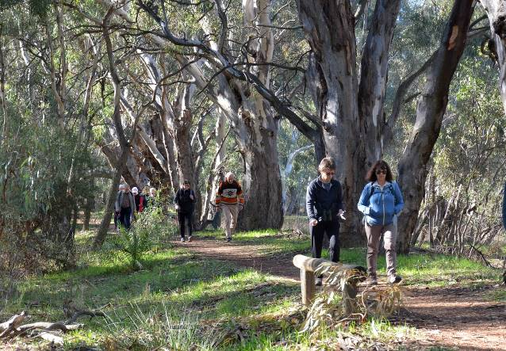
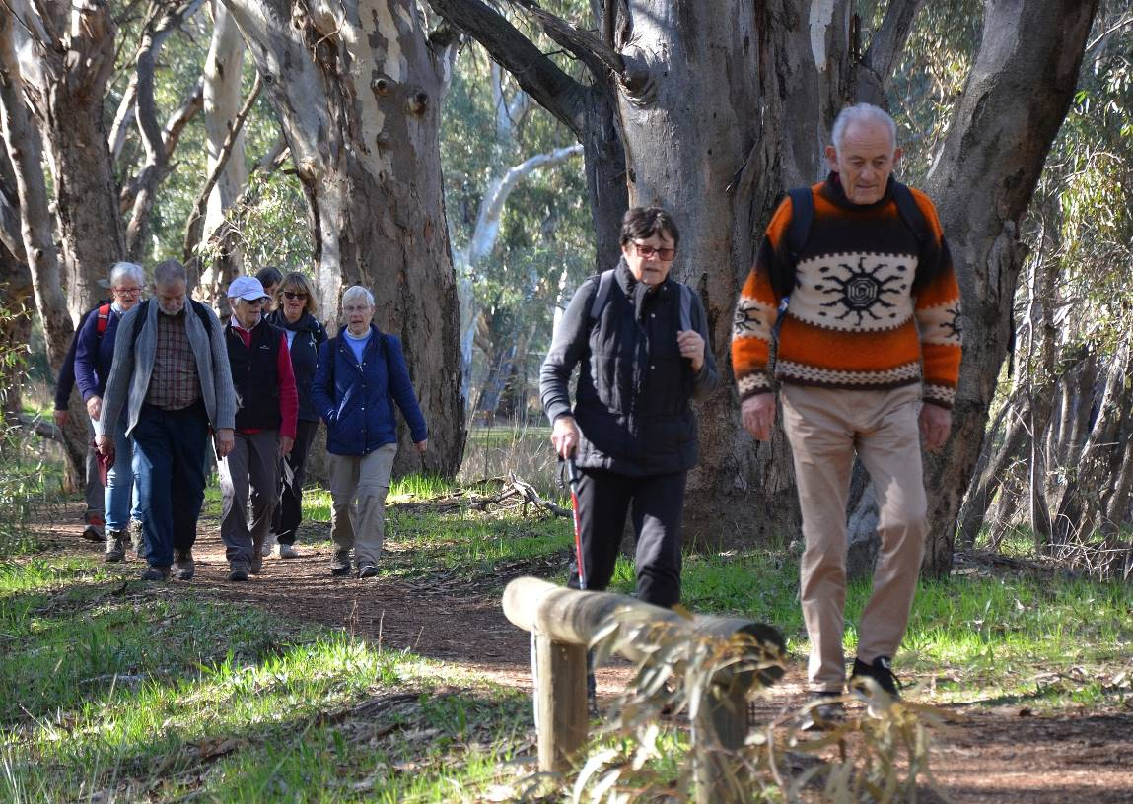
Thanks to Dallas James for the photos
Mid week walk July 30 2019

Shepparton Adventure Club Midweek Walkers
The July walk was held in the Australian Botanic Gardens Shepparton and nearby forest.
It was foggy when we arrived at the Gardens but soon cleared to blue sky giving us ideal walking conditions.
Jill Grant, president of the Friends of ABGS, kindly gave us an informative talk about the establishment of the Gardens, work achieved and activities held.
Thirteen walkers then set off and walked through the 22.5 hectare site on well kept tracks. Areas that we walked through included natural bushland, beside the wetland and Broken River and through planted areas. Some of the features we enjoyed seeing as we walked were the weaving garden, children’s garden and the themed garden on top of Honeysuckle Rise. When visiting the Gardens it is always good to see how the plants are growing and new areas that are continually being developed.
Morning tea was taken in the Turtle Garden near the entrance after which we walked in the nearby forest among the magnificent Red Gums and along the edge of the Goulburn River. During our walks we saw a number of bird species and had a good view of a pair of Golden Whistlers, winter visitors to the area.
After about a total of 9 kilometres of walking we had our picnic lunches back at the Botanic Gardens next to a garden where some Acacias, Grevilleas and Eremophilas were in bloom.
Our monthly walks are held at places that are a variety of distances from Shepparton. We thank Karen Speedy for organising this one, which was close by and most enjoyable.
Marg Clarke

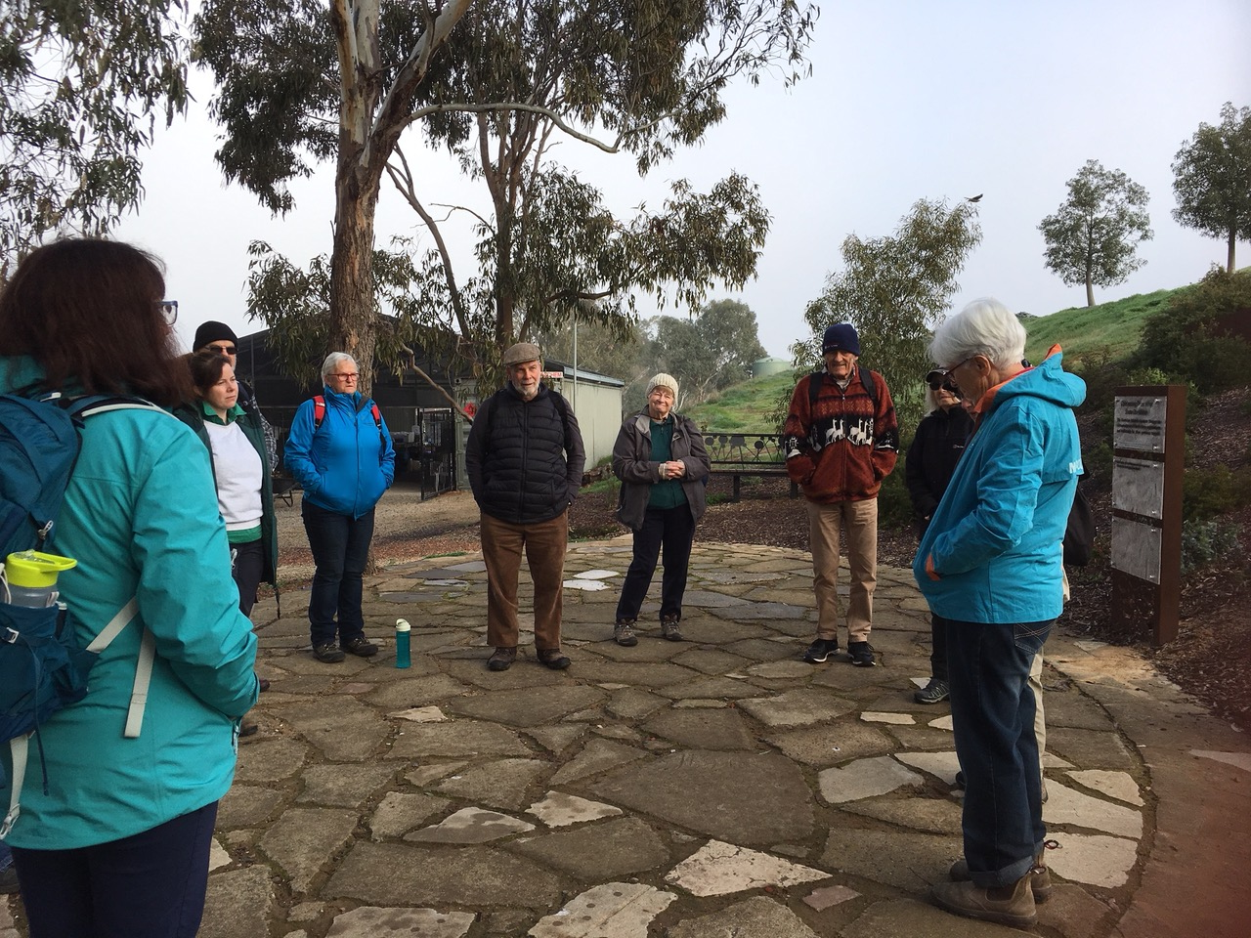
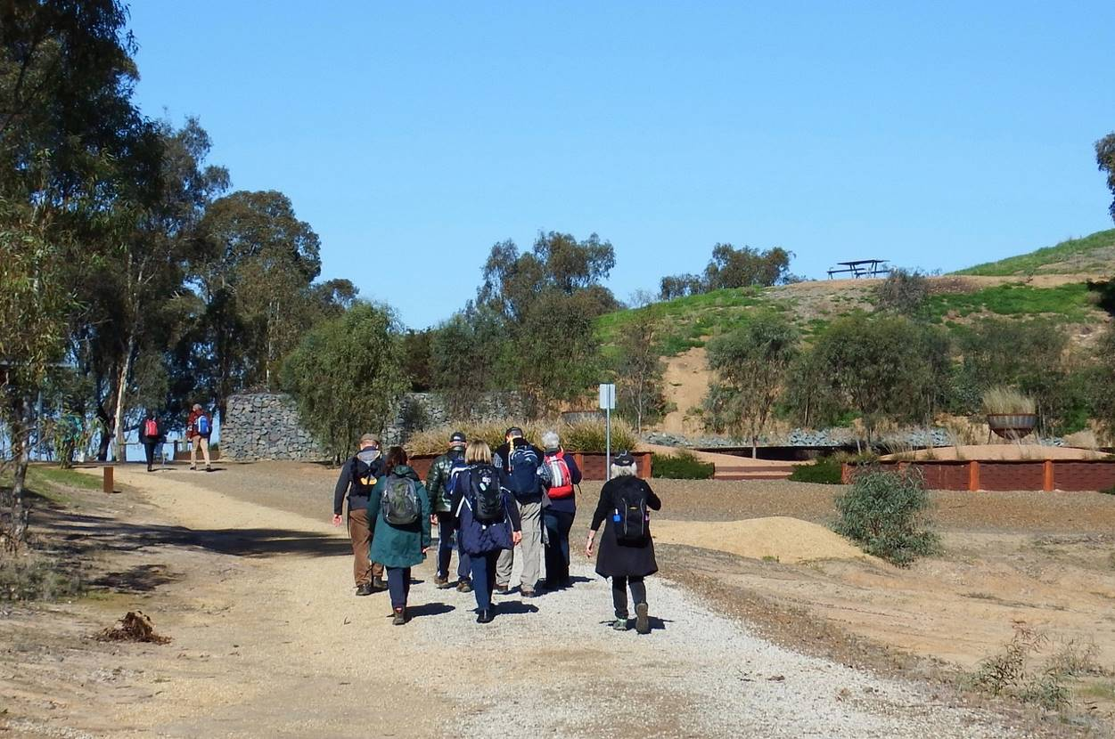

MEMBERSHIP FORM SHEPPARTON ADVENTURE CLUB Inc. A0002076S

Membership Fees for the 2019 / 2020 year are due on 1st JULY 2019. Please return this form with your payment to: The Treasurer, Shepparton Adventure Club Inc. 6 Holland St, Shepparton. Vic 3630.

Please list name of each person and circle their age group (Insurance underwriting categories)

Name _________________________________________ U16 16-17 18-34 35-54 55-94 95+

Name __________________________________________ U16 16-17 18-34 35-54 55-94 95+

Name _________________________________________ U16 16-17 18-34 35-54 55-94 95+

Name _________________________________________ U16 16-17 18-34 35-54 55-94 95+

Name __________________________________________ U16 16-17 18-34 35-54 55-94 95+

Address: __________________________________________________________________

__________________________________________________________________

Phone: BH _____________________________ AH ________________________________

Mobile _______________________ Email Address: ___________________________________

Single Club Membership $35 ________

Family Club Membership $60 ________

Concession (Single Membership)* $30 ________

Concession (Family Membership)* $45 ________ *Concession applies to Pensioner/Senior/Student Cardholders

TOTAL $ _________

ACKNOWLEDGEMENT OF RISK - ALL Adults must sign I acknowledge that when I am participating in any activity of the Shepparton Adventure Club Inc, I am doing so as a volunteer in all aspects and as such I accept all responsibility for loss of property or bodily injury to me however it may occur. I acknowledge that my participation in this activity may expose me to hazards and risks that could lead to injury, illness or death or to loss of or damage to my property. In particular when participating in abseiling, caving or above the snowline activities I am aware that these activities expose me to additional hazards and risks. I will make all reasonable effort to avoid or minimise these risks by : • only participating in activities within my capabilities, • carrying food, water and equipment appropriate for the activity, and • advising the leader if I am taking any medication or have any physical or other limitation that might affect my participation in the activity.

I acknowledge that the payment of my (renewal) subscription will be deemed as full acceptance and understanding of the above. I agree to be bound by the rules of the Shepparton Adventure Club Inc. (which are available from the secretary).

Signed ………………………………………………………………………… Date ………………………………

Signed ………………………………………………………………………… Date ………………………………
Payment options (please circle):

1. Mail cheque or Money Order to 6 Holland St, Shepparton 3630

2. Direct deposit to Bendigo Bank BSB 633 000 Account No. 129 076 972 Please add your name as the reference and post the signed membership renewal form back.

2019/20 COMMITTEE ELECTIONS

New And Enthusiastic Volunteers Needed

Shepparton Adventure Club committee elections will be held during the Annual General Meeting at the Mechanics Institute/Shepparton Access, Wyndham St, Shepparton on
Tuesday 27th August 2019, 7.30pm start.

All positions will be declared vacant and new volunteers are eagerly sought. Please consider offering your services to keep our club going for the benefit of our members.

Elected positions are: President, Vice President, Secretary, Treasurer and up to 6 ordinary members, which can include Newsletter Editor, Publicity Officer, Calendar Co-ordinator, Mid-Week Activity Coordinator and Equipment Officer. No particular skills are needed, just a willingness to participate and learn.

Our committee meetings are held every 2 to 3 months and believe it or not it make for a good night out. Join the committee to find out why.

Nominations should be made on the form below and submitted to any committee member at least 1 day before the AGM. Nominees must be paid up members and be nominated by another member.



SHEPPARTON ADVENTURE CLUB COMMITTEE 2019/2020

NOMINATION FORM

I _______________________________________________________________________

wish to nominate ___________________________________________________________

for the position of ___________________________________________________________

for the 2019/2020 year.

I hereby accept the nomination (nominees signature) ……………………………………………

Signed by the Nominator ……………………………………………………………………………

