

If undelivered, please return to PO Box 264, Shepparton 3632

SHEPPARTON ADVENTURE CLUB inc. A0002706S

NEWSLETTER June - July 2014

New website: www.shepadventureclub.org.au Affiliated member of

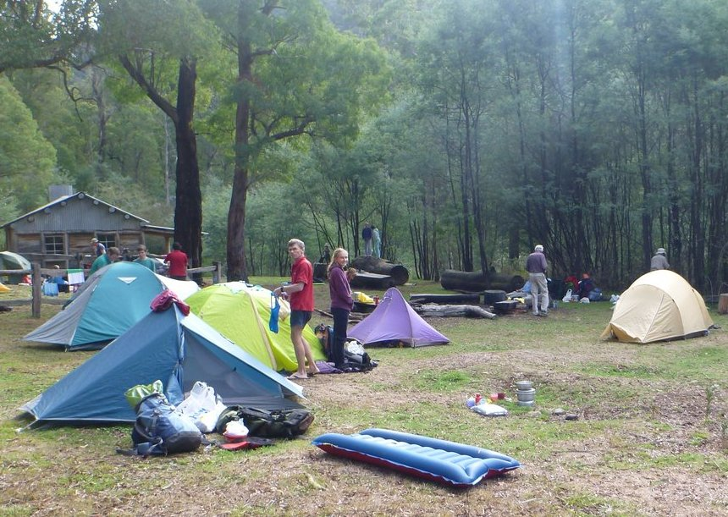

Hikers at Howqua River

Come along and hear guest speaker Rolf Weber present on the flora and fauna in our Goulburn river on Tuesday June 24th 7.30pm

Newsletter Printing:
Our newsletter printing is kindly sponsored by Wendy Lovell, Member for Northern Victoria
138 Welsford Street
Shepparton Victoria 3630
Phone 03 5821 0055
Fax 03 5831 1062
The Hon. Wendy Lovell MP
Minister for Housing and
Minister for Children and Early Childhood Development

The SHEPPARTON ADVENTURE CLUB Inc.
General Meeting: 4th Tuesday of the months: February, April, June, August, October
usually: 7:30 pm at the Mechanics Institute, Wyndham St, Shepparton.
Committee Meeting: Monthly at 8pm.
Correspondence to: The Secretary SAC, PO Box 264, Shepparton 3632
Email: sacvicau@yahoo.com.au

OFFICE BEARERS
President vacant
Vice President Bruce Gill 5824 2548 tatgills@westnet.com.au
Secretary Cathy O'Brien 5831 5068 cathy.peter@optusnet.com.au
Treasurer Scott Birchall 5831 6063 scottbirchall@aapt.net.au
(for email distribution to members)
Newsletter Editor Fiona Cameron 0407 299 036 richardcameron@bigpond.com
Equipment Officer Richard Graves 5824 2929 RICHSUE@BIGPOND.COM
Publicity Officer Maartje Heuperman 5824 1543 maartjeheup@bigpond.com
Calendar Coordinator vacant
Mid-week coordinator Dianne Hanna 0437 289 281 dhanna3@bigpond.com
Web Master Greg Smith 5824 1143 gregs@g-mwater.com.au

MEMBERSHIP FEES

Single Club Membership $25
Family Club Membership $40 plus $5 per nominated child aged 5 to 18 years
Concession – Single Membership $20 - Pensioner/Senior/Student Cardholders
Concession – Family Membership $35 - Pensioner/Senior/Student Cardholders

Membership benefits
Your Bushwalking Vic membership card enables you to obtain discounts at a number of retailers including Ajays (Heathmont), Bogong (Melb), Bushwackers (Essendon), EMC (Deepdene), Melb Map Centre (Malvern East), The Wilderness Shop (Box Hill), Outsports (Moorabbin), Paddy Pallin, Pinnacle, Snowgum, Escape 2 (South Wharf DFO).
You can also become a member of Anaconda, Columbia, Ray's Outdoors and Snowgum for free and thereafter obtain discounts.

Sunrise & Sunset (Melbourne GPO)
June 1st 7.26 17.09  July 1st 7.36 17.11  Aug 1st 7.21 17.33 | June 15th 7.33 17.07  July 15th 7.33 17.20  Aug 15th 7.06 17.44
Full Moons
2014
13th June, 12th July 11th Aug 9th Sept 7th Nov 6 Dec
Source: www.ga.gov.au

President’s Report

“Vale” Christine Taylor

Most of you are aware by now that our good friend and Club member Christine Taylor, (nee Kennedy), died on the 12th April 2014. Quite a large number of Club members attended her funeral.

Christine has been a SAC member since the very early days of our Club and was most of the time actively involved in its operation. She was almost a permanent member of the committee where her organisational skills were unsurpassed. She always remembered when key tasks had to be done and she didn’t mind coaxing other people onto the committee.

Chris played a major role in the sale of our old Club Hall (the SAC Shack) and the negotiations with Shepparton Council for the 25 year lease on the land where our shed now stands. Christine was also involved in the process of incorporation of the Club, ensuring it could continue to operate successfully.

The Shepparton Adventure Club played a major part in her life. Chris loved the outdoor life and organised and participated in many of the Club’s activities over the years, including walking, bike riding and rock climbing, canoeing and skiing.

The skiers among us will well remember her organising the annual moonlight backpacking ski trip out to Johnsons Hut on the Bogong High Plains and the Howman’s Gap ski skills weekends. A number of members have mentioned they learned to cross-country ski under her patient guidance.

Everyone that has walked with Chris will, with some humour, remember the almost compulsory lunch stop at 11.30am.

Despite her worsening illness Chris never grumbled of complained about her sometimes obvious discomfort. Even during this time she had a major input in guiding of the club in sorting the legal ramifications of updating our constitution in line with the amendments to the Incorporations Reform Act passed by the State Government in 2012. A remarkable feat that worked out smoothly for SAC thanks to Chris’ efforts.

Chris was a real animal lover and was very close to their dog Quinn and cat Patches.

Chris will be sorely missed by us all and while the club will be the poorer for her passing, it is in a healthy condition due to her long-term contributions.
Our thoughts are with Len and her family...
‘(Maartje, Alfred, Richard & Greg).

Please all note that memberships are due July 1st and can be paid on line but signed form needs to be returned asap. Thank you.


www.bushwalkingvictoria.org.au
PO Box 1007 Templestowe Vic. 3106
Phone: (03) 8846 4131
Fax: (03) 9846 7473 admin@bushwalkingvictoria.org.au

News
BWV is holding a leadership training week end on 28-29 June at Westerfold Park, Tempelstowe DEPI 9-4.30pm free of charge with light lunch and am and pm teas provided both days. A great opportunity for trip leaders! Contact Gerard Vander at 03 94354477 or Vanderg@gmail.com (preferred) asap

Also BWV is holding a leadership forum 9.30 Saturday June 14 – a great opportunity for club members to get together to discuss bushwalking matters admin@bushwalkingvictoria.org.au

For overnight hikes check: www.packcarryvic.pbwiki.com

Several brochures on walking safely & softly are available at: www.bushwalkingvictoria.org.au/brochures.htm

Please upload the details of any walk that you have done to BWV website for them to advocate for better funding to support bushwalking. www.bushwalkingvictoria.org.au Go to where2walk content login (top-of-page menu) with username: sacvicau and password: bushwalk.

Calendar of Activities

Date | Activity | Location & details | Grade | Leader | Contact
22 April  Tues | General meeting | Mechanics institute – speaker Alfred Heuperman 7.30pm
23 April  Weds | Mid-week walk | Polly McQuinn’s/Gooram Falls | E | Graeme and Kerry Betts | 5821 6596
20 May  Tues | Committee meeting | At Dianne Hanna’s 8pm
28 May  Weds | Mid-week walk | Justice Hagan walk; Ruffy | ? | Howard Hanna | 0437628279
6 – 9 June | XC/XCD/D skiing | This is the opening weekend for the snow season so there will be activities organised by the resort including welcome party and fireworks if the weather is suitable. Come for a day or stay for all four. This trip is based in family friendly lodge accommodation at Mt Hotham. There will be the opportunity to do day ski tours, improve telemark technique on the slopes or just relax on the verandah with a book and warm drink. Low season rates apply for this weekend. There is a 10% discount on advertised prices when booked through Barb and Ian. | Beginner to advanced | Barb and Ian Stansfield | 0408299497
17 June Tues | Committee meeting | Scott’s place 8pm
24 June  Tues | General meeting | Mechanics Institute – Come and join guest speaker Rolf Weber for his presentation on wetlands encountered on the Goulburn and tributaries 7.30pm. Meet before at The Vic for a meal if you like at 6pm | Social | Fiona | 0407299036 for meal bookings
25 June Weds | Mid week walk | Kamarooka Forrest | Easy | Richard Graves | 58242929
27-29 June | XC/XCD/D skiing | This is the start of the June school holidays and so will fill very quickly. Always a great time to be up at the lodge with other young people to make snow caves, build igloos and snowmen…. A chance to ski the slopes, ski tour from the lodge or use the bus to tour out of Wire Plain. | Beginner to advanced | Barb and Ian Stansfield | 0408299497
23 July Wed | Mid week walk | Barmah Forrest | Easy | Dianne Hanna | 0437289281
1 – 3 Aug | XC/XCD/D skiing | A great weekend to ski with some experienced skiers who are already booked on this trip as we explore all that Mt Hotham has to offer. Hopefully there may even be some Snow Cat skiing out the back of Hotham. Limited places available & will fill very quickly. | Moderate to advanced | Barb and Ian Stansfield | 0408299497
3 – 8 Aug | XC/XCD/D skiing | A great weekend to ski with some experienced skiers who are already booked on this trip as we explore all that Mt Hotham has to offer. Hopefully there may even be some Snow Cat skiing out the back of Hotham. Limited places available & will fill very quickly.  GRADE: Moderate to advanced | Moderate to advanced | Barb and Ian Stansfield | 0408299497
15 -17 Aug | XC/XCD/D skiing | A great weekend to ski with some experienced skiers who are already booked on this trip as we explore all that Mt Hotham has to offer. Hopefully there may even be some Snow Cat skiing out the back of Hotham. Limited places available & will fill very quickly. | Moderate to advanced | Barb and Ian Stansfield | 0408299497
22 – 24 Aug | XC/XCD/D skiing | A great weekend to ski with some experienced skiers as we explore all that Mt Hotham has to offer. Hopefully there may even be some Snow Cat skiing out the back of Hotham. Only 5 places available & will fill very quickly. | Moderate to advanced | Barb and Ian Stansfield | 0408299497
26 Aug  Tues | Annual General meeting | Mechanics Institute – speaker TBA
27 Aug Wed | Mid week walk | Goulburn River Mooroopna Toolamba | Easy | Maartje Heuperman | 58241543
24 Sept Wed | Mid week walk | Rushworth to Whroo | Easy | TBA
8 Oct Wed | Mid week walk | Sunrise track comples Warbie Ranges. Note this is an extra walk for the wildflower season | Easy to Mod | TBA
22 Oct Wed | Mid week walk | Whroo Wildlife Reserve (Mt Black area) | Easy | TBA
8/ 9th Nov  Sat/Sun | Base camp | Famliy week end Mt Buffalo | E | Maartje Heuperman | 58241543
7-9 Nov | Walking | Federation Day Walks around Rawson Village in Gippsland organized by BWV | various | BWV
26 Nov Wed | Mid week walk | Broken Creek Nathalia | Easy | Barb Brown | 58318447
Jan – Feb 2015 | Musical Festival | Cool Summer Festival is a one of a kind music festival is set to return in 2015. Imagine this – it’s sweltering hot, parched and crawling with tourists on the ‘flatlands’ (y’know, Melbourne, Albury, Geelong, Shepparton, Bright… those flatlands) and you know the beaches and rivers will be swarming with manic families trying to cool down for their last weekend of school holidays. Yet up at Mt Hotham, the air is balmy, laced with the sweet smell of wildflowers. Beside you, an esky full of your favourite boutique beer, soft drinks and a bottle of wine is nestled amongst a picnic, some cushions, a bottle of sunscreen, French cheese and your very best mates. You’ve just wandered up the slope from your lodge, freshly showered and ready for two days of fabulous, hip shaking funk, roots, rock & roll. Cool Summer Festival will be held at Mt Hotham for the 8th glorious year in Jan 2015. The festival organisers have stayed true to their original idea of remaining independent, resisting the spoils of large commercial sponsorship. As a result, the festival boasts low security, BYO alcohol, cheap tickets, free entry for kids under 16 and a whole bunch of great Australian musicians. Camping is available at Whiskey Flat, a fantastic flat stretch of ground in among the snow gums, with a free shuttle bus to get campers to and from the main stage all weekend or you can book in and stay with us at lodge accommodation only a few minutes walk from all the festival activities. | Social | Barb and Ian Stansfield | 0408299497

PLEASE RING THE TRIP LEADER TO MAKE SURE IT IS WITHIN YOUR CAPABILITY AND CONFIRM THAT IT IS GOING AHEAD.

Benalla Bushwalking Club trips
Jun7-9 Moroka Gorge Jun 9 Mt Teneriffe Jun14-15 Navigation training Jun 21 Blowhard Circuit Jun 28 Lake Moodemere
More trips and booking information at http://home.vicnet.net.au/~benbwclb/index.htm

OTHER CLUBS’ ACTIVITIES
Border Bushwalking Club (Albury & Wodonga) - www.borderbushwalkingclub.com.au
Wangaratta Out and About Club - http://members.westnet.com.au/wangoutandabout
Bendigo Bushwalking and Outdoor Club - http://home.vicnet.net.au/~gobush/
Echuca-Moama Bushwalkers - http://www.echucamoamabushwalkers.org.au
If you are interested in overnight hikes check out www.bushwalkingvictoria.org.au
Just follow the step-by-step instructions for access to the site called Packcarry Vic

TOTAL FIRE BAN
If a day of TOTAL FIRE BAN is declared please contact the Activity Leader for confirmation whether the activity will go ahead or not.

Note: TRIP LEADERS – it is imperative for every trip that temporary members/visitors sign the “Acknowledgement of Risk Form”. These completed forms must be forwarded to the SAC Secretary for filing as soon as possible after the trip – otherwise, in the case of a claim, the insurer will not acknowledge the risk.
Form can be downloaded from www.bushwalkingvictoria.org.au , in http://www.bushwalkingvictoria.org.au/forms/Risk_Management_Guidelines.pdf

Emergency Contact Procedures
All enquiries about the return of participants from club activities should first be directed to the activity leader, and then to the Emergency Contact Person (ECP) for the activity if the leader cannot be found.
It is the activity leader's responsibility to organise an ECP and advise him/her (in writing) of trip & participant details and what to do if contact is not made by the nominated time.

Travel Cost Reimbursement
Option 1: Preferred. Fuel Cost per car plus 5 cents per km per car to be split equally between the numbers of people in the car including the driver. If appropriate, the cost of running all vehicles should be shared equally amongst all trip participants.
Option 2: 25 cents per km per car split between all trip participants.

Summary of Public Liability insurance coverage effective from 30 June 2009
Bushwalking, Recreational Walking, Walking, Track/Hut Construction and Maintenance, Caving, Canyoning, Liloing, Abseiling, Alpine Walking (Summer and Winter),Snow Skiing, Canoeing, Kayaking, Boating, Rafting, Swimming, Cycling, Rock Scurrying and use of hand held ropes as part of a Bushwalk, Orienteering, Rogaining, Leader Training, Rescue Training and other related instructions where no fee is charged other than to recoup expenses (Errors & Omissions), Voluntary Work for various Charities and not- for-profit organisations.
Activities NOT COVERED include Rock Climbing, Mountaineering, Water Skiing and Animal Riding

.
Trip Reports

Murray River Kayak - Morgans Beach to Barmah Lakes. 4th - 7th May

My friend, Damien has always wanted to kayak the length of the Murray, and has the perfect craft for the tour - Canadian Sea Kayaks. His original companion apparently decided the Murray was too boring after completing the first leg to Tocumwal. I was very happy to volunteer for the next leg through the Barmah National Park, which has long been on my 'bucket list'.

Supremely optimistic, we travelled up through Shepparton and arrived at Morgans Beach on a very cold and windy Sunday afternoon. River kayaking is so much easier when a willing partner offers to drop you off and pick you up at the end - no car shuffling was much appreciated.

The river level was quite low for our tour, coinciding as we did with the end of the irrigation season and autumn rainfalls.

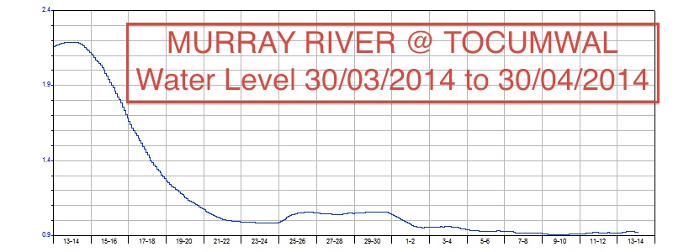

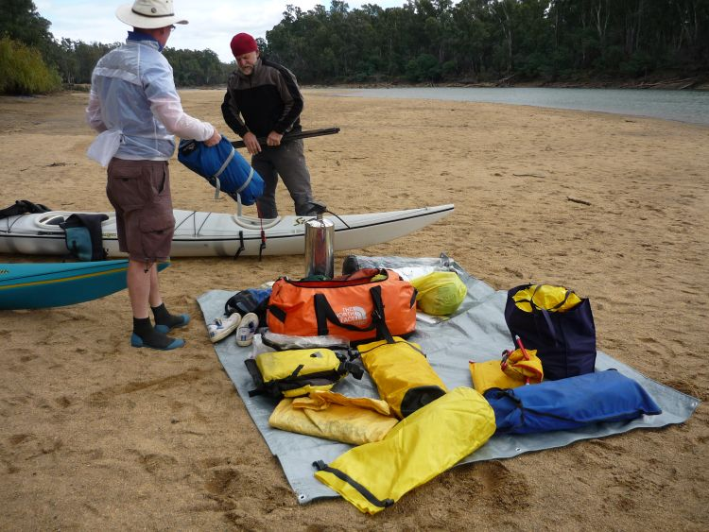
Packing was also a challenge for me not knowing how everything was going to fit into those little storage hatches. Amazed myself with how much you can stuff in.

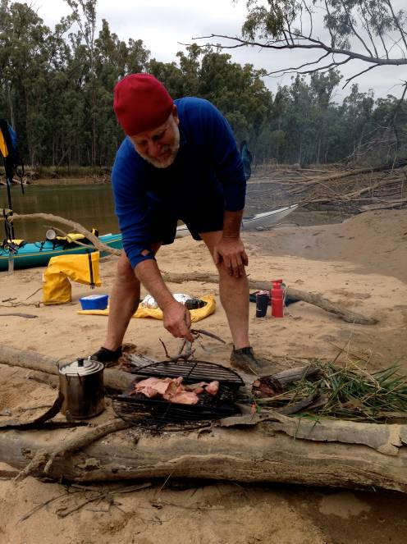
After some nervous moments we took off down river and put in a couple of
hours paddling. I found the Sea Kayak really comfortable and quite warm with skirt attached and a life jacket on. The craft are wonderfully stable and the rudders provide quite good manoeuvrability.

We decided to stop for our first camp early and soon had a roaring fire going, tents up and a change into dry clothes. We had covered approximately 12Km in 2 hours and were now confident we could cover the required distance. The sandy beach heads were a dream to camp on and it was great to have the place to ourselves, apart from a couple of hardy fishermen.

The trip took 2 half days and 2 full days paddling to cover around 80Km to Barmah Lakes, and we pulled out in bright sunshine on Wednesday morning. We ate like kings, tasted some lovely wines, listened to so many hungry birds, and some amazing night time noises, and almost shook hands with a friendly Sea Eagle.
It was a very special time in a very special place. Do yourselves a favor and put it on your bucket list too

Chris Halpin

Life’s a squelch (Howqua River walk 29-30 March)

“Aaaahhh, man that’s freezing!” I yelped as the icy water soaked into my shoes. We had come to the first river crossing we would be going through that day. Our big, heavy packs made it a bit hard to balance at first but the farther we got the more we got used to it. Also the rocks were slippery with slime so that made it even harder. After we’d all gotten through the first one we started walking again. The feeling of water in your shoes was interesting, it kind of felt like a massage. My uncle’s hiking boots were dribbling bubbly water out the back which looked rather funny. You could also hear a chorus of squelching as we trudged through the bush to the next river crossing. During some parts of the walk the bush was so thick that if you were too close to the person in front of you, you would get wacked in the face by a branch.
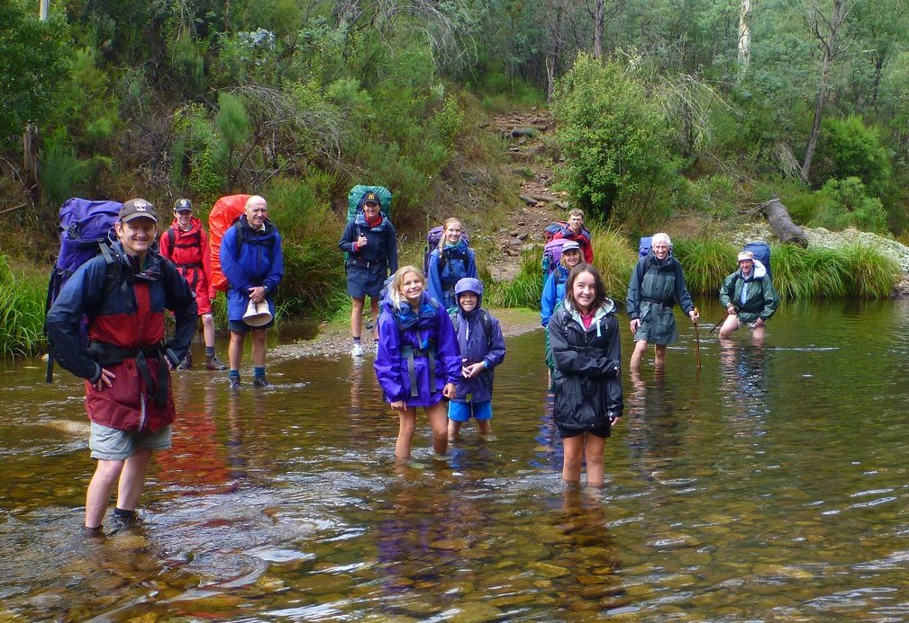
In what felt like no time at all we were at the last river crossing. We stopped for lunch and, while eating, my uncle spotted a leech on his leg. I was horrified. I have a phobia of leeches and was promised there were going to be none. I started checking myself for them and got onto a rock in the water where I thought leeches would not be able to get to. Luckily there were none on me but I couldn’t calm down because I knew they were still out there waiting to latch onto some unsuspecting hiker. For the rest of the walk I tried very hard to stay on the track and not touch the bushes.
Finally we got to the little creek that ran into the river, right before the beautiful, wooden Ritchies Hut and grassy campsite. I felt relieved to stop and rest, but scared of what I might find inside my shoes. With my heart in my throat I pulled off my shoes and was incredibly relieved to find no leeches.
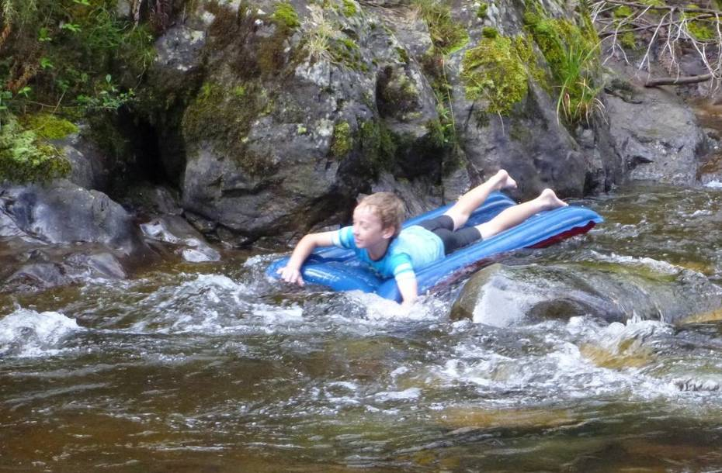
We were the first to arrive so we got the best spots to pitch our tents. It was still way before dinner time and we had brought an air mattress to try liloing down the river. We found a perfect stretch where you could float without getting stuck so my mum, setting the fashion trend, went down first in her boots and bathers. Soon it was my go. I hopped onto the mattress and immediately my whole chest froze! The water felt like I was in a bath of ice. But I didn’t have time to think about being cold because I was already at a little rapid. I got momentarily stuck but was pushed on by the current. I kept going but my steering was so bad I ended up spinning around so I was facing the way I had already come and went down the rest backwards. Even though it was freezing it was totally awesome. We also went down a bigger rapid that was really fast and exciting. Lots of people had arrived at the campsite while we were liloing so after dinner we all toasted marshmallows and ate chocolate around a campfire together.
The next morning it was raining. Everything was soaked in water. All I could think about was that leeches like the wet and now it was wet, so that meant more leeches. I could just imagine them all over me, wriggling and getting fatter as they sucked the blood from my body. We decided we would go back the way we came because it was more exciting than the other track. So we set off back through the river twelve more times. I tried hard not to imagine leeches all over my bare legs but as we went I just stopped bothering because I was wet, muddy and all I wanted to do was get back to the cars. We kept squelching along and at the third last crossing someone finally went splash. Luckily Alice was the first and the last one to fall in.
Soon we could see the cars through the bushes. The people that had been at the campsite the night before were there waiting already, having taken the easy track. We finally got to rest and put dry shoes on. It felt so good to have completed the walk and survived without getting bitten by any leeches.
By Lizzy Smith

PS. Thanks to fellow adventurers the O’Briens, Lamberts, Smith/Clappertons and grandpas Smith & Graves.

Ruffy Midweek walk report May 2014

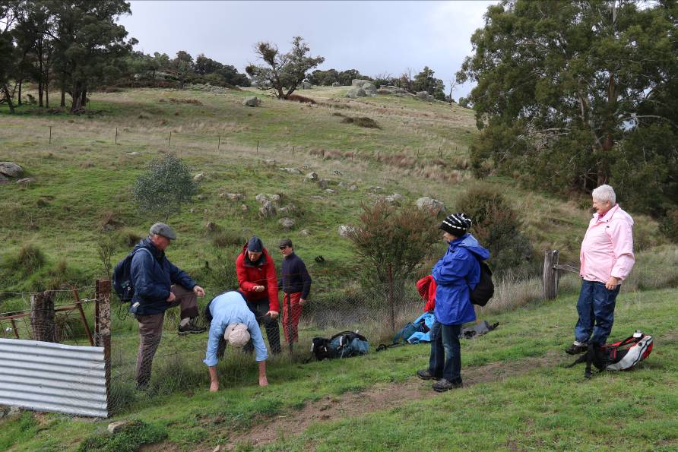
I have often thought that the Strathbogie Ranges are Victoria’s hidden secret and our May walk really confirmed this. Longtime Ruffy local, Justus Hagan, organised an incredible walk in the Western Strathbogies along a section of Chrystal Brook Creek and Hughes Creek. His local knowledge meant we were able to explore the spectacular landscape which otherwise would have been hidden from us. We walked in the shadow of the local mountain with the wonderful name of Mt Good Morning Billy, We started by rambling and scrambling along Chrystal Brook on its way to the confluence with Hughes Creek. The day before Justus saw a platypus at the confluence but alas we weren’t in luck. As we continued along Hughes Creek there were lots of rock hopping and scrambling over many granite boulders in very damp conditions underfoot. Concentration was required! However, we still had time to enjoy the many mini waterfalls and rockpools, as well as the incredible views in the canyon like section of Hughes Creek. We ended the walk tasting the mineral water from a natural spring and took the opportunity to collect samples. Justus told us of historic picnics to the area to collect samples of this water.

The weather was a bit threatening but the overcast and misty damp atmosphere added to the beauty and didn’t spoil the day. Thank you to Howard and Justus for organising this special walk.

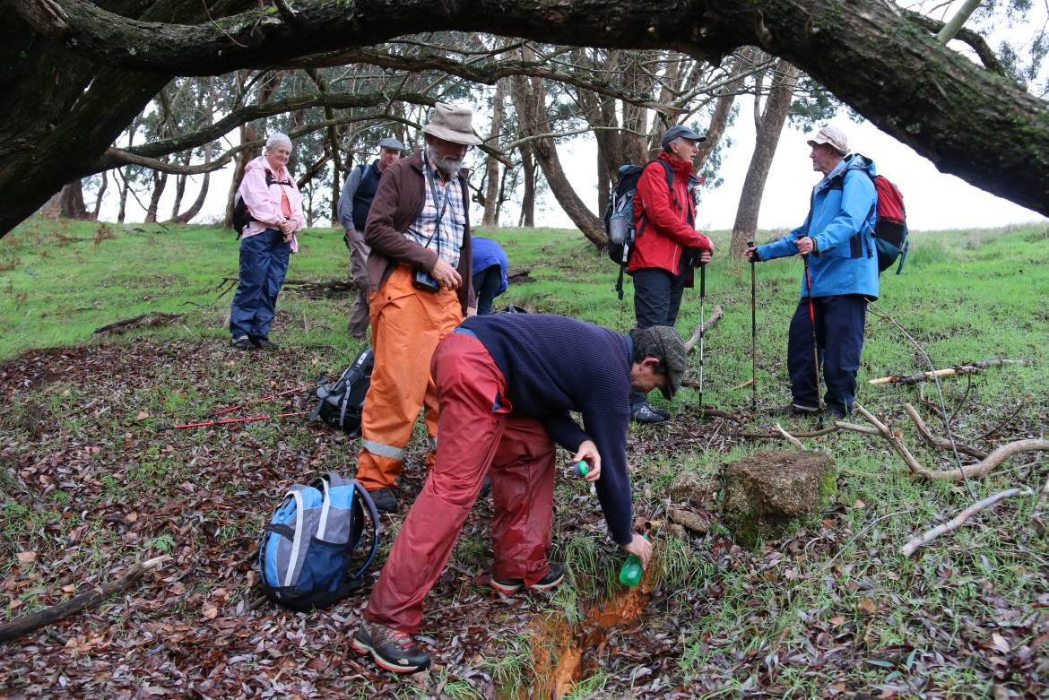
Justus has offered to lead another walk next year and we urge everyone to make a special note of the date when it is known.

Next month we return to the flat plains and Richard will be leading a walk to Kamarooka Forest.
Dianne Hanna

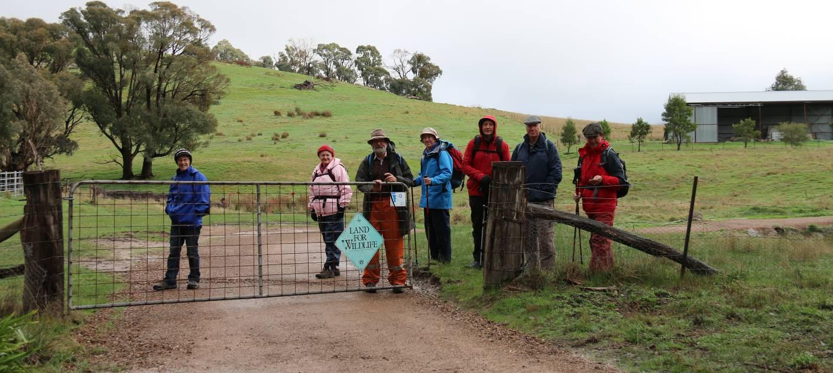

Euroa Mid Week Walk April

A group of 8 walkers enjoyed a really good 7 km walk up Balmattum Hill on a glorious autumn day for the April midweek walk. We started with the usual morning tea, this time in the park beside Seven Creeks in Euroa, from where our walk commenced. After chatting with some travellers who were passing through, we set off upstream along Seven Creeks in the attractive riparian zone and residential areas. After passing under the Hume freeway the gentle stroll like conditions changed as we headed up the steepish incline of Balmattum Hill. As we climbed the well made track, we had time to stop and take in the great views over the town of Euroa, across the Strathbogie ranges and beyond to the northern plains country. The top provided an ideal spot to have lunch before we then retraced our steps down the hill and along the southern side of the creek to the park. After the mandatory coffee stop we travelled back to Shepparton.

We all voted it a really good walk, one to be added to our list of walks. Thanks to Graeme and Kerry Betts for researching and leading this walk.

Dianne Hanna

MEMBERSHIP FORM
SHEPPARTON ADVENTURE CLUB Inc. A0002076S

Membership Fees for the 2014 / 2015 year are due on 1st JULY 2014.
Please return this form with your payment to:
The Treasurer, Shepparton Adventure Club Inc. PO Box 264, Shepparton. Vic 3632.

Please list name of each person and circle their age group (Insurance underwriting categories)

Name _________________________________________ U16 16-17 18-34 35-54 55-94 95+

Name __________________________________________ U16 16-17 18-34 35-54 55-94 95+

Name _________________________________________ U16 16-17 18-34 35-54 55-94 95+

Name _________________________________________ U16 16-17 18-34 35-54 55-94 95+

Name __________________________________________ U16 16-17 18-34 35-54 55-94 95+

Address: __________________________________________________________________

__________________________________________________________________

Phone: BH _____________________________ AH ________________________________

Mobile _______________________ Email Address: ___________________________________

Payment options (please circle):

1. Mail cheque or Money Order to PO Box 264, Shepparton 3632

2. Direct deposit to Bendigo Bank
BSB 633 000
Account No. 129 076 972
Please add your name as the reference and post the signed membership renewal form back.

Single Club Membership $25 ________

Family Club Membership (2 people) $40 ________

plus $5 per dependent child over 5 years ________

Concession (Single Membership)* $20 ________

Concession (Family Membership)* $35 ________
*Concession applies to Pensioner/Senior/Student Cardholders

TOTAL $ _________

ACKNOWLEDGEMENT OF RISK - ALL Adults must sign
I acknowledge that when I am participating in any activity of the Shepparton Adventure Club Inc, I am doing so as a volunteer in all aspects and as such I accept all responsibility for loss of property or bodily injury to me however it may occur.
I acknowledge that my participation in this activity may expose me to hazards and risks that could lead to injury, illness or death or to loss of or damage to my property. In particular when participating in abseiling, caving or above the snowline activities I am aware that these activities expose me to additional hazards and risks.
I will make all reasonable effort to avoid or minimise these risks by :
- only participating in activities within my capabilities,
- carrying food, water and equipment appropriate for the activity, and
- advising the leader if I am taking any medication or have any physical or other limitation that might affect my participation in the activity.

I acknowledge that the payment of my (renewal) subscription will be deemed as full acceptance and understanding of the above.
I agree to be bound by the rules of the Shepparton Adventure Club Inc. (which are available from the secretary).

Signed ………………………………………………………………………… Date ………………………………

Signed ………………………………………………………………………… Date ………………………………

