

If undelivered, please return to PO Box 264, Shepparton 3632

SHEPPARTON ADVENTURE CLUB inc. A0002706S

NEWSLETTER June - July 2013

New website: www.shepadventureclub.org.au Affiliated member of

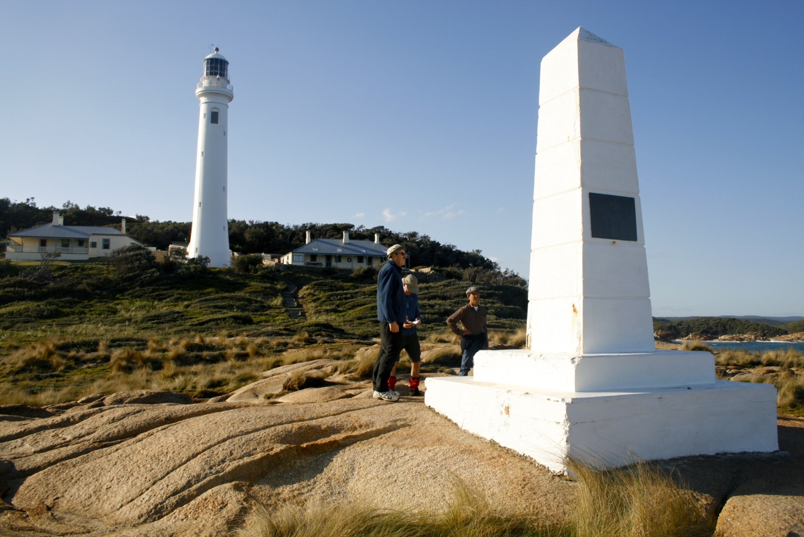

Photo of intrepid SAC explorers admiring Point Hicks memorial at the lighthouse

Next meeting come and hear Sarah Partington from the DPI speak on weed identification while walking on Tuesday 25th June at 7.30pm at the Mechanics Institute. Dinner before.

Newsletter Printing:
Our newsletter printing is kindly sponsored by Wendy Lovell, Member for Northern Victoria
138 Welsford Street
Shepparton Victoria 3630
Phone 03 5821 0055
Fax 03 5831 1062
The Hon. Wendy Lovell MP
Minister for Housing and
Minister for Children and Early Childhood Development

The SHEPPARTON ADVENTURE CLUB Inc.
General Meeting: 4th Tuesday of the months: February, April, June, August, October
usually: 7:30 pm at the Mechanics Institute, Wyndham St, Shepparton.
Committee Meeting: Monthly at 8pm.
Correspondence to: The Secretary SAC, PO Box 264, Shepparton 3632
Email: sacvicau@yahoo.com.au

OFFICE BEARERS
President
Vice President Richard Graves 5824 2929
Secretary Cathy O'Brien 5831 5068
Treasurer Scott Birchall 5831 6063 scottbirchall@aapt.net.au
(for email distribution to members)
Committee Members Fiona Cameron 0407299036
Bruce Gill 5824 2548

CO-OPTED POSITIONS
Newsletter Editor Fiona Cameron 0407299036 richardcameron@bigpond.com
Equipment Officer Maartje Heuperman 5824 1543 maartjeheup@bigpond.com
Publicity Officer Maartje Heuperman 5824 1543 maartjeheup@bigpond.com
Calendar Coordinator vacant
Mid-week coordinator Maartje Heuperman 5824 1543
Web Master Greg Smith 5824 1143 gregs@g-mwater.com.au

MEMBERSHIP FEES

Single Club Membership $25
Family Club Membership $40 plus $5 per nominated child aged 5 to 18 years
Concession – Single Membership $20 - Pensioner/Senior/Student Cardholders
Concession – Family Membership $35 - Pensioner/Senior/Student Cardholders

Membership benefits
Your Bushwalking Vic membership card enables you to obtain discounts at a number of retailers including Ajays (Heathmont), Bogong (Melb), Bushwackers (Essendon), EMC (Deepdene), Melb Map Centre (Malvern East), The Wilderness Shop (Box Hill), Outsports (Moorabbin), Paddy Pallin, Pinnacle, Snowgum, Escape 2 (South Wharf DFO).
You can also become a member of Anaconda, Columbia, Ray's Outdoors and Snowgum for free and thereafter obtain discounts.

Sunrise & Sunset (Melbourne GPO)
June 1 0726 1709 June 15 0734 1707  Aug 1 7.18 1737 Sept 1 6.41 1801 | July 1 7.33 1717
Full Moons
2013 23 June, 22 July, 21 August, 19 Sept, 18 Oct, 17 Nov, 17 Dec
Source: www.ga.gov.au

President’s Report

Vice President’s Ravings

Chris Halpin, our President for the past two years, has regretfully tendered his resignation from the position. He and Angie have sold their Shepparton home and are moving to Geelong closer to family. Chris has been a very active member and a power of strength for the club during his presidency. We wish them well in their new environment. Chris will continue his SAC membership and hopefully we will see him on occasional activities in the future.

The time is fast approaching for our annual election of committee office bearers. The Annual General Meeting will take place in August. Please give it some thought and have a go. The committee only meets once a month, usually the 3rd Tuesday. I know that a number of members have put in a lot of time over the years, but maybe your circumstances have now changed and you have a little spare time on your hands.

I would also like to acknowledge and thank the retiring committee for their support and commitment over the past year.

There have been a number of very enjoyable activities over the past months, so let’s try and keep up the impetus for future activities. I personally have been on an excellent mid-week walk to Ruffy in the Strathbogie Ranges and a group of 10 of us spent a week walking and assisting with car shuffles in the East Gippsland Wilderness Coast area.

Don’t forget that our annual subs will become due on the 30th June. A renewal form will appear in newsletters.

Hope to see you out and about,
Richard.
See you at the next general meeting for the DPI talk on weed identification while walking


PO Box 1007 Templestowe Vic. 3106
Phone: (03) 8846 4131
Fax: (03) 9846 7473 admin@bushwalkingvictoria.org.au www.bushwalkingvictoria.org.au

News

For overnight hikes check: www.packcarryvic.pbwiki.com

Several brochures on walking safely & softly are available at: www.bushwalkingvictoria.org.au/brochures.htm

BWV has had 544 walks entered on to their website www.bushwalkingvictoria.org.au Go to where2walk content login (top-of-page menu) with username: sacvicau and password: bushwalk. Please upload the details of any walk that you have done to help them to advocate for better funding to support bushwalking. Greg Smith won a clothing voucher for entering a walk so worth taking the time!

MEMBERSHIP FORM
SHEPPARTON ADVENTURE CLUB Inc. A0002076S

Membership Fees for the 2013 / 2014 year are due on 1st JULY 2013.
Please return this form with your payment to:
The Treasurer, Shepparton Adventure Club Inc. PO Box 264, Shepparton. Vic 3632.

Please list name of each person and circle their age group (Insurance underwriting categories)

Name _________________________________________ U16 16-17 18-34 35-54 55-94 95+

Name __________________________________________ U16 16-17 18-34 35-54 55-94 95+

Name _________________________________________ U16 16-17 18-34 35-54 55-94 95+

Name _________________________________________ U16 16-17 18-34 35-54 55-94 95+

Name __________________________________________ U16 16-17 18-34 35-54 55-94 95+

Address: __________________________________________________________________

__________________________________________________________________

Phone: BH _____________________________ AH ________________________________

Mobile _______________________ Email Address: ___________________________________

Payment options (please circle):

1. Mail cheque or Money Order to PO Box 264, Shepparton 3632

2. Direct deposit to Bendigo Bank
BSB 633 000
Account No. 129 076 972
Please add your name as the reference and post the signed membership renewal form back.

Single Club Membership $25 ________

Family Club Membership (2 people) $40 ________

plus $5 per dependent child over 5 years ________

Concession (Single Membership)* $20 ________

Concession (Family Membership)* $35 ________
*Concession applies to Pensioner/Senior/Student Cardholders

TOTAL $ _________

ACKNOWLEDGEMENT OF RISK - ALL Adults must sign
I acknowledge that when I am participating in any activity of the Shepparton Adventure Club Inc, I am doing so as a volunteer in all aspects and as such I accept all responsibility for loss of property or bodily injury to me however it may occur.
I acknowledge that my participation in this activity may expose me to hazards and risks that could lead to injury, illness or death or to loss of or damage to my property. In particular when participating in abseiling, caving or above the snowline activities I am aware that these activities expose me to additional hazards and risks.
I will make all reasonable effort to avoid or minimise these risks by :
- only participating in activities within my capabilities,
- carrying food, water and equipment appropriate for the activity, and
- advising the leader if I am taking any medication or have any physical or other limitation that might affect my participation in the activity.

I acknowledge that the payment of my (renewal) subscription will be deemed as full acceptance and understanding of the above.
I agree to be bound by the rules of the Shepparton Adventure Club Inc. (which are available from the secretary).

Signed ………………………………………………………………………… Date ………………………………

Signed ………………………………………………………………………… Date ………………………………

Calendar of Activities

Date | Activity | Location & details | Grade | Leader | Contact
12 June | 4WD tag along | Aim to explore the north west coast to Carnarvon, then head inland via Gunbarrel Hwy to Meekatharra/Wiluna/Carnegie paying respects to Len Beadell then on into Uluru (Ayer`s Rock) and home 3-4 weeks all up.  Happy to welcome fellow adventurers to tag-along….........if suitably prepared. | M | Justin Halpin | 0488040444
18 June Tues | Committee meeting | Greg Smith’s house 8pm
June/  July/  August | Snow skiing | Ian and Barb Stansfield will be staying at Wongungarra Lodge (Mount Hotham) numerous times during the winter and are happy to book SAC members at the lodge who receive a 10% discount on normal rates and show you the ropes – XC/XCD/reading/eating/relaxing!  June 7-10 Queens Birthday Long Weekend  June 21- 30 School Holidays  July 1 – 7 School Holidays  July 12 -14 School Holidays (almost full – be quick)  July 26 – 28 (End of Uni Holidays) | Social to Hard | Ian Stansfield | 0418127 831
25 June Tues | Meeting | Mechanics Institute Hall – Sarah Partington DPI on weed identification while out walking. She will bring live plants, slide show and explain how to report them to the DPI. Dinner before at Vic Hotel from 6pm | Social  7.30pm | Richard G | 5824 2929
26 June Weds | Mid-week walk | Yeddon Aboriginal Area, Mt Pilot and Reid’s Walk, El Dorado | Easy 8km | Maartje H | 5824 1543
9July Tues | Bike ride | Easy 10km or so bike ride from SAC shed to Kialla Lakes and back– we will try and finish it this time without any accidents! Meet at 1.30pm. Phone before if weather bad! | Easy/  family | Fiona C | 0407299036
24 July  Weds | Mid-week walk | Dargile Picnic Grounds | Easy 8km | Maartje H | 5824 1543
Aug 4  Sunday | Training | Apply first aid’ training provided by paramedic Wayne Uhe. Shepparton 9am to 3pm. All Community Action Grant funded positions are allocated but call Scott if interested in paying your own way or going on a reserve list (5821 6063 | 9am – 3pm | Scott | 5831 6063
Aug 20  Tues | Meeting | Committee meeting at Richard G’s home
27 August  Tues | AGM | Mechanics Institute Hall – Richard Graves slide show on the Croajingalong wilderness walk. Dinner before at The Vic Hotel at 6pm | Social | Richard G | 5824 2929
25-29 Sept | Camping/  bushwalks | Join Jill and Greg Smith in the Grampians to explore and experience spring flowers | M | Greg Smith | 5824 1143
13 October | Federation Walks | Boroondara Bushwalkers will be hosting the 2013 Federation Day Walks near Bacchus Marsh. There will be 20-25 walks of grades ranging from Easy to Medium in the western gorges region, west of Melbourne, including Lerderberg State Park, Werribee Gorge State Park, Brisbane Ranges National Park and Wombat State Forest. | E-M/H | BWV | http://tinyurl.com/c3esmyb
22 Oct | Meeting | Mechanics Institute Hall – speaker to be confirmed
Dec | Xmas party | Venue and date to be confirmed
PLEASE RING THE TRIP LEADER TO MAKE SURE IT IS WITHIN YOUR CAPABILITY AND CONFIRM THAT IT IS GOING AHEAD.

Benalla Bushwalking Club trips
How about some of our Shepparton members join Benalla on their walk along the Goulburn just west of Mooroopna on Sunday July 7th? Phone Adele Ritchie 5727 9501
June 2 Killawarra, June 8-10 Kooyoora SP?Melville Caves Car Camp, June 12 The Paps, June 15-16 Bike ride, Juen 23 Great Divide Trail, june 26 Sunrise Track – Warby Ranges, June 29 Goughs Bay, July 7 Goulburn River walk, July 10 Loggers Track Warby Ranges, July 14 Mt Samaria, July 27-28 Camp Cookout

More trips and booking information at http://home.vicnet.net.au/~benbwclb/index.htm

OTHER CLUBS’ ACTIVITIES
Border Bushwalking Club (Albury & Wodonga) - www.borderbushwalkingclub.com.au
Wangaratta Out and About Club - http://members.westnet.com.au/wangoutandabout
Bendigo Bushwalking and Outdoor Club - http://home.vicnet.net.au/~gobush/
Echuca-Moama Bushwalkers - http://www.echucamoamabushwalkers.org.au
If you are interested in overnight hikes check out www.bushwalkingvictoria.org.au
Just follow the step-by-step instructions for access to the site called Packcarry Vic

TOTAL FIRE BAN
If a day of TOTAL FIRE BAN is declared please contact the Activity Leader for confirmation whether the activity will go ahead or not.

Note: TRIP LEADERS – it is imperative for every trip that temporary members/visitors sign the “Acknowledgement of Risk Form”. These completed forms must be forwarded to the SAC Secretary for filing as soon as possible after the trip – otherwise, in the case of a claim, the insurer will not acknowledge the risk.
Form can be downloaded from www.bushwalkingvictoria.org.au , in http://www.bushwalkingvictoria.org.au/forms/Risk_Management_Guidelines.pdf

Emergency Contact Procedures
All enquiries about the return of participants from club activities should first be directed to the activity leader, and then to the Emergency Contact Person (ECP) for the activity if the leader cannot be found.
It is the activity leader's responsibility to organise an ECP and advise him/her (in writing) of trip & participant details and what to do if contact is not made by the nominated time.

Travel Cost Reimbursement
Option 1: Preferred. Fuel Cost per car plus 5 cents per km per car to be split equally between the numbers of people in the car including the driver. If appropriate, the cost of running all vehicles should be shared equally amongst all trip participants.
Option 2: 25 cents per km per car split between all trip participants.

Summary of Public Liability insurance coverage effective from 30 June 2009
Bushwalking, Recreational Walking, Walking, Track/Hut Construction and Maintenance, Caving, Canyoning, Liloing, Abseiling, Alpine Walking (Summer and Winter),Snow Skiing, Canoeing, Kayaking, Boating, Rafting, Swimming, Cycling, Rock Scurrying and use of hand held ropes as part of a Bushwalk, Orienteering, Rogaining, Leader Training, Rescue Training and other related instructions where no fee is charged other than to recoup expenses (Errors & Omissions), Voluntary Work for various Charities and not- for-profit organisations.
Activities NOT COVERED include Rock Climbing, Mountaineering, Water Skiing and Animal Riding

ALPINE – SKI GEAR URGENT DISPOSAL -ALL MUST GO DUE TO DOWNSIZING EVERY OFFER CONSIDERED
1 – Sierra Leone alpine tent, 2 man, c/w sep. insulated floor VG ,German
1 – Blacks, 1 man, c/w extra poles ridge, A, VG. UK
1 – Kodiak kit tent, alpine [only 7 pegs req] USA
1 – Pulk, c/w all harness, brakes, VG
1pr –Skis touring, 200cm, full metal edge, cable bindings inc. spare cable .
1pr – Skis touring, 200cm, ½ metal edge, cable binding inc. spare cable
1pr – skins, plastic to suit above
1pr – Stocks, adjustable.
1pr – Crampons, adjustable, VG
2 – Ice axes, wooden shaft, 1 plain, 1 hammer
Various climbing accessories, rock & ice
1pr - Boots,Meindl leather touring, size 42, VG, c/w Berghaus Yeti leggings
1 – Bivvy sack, gortex
1pr- Booties, alpine après.
1 – Sleeping bag, full alpine, Everest mummy, VG
1 - Sleeping bag, Bogong
1 – Rucksac, 60l, ladies, VG
Contact Peter Abbey – [03] 5821 9693. Shepparton

Shepparton Adventure Club Inc A0002706S Incorporation and New Rules (ie constitution)
A new law affecting Victoria's incorporated associations came into effect on 26 November 2012. The Associations Incorporation Reform Act 2012 has now replaced the Associations Incorporation Act 1981.
This means that some of SAC’s legal obligations have changed, including:
• annual financial reporting provision
• trading activities
• rules
• protection for office holders
• minimum rights of members
• meetings and record keeping
• role of the secretary
• disciplinary proceedings and grievance procedures
• register of members and personal information.
There are two sources of information regarding what is required to make the change to the new Associations Incorporation Reform Act 2012. They are:
The Consumer Affairs website www.consumer.vic.gov.au and
The PilchConnect website www.pilchconnect.org.au
The PilchConnect website gives a good summary to the differences between the old ACT requirements and the new ACT requirements.
The SAC Committee has been looking at the options available to update the old SAC Rules to the new Act and has decided to adapt the ‘Simple Rules’ developed by PilchConnect. These new rules will be forwarded to SAC members for their perusal and at the AGM a motion will be put forward to adopt these new rules. The new rules will then be sent to Consumer Affairs and once they have been approved will become SAC’s new rules.If you have any queries regarding these changes, please check out the websites above or speak to a Committee member


.
Trip Reports

Wilderness Coast Walk (Croajingolong National Park) 20th to 27th April 2013

Contributors: Richard Graves, Geoff Graves, Chris Halpin, Justin Halpin, Cathy Milner

This section of East Gippsland’s Wilderness Coast Walk covers in excess of 50 klms from Thurra River (near Point Hicks where Captain Cook & his shipmates first sighted Australia) to Shipwreck Creek (Mallacoota). Our plan was to take five days to cover this section, walking between five and six hours a day.
The walk has been planned and organised over the past twelve months and required a Parks Victoria Permit for the privilege of walking this amazing pristine wilderness area. The organisation and planning has not been without its dramas as 3 weeks prior to our trip the relevant government authority decided to do a controlled burn in a large section of the area that we were to traverse and closed the eastern part of the National Park to all walkers, even though they had previously given us a permit to go. We were finally given the ok to go by Parks Vic. just 3 days before we departed. We were not to see any sign of this controlled burn at any stage of the walk.

Day 1: Cann River
Saturday morning saw 10 excited SAC members, with full packs weighing between 18 and 22 kgs., making our way to our meeting point in Cann River in East Gippsland.

Richard, Chris, Rae, Ted, Judy, Dianne and Howard departed from Shepparton and travelled over the snow covered Mount Hotham and Justin and Geoff departed from Melbourne and collected Cathy in Traralgon on the way. We all met at the Cann River Hotel where we took rooms for the night as the area had 65mm of rain the days prior and the camp ground was quite wet. Dianne and Howard stayed in the Caravan Park in their Camper Trailer.
We spent a productive Saturday evening over a counter tea discussing our plans for the coming week. Judy invited a Canadian bloke, currently living in Tasmania, to join us at the table for dinner. He was obviously quite lonely because he hardly shut up all evening, although he was actually quite interesting to talk to. Dianne, Ted and Judy had generously agreed to assist the seven walkers as a back-up crew for car shuffles between Thurra River and Shipwreck Creek and also a food and water drop a third of the way at Wingan Inlet. We all retired to our comfy hotel beds knowing that this was to be the last opportunity for a shower for the next week.

Day 2: Cann River to Thurra River
Commenced 6am on with use of luxury facilities at Cann River Hotel prior to breakfast for 7 of the 10 participants at road house opposite the Hotel. Howard and Dianne used own facilities at Caravan Park and Geoff on Hotel veranda. Packed up 3 vehicles and proceeded down Tamboon Road which became narrow and sandy for an hour plus to Thurra River. Tents were set up and campervan erected. All enjoyed their lunch and general exploration followed. A large Black Snake was sighted passing through the camp site.

Judy and Ted drove to Point Hicks Lighthouse. Geoff walked to Lighthouse and others checked out Mueller Inlet crossing to see if access was available should our river crossing be too difficult the next day. Later most walked to light house from car park. Judy drove to her accommodation at Mallacoota. Dinner was completed individually and a campfire enjoyed followed by an early night.

Day 3: Thurra River to Gale Hill
The big question - Can we ford the Thurra River beachhead? Must we go the long way around? The answer was YES, a favourable tide and we can easily cross. Much relief all round.
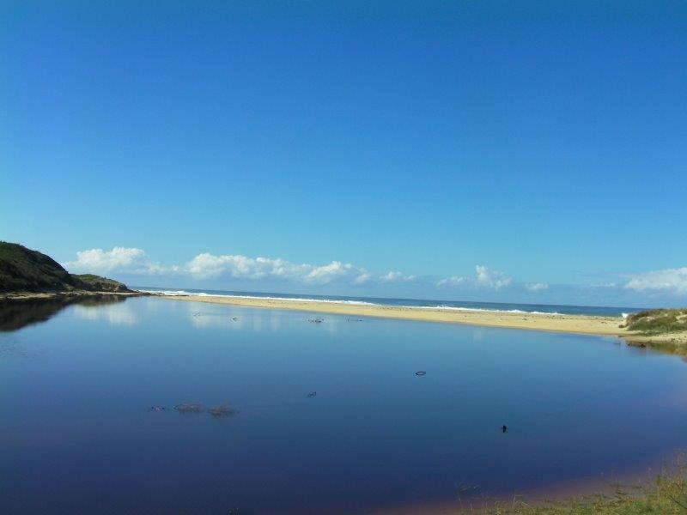
Our first day on the walk started very positively and just got better. Lovely trek along the beach, with Point Hicks Lighthouse providing a scenic backdrop. Everyone's spirits quite high. Found our campsite at Gale Hill Track, by a freshwater creek amongst the tea tree, quite easily. Excellent camping area with running water. Soon joined by a Melbourne girls’ school group travelling the reverse direction. Fortunately we had our 'elders’ landrights' acknowleged and they camped below us on the beach. Early dinner and a great way to start.

Thurra River...looking at the ocean from our camp site

Day 4: Gale Hill to Wingan
Awoke to a few spots of rain around 6am after a l-o-n-g night. Fortified with a Trangia breakfast we were up and running by 8am. ‘Dr Richard’ exercised his skills in ‘tick surgery’ with the tweezers on a rather wan student from the school group. Some scrambling was required over lichen-covered rocks with plenty of flotsam and jetsam evident on the near-deserted beach.
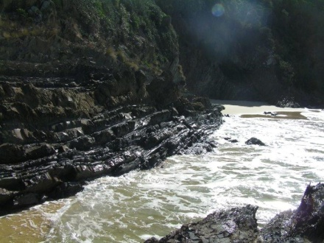
Around Petrel Point we were treated to a seal and a pod of dophins close to shore as we enjoyed an early lunch. A steep ascent greeted us as we left the beach to negotiate the noticeably softer under-foot country inland from Rame Head. The weather improved and our mood lightened immeasurably when we met Di and Ted walking from Wingan to greet us. That evening we supped at Di and Howard’s cafe-de-wheels with home-grown spag bol - what an oasis!

Day 5: Wingan to Red River Inlet
A sunny mild morning was introduced by resident kookaburras. We had repacked for a further three days of hiking and met cheerful Laurie-from-Wonthaggi in his now seriously overloaded ‘tinnie’, having volunteered to transport us across the inlet… he was very happy that we were doing the walking when he tried to lift one of the packs from the boat at journey’s end.
The initial section of the walk was in the bush which soon gave way to the beach and plenty of sharp rocks to negotiate. Our fearless leader Richard armed with maps, compass and GPS was leaving nothing to chance and at day’s end steered us to a delightful wind-protected camp site in earshot of the familiar sounds of surf. The locals explained the inordinate number of dead mutton birds by describing them as the ‘runts of the litter’ and unprepared for the long northward journey.

Day 6: Red River Inlet to Bendore River
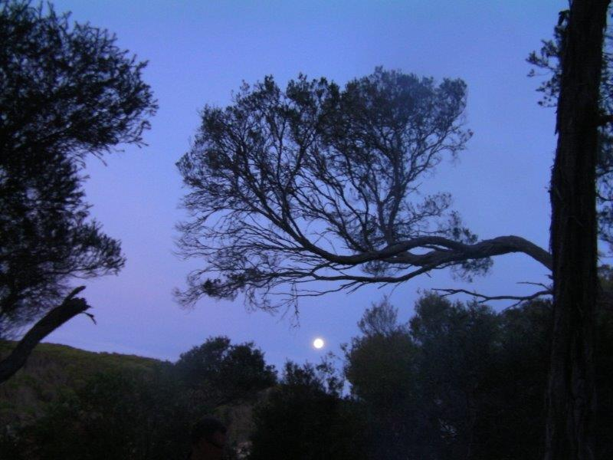
Early Anzac Day ceremonies beamed in from the National Capital on local radio, very moving as always. Took a brief dip in the briny which was like a Jaccuzzi! We had camped a mere 75m from the surf’s edge adjacent to the lagoon … pure bliss.
The track was delightful, comprising previously burnt terrain featuring solid regrowth including grass trees and colourful, flowering understorey. Parks apparently utilize a self-propelled clearing machine to maintain track conditions. We took a brief ‘smoko’ at the intersection of Red River and Rockey Ridge tracks and later lunch and water top-up from the free-running supply among the rocks adjacent the beach. Today the ocean was deserted except for a couple of container ships well out to sea and closer, a solitary yacht. The day concluded with another dip in the turbulent surf. Pre-dinner hot soup was very welcome and we dispatched our last unexciting, reconstituted dinner around the cosy fire.

DAY 7: Bendore River to Shipwreck Creek
Leaving our last campsite at Benedore River. After a night of a full moon and dogs howling. We never saw them, but were aware of their footprints. Often. They knew where we were. Around the Benedore River and into the bush. Howard stopped and pointed out a large black snake on our track. We only had a few minutes to discuss our options and it decided to depart. Pretty happy about that.
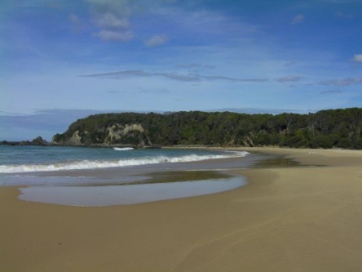
An early lunch in Seal Bay. Another spectacular beach spot. Justin had to chase his hat, full pack and all...it went for a surf, backwards and forwards, backwards and forwards until he impaled it on the end of a walking stick. Back into the bush. An easy walk.
The option of a 2k walk to Little Rame Head was declined by all. I can't imagine why......
Met the backup crew enroute to Shipwreck Creek. Where is the car? Only 300 metres around the beach. Thank you Nathan for the wonderful treat of champagne, strawberries and chocolate. How lucky are we. Thanks you to the backup crew for their dedication and support. Back to civilisation. Mallacoota with a real bed and a pub meal.
High points.... .....magnificent scenery.........fantastic weather...... tail wind......low tide at the correct times........great crew..........octopus chasing food in the rock pool, black specks in a rock pool, hatched the next day, lots of wrigglers.....mosquitoes going to be plentiful.

Kinnards Wetland Mid-Week Walk in March

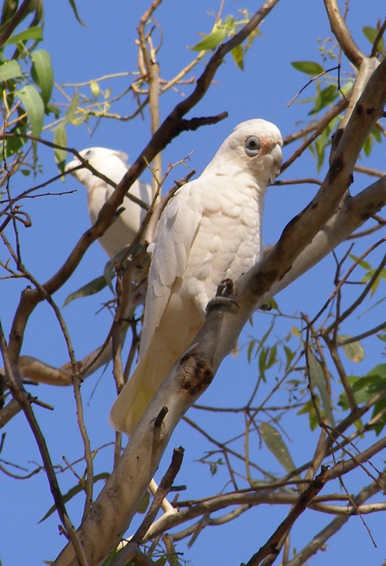
Three members ventured out in the warm weather for our March midweek walk. Unfortunately, Peter Abbey was not well enough to lead the scheduled walk to Tallangarook Mines so it was decided to head to Kinnards Wetlands instead. The incessant screeching of the Little Corellas accompanied us on our walk from the Numurkah centre along the Broken Creek; fascinating for us to see them in such
numbers but no doubt very wearing indeed for the locals .

The walk around the circumference of the wetlands was uneventful but enjoyable....Great to see such a successful combined environmental and drainage project. After lunch at the wetlands shelter we returned to the township back along the creek and beside the manmade lake.

We decided to check out the Wunghnu Bushland Reserve as it is the best example of remnant Grey Box- Buloke Grassy woodlands in the Shepparton irrigation Region. This type of environment is a nationally threatened vegetation community. We weren’t knowledgeable enough to identify the rare plants found in this reserve but found it interesting to walk through.

Iced chocolates and iced coffees from the Wunghnu cafe were very welcome before returning to Shepparton.

Dianne Hanna

Cussen Park Mid-Week Walk April
What better than promoting your own township during a midweek walk. That's what I did last Wednesday, leading a group of five Shepparton Adventure Club members through Cussen Park with its
bird hides and wetlands teaming with bird life.
We then continued via the walking track that connects to Hogan Street where we enjoyed a coffee and slice at the bakery. After sharing local knowledge and a lot of social chatter, we walked past the Mosaic Murals at Stuart Mock Place to Barttlet Lake.
Back to Cussen Park where we concluded the lovely walk with lunch at the rotunda.
Maartje Heuperman

O’Keefe Rail Trail Bike Ride in May
Four keen SAC members, on a beautiful sunny Sunday in May, started their bike ride from the car park at Weeroona Lake in Bendigo. With a coffee of course, while hundreds of participants in the "million paws walk" waited with their dogs for the starting sign to walk around the lake.
The O'Keefe Rail Trail is a relatively flat trail through iron bark and yellow gum woodland. Build by Andrew O'Keefe to link Bendigo to Heathcote in 1888, after he migrated with his family from Ireland to escape the great potato famine.
The rail trail section from Bendigo to Axedale was opened in 1993 and consist of 23 km of sandy gravel tracks. All the low creek crossings have been replaced by bridges after the big flood.
A number of former railway stations and platform sites have been signed and replica concrete railway mileposts have been installed along the track. We past the Axedale cemetery, a place we visited on one of our midweek walks last year, and continued to the park behind the school where we had lunch. The return trip was definitely less flat than we thought or was it just that the legs were getting tired?
Thank you Mark for organising, great day, good company and it feels good to have replenished the vitamin D levels again.
Maartje Heuperman

May Mid week walk to Tarcombe in the Strathbogies.
For the May midweek walk we went to the Ruffy district to walk in some of the most beautiful but fragile grazing country of the Strathbogie region. It was a grey overcast day when we left Shepparton and we left fully expecting the forecast rainy conditions to make for an uncomfortable finish to the day. We arrived at the Ruffy Community Centre and office of the Landcare coordinator a little after 10am, where we met Justus Hagan, who was to be our guide for the day.
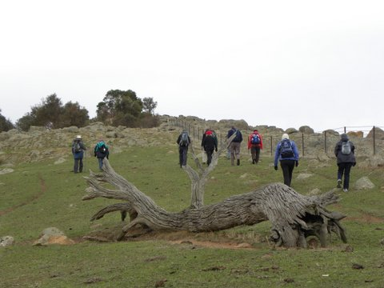
After a hot drink we drove west of Ruffy along Nolans road, past the Bishops Mitre Rock towards Tarcombe. We then began our walk, climbing quickly to the top of the ridge at 447metres on the west side of the County Creek. From there we could see cross the valley to The Peak, which Justus said was another good walk that our group could do at another time. On the other side of the valley we could see angus cattle grazing, but they were so far away they looked more like black sheep than cattle. Looking to the south west we could see across towards Highlands and Habbies Howe
Justus lives locally and is very knowledgeable and enthusiastic about the revegetation of the area. He and his wife (Janet) have a direct seeding business and have successfully established many native revegetation plots throughout north eastern Victoria. Throughout the day Justus was able to tell us very interesting stories about the history of the area, its geology and ecology.
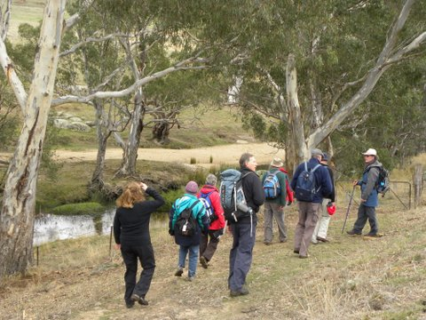
We carefully picked our way down the steep slope from the ridge towards Hughes Creek, which along with Sevens Creek is a tributary to the Goulburn River. After scrambling under a fence protecting the creek from grazing, we found a lovely spot to eat our lunch.
Sitting under the big red gums with the air almost completely calm and the creek flowing silently by, we could see many small birds foraging in the tree tops. They were difficult to see against the grey, overcast skies, however a shrill, one-note call could be heard and with the aid of binoculars we were able to make out the form of the beautiful Eastern Shrike-tit amongst the common honey eaters.
When everyone had finished eating we began our way back. We walked beside the creek, amazed at how much evidence there was of the wombat population, and much to our surprise suddenly we there was a wombat standing in front of us. Naturally it scampered off and down its hole as soon as it became aware of our presence.
We scrambled through a fence designed as a flood wall which would swing up in times of high water flow, allowing floating vegetation to flow past rather than break the fence down. As we continued along the creek bank Justus encouraged us to visualize groups of aborigines camped in this idyllic setting many years ago.
Climbing up from the creek bed, along a fence line, through a gate and then across a large paddock, we then had one last very awkward scramble through a fence that had live electric wires (5000 volts) on both sides. That successfully negotiated we had a very short walk along the Ruffy-Tarcombe road to get back to the cars.

Before leaving Justus at Ruffy he told us of his walking group that walk on the first Sunday of the month. Everybody is welcome; contact him at the Euroa Library for more details if you are interested.
We were very grateful to Justus for leading such a really good day and agreed that we would love to take up his offer and come back for another walk in the Strathbogies in the not too distant future.
This was the last walk that our good friend and club President Chris Halpin will walk with us, before he leaves Shepparton. We thank him very much for his leadership of SAC. The mid week walkers cannot express how much we will miss his good humour and constant enthusiasm. We wish him all the very best and feel sure he will find another such group that will also value his support. We hope we see him again sometime in the future, maybe on a winding track in some beautiful bush somewhere. Good Luck and Thank you.
Maartje’s hat was a highlight and was complemented upon by the waitress in Euroa, when we stopped for our coffee on our way home.
Howard Hanna

Bike Ride and Canoe in March

Seventeen kids under 11 and six adults started out on a leisurely ride from the SAC shed heading to Kialla Lakes. The bike path is paved all the way and meanders delightfully through the red gum forest along the Goulburn and Broken creek. It really is a pleasant ride in the heart of Shepparton and I encourage you to walk/run/ride it at least once. The kids sped along at a great pace with some adults taking the rear. The first “hill” bridge over a creek resulted in Taryn’s (10 years old) front tyre touching Abbie’s (also 10 ) back tyre when someone appeared coming in the opposite direction at the critical down-hill moment, causing bike and child to hit the ground! A grazed knee and sore arm ended the excitement. Everyone gathered and it was decided to turn around and head back while Taryn and Richard went off to casualty. Luckily, it was a simple greenstick fracture which needed a plaster of Paris cast for 4 weeks only. In hindsight the RULES should have been laid down in the beginning – keep to the left and keep your distance! My kids (Taryn being one of them!) ride bikes at home but we live out of town on the flat! When we got back to the shed we had done 8.5kms which was probably long enough for some of the Mum’s. Cathy O’Brien organized 2 kayaks and some RULES about whom, where and when while I went to retrieve the hidden bikes. It was a warm afternoon and most of the kids were swimming and splashing near the beach entrance waiting for their turn. Sailability were just leaving when we were putting the kayaks in and as were getting them out the rowing club were lining up behind us – great to see the lake being used so much by so many different users. We plan to repeat this bike ride in the July school holidays – hopefully without incident! Fiona Cameron

