

If undelivered, please return to PO Box 264, Shepparton 3632

SHEPPARTON ADVENTURE CLUB inc. A0002706S

NEWSLETTER February - March 2014

New website: www.shepadventureclub.org.au Affiliated member of

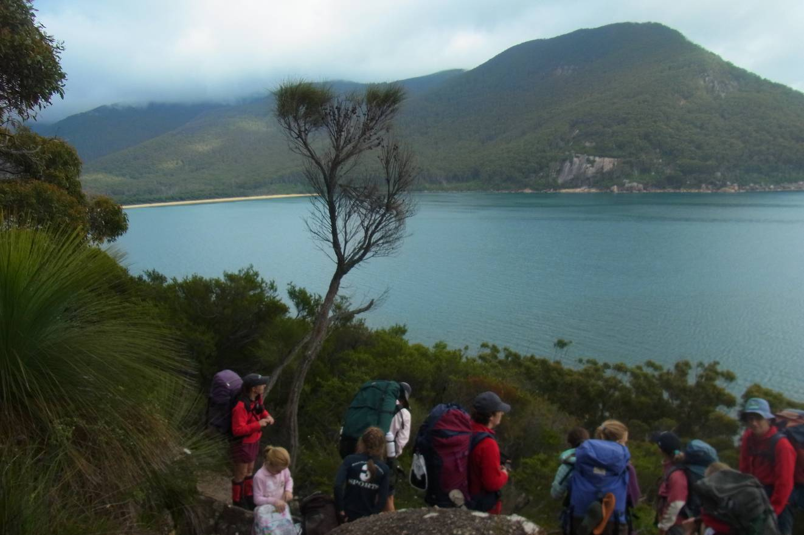

Wilson’s Prom hikers in December ages 7 to 40 plus

Come along to the shed BBQ on Tuesday 25th February BYO

Newsletter Printing:
Our newsletter printing is kindly sponsored by Wendy Lovell, Member for Northern Victoria
138 Welsford Street
Shepparton Victoria 3630
Phone 03 5821 0055
Fax 03 5831 1062
The Hon. Wendy Lovell MP
Minister for Housing and
Minister for Children and Early Childhood Development

The SHEPPARTON ADVENTURE CLUB Inc.
General Meeting: 4th Tuesday of the months: February, April, June, August, October
usually: 7:30 pm at the Mechanics Institute, Wyndham St, Shepparton.
Committee Meeting: Monthly at 8pm.
Correspondence to: The Secretary SAC, PO Box 264, Shepparton 3632
Email: sacvicau@yahoo.com.au

OFFICE BEARERS
President vacant
Vice President Bruce Gill 5824 2548 tatgills@westnet.com.au
Secretary Cathy O'Brien 5831 5068 cathy.peter@optusnet.com.au
Treasurer Scott Birchall 5831 6063 scottbirchall@aapt.net.au
(for email distribution to members)
Newsletter Editor Fiona Cameron 0407 299 036 richardcameron@bigpond.com
Equipment Officer Richard Graves 5824 2929 RICHSUE@BIGPOND.COM
Publicity Officer Maartje Heuperman 5824 1543 maartjeheup@bigpond.com
Calendar Coordinator vacant
Mid-week coordinator Dianne Hanna 0437 289 281 dhanna3@bigpond.com
Web Master Greg Smith 5824 1143 gregs@g-mwater.com.au

MEMBERSHIP FEES

Single Club Membership $25
Family Club Membership $40 plus $5 per nominated child aged 5 to 18 years
Concession – Single Membership $20 - Pensioner/Senior/Student Cardholders
Concession – Family Membership $35 - Pensioner/Senior/Student Cardholders

Membership benefits
Your Bushwalking Vic membership card enables you to obtain discounts at a number of retailers including Ajays (Heathmont), Bogong (Melb), Bushwackers (Essendon), EMC (Deepdene), Melb Map Centre (Malvern East), The Wilderness Shop (Box Hill), Outsports (Moorabbin), Paddy Pallin, Pinnacle, Snowgum, Escape 2 (South Wharf DFO).
You can also become a member of Anaconda, Columbia, Ray's Outdoors and Snowgum for free and thereafter obtain discounts.

Sunrise & Sunset (Melbourne GPO)
Jan 1 05.02 19.45 Jan 15 06.15 20.43  Feb 1 06.34 20.33 Feb 15 06.50 20.18 | Mar 1 07.04 20.00 Mar 15 07.18 19.39
Full Moons
2014 16 Jan, 14 Feb, 16 Mar
Source: www.ga.gov.au

President’s Report

Vice President’s Ramblings:

Whooaa, 2014, Here we go! With such a warm start to the year, land based activities probably aren't at the top of every-members mind when it comes to Adventure Club options, so it's not surprising canoe activities have been featuring on the trip menu lately. On a recent SAC canoe trip on the Goulburn, a couple of our members (anticipating the hot weather perhaps?) decided to go swimming right at the start of the trip. However, the instability of the old canadian canoes and the fact that most of the club's canoe and kayak fleet is quite old or of the white-water variety got the committee thinking about getting a couple of new boats that will have less tendency to flip unwary paddlers into the water. So if you have any thoughts on types of canoes / kayaks we should consider, please pass your thoughts on to a committee member. While we won't have them in time for Rachael's day trip to the Alexander - Molesworth stretch of the Goulburn on Saturday 22 February, some new boats on our new boat trailer will mean we're well set up for future aquatic adventures during the warmer months of the year.
For myself, I was able to spend much of the first stinking hot week of the year submerged in or floating on Lake Hume, but with school now back in swing and no more leave, beating the heat now relies on the garden hose and some electricity to keep cool (and just relaxing too). Anyway, if you would like to check out the club's existing fleet of canoes, please come along on Tuesday 25th Feb for the next general meeting, which is a social by the lake, where the canoes are ready and available for members to go for an evening paddle. At this stage, it looks like the weather will probably be HOT, but at least the days are getting shorter. Cheers Bruce

Hope to see you in February at the SAC shed on a walk or kayak soon


PO Box 1007 Templestowe Vic. 3106
Phone: (03) 8846 4131
Fax: (03) 9846 7473 admin@bushwalkingvictoria.org.au www.bushwalkingvictoria.org.au

News

For overnight hikes check: www.packcarryvic.pbwiki.com

Several brochures on walking safely & softly are available at: www.bushwalkingvictoria.org.au/brochures.htm

Please upload the details of any walk that you have done to BWV website for them to advocate for better funding to support bushwalking. www.bushwalkingvictoria.org.au Go to where2walk content login (top-of-page menu) with username: sacvicau and password: bushwalk.

Calendar of Activities

Date | Activity | Location & details | Grade | Leader | Contact
22 Feb Saturday | Kayak | Meet Shepparton 8am back at 5pm to kayak from Alexandra to Molesworth. | M | Rach | 0400238276
18 Feb | Committee meeting | Richard Grave’s at 8pm
25 Feb  Tuesday | Social | Come down to the SAC shed for a BBQ and a chat or kayak from 6pm. BYO dinner. | Social
26 Feb  Weds | Mid- week walk | The walk will be to Loch Garry. This will be an easy walk around the horseshoe lagoon and wetland area near the Goulburn River approximately 20 kms north of  Shepparton. It is an interesting area both environmentally and historically. The Loch, built in 1924, has formed a key part in the Goulburn River flood mitigation scheme.  Walkers have suggested that if it is to be warm that we meet at 8am rather than 9am. If this is the case members will be notified by email. | E | Dianne Hanna | 0407289281 or  58289281
18 March  Tues | Committee meeting | Cathy’s place at 8pm
28-30 March | Overnight hike | Driving Friday night to the Howqua River at 8 mile flat. Walking from 8 mile flat to Ritchies Hut and Rtn. Camping at Ritchies Hut. About 7 km each way. Hopefully walking in via the river track which has many river crossings. Lilos on the river and swimming would be part of the plan. Car travel time from Shepp to 8 mile flat would be approx 2.5 hours. | M | Greg and Jill | 5824 1143
26 March  Weds | Mid-week walk | Bull Creek to Murrindi Cascades and return | E
22 April  Tues | General meeting | Mechanics institute – speaker TBA 7.30pm
23 April  Weds | Mid-week walk | Polly McQuinn’s/Gooram Falls | E
28 May  Weds | Mid-week walk | Justice Hagan walk; Ruffy | ? | Howard Hanna | 0437628279
24 June  Tues | General meeting | Mechanics Institute – speaker TBA

PLEASE RING THE TRIP LEADER TO MAKE SURE IT IS WITHIN YOUR CAPABILITY AND CONFIRM THAT IT IS GOING AHEAD.

Benalla Bushwalking Club trips
Feb 8-9 The Grey Hills, Feb 9-23 Tasmania, Feb 12 Howqua River, Feb 16 canoeing, Feb 23 Fitzgeralds Hut,March 1-8 AAWT – Round Mountain trailhead to Dead Horse Gap, March 2 Albury riverside walk, Mar 8-10 Queens Spur, Mar 9 The Bluff, Mar 12 Mt Buffalo short walks, Mar 14 Reef Hiills Sunset and Moonlight walk, Mar 15 Mt Samaria, Mar 23 Mt Buffalo Black wall, Mar 22-23 The Fainters, Mar 29-30 Buckety Plains car camp
More trips and booking information at http://home.vicnet.net.au/~benbwclb/index.htm

OTHER CLUBS’ ACTIVITIES
Border Bushwalking Club (Albury & Wodonga) - www.borderbushwalkingclub.com.au
Wangaratta Out and About Club - http://members.westnet.com.au/wangoutandabout
Bendigo Bushwalking and Outdoor Club - http://home.vicnet.net.au/~gobush/
Echuca-Moama Bushwalkers - http://www.echucamoamabushwalkers.org.au
If you are interested in overnight hikes check out www.bushwalkingvictoria.org.au
Just follow the step-by-step instructions for access to the site called Packcarry Vic

TOTAL FIRE BAN
If a day of TOTAL FIRE BAN is declared please contact the Activity Leader for confirmation whether the activity will go ahead or not.

Note: TRIP LEADERS – it is imperative for every trip that temporary members/visitors sign the “Acknowledgement of Risk Form”. These completed forms must be forwarded to the SAC Secretary for filing as soon as possible after the trip – otherwise, in the case of a claim, the insurer will not acknowledge the risk.
Form can be downloaded from www.bushwalkingvictoria.org.au , in http://www.bushwalkingvictoria.org.au/forms/Risk_Management_Guidelines.pdf

Emergency Contact Procedures
All enquiries about the return of participants from club activities should first be directed to the activity leader, and then to the Emergency Contact Person (ECP) for the activity if the leader cannot be found.
It is the activity leader's responsibility to organise an ECP and advise him/her (in writing) of trip & participant details and what to do if contact is not made by the nominated time.

Travel Cost Reimbursement
Option 1: Preferred. Fuel Cost per car plus 5 cents per km per car to be split equally between the numbers of people in the car including the driver. If appropriate, the cost of running all vehicles should be shared equally amongst all trip participants.
Option 2: 25 cents per km per car split between all trip participants.

Summary of Public Liability insurance coverage effective from 30 June 2009
Bushwalking, Recreational Walking, Walking, Track/Hut Construction and Maintenance, Caving, Canyoning, Liloing, Abseiling, Alpine Walking (Summer and Winter),Snow Skiing, Canoeing, Kayaking, Boating, Rafting, Swimming, Cycling, Rock Scurrying and use of hand held ropes as part of a Bushwalk, Orienteering, Rogaining, Leader Training, Rescue Training and other related instructions where no fee is charged other than to recoup expenses (Errors & Omissions), Voluntary Work for various Charities and not- for-profit organisations.
Activities NOT COVERED include Rock Climbing, Mountaineering, Water Skiing and Animal Riding

.
Trip Reports

Midweek Walk: Golden Mount, Strathbogie Range, 27th November 2014

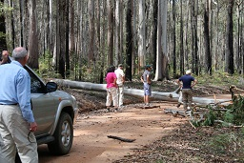
Seven members met at Euroa for morning tea in bright sunshine before travelling through the Strathbogie township and along the bush track to Golden Mount. Part way along the track we struck our first hurdle, a tree across the track. Never daunted our combined strength pulled the tree to one side to allow the vehicles through. Alas, a few kilometres on a huge tree completely blocked the track. Our ever-resourceful leader Richard reversed the route. We walked back along the road to our starting point – the climb up Golden Mount. The walk up was likened to the ‘big dipper’, a series of short sharp rises followed by steep declines into the hollows which took us slowly but surely to the top. A splendid view in all directions was enjoyed by everyone as we ate lunch perched on the rocks. After exploring the Mount we completed the circuit noting the changes in vegetation and enjoying a scattering of wildflowers. A coffee stop at the Strathbogie café completed an enjoyable and challenging walk to finish the year. Barbara Brown

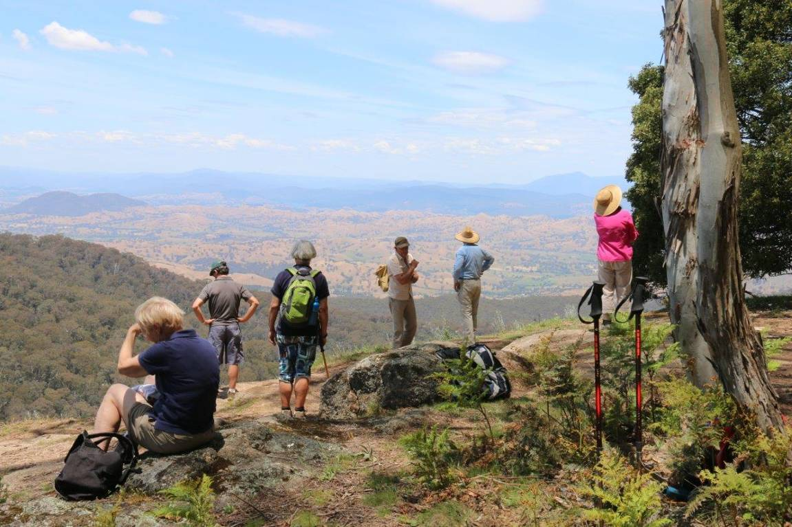

Kayak trip from Trawool to Seymour Saturday 4th January 2014

I type this from my bed of pain, having been soaked, battered, bruised, humiliated and sunburnt this morning on a canoe journey on my favourite river in the world – the mighty Goulburn River. Actually, it was fantastic.

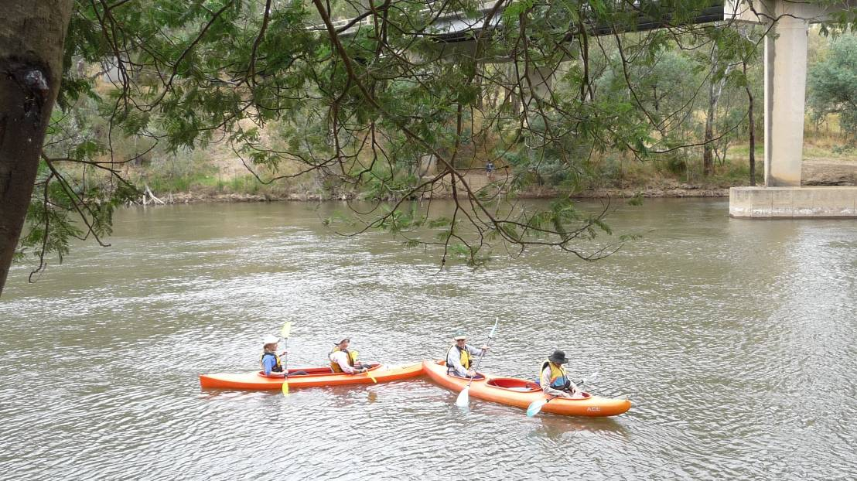
Peter (my brother and SAC lad) insisted upon my coming because the challenge of canoeing from Trawool to Seymour was really playing on his mind. As a veteran traveller of this beautiful river, I was the obvious choice to help him out (he is older and has difficulties with quite a few things).

We began at the Trawool bridge where I was introduced to SAC members and friends –Richard, Maatje, Alfred, Dianne, Howard, Judith and Rachel (our very capable leader). Peter and I were awarded the green Canadian, which we promptly tipped over. Is this some sort of devious initiation, where the new chum is unceremoniously dumped fully into the river? At least the water was quite warm; unlike the time the dear Peter dropped me into same said river once in Spring at Alexandra, just after the gates had been opened at Eildon, affording me a snow fresh bath.

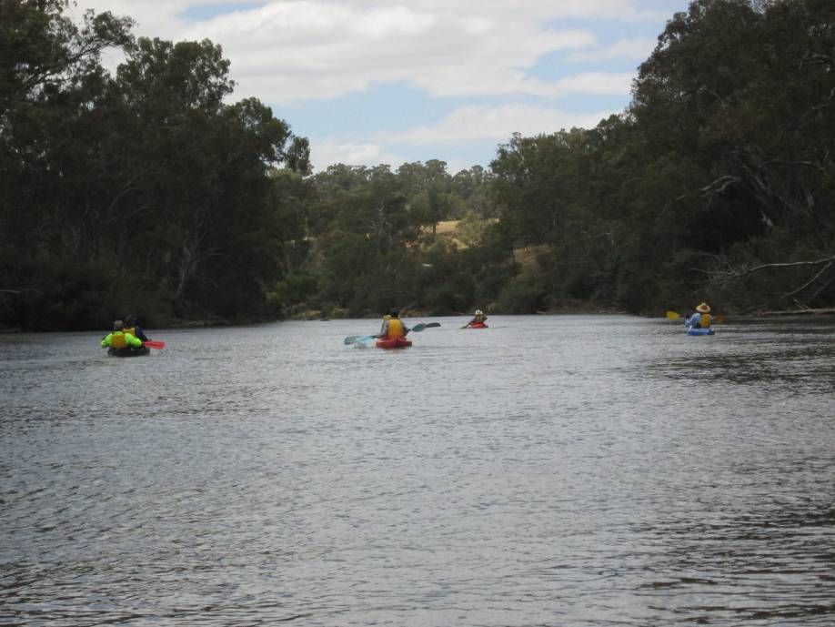
After some severe adjustment of the seating arrangement in our canoe and handing my (now) destroyed mobile phone to my wife Deb, who had the good sense not to laugh (we do still live together), we set off with more determination than Captain Phillip into (almost)
uncharted waters.

But what a lovely river! Coolish weather, eagles, kingfishers, cockies (flying and farming), too many cows in the water and a light breeze made this journey closer to what Jerome K Jerome’s 3 men had in mind (no Montmorency, thank you).

Morning tea and lunch was more a time of gloating that resting. Rachel pulled out her complete sized picnic rug and set up camp. I revealed the two largest vanilla slices with bright pink icing to accompany the brewed coffee, Judith opened up some Thai cuisine!

We arrived at Seymour early in the afternoon, in time to watch some young lout hacking into one of the park trees with an axe. He was given a suitably arresting word of advice and subsequently sulked off into a corner somewhere. We loaded up the vehicles and went our ways, having had a top trip down Victoria’s premier waterway. Thanks Rachel for organizing this, and thanks all for allowing me to be there to help my brother.

Cheers

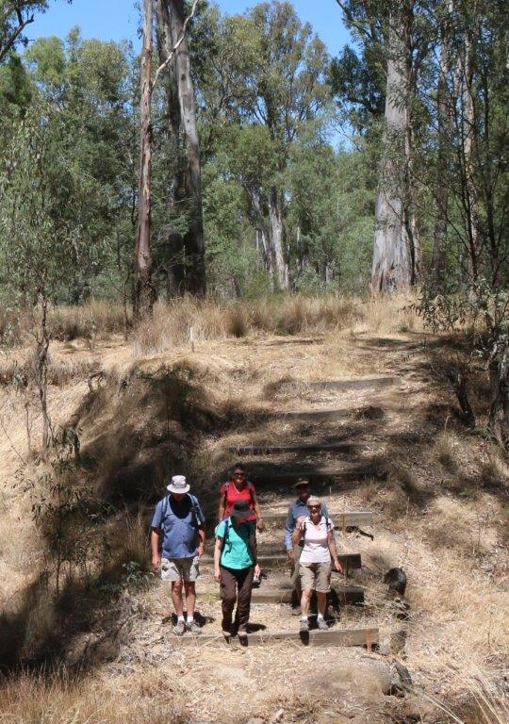
Bill Howard
Mid-week Walk at Moira Park – Wednesday Jan 22.

Following a week of searing temperatures, the mid-week walkers who met at the library car-park were heartened by the weather forecast of 33° with gentle southerly breezes. A small, but enthusiastic group of six took the short drive to Belstack Strawberry Farm.
With cars parked, we set off on a short loop walk in a southerly direction along the banks of the Goulburn under the majestic River Redgums – part of the Shepparton Regional Park. A break for morning tea on what felt like a sand-bar, despite the absence of sand, allowed us to study the free-flowing Goulburn River – Victoria’s longest and largest (if we exclude the Murray which we have to share). As the river made its 654 kilometre journey from Woods Point to the Murray, the walkers reminisced on rural childhoods complete with telephone exchanges, party lines and community life.
On the walk back to the starting point we strolled along a channel bank which afforded us views of the extensive gardens surrounding a property formerly established and owned by the parents of our mid-week walk co-ordinator.
Energised by our completion of the loop walk, we set off on a 6.5 km circular walk along vehicular tracks, but still under the dappled shade of the gums. After a short pause at the Moira Park Scout Camp, now completely restored following senseless vandalism, we continued the circuit - stopping occasionally to shoot unidentified birds with a Nikon camera.
Back at the strawberry farm surrounds, we sat at rustic tables and benches, well weathered following their construction by Kialla Apexians in 1991, and enjoyed lunch.
Now, in the full heat of the day, the air was filled with the distinctive summer sound of cicadas. Referred to as ‘the suicidal lovers of the insect world’, the male cicadas risk death by predators in their desperate attempts to attract a mate during their short life-span.
Ignoring the plight of the cicadas, we retired to the Bellstack restaurant and turned our attention to strawberry ice-creams and milkshakes. Many thanks to Barb Brown for her excellent leadership which involved forward planning and reconnaissance work. Thanks also to our fellow walkers -Howard, Di and Marg for your company and good cheer.
Graeme and Kerry Betts.

Wilson’s Prom 35.5km Hike from Oberon Carpark, to Sealers and Refuge Coves.
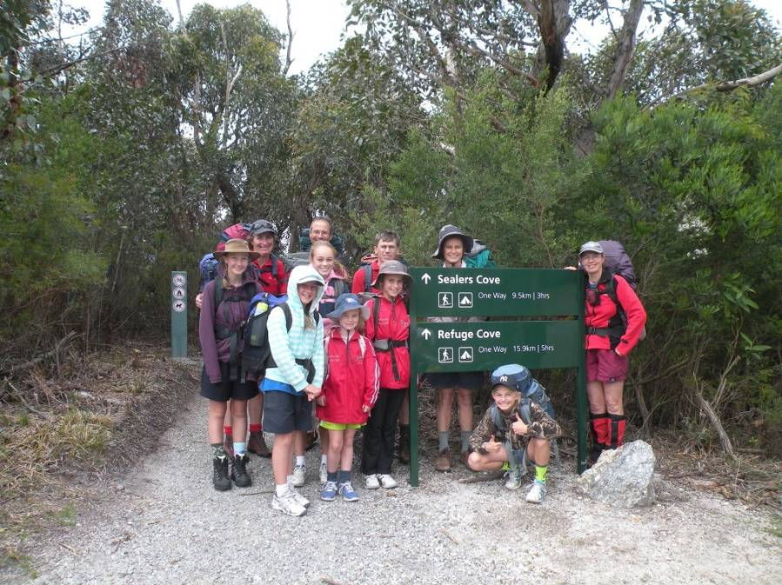
On the first day of hiking 11 of us did 10.5kms. The first bit was up hill until we stopped for a break at Windy Saddle. The next bit was muddy. We were going down hill. We had stops inbetween then we had a longer break at a waterfall where we all drank the water and filled up our bottles. We still walked for a long time until the board walk. This went on forever. We crossed a bridge onto sand and took our shoes off and went into the sea. After the break we started walking along the beach then we crossed a creak which was coca-cola colour. We camped at Sealer’s Cove. The adults set up camp while the kids climbed rocks. The biggest rock was called “Henry”. A bum-pusher had to get you started then someone else pulled you up to the very top. From the top you can see everything. It was a 45 degree angle so we got the adults to take a photo. We had dinner and played elastics and climbed more rocks then went to bed. Therese (10) and Trinity (7) Cameron.

The Lunch
Ok, so we have just walked 6km and we have stopped for lunch. Where we stopped for lunch had a beach. It was called Refuge Cove. We all put our packs down and got ready to settle down for some lunch. After Moira, Lizzy, Taryn, Therese, Trinity and I had our lunch we got our bathers on. We felt the water, and in my opinion it was very cold. There was a rock that was not too far out from the shore which we climbed on. Some of us slid down the other side of the rock into the ocean and swam to shore. After our swim we all got dry. There was a big rock nearby so all the kids climbed it. It was pretty hard. You felt like spider man when you were climbing it. Then it was time to go. We all put on our packs. We only have 6 more km to go!
Alice O’Brien (11)

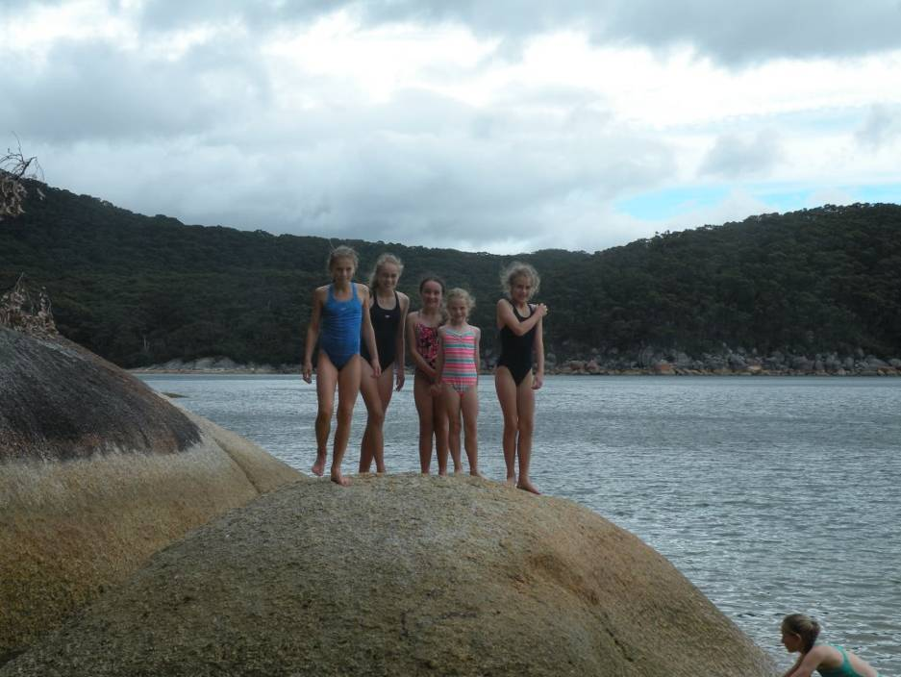

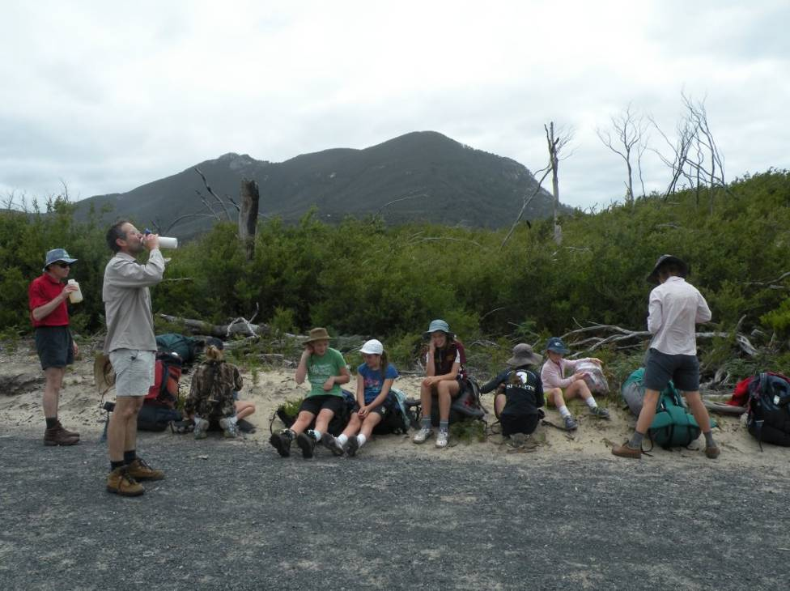
By the third day everyone was getting quite tied and had sore hips, feet, backs and everything else. The day started off by walking across the beach which then led to a board walk. Everyone started to think it was going to be easy. That was before it started going uphill for what felt like ages. Along the boardwalk there were quite a few massive rocks on the sides and we had some fun guessing what they look like. After about 3 km we had a small break. The flies were terrible and seemed quite attracted to people who had lollies. After about 5 km we had to walk along the road until we reached the car park again. The road was pretty boring but everyone was thinking about the end. We walked for a few hours and then had lunch. When we had lunch Therese, Trinity and I played a game where we pretended we were tigers. All the kids thought it was quite funny. Along the road there was tons and tons of ciccadas which gave the most annoying sound you could listen to. It almost major brain rattle. It was a big relief when they stopped. In about the last 5 km it started going steep uphill. Everyone thought there was bound to be a downhilll soon but there was none and it got very tiring but all the kids still managed to have races up the steep hills. Trinity and Mora won nearly every race. Just the thought of the end made everyone excited. All the kids kept asking how many kilometres were left and the parents will make up gibberish to try make us believe it was almost over, but to find 4 km later that there is another 4 to go. That only made us race faster these races went on for quite some time to the parents’ amazement. After a few kilometres racing all the kids except Trinity and Mora gave up. Everyone would look up and see Mora and Trinity running up the hills and then they would disappear over the hill. No one knew how they did it. At last the car park came into view and everyone felt so excited and they could do the last two kilometres again! Everyone wanted to be the first to the cars. At the end everyone felt like it was all completely worth it, the pain and all. We took off our packs and changed shoes. Lots of people including me had such sore feet they could hardly walk. But the thought of ice cream at Tidal River made everyone walk through the pain. The ice cream tasted amazing. That night everyone slept well in their tents and were looking forward to the morning.
By Taryn Cameron

Despite the complaints all the kids enjoyed the hike and are keen to do it again! Something I learnt on this hike was to try out the dried meals before you go! Richard Grave’s had suggested that the commercial packets from Ray’s were very tasty so I bought 2 for the two nights of dried food. They were for 2 adults so I added a bag of dried peas and lentils to each to bulk it up a bit for the 3 girls who do not have big appetites for main meals. Well, what was hydrated could possibly feed 5 leprechauns or maybe one small adult on a diet! But they were tasty just tiny expensive meals. So next time I will stick to pasta packets or dehydrate some spag bol myself. And take lots and lots of healthy treats and snacks. We ate 1kg of nuts, dried fruit, brownies and chocolate very quickly! Another thing I learnt was as well as checking the kids bags for excessive “stuff” I must also check the husbands! He had enough warm clothes for all of us (I did borrow some on the second night though so they were useful) but as we were alternating the packs around I carried them too! Plus the ancient back pack needs a new hip strap! We all had a great time enjoying the scenery, exercise and company. Thanks to Jill and Greg for organizing another trip.
Fiona Cameron


