

If undelivered, please return to PO Box 264, Shepparton 3632

SHEPPARTON ADVENTURE CLUB inc. A0002706S

NEWSLETTER April-May 2012

www.vicnet.net.au/~sac1 Affiliated member of
& soon www.shepadventureclub.org.au

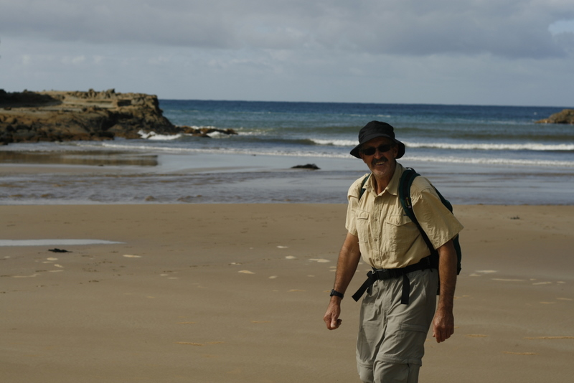

The Great Ocean Walk March 2012

Next meeting Tuesday 26 June 2012 - Hiking & Kayaking in Nepal - slide show by Neville …………………………….
7:30 pm at the Mechanics Institute, Wyndham St, Shepparton (rear entrance via carpark)

Newsletter Printing:
Our newsletter printing is kindly sponsored by Wendy Lovell, Member for Northern Victoria
138 Welsford Street
Shepparton Victoria 3630
Phone 03 5821 0055
Fax 03 5831 1062
The Hon. Wendy Lovell MP
Minister for Housing and
Minister for Children and Early Childhood Development

The SHEPPARTON ADVENTURE CLUB Inc.
General Meeting: 4th Tuesday of the months: February, April, June, August, October
usually: 7:30 pm at the Mechanics Institute, Wyndham St, Shepparton.
Committee Meeting: Monthly at 8pm.
Correspondence to: The Secretary SAC, PO Box 264, Shepparton 3632
Email: sacvicau@yahoo.com.au

OFFICE BEARERS
President Chris Halpin 0417 516703
Vice President Richard Graves 5824 2929
Secretary Cathy O'Brien 5831 5068
Treasurer Scott Birchall 5831 6063 scottbirchall@aapt.net.au
(for email distribution to members)
Committee Members Richard Cameron 0428 486402
Bruce Gill 5824 2548

CO-OPTED POSITIONS
Newsletter Editor Greg Smith 5824 1143 gregs@g-mwater.com.au
Equipment Officer Maartje Heuperman 5824 1543
Publicity Officer Maartje Heuperman 5824 1543
Calendar Coordinator vacant
Mid-week coordinator Robyn Fennell 5824 1724
Web Master Greg Smith 5824 1143

MEMBERSHIP FEES

Initial Club Joining Fee $5
Single Club Membership $25
Family Club Membership $40 plus $5 per nominated child aged 5 to 16 years
Concession – Single Membership $20 - Pensioner/Senior/Student Cardholders
Concession – Family Membership $35 - Pensioner/Senior/Student Cardholders

Membership benefits
Your Bushwalking Vic membership card enables you to obtain discounts at a number of retailers including Ajays (Heathmont), Bogong (Melb), Bushwackers (Essendon), EMC (Deepdene), Melb Map Centre (Malvern East), The Wilderness Shop (Box Hill), Outsports (Moorabbin), Paddy Pallin, Pinnacle, Snowgum, Escape 2 (South Wharf DFO).
You can also become a member of Anaconda, Columbia, Ray's Outdoors and Snowgum for free and thereafter obtain discounts.

Sunrise & Sunset (Melbourne GPO)
Fri 1 Jun 0727 1709 EST  Fri 29 Jun 0736 1711 EST  Fri 27 Jul 0725 1729 EST  Fri 24 Aug 0653 1752 EST | Fri 15 Jun 0734 1707 EST  Fri 13 Jul 0733 1718 EST  Fri 10 Aug 0711 1740 EST  Fri 7 Sep 0632 1804 EST
Full Moons
2012 Thu 8 Mar, Sat 7 Apr, Sun 6 May, 4 Jun, 4 Jul, 2 Aug, 31 Aug, 30 Sep, 30 Oct, 29 Nov, 28 Dec
Source: www.ga.gov.au

President’s Report

Hi all,
Seems we have had an enjoyable year of activities and socialising so far in 2012 and can look forward to a pretty full calendar for the rest of the year. It is also timely to reflect on how lucky we are to have such a great Club facility at Victoria Park Lake.

In this issue of our newsletter you will see the inclusion of the Annual Membership form for you to complete and return. The subscription process has been streamlined this year thanks to Treasurer Scott, so that we can now make the payments 'on-line' and avoid extra costs with cheques. Unfortunately we still need signed forms returned because of our commitment to the club's insurer. So please help us by getting both your subs and the forms returned as soon as you can.

The new Club canoe has proved to be a valuable addition to our fleet. It performed very well on last week's trip on the Goulburn River. Many thanks to Richard for completing this purchase. Participation in the various activities this year has been great. The mix of canoeing, walking and bike trips has proved popular - now for skiing too. Also the new trailer has had a few outings in recent weeks carrying both canoes and bikes and works exceptionally well.

None of these activities happens without a lot of effort from your committee and supportive volunteers so now is a good time to consider how you could help a little bit more.
Several committee positions will be available for new 'blood' in the coming year, after the AGM in August. After 2 years, Greg Smith has announced he will step down from the Newsletter Editor position due to increasing commitments elsewhere and to let others have go. We owe Greg a significant acknowledgement for the quality and timeliness of our newsletter - so this is a great opportunity for you to become involved. Maartje Heupermann has done great things reviewing our equipment list and posting regular media articles - I know she would like a rest. Personally, I am looking forward to a tough campaign against stiff opposition to see who will win the Presidency next year. So please think about how you can help to keep the club successful and growing into the future.
The annual Changeover Dinner is set for Tuesday 11 September at the TAFE restaurant "Covers", details are in the calendar.

Finally, we look forward to launching our new web site in coming weeks at www.shepadventureclub.org.au, thanks to Bushwalking Victoria. There will be a link from our old website when that happens. More later.

Cheers for now,
Chris

WALKSAFE Food & Water (from Walksafe booklet, by VicWalk/BWV)

Carry at least 1 litre of water on a day walk, more in hot weather and for more energetic trips. Don't trust water in streams downstream of towns, resorts etc, grazing or other agricultural land ... unless boiled for 5 minutes.

A day spent bushwalking generally expends more energy than a typical one at home. So don’t skip breakfast, eat a little more than usual and have frequent snacks of high energy, easily digestible food. On overnight walks, have a generous serving of carbohydrates such as rice or pasta for the evening meal. Hot soup replaces lost salts and is an excellent starter to warm a tired body whilst preparing the main meal.

Popular quick acting high energy snacks include dried fruit, nuts and chocolate which, when mixed together, acquire the colourful bushwalking name of “scroggin”. Simple but adequate lunches include bread or biscuits and cheese, with a little fresh fruit or salad vegetable. Evening meals are generally prepared from dehydrated ingredients because of weight considerations. However, a little fresh capsicum, snow peas or bean shoots are also light and can improve edibility of a dish. Although today there is a substantial range in price and variety of commercial dehydrated food on the market, there are an increasing number of overnight bushwalkers who enjoy the challenge of producing their own creations with home food dryers.

Read more at http://www.bushwalkingvictoria.org.au/walk_safe.htm


PO Box 1007 Templestowe Vic. 3106
Phone: (03) 8846 4131
Fax: (03) 9846 7473 admin@bushwalkingvictoria.org.au www.bushwalkingvictoria.org.au

News

For overnight hikes check: www.packcarryvic.pbwiki.com

Several brochures on walking safely & softly are available at: www.bushwalkingvictoria.org.au/brochures.htm

There's a heap of useful info in the BWV newsletters that I encourage you to read, too much to fit in here - Ed.

Federation Day 2012: Marysville 14 October
Maroondah Bushwalking Club will be hosting the 2012 Federation Walks at Marysville on Sunday 14 October. More details to come.

Wilsons Prom update
Wilsons Prom NP tracks have been gradually reopening since the March 2011 flood but Telegraph Saddle is still inaccessible meaning Mt Oberon and Sealers Cove can't be accessed from there. However, you can get to Sealers via Waterloo Bay and Refuge Cove. The lighthouse, Oberon Bay and other southern tracks are also open as well as most northern tracks.
Check www.parkweb.vic.gov.au

Rail trails
- The High Country RT in north-east Victoria has bridged the 600m long gap across Lake Hume. The spectacular new bridge, which is quite a feat of engineering, will be opening in mid-2012.
- By the time you read this, all 134km of the Goulburn River High Country RT should be open. But before deciding to travel its length and for official opening information, check
http://www.victorianrailtrails.com.au/
- Both icon and bane of the O’Keefe RT, the Axe Creek Swing Bridge, built in 1993, is no more. The foundations for the new bridge were poured in February. Unlike the old bridge, the new bridge will cross the creek at the same level as the trail, opening the trail to people who were unable to cross the old swing bridge. The trail has been reformed and resurfaced between its start on the Bendigo Creek and Pratts Park Rd in Bendigo East. The trail now links with the new Hargreaves Creek Bridge constructed in 2011 to Crows Rd/Burns St in Axedale.
- Port Fairy to Warrnambool – a large section of the 37km trail in SW Victoria has been complete for a few years now, but completing the rail trail to Warrnambool has been a slow process. However, a boardwalk across Kelly’s swamp is currently being constructed, providing the missing link. It was scheduled for completion by Easter, with an opening to follow by June.
- Grand Ridge Rail Trail has been re-opened with new bridges and surfaces replacing what was destroyed in the 2009 bushfires.
- Daylesford-Woodend Rail Trail strategy has got the green light for strategic planning work.

High Plains Huts - Report vandalism and vandals
Police stationed in and around the Victorian Alpine area ask for assistance in apprehending vandals and hoons who cause damage to huts. If you encounter any hut damage please record the date, time and place, and if you see suspicious behaviour take photos record vehicle registrations etc. But do not try and apprehend these people, let the police take care of them.
Send information direct to the nearest police station, 4WD Victoria or to Victorian High Country Huts Coordinator at www.hutsvictoria.org.au

How to remove a leech?
Simply flick it away; sprinkle with salt, salty water (eg. an eye wash solution) or vinegar; or wipe with toothpaste (use a match to apply) to chemically burn the leech; or carefully burn with a lighted match. Do not pull the leech off as the leech may regurgitate some of its stomach contents and parts of the sucker may be left behind causing an infection.
For that terrible itch which goes on for weeks – a cold pack, an antihistamine, local anaesthetic and antiseptic cream are all useful remedies.

Calendar of Activities

Date | Activity | Location & details | Grade | Leader | Contact
now 20 May | Mid-week cycle | Section of the Mansfield to Tallarook Rail Trail. Approx 30 km. | M | Chris Halpin | 5831 3446
23 May | Mid-week walk | Reef Hills Park, Benalla | E  9km | Maartje H | 5824 1543
2-3 June | Camp | Base camp at Friday's Camp Ground in the Brisbane Ranges National Park. Day walks and exploring the old ghost town of Steiglitz. | E | Chris Taylor | 5825 1267
8-11 June | Skiing | Mt Hotham. Ski the many cross country trails or take to the slopes for some downhill/XCD/telemark skiing. Suitable for all levels of ability. Non skiers most welcome to relax and enjoy the ambience of the snow without actually getting out into it! Staying at discounted lodge accommodation opposite the Davenport Access trail to the ski slopes. Book in early as numbers are limited. (This is low season accommodation). |  | Barb & Ian Stansfield | 58299497 or 0408299497
9-11 June | Base camp | Long-weekend bush camp, probably usual private spot near Guildford. Lots of things to do on and around property. | E | Greg & Jill | 58241143
13 June | Mid-week cycle | Section of the Mansfield to Tallarook Rail Trail. Approx 30 km. | M | Chris Halpin | 58313446
15-17 June | Skiing | Mt Hotham. Details as per 8-11 June. |  | Barb & Ian Stansfield | 58299497 or 0408299497
22-24 June | Skiing | Mt Hotham. Details as per 8-11 June. |  | Barb & Ian Stansfield | 58299497 or 0408299497
26 June | Meeting | Hiking & Kayaking in Nepal - slide show by Neville. 7.30pm at the Mechanics Institute, Shepparton | social
27 June | Mid-week walk | Mt Black, Rushworth | M | Chris Halpin | 0417 516703
29 June - 20 July (but 8-13 July full) | Skiing | Mt Hotham. Come for a day or stay a week. Ski the many cross country trails or take to the slopes for some downhill/XCD/telemark skiing. Suitable for all levels of ability. Non skiers most welcome to relax and enjoy the ambience of the snow without actually getting out into it! Staying at discounted lodge accommodation opposite the Davenport Access trail to the ski slopes. Book in early as numbers are limited. (This is high season). |  | Barb & Ian Stansfield | 58299497 or 0408299497
22-29 July | Skiing | Mt Hotham. As above & this trip also incorporates Ski.com's annual ski weekend, which is taking place at from Friday July 27 - Sunday July 29. |  | Barb & Ian Stansfield | 58299497 or 0408299497
25 July | Mid-week walk | Echuca | E | Cathie M | 0434343327
3-5 Aug | Skiing | Mt Hotham. Details as per 29 June. |  | Barb & Ian Stansfield | 58299497 or 0408299497
11-16 August | Jatbula Walk - 5 days Katherine Gorge to Edith Falls, Northern Territory. NOW FULL. |  | M (contingent on weather) | Justin Halpin | 0488 040444
22 August | Mid-week walk | Whipstick Forest | E 6km | Richard G | 5824 2929
28 August | Annual General Meeting | Speaker to be advised | social
11 Sep | Social | CHANGEOVER DINNER at Covers restaurant (TAFE) Book with Maartje. | social | Maartje Heuperman | 5824 1543
26 Sept | Mid-week walk | Warby’s Salisbury Walk | E/M 4.6km | Robyn Fennell | 5824 1724
26-30 Sep | Camp & walks | Somewhere flowery for spring school holidays, maybe the Grampians yet again? | E-M | Greg & Jill | 5824 1143
Oct - 1 week date to suit those interested. | Base Camp | Explore the old mining town of Walhalla in Gippsland. Day walks along historic tracks, a train ride, a gold mine tour and exploring the historic town. Base camping at North Gardens Camping area – flushing toilets, fire places and picnic tables. Suitable for small vans/camping trailers and plenty of room for tents. Suggest one day to drive there, 3 days of activities, one day to drive home. Expressions of interest welcome to determine which dates suit the majority who would like to attend. | E | Chris Taylor | 58251267
14 Oct | Day walks | Federation Day walks at Marysville run by BWV | see www.bushwalkingvictoria.org.au nearer to time
24 Oct | Mid-week walk | Chiltern Whitebox Walk | E 8.5km | Maartje H | 5824 1543
28 Nov | Mid-week walk | Barmah or Dookie Bushland Reserve | E | Dianne/ Howard | 5828 9281

PLEASE RING THE TRIP LEADER TO MAKE SURE IT IS WITHIN YOUR CAPABILITY

Benalla Bushwalking Club trips

25-28 May - Four day cycle 2-3 June - Camp Cook-out
8-11 June - Hume & Hovell base camp 9 June - Beechworth-Stanley
13 June - Mt Major 23 June - Canoeing at Lake Nillahcootie
More trips and booking information at http://home.vicnet.net.au/~benbwclb/index.htm

OTHER CLUBS’ ACTIVITIES
Border Bushwalking Club (Albury & Wodonga) - www.borderbushwalkingclub.com.au
Wangaratta Out and About Club - http://members.westnet.com.au/wangoutandabout
Bendigo Bushwalking and Outdoor Club - http://home.vicnet.net.au/~gobush/
Echuca-Moama Bushwalkers - http://www.echucamoamabushwalkers.org.au *new website

If you are interested in overnight hikes check out www.bushwalkingvictoria.org.au
Just follow the step-by-step instructions for access to the site called Packcarry Vic

TOTAL FIRE BAN
If a day of TOTAL FIRE BAN is declared please contact the Activity Leader for confirmation whether the activity will go ahead or not.

Note: TRIP LEADERS – it is imperative for every trip that temporary members/visitors sign the “Acknowledgement of Risk Form”. These completed forms must be forwarded to the SAC Secretary for filing as soon as possible after the trip – otherwise, in the case of a claim, the insurer will not acknowledge the risk.
Form can be downloaded from www.bushwalkingvictoria.org.au , in http://www.bushwalkingvictoria.org.au/forms/Risk_Management_Guidelines.pdf

Emergency Contact Procedures
All enquiries about the return of participants from club activities should first be directed to the activity leader, and then to the Emergency Contact Person (ECP) for the activity if the leader cannot be found.
It is the activity leader's responsibility to organise an ECP and advise him/her (in writing) of trip & participant details and what to do if contact is not made by the nominated time.

Travel Cost Reimbursement
Option 1: Preferred. Fuel Cost per car plus 5 cents per km per car to be split equally between the numbers of people in the car including the driver. If appropriate, the cost of running all vehicles should be shared equally amongst all trip participants.
Option 2: 25 cents per km per car split between all trip participants.

Summary of Public Liability insurance coverage effective from 30 June 2009
Bushwalking, Recreational Walking, Walking, Track/Hut Construction and Maintenance, Caving, Canyoning, Liloing, Abseiling, Alpine Walking (Summer and Winter),Snow Skiing, Canoeing, Kayaking, Boating, Rafting, Swimming, Cycling, Rock Scurrying and use of hand held ropes as part of a Bushwalk, Orienteering, Rogaining, Leader Training, Rescue Training and other related instructions where no fee is charged other than to recoup expenses (Errors & Omissions), Voluntary Work for various Charities and not- for-profit organisations.
Activities NOT COVERED include Rock Climbing, Mountaineering, Water Skiing and Animal Riding

Trip Reports

Great Ocean Walk 14-18 March 2012

This part of the southern Victorian coastline is well known for its variable weather and this trip was no exception. Over the 3 days of walking we experienced nearly everything that nature can throw at you, from beautiful & sunny days to squally & heavy rain & strong winds. Made the trip exciting and adventurous, particularly along the deserted beaches and rugged high cliff tops overlooking magnificent seascapes. This walk has got to be up there with some of the best in Australia.

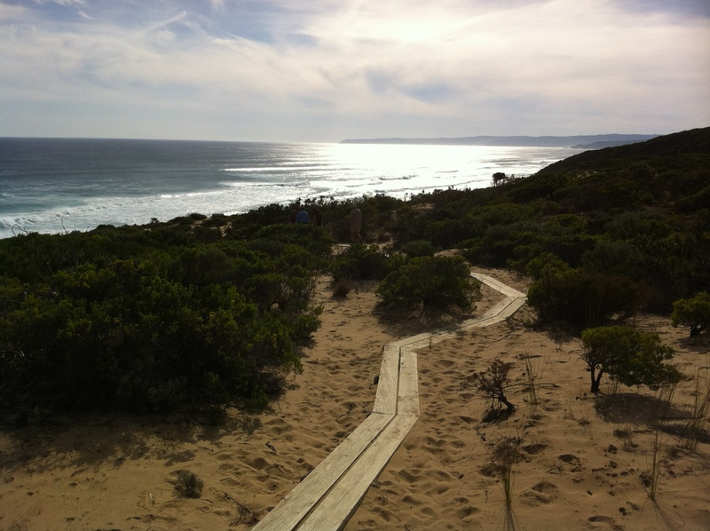
Seven of us stayed in comfortable bunkroom accommodation at Bimbi Park Cape Otway and Chris & Len slummed it in their cosy caravan. The Koala population has not diminished at Bimbi Park and Photographer Judy had a field day(s) recording them & almost every metre of the walk for posterity. We lost count of the number of photos she took over the trip, but over 1,000 was our consensus. It is not often you witness a koala drinking from a puddle after rain, but one young one treated us to this sight outside our bunkrooms. It was completely oblivious of us and must have sat there for half an hour. Fascinating.

Bimbi Parks shuttle bus & knowledgeable driver with his entertaining chatter assisted with our daily car shuffle and we managed to fit in well timed coffee breaks before & after walking. We must have looked a motley mob at times rugged up in our various wet weather gear and Alfred carrying his umbrella & Ted with his torn plastic poncho.

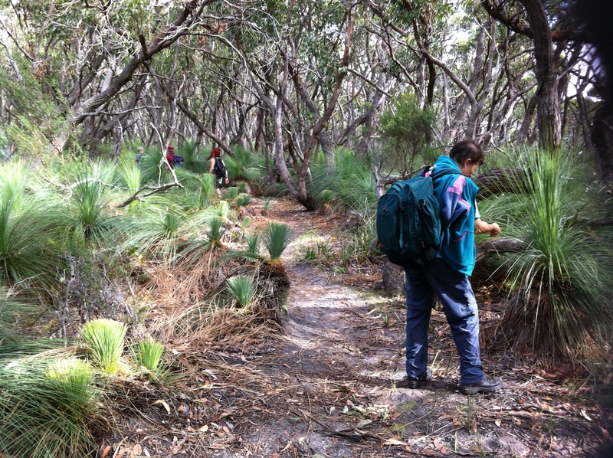
First day we did 14kms from Aire River to near Moonlight Head, second day 10km from Cape Otway Lighthouse to Aire River & a shorter 7kms from Blanket Bay to a track junction past Parker Hill on the last day. We shortened the last days walk as we were booked to tent it for the final night (bunkrooms were booked out that night) but we piked out camping after the camping area was covered in water following very heavy rain falling. 70 secondary school students were not so lucky. They returned from their days walk many of them literally soaked to the skin only to find their tents surrounded by a sea of water. We undoubtedly were far better equipped for the weather than they were. They were given emergency accommodation in the parks undercover eating and lounge area. To compound their misery, one of their pranksters turned off the gas to the hot water in the male shower block. Consequently all males, including us, had cold showers that night.

Rae’s desire to have a dip in the ocean was realised on our way home at Wye River beach where she kept the lifesavers on duty vigilant as no one else was swimming at the time.
The group’s consensus was that this will not be the last time we visit the Great Ocean Walk.
Many thanks to Chris H., Alf, Maartje, Judy & Ted, Rae, Chris & Len for your good humour & company.

by Richard Graves

Bike ride on the Rail-trail from Tallarook to Yea 11 April 2012
On Wednesday the 11th of April a group of mixed-ability bike riders of all ages and both sexes enjoyed the beautiful autumn weather on the new Goulburn River High Country Rail Trail. After an elaborate car shuffle operation we finally ended up with one car and bike trailer in Yea and all of us with the bikes in Tallarook, ready to go.
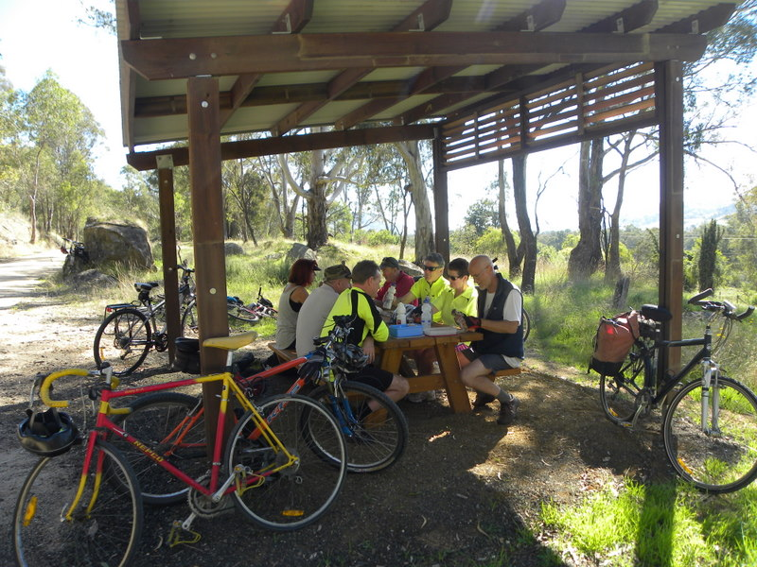
After the rains the track was rough in places; well passable for hybrid and mountain bikes, but a bit ‘loose’ for the one road bike in the group.
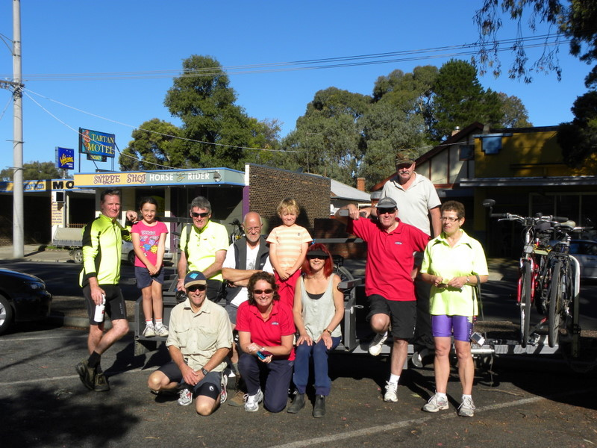
No complaints about the weather; we couldn’t have asked for better with little wind, lots of sun and cool temperatures. The total track section from Tallarook to Yea is 38 km but the O’Briens with the 2 kids started in Trawool and the rest of us caught up with them on the top of a rather high hill (it felt actually more like a ‘mountain’; who said that rail trails are “flat”?).
Jeremy on his new bike did very well on his first real 27km trip!!
The trip was such a success that the next section from Yea to Mansfield is already on the calendar; don’t miss out on that one.
Thanks to Chris Halpin for organising this most enjoyable day.
by Alfred H

Canoeing the Goulburn River from Alexandra to Yea 5-6 May 2012
Adventurous, brave or mad?? Tackling the Goulburn from Alexandra to Yea in early May was maybe a little late in the season but very rewarding. The weather forecast wasn't terrific - maximums of 16C, possible showers, morning fogs ... but we set off anyway.
Starting at the bridge 3km out of Alexandra on Saturday morning was a bit challenging. Flow rates on the river were quite good due to extra late season flood releases from Lake Eildon. The river was not quite to minor flood levels but enough to provide for what felt like a jet propelled trip to Molesworth in a little under 3 hours canoeing time. Six keen Club members canoed Saturday and camped overnight at the Molesworth Recreation Reserve. Quite a handy campsite, roomy, clean kitchen and toilet facilities and close to modern amenities such as pub counter meals and a coffee shop. Early concerns about a clash with the local 'Ute Muster' were quelled very gratefully by Richard who identified them as the resident Rock Band. They were good too.
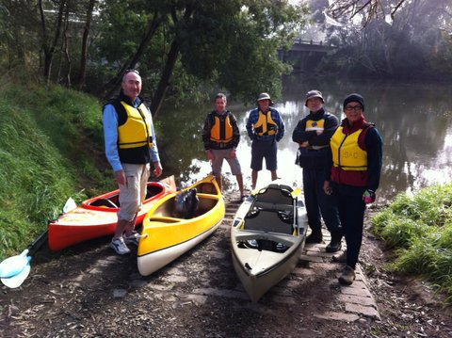
Sunday morning broke to misty rain and a miserable atmosphere. Nearly cancelled proceedings but finally found our Adventurous button and sailed off towards Yea. Thankfully the sun did break through on occasions but everyone had good warm gear on and plenty of nibbles to keep the cold at bay. Even more importantly no-one went for a swim so no harm done and a happy group finished at the Killingworth Reserve just east of Yea again in very fast time. In total we covered around 40 river kms in about 6 hours on the water, plus breaks and lunch stops.
The new Club canoe, a 16ft Native Watercraft Ultimate, has proven a great addition to our fleet. Well done Richard for organising the purchase of this craft. It will be a great asset to the club for many years to come. The new seats have made dear old Hagar a lot more comfortable too. Poor thing needs some TLC soon to restore her former glory. Perhaps a working bee might be needed.
by Chris Halpin

MEMBERSHIP RENEWAL FORM
SHEPPARTON ADVENTURE CLUB Inc. A0002076S

Membership Fees for the 2012 / 2013 year are due on 1st JULY 2012.
Please return this form with your payment to:
The Treasurer, Shepparton Adventure Club Inc. PO Box 264, Shepparton. Vic 3632.

Please list name of each person and circle their age group (Insurance underwriting categories)

Name _________________________________________ U16 16-17 18-34 35-54 55-94 95+

Name __________________________________________ U16 16-17 18-34 35-54 55-94 95+

Name _________________________________________ U16 16-17 18-34 35-54 55-94 95+

Name _________________________________________ U16 16-17 18-34 35-54 55-94 95+

Name __________________________________________ U16 16-17 18-34 35-54 55-94 95+

Address: __________________________________________________________________

__________________________________________________________________

Phone: BH _____________________________ AH ________________________________

Mobile _______________________ Email Address: ___________________________________

Initial Club Joining Fee: $ 5 ________
Payment options:

1. Mail cheque or Money Order to PO Box 264, Shepparton 3632

2. Direct deposit to Bendigo Bank
BSB 633 000
Account No. 129 076 972
Please add your name as the reference and post the signed membership renewal form back.

Single Club Membership $25 ________

Family Club Membership (2 people) $40 ________

plus $5 per nominated child aged 5 to 16 years ________

Concession (Single Membership)* $20 ________

Concession (Family Membership)* $35 ________
*Concession applies to Pensioner/Senior/Student Cardholders

TOTAL $ _________

ACKNOWLEDGEMENT OF RISK - ALL Adults must sign
I acknowledge that when I am participating in any activity of the Shepparton Adventure Club Inc, I am doing so as a volunteer in all aspects and as such I accept all responsibility for loss of property or bodily injury to me however it may occur.
I acknowledge that my participation in this activity may expose me to hazards and risks that could lead to injury, illness or death or to loss of or damage to my property. In particular when participating in abseiling, caving or above the snowline activities I am aware that these activities expose me to additional hazards and risks.
I will make all reasonable effort to avoid or minimise these risks by :
- only participating in activities within my capabilities,
- carrying food, water and equipment appropriate for the activity, and
- advising the leader if I am taking any medication or have any physical or other limitation that might affect my participation in the activity.

I acknowledge that the payment of my (renewal) subscription will be deemed as full acceptance and understanding of the above.
I agree to be bound by the rules of the Shepparton Adventure Club Inc. (which are available from the secretary).

Signed ………………………………………………………………………… Date ………………………………

Signed ………………………………………………………………………… Date ………………………………

